MGX3991- LEADERSHIP: PRINCIPLES AND PRACTICES

The leadership theories
- Are fixated on performance and growth at the expense of staff
- Treat employees as a means to an end (as human resources)
- Often neglect the emotional, ethical and spiritual dimensions

Leader never exists alone
It takes three to tango
Context, followers, leaders

3 MOMENTS OF LEADERSHIP past, present and future is what the leadership development relies on.

The U.S. army relies on being, knowing and doing

- Assess the strengths and weaknesses of major theories of leadership
- Current and future leadership experiences
- Develop higher self-awareness
- Construct a personal leadership philosophy
- Analyse and synthesise crucial roles and positive impacts that managers have

Professor Larry Roper
- Don’t steal other people’s pauses
- Treat the conversation and each other as if they matter- they have the permission to say and ask anything

Social learning theory (Bandura, 1986)

Individuals learn from observing, and emulating the attitudes, values and behaviour of important role models
Followers likely to mimic the leader’s behaviour when they are perceived to be a credible role model

Social Information processing perspective

- What is the differences between management and leadership?
Management | Leadership
- Task oriented  - Appointed + formal  - Control  - Allocating + organising  - MAYBE good leader  - Within the box | - People oriented  - VISION  - Work towards a purpose  - Organic and informal  - Influencing  - Not always to have power  - MAYBE good managers  - Focuses on culture

- Do you think it alters how you lead?
- CONTEXT matters, depending on what context you’re in, it’ll determine if you can be a leader (describes the situational leadership)
- Be more inclusive
- Value opinions and commitments of people
- Social Well being
Agree:
- Very little of biological features affects leadership, leaders are emerged and made through their actions and experiences
Disagree:
- Leadership is biological

Evaluate your own leadership:
Think back to the last time you were the leader

How did you embrace your first follower?

How were you easy to follow?

Richard Ranson
Oprah Winfery
Elon Musk
Narendra Modi
Ellen De genes
Tim Dook
Sundar Pichai
Mark Zuckerberg

Assignment
2500 profile of the chosen person
Social economic background
Age
Education
Gender

How it affects their context, followers and the leader him or herself.

Leadership category theory suggests that we all have our own opinion of what a leader is.
- Lord, Brown, Harvey & Hall, 2001

This is built over time and experience, so a great leader to one person (or situation) may not be in another

Three main lenses are used to understand leaders
- Trait (Post WW1 era)- you are born with it, it is innate
Distinguishing personal characteristics of a leader, such as in intelligence, values and self-awareness.
- Behavioural
- Situational- when situation arises ordinary people emerge into leaders, some situations make the leader

Will cover 7 leadership styles
- Servant leadership
- Authentic leadership
- Transformational leadership
- Charismatic leadership
- Corrupt leadership
- Destructive leadership
- Ethical leadership
- Paternalistic leadership

In the assessment, you can show how the leader chosen does or does not fit in one type of leadership.

Week 2- Seminar
- Can you identify an early event in your life that has sparked you to be on the path you are on today?
I was part of a mentorship program in Year 9, it changed me completely and the perspective I had on life. I have taken on more opportunities from then and become the person I am today.
- Create a list of the 5 people in your life who have influenced your leadership the most. What was the one lesson you learnt from each of them?
- My parents
- My mentor
- Friends
Question: Evaluate your leadership:
- Look at Murphy's leadership development table.
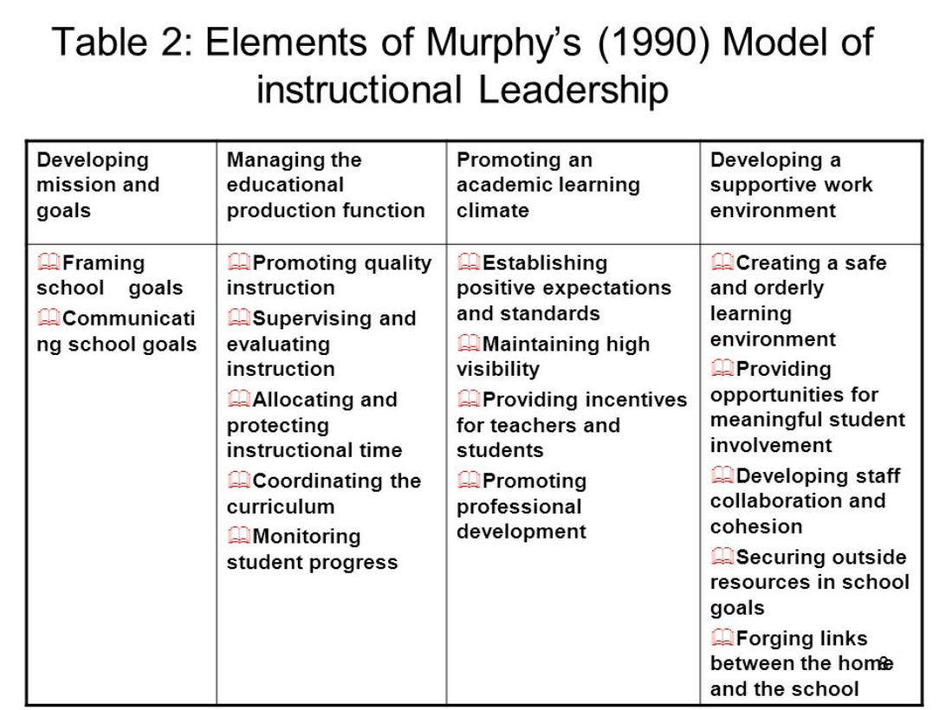
- List out which of these you undertook

- What was the main leadership lesson you took from each of these activities?
What is leadership?

Leadership is about leading, guiding and enlightening the followers. Leadership cannot exist alone, it needs the three aspects; context, followers and leaders. Depending upon the situation and scenario one ends up in, individuals are made leaders. This highlights situational leadership. There are many types of leadership, it is not possible to choose which one is best as they aid for different scenarios and different people. A type of leadership style that suits one person may not necessarily suit the other. It is very important to understand the basis of trait leadership and the significance it places on individual qualities, for example if a person is not by nature firm and high pitched, it is they will be able to exercise authoritative leadership or toxic leadership. Over the course of time, leaders evolve and take on new characteristics and move to different leadership styles. A good leadership is when the followers complete their goal and be able to say that “they did it all by themselves”. Leaders inspire their followers to achieve beyond what they think is doable.

