
SHERYL SANDBERG
AUTHENTIC LEADERSHIP
Poojitha SIVAKUMAR
28805925 (TUESDAY 8AM)


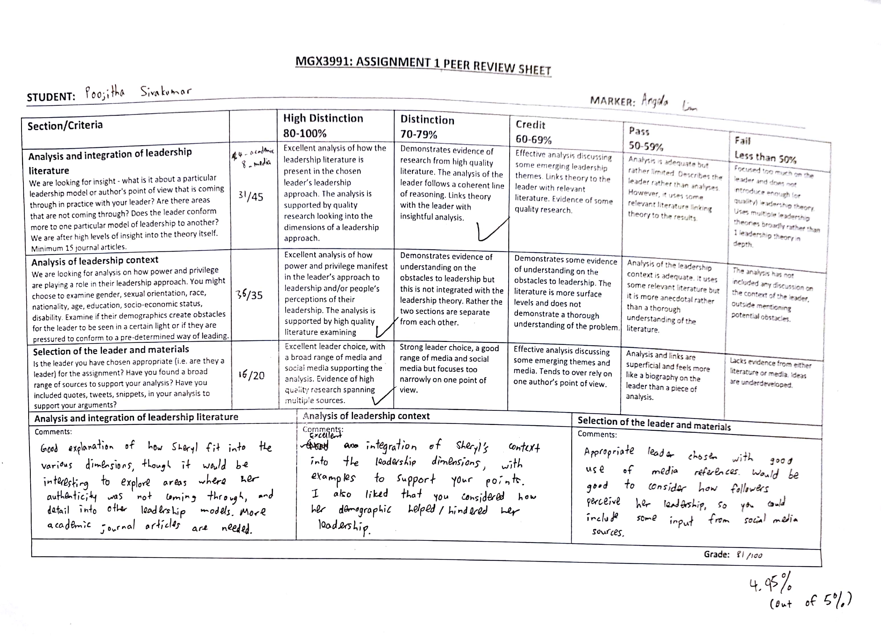
“Presenting leadership as a list of carefully defined qualities (like strategic, analytical, and performance-oriented) no longer holds. Instead, true leadership stems from individuality that is honestly and sometimes imperfectly expressed.... Leaders should strive for authenticity over perfection.” -Sheryl Sandberg

Authentic leadership is “being yourself and being the person, you were created to be” rather than emulating from the societal stereotypes of a leader (B. George, 2003, p11). Furthermore, an authentic leader is described as someone who has self-knowledge and strong personal stance on issues they are interested in and making decisions based on their moral values and convictions (Shamir & Eilam, 2005). Therefore, it was established that there were four dimensions to this leadership theory: self-awareness, internalised moral perspective, balanced processing and relational transparency (Walumbwa et al., 2008). Self-awareness is described as a deeper understanding of one’s motivations and inclinations, in addition to their strengths, weaknesses, desires and personal goals. Confidence and honesty are often hallmarks of a self-aware person. People with internalised moral perspective is a person who displays altruism through solving problems due to concern for the welfare of others (Alvesson, M., & Einola, K. 2019). Lastly, balanced processing and relational transparency means that they ensure all perspectives on an issue are considered before executing a well-planned decision and they are completely honest about their agenda. This essay focuses on self-awareness, ethical decision-making and relational transparency through the journey of Sheryl Sandberg’s Lean In movement.

Sheryl Sandberg’s leadership journey started in 2004, she was put in charge of the philanthropy arm of Google, Google.org, to combat climate change, poverty, lack of education and health. In 2008, she was hired by Facebook as COO where she implemented an advertising strategy which is responsible for majority of Facebook’s revenue. Whilst working in Facebook, she went on to establish the ‘Lean In’ initiative in January 2013 which was dedicated to “bring women together to learn from each other and achieve their goals. [Lean in website] She has been a strong advocate of gender equality and women empowerment. She was able to achieve this through her Lean In initiative, TED talks and the two books she published. However, Sheryl Sandberg’s leadership style changed following the death of her husband to authentic leadership. Sheryl Sandberg ever since has presented herself as a very strong woman despite the grief, “the elephant that is always in the room which can’t be ignored” (TheEllenShow. 2017), and has taken serious initiatives to improve the life of other women undergoing personal tragedy. She is able to inspire 2,265,762 followers on Facebook while being interactive on Twitter as well.
Self-awareness refers to understanding one’s strengths, weaknesses, motivations and desires, thus gaining insight into the multifaceted nature of the self (Walumbwa, Avolio, Gardner, Wernsing, and Peterson, 2008). As self -aware individuals, authentic leaders are realistic and honest about their true nature. They tend to capitalize on their strengths, whilst taking measures to rectify their weaknesses. Sheryl Sandberg portrays great level of awareness, both around herself and within. Self- awareness refers to the ability to understand the strengths and weaknesses of oneself and acknowledging the true nature of his/her identity (Gatling, A., Castelli, P., & Cole, M. 2013). Sheryl has shown to be a self-aware person, as she was able to turn around her weaknesses into positive aspects of not just her life but of others around her. During the initial stages of the Lean In movement, it was highly being criticized by media as for developing her brand as a leader.

“She had it all — a husband, children, a beautiful home, a seat on the board of a billion-dollar company, a nine-figure net worth of her own. But there was one thing Sheryl Sandberg didn’t have…. this is simply the elite leading the slightly-less-elite, for the sake of Sandberg’s bottom line. The “movement” Sandberg seeks to lead with Lean In resembles a social movement only so far as it supports the growth of her brand as leader.” (The Washington Post, 2013)

Whilst this might have been true to some extent, as Sheryl had not faced any hardships till then as she was considered “gifted” (TED Talk. 2013). Even though she had good intentions, her actions were misunderstood and critiqued. However, life provides all of us with twists and turns at the most unexpected times. Dave Goldberg, Sheryl’s husband, died in 2013. This traumatic irreversible event in her life was the catalyst to the growth of her leadership. “Grief which I had never experienced before, it is an overwhelming thing, it just stays with you. I felt like there was a void closing in on me” (TheEllenShow. 2017), Sheryl juxtaposes the difference between someone experiencing grief and the view of grief by bystanders. This demonstrates that Sheryl is a self-aware person who has in-depth clarity about the realities of the world as well as her emotions. Whilst this grief could have overtaken Sheryl, she managed to cope with her loss and more importantly, channel her personal experience into developing initiatives to support employees who are undergoing their own form of tragedies (TED Talk. 2010). However, Sheryl proves to be an authentic leader, as she is “genuine, true to herself” and is transparent about her true self. Throughout this journey, Sheryl’s increase in resilience is clearly evident. She describes resilience as a muscle which can be built within us and within the people around as well. Even before Dave died, she was not afraid to ask people if they needed help facing challenges, she would ask if there was anything she could do or tell them that it is going to be ok, which shows that she was more of a doer and a fixer when it came to crisis. However, only until she was in that position, she did not realise that “grief cannot be fixed” (Anderson, 2019), hence, decided that she is going to do something about it than just watch the grief. Sheryl’s authenticity lies in her intention to help other women and men out there who are going through similar situations, therefore she developed Lean In more rigorously than before, and released her second book “Option B, facing adversity, building resilience and finding joy” which is based around how resilience can be built and how happiness comes after grief (Ford, J., & Harding, N. 2011).

Relational transparency refers to presenting one’s authentic self openly and sharing one’s true thoughts and feelings (Walumba et al, 2006). Authentic leaders are often referred to as relational transparent leaders as they do not hold back expressing their true self and sharing their internalised morals and values. This also means they do not portray a ‘false self’ which is to fake emotions, have loss of voice and projects false images. However, it is inevitable in the corporate world to survive without possessing multiple selves which enables them to fit into situations depending upon the circumstance (Sendjaya, 2015). For example, a leader who is very sociable with his/her subordinates may change his/her self to become authoritative towards the financial year end to push the results of the company to a better position. This change to and from multiple selves can also be observed in authentic leaders which will be explained in this essay referring to the focal character, Sheryl Sandberg. However, having multiple selves does not necessarily diminish the efficiency of relational transparency.

Authentic leaders remain consistent in their ideas as they speak their actions and transform their words into their actions, which means they are not just dictators of followers but rather a follower of their own thought and feelings. Sheryl Sandberg was found to have expressed her grief publicly in numerous occasions about losing her husband. The six weeks from 1 January 2017 to mid-February 2017 she took part in significant changes and initiatives. She wrote and published her second book, “Plan B” which was about how she dealt with loss and grief after she lost her husband (CBS News, 2018). In addition, she openly expressed her feelings in Facebook of losing her husband and the struggles she faces to find comfort during the difficult times of her life. She believes that this negative experience in her life was the reason for creating a tribute section for memorialised accounts in Facebook that honours the memory of loved ones. Another indication of Sheryl portraying her true self was during the Facebook Privacy Scandal. When Facebook faced numerous scandals and when media reported that Zuckerberg criticised Sheryl for these scandals, it was reported that Sheryl publicly expressed that she felt “deeply personally responsible, because a lot of mistakes were made” (Salinas, 2018). She clearly expressed in public social media that she takes responsibility for the damage caused due to the scandal despite it being her fault (Fink, 2018). Therefore, Sheryl Sandberg conforms to the relational transparency dimension.

Ethical decision making refers to making decisions based on moral and ethical reasoning and thereby minimising negative consequences on all affected parties in that decision. According to Walumba et al (2008), this also relates to internalised moral perspective which is making decisions based on internalised moral standards and values rather than societal pressures.
Authentic leaders are always driven by a set of internalised morals and values to which they stay true to, and these guide their actions and behaviours. It is a widely accepted fact that with power comes corruption where most leaders use their power to gain personal benefits through unethical actions. However, authentic leaders are identified as leaders who are not morally disengaged with the power they are given and also impact followers to behave according to the accepted moral standards (Černe, M., Jaklič, M., & Škerlavaj, M. 2013)

Wharton Professor, Steward D. Friedman described Sheryl Sandberg in his case study as acting with integrity (McDonald, 2018). She has a set of core values that speaks for gender equality. She does not believe it is ‘ethical’ to have only men rule the corporate world when women are as much as capable as men to hold responsibilities. Her interview with McKinsey and company (2013), she revealed that as she worked in teams at both Google and Facebook, she realised how women were held back either due to duties to their families or as they did believe they suited for the role. She also spoke about the pay gap between male and female employees and thus make women less promoted in the corporate world. She believed that “we do not live in an equal world”. Hence, she started the campaign, Lean In that was definitely an ethical decision she made in her life to support gender equality. However, it is necessary to understand that power and privilege existed in her context. As a white-female, she was at a privilege in the Silicon Valley. She was appointed as Treasurer for the government and subsequently COO of Facebook as she was prominent among other females in the industry due to her background as an educated white female. Also Sheryl admits herself as a single working mother and thus encourages every such mother to excel in workplace despite having kids. Many female writers have argued about this in media sources stating Sheryl, appearing in 2013 Forbes’ Billionaire List, earns a decent sum of money and thus does not have financially difficulties in raising kids. Writers have argued it can be an extremely difficult situation for average earning working single women to raise children while working, it can be incredibly difficult for many women to manage both career and motherhood (Adams, 2013). Hence, Sheryl’s empowerment for every woman may not suit their context. In that context, it is questionable whether she began Lean In with an understanding of women who do not have the same privilege and financial power as her.

Nonetheless, it is important to identify the significance of power and privilege in Sheryl’s development as an authentic leader. She studied at one of the world’s best-renowned universities, Harvard Business School, hence she had the privilege to gain access to the best education and also gain fame that will eventually help her in establishing her name in the corporate world. Also, being born and raised in a country that is the centre for tacit knowledge and had headquarters of all emerging and successful companies in the world, she was at an upper hand compared to majority of women, hence gives her an advantage in fast-pacing her dreams. She had the chance to reach all the best employers and even improve her competencies by associating with the best employees in these companies. Hence, her education and her nationality acted as a privilege that allowed her to build most of the above-mentioned skills and talents that she shared with others through Lean In.

In conclusion, it is evident that Sheryl Sandberg depicts self-awareness, relational transparency and ethical decision making throughout her multifaceted aspects of life. She is a charismatic leader who has the ability to fabricate a movement like Lean In in spite of all odds, where now it is used as a common phrase which associates with calling for help. Power and privilege played a major role in the way she was depicted by her followers. Due to the fact that she was given all the resources and came from the upper class, she was not greatly appreciated by her followers. Her followers were all from the upper middle class and upper class of the society, the lower middle class to the bottom were never able to associate with her intentions and believes as she has not gone through the hardships in life. However, the way Sheryl dealt with the loss of her loved one shows her strength through vulnerability, however, what makes her an authentic leader is her willingness to help other people out there who are going through the grief that she went through. Her mere thought of giving back to the community of what she has gained highlights the true essence of authentic leadership (George, B. 2018).
Since Authentic leadership is a new concept, there are many gaps in the characteristics and features of what it means to be Authentic. In particular the dimension around ethical decision making it needs further clarity as it does not acknowledge “how the values of justice and community influence the ability to lead” (Northouse, 2016). This theory focuses much more on positive psychology, an authentic leader is only seen as a person who has a positive outlook on life (Diddams, M., & Chang, G. 2012). At times this makes the followers feel that their leader is rather fake as it is not humanly possible to remain composed and optimistic at times of grief and loss (Alvesson & Einola, 2019). Overall, Sheryl Sandberg conforms to the three dimensions explored in this report which makes her an inspirational authentic leader.

Reference list
Social media references
Adams, S. (2013, March 4). 10 Things Sheryl Sandberg gets exactly right in 'Lean In'. Forbes. Retrieved from https://www.forbes.com/sites/susanadams/2013/03/04/10-things-sheryl-sandberg-gets-exactly-right-in-lean-in/#202a91827ada
Anderson, J. (2019). Sheryl Sandberg on how having her self-confidence shattered made her a better leader. Retrieved from https://qz.com/983401/sheryl-sandberg-on-how-having-her-self-confidence-shattered-made-her-a-better-leader/
Facebook's Sheryl Sandberg under fire as scandals mount. (2018, November 21). CBS News.
Facebook’s Sheryl Sandberg: No Progress for Women in Top Jobs. (2019). Retrieved from https://www.nationalgeographic.com/magazine/2017/01/3-questions-sheryl-sandberg/
Fink, J. (n.d.). Sheryl Sandberg Timeline: From Harvard to Facebook and George Soros Scandal. NewsWeek. Retrieved from https://www.newsweek.com/sheryl-sandberg-timeline-harvard-facebook-definers-looking-george-soros-1239166
George, W. (2003). Authentic leadership: Rediscovering the secrets to creating lasting value. San Francisco 7 Jossey Bass Join a Circle and get involved. (n.d.). Retrieved from https://leanin.org/
George, B. (2018). Lead True: Authentic Leadership and Sheryl Sandberg of Facebook [Video]. Retrieved from https://www.youtube.com/watch?v=ezlTM5xnBkc
McDonald, D. (2018, November 27). When you get that wealthy, you start to buy your won bullshit”: The Miseducation of Sheryl Sandberg. Vanity Fair. Retrieved from https://www.vanityfair.com/news/2018/11/sheryl-sandberg-harvard-business-school-leadership
Salinas, S. (2018, November 20). Mark Zuckerberg reportedly blamed Sheryl Sandberg as Facebook faced numerous scandals. CNBC. Retrieved from https://www.cnbc.com/2018/11/19/facebooks-zuckerberg-blamed-sandberg-after-data-scandal-wsj.html
Sheryl Sandberg - Biography. Biography (2019). Retrieved from https://www.biography.com/business-figure/sheryl-sandberg
Sheryl Sandberg is inspiring more humane policies for grieving workers. (2019). Retrieved from https://qz.com/work/1106619/sheryl-sandberg-has-inspired-more-humane-policies-for-grieving-workers-at-facebook-and-beyond/
Sheryl Sandberg. (2019). Retrieved from https://www.facebook.com/sheryl
Ted Talk. (2010). Why we have too few women leaders [Video]. Retrieved from https://www.ted.com/talks/sheryl_sandberg_why_we_have_too_few_women_leaders?language=en
Ted Talk. (2013). So we leaned in ... now what? [Video]. Retrieved from https://www.ted.com/talks/sheryl_sandberg_so_we_leaned_in_now_what/transcript
TheEllenShow. (2017). Facebook COO Sheryl Sandberg's First Sit-Down with Ellen [Video]. Retrieved from https://www.youtube.com/watch?v=_TFVTP0Q1Sc

To Address Gender Gap, Is It Enough To Lean In? (2013, September 24). The New York Times. Retrieved from https://www.nytimes.com/2013/09/25/business/economy/for-american-women-is-it-enough-to-lean-in.htm
Journal Articles
Alvesson, M., & Einola, K. (2019). Warning for excessive positivity: Authentic leadership and other traps in leadership studies. The Leadership Quarterly. DOI: 10.1016/j.leaqua.2019.04.001
Černe, M., Jaklič, M., & Škerlavaj, M. (2013). Authentic leadership, creativity, and innovation: A multilevel perspective. Leadership, 9(1), 63-85. doi: 10.1177/1742715012455130
Diddams, M., & Chang, G. (2012). Only human: Exploring the nature of weakness in authentic leadership. The Leadership Quarterly, 23(3), 593-603. doi: 10.1016/j.leaqua.2011.12.010
Ford, J., & Harding, N. (2011). The impossibility of the ‘true self’ of authentic leadership. Leadership, 7(4), 463-479. doi: 10.1177/1742715011416894
Gatling, A., Castelli, P., & Cole, M. (2013). Authentic Leadership: The Role of Self-Awareness in Promoting Coaching Effectiveness. Asia-Pacific Journal Of Management Research And Innovation, 9(4), 337-347. doi: 10.1177/2319510x14523097
Gunderman, R., & Maas, M. (2014). Authentic Leadership. Journal Of The American College Of Radiology, 11(5), 518-519. doi: 10.1016/j.jacr.2013.11.002
Ladkin, D., & Taylor, S. (2010). Enacting the ‘true self’: Towards a theory of embodied authentic leadership. The Leadership Quarterly, 21(1), 64-74. doi: 10.1016/j.leaqua.2009.10.005
May, D., Chan, A., Hodges, T., & Avolio, B. (2003). Developing the Moral Component of Authentic Leadership. Organizational Dynamics, 32(3), 247-260. doi: 10.1016/s0090-2616(03)00032-9
Nyberg, D., & Sveningsson, S. (2014). Paradoxes of authentic leadership: Leader identity struggles. Leadership, 10(4), 437-455. doi: 10.1177/1742715013504425
Shamir, B., & Eilam, G. (2005). “What's your story?” A life-stories approach to authentic leadership development. The Leadership Quarterly, 16(3), 395-417. doi: 10.1016/j.leaqua.2005.03.005
Sparrowe, R. T. (2005). Authentic leadership and the narrative self. The Leadership Quarterly, 16(3), 419-439. doi:10.1016/j.leaqua.2005.03.004
Waite, R., McKinney, N., Smith-GLASGOW, M., & Meloy, F. (2014). The Embodiment of Authentic Leadership. Journal Of Professional Nursing, 30(4), 282-291. doi: 10.1016/j.profnurs.2013.11.004
Walumbwa, F. O., Avolio, B. J., Gardner, W. L., Wernsing, T. S., & Peterson, S. J. (2008). Authentic leadership: Development and validation of a theory-based measure.
Wang, H., Sui, Y., Luthans, F., Wang, D., & Wu, Y. (2012). Impact of authentic leadership on performance: Role of followers' positive psychological capital and relational processes. Journal Of Organizational Behavior, 35(1), 5-21. doi: 10.1002/job.1850
White, K., Stackhouse, M., & Argo, J. J. (2018). When social identity threat leads to the selection of identity-reinforcing options: The role of public self-awareness. Organizational Behavior and Human Decision Processes, 144, 60-73. doi:10.1016/j.obhdp.2017.09.007
Woolley, L., Caza, A., & Levy, L. (2010). Authentic Leadership and Follower Development. Journal Of Leadership & Organizational Studies, 18(4), 438-448. doi: 10.1177/1548051810382013
Zehir, C., & Narcıkara, E. (2016). Effects of Resilience on Productivity under Authentic Leadership. Procedia - Social And Behavioral Sciences, 235, 250-258. doi: 10.1016/j.sbspro.2016.11.021

