
Leadership Reflections Part 1 Weeks 2-6
MGX3991- Leadership Principles and practices
By- Poojitha Sivakumar
28805925

Week 2- Leadership Development (12/03/2019)
My parents, mentors and well-wishers have given me two contradicting advices throughout my life: “Follow your passion and you will be content” and “Study hard, aim for a stable job and then pursue your dream”. Since both advices were of value, I intended to make the best of both of them. Academically and professionally, I have joined DOXA Social Club as an Assistant Accountant, become a mentor at Monash, took a part-time job as a Kumon Instructor and have established myself as a private tutor. On the other hand, I have also pursued my interest in Indian classical music and dance and am learning it at a professional level. I believe this level of commitment and engagement is not possible if not for the highly competitive environment and the support of my parents. I believe that with perseverance and clear vision, we all can develop to be great leaders in our respective fields of expertise.

Week 3- Leading with your authentic self (19/03/2019)
One of the greatest revelations I had during this week’s lesson was mimicking great leaders is not the best approach to become a leader. My peers shared their experience of having bosses who have an authoritative style of management yet mask themselves to be humble and genuine. “Pity the leader caught between unloving critics and uncritical lovers”. Situations often push leaders along the continuum from authentic self to false self, however now I believe that a leader is stronger when they are able to endure all hardships and remain true to their authentic self.
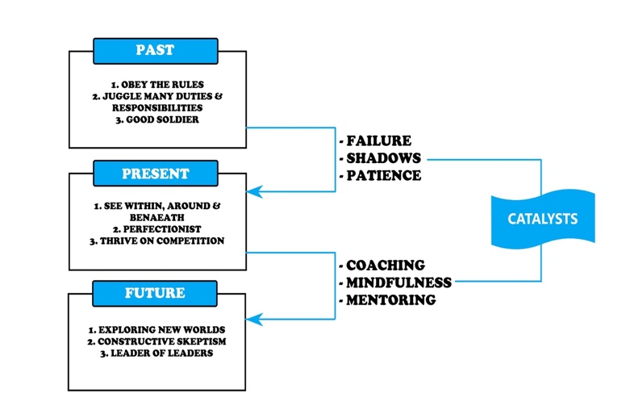
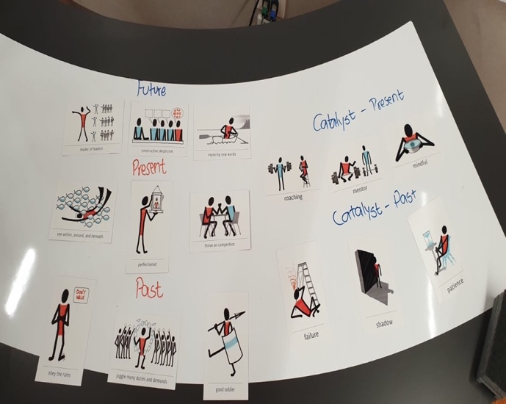
The class activity of mapping our improvements, the catalysts and our ‘future self’ helped me to clearly see the key aspects I had to change or alter within myself. This week I was able to cherish how I have evolved from my past experience, also learnt that I need to retain the skills which I have developed regardless of dynamic situations I go through each day. I converted the task in class into a diagram above and printed in A1 size and pasted it in my room, so that I am reminded each day to be authentic.

Week 4- Leadership excellence through service (26/03/2019)
This week was enthralling for me, initially it was not attractive and did not sound like a positive leadership style. The perception I had about servant leadership was that people unwillingly providing for others that are above them, but I learnt that servant leadership is a leader handing over power to the followers. This form of leadership is very inspiring and intriguing for me, as the leader is thriving to administer growth and support for their followers. I was able to identify myself with this leadership style as I aspire to be a leader who can inspire people around and achieve great results together. I identified that I work to my utmost potential when I am led in this leadership style. I am able to work better in environments that are supportive than in environments that are authoritative and task- oriented. A good leader should inspire and motivate the followers to achieve best results and ensure that each follower receives share of success. This statement till this date lingers in my thought and has been an extremely inspiring topic so far in this unit. When I open my own school, this leadership style is definitely something I will look into and inquire the ways in which I can implement it into my management style.

Week 5- Leading ethically and effectively (02/04/2019)
The video from the Behavioural Science guys on the “4 ways you’re being manipulated” was insightful. It was astonishing to see the ways in which we are influenced despite the values and believes.
- Offer moral justification
As I am working at Kumon Berwick, which is a tutoring centre. We run Kumon Stalls to promote awareness. I tend to oversell the program as sometimes I believe that my intentions are to improve the children’s future.
- Minimise the consequences
At my Cadetship, as part of my duty I will have to prepare monthly reconciliations. When my manager says to run a system check and sign off variances, I tend to hesitate as the company could be penalised for these variances. However when my manager takes responsibility of signing off the variances, I am more at ease in taking up the job.
- Dehumanise the victims
When I know that the people in opposition are not loyal or not with the right motives, it helps me justifies the means, “the end justifies the means”.
- Displace responsibility
“With great power comes great responsibility”, when the responsibility is taken off my shoulders it is easier to complete an unethical task than when it is on me.

I was able to understand that more than leading efficiently, it is important to lead ethically. I believe that “what we do, comes back”, I want to be ethical and socially responsibile before blaming our society or the organisations I work in, it should start from within.

Week 6- The Dark Side of Leadership (09/04/2019)
This style of leadership is something I completely misunderstood, I had a perception that destructive leadership is always bad and negative. However, I identified how charismatic leaders can turn into destructive leaders when their inner self is not natural to characteristics of authentic and servant leadership.

Although, Hitler is one of the best examples of destructive leaderships, I wasn’t able to identify the characteristics as I have grown up hearing his leadership style. When we explored the examples of Jim Jones and Stanford Prison experiment which focuses on the psychological effects of perceived power, which highlights the struggle between prisoners and guards, it affected me more severely than I anticipated.

When the environment imposes pressure on an individual, he/she is likely to make unethical and rather irrational decisions only based on survival instinct. Leaders who possess this style have such powerful management when used appropriately has the capacity to create massive movements of change happen.

I was stirred by the fact that even the person next to me or even I can become a destructive leader if I do not have the control on my inner self and maintain and abide by ethical and moral values. I am glad that I came out of this seminar understanding the significance of exemplary followers, followers are the enormous strength of the organisation. Now when I learn about a leader, I quickly identify and scan characteristics before emulating from them as I want to be an independent follower and a critical thinker.

