
Leadership Reflections Part 1 Weeks 2-6
MGX3991- Leadership Principles and practices
By- Poojitha Sivakumar
28805925

Week 2- Leadership Development

“Happiness is not a function of your circumstances, but a function of your outlook on life (p. 44)” and “find opportunity where others might find only despair (p. 45)”. The takeaways from the reading of this article affected me much deeper than I forecasted. I agree that obstacles are only a part of life and a child who has everything, is one of the most unfortunate children.

Add one sentence about areas of improvement to enhance leadership effectiveness and how you would go about achieving it

My childhood has played a major role in shaping me into what I am today. My parents are mostly authoritative, my earliest childhood advice that I can recall is “study hard, knowledge is power” and “the harder you work now the more you’ll be relaxed in the later parts of your life”. However, my parents both played a divergent role in guiding and mentoring me. My father was always the one who told me that “one should follow their passions to attain content and satisfaction” whereas my mother told me that “once you gain the knowledge and expertise in your field, by all means you can spend time on passions without having to worry about your future”. How can one develop both academically and through fine arts when time is of essence?

Over a period of time, I have developed myself in such a way that I am able to adhere to all my academic expectations “my mother’s expectations” and my inner passion for fine arts “my father’s expectations” simultaneously through the support of mentors, teachers and friends.
I started to pursue my passion for Indian Classical Dance and Carnatic Music from the age of 7, now am an advanced student at Nadanalaya School of Dance and at an advanced level in Carnatic Music. On the other hand, I have been able to score and do well at Monash university while completing a Cadetship at DOXA youth foundation as an Assistant Accountant, mentoring at Monash university and taking private tuitions for primary and secondary school students. If not for the pressure I faced in my early childhood from my parents and the highly competitive environment that I was raised in, I would not be where I am today.

I believe that with perseverance and clear vision, we all can develop to be great leaders in our respective fields of expertise.

Week 3- Leading with your authentic self

Emulating from successful leaders is not the best way to satisfy our inner authentic self. I have been fortunate to have humble leaders at my workplace, I was shaken by the experiences my peers shared in class of having bosses who have an authoritative style of management yet mask themselves to be humble and genuine. “Pity the leader caught between unloving critics and uncritical lovers”, Situations often push leaders along the continuum from authentic self to false self, however good leaders resist whatever may come their way and stay strong to not sacrifice on their authentic style of leadership.
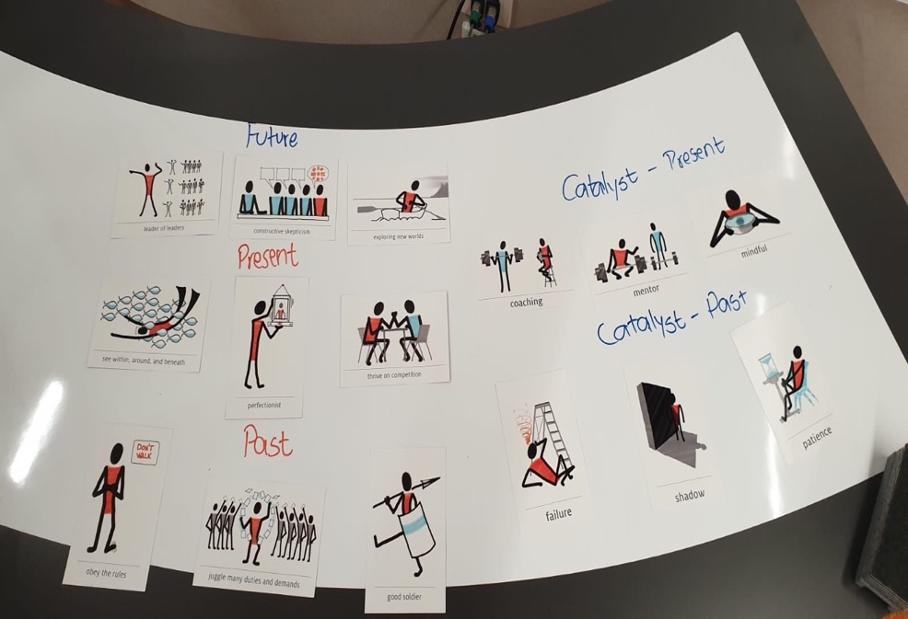
The activity we did in class of choosing from the pool of what I qualities I possessed in the past, what were the catalysts helped me in looking at myself critically and aided in identifying where I want to be in the future. I was able to clearly see the key aspects I had to change or alter within myself. This week I was able to cherish how I have evolved from my past experience, also learnt that I need to retain the skills which I have developed. No matter what challenge the situation might pose, I want to be able to lead myself with authenticity.
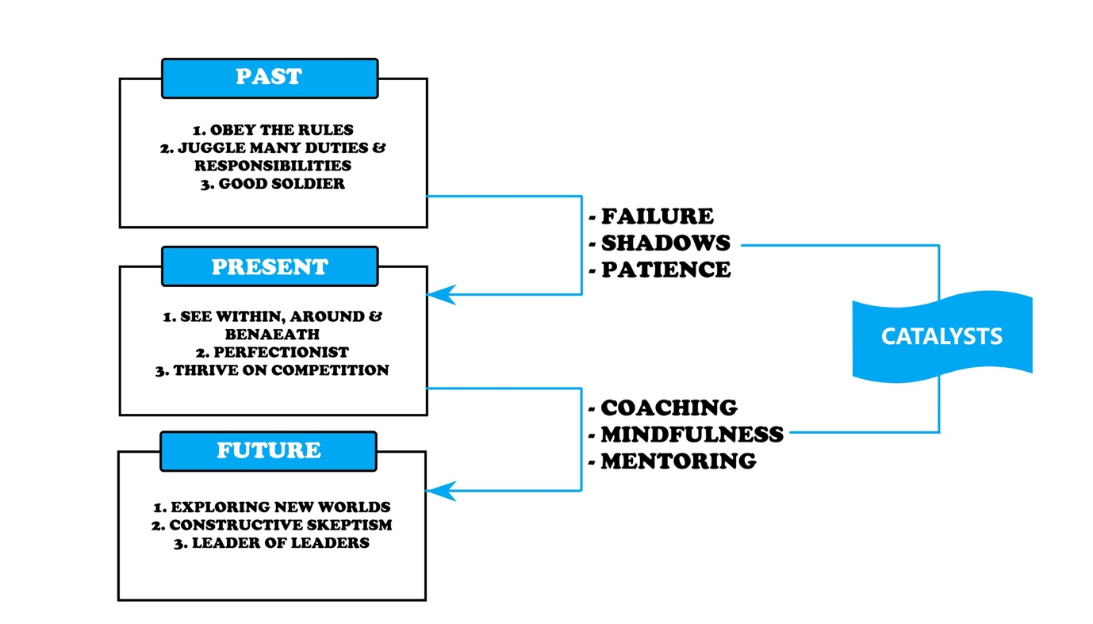
Week 4- Leadership excellence through service

This week was enthralling for me, as this leadership style was not attractive and did not sound like a positive leadership style. The perception I had about servant leadership was that people unwillingly providing for others that are above them, but I learnt that servant leadership is a leader handing over power to the followers. This form of leadership I think is very inspiring and intriguing for me, as the leader is thriving to administer growth and support for their followers. I was able to identify myself with this leadership style as I aspire to be a leader who can inspire people around and achieve great results as a team effort than delegating and administering power. I identified that I work to my utmost potential when I am led in this leadership style. I believe that trust is the key factor for the motivation to succeed for the stakes of the company, I am able to work better in environments that are supportive than in environments that are authoritative and task- oriented. A good leader should inspire and motivate the followers to achieve best results and feel something good and say they did it all by themselves. This statement till this date lingers in my thought and has been an extremely inspiring topic so far in this unit. When I open my own school, this leadership style is definitely something I will look into and inquire the ways in which I can implement type of leadership into my management style.

Week 5- Leading ethically and effectively

This week stimulated my ethical self and question how ethical I am when posed to different circumstances. The video from the Behavioural Science guys on the “4 ways you’re being manipulated” was insightful and attractive as I could align with it. It was astonishing to see the ways in which we are influenced despite the values and believes we hold strongly.

- Offer moral justification
As I am working at Kumon Berwick, which is a tutoring centre. We run Kumon Stalls to promote awareness. At those places I usually tend to oversell as I believe that I am only doing it for a good cause, the kids’ education.
- Minimise the consequences
I am completing a Cadetship at Doxa Social Club, as part of my duty I will have to prepare monthly reconciliations. When my manager says to tamper figures or run a system check and sign off variances, I tend to hesitate but when she says she’ll sign it off, then it makes me feel lighter and in most cases I do complete the task.
- Dehumanise the victims
When I know that the people in opposition are not loyal or not with the right motives, it helps me justifies the means. Like said in the video “the end justifies the means”.
- Displace responsibility
“With great power comes great responsibility”, when the responsibility is taken off our shoulders then it is easier to complete an immoral task than when it is on me.

This week I was able to understand that more than leading efficiently, it is important to lead ethically. Ethics plays a major role in all of our lives and I believe that “what we do, comes back”, I want to have ethical and social responsibility in all dimensions possible, before blaming our society and the organisations I work in, it should start from within.

Week 6- The Dark Side of Leadership

Just like servant leadership, this style of leadership is something I completely misunderstood, I had a perception that destructive leadership is always bad and negative. However, after analysis it is transparent to identify how charismatic leaders can turn into destructive leaders when their inner self is not natural to possess characteristics of authentic and servant leadership. Although, Hitler is one of the best examples of destructive leaderships, it did not affect me as his example was something, I have grown up hearing and use as nicknames for people who have an attitude of dictatorship. When we explored the examples of Jim Jones and Stanford Prison experiment which focuses on the psychological effects of perceived power, which highlights the struggle between prisoners and guards, it affected me more severely than I anticipated. When the environment imposes pressure on an individual, he/she is likely to make unethical and rather irrational decisions only based on survival instinct. Leaders who possess this style have such powerful management when used appropriately has the capacity to create massive movements of change happen. I was moved by the fact that even the person next to me or even I can become a destructive leader if I do not have the control on my inner self and maintain and abide by ethical and moral values. I am glad that I came out of this seminar understanding the significance of exemplary followers, followers are the enormous strength of the organisation. Now when I learn about a leader, I quickly identify and scan all their characteristics before emulating from their actions as I want to be an independent follower with critical thinking.

