Module 3 – Kumon’s Missions

Targets for new instructors

KUMON’s MISSION

“By discovering the potential of each individual and developing his or her ability to the maximum, Kumon aims to foster sound, capable people and thus contribute to the global community.”

- We believe that each Kumon centre will contribute to the development of many local children through discovering their potential. In doing so, will contribute to the development of society.

KUMON OFFICER MISSION
“To foster self-confidence and independence in the next generation of learners by enhancing their self-study habits and enabling them to reach their fullest potential.”

GOAL in the first 12 months
- Full licence status in both maths and English
- A minimum of 500 cumulative enrolments
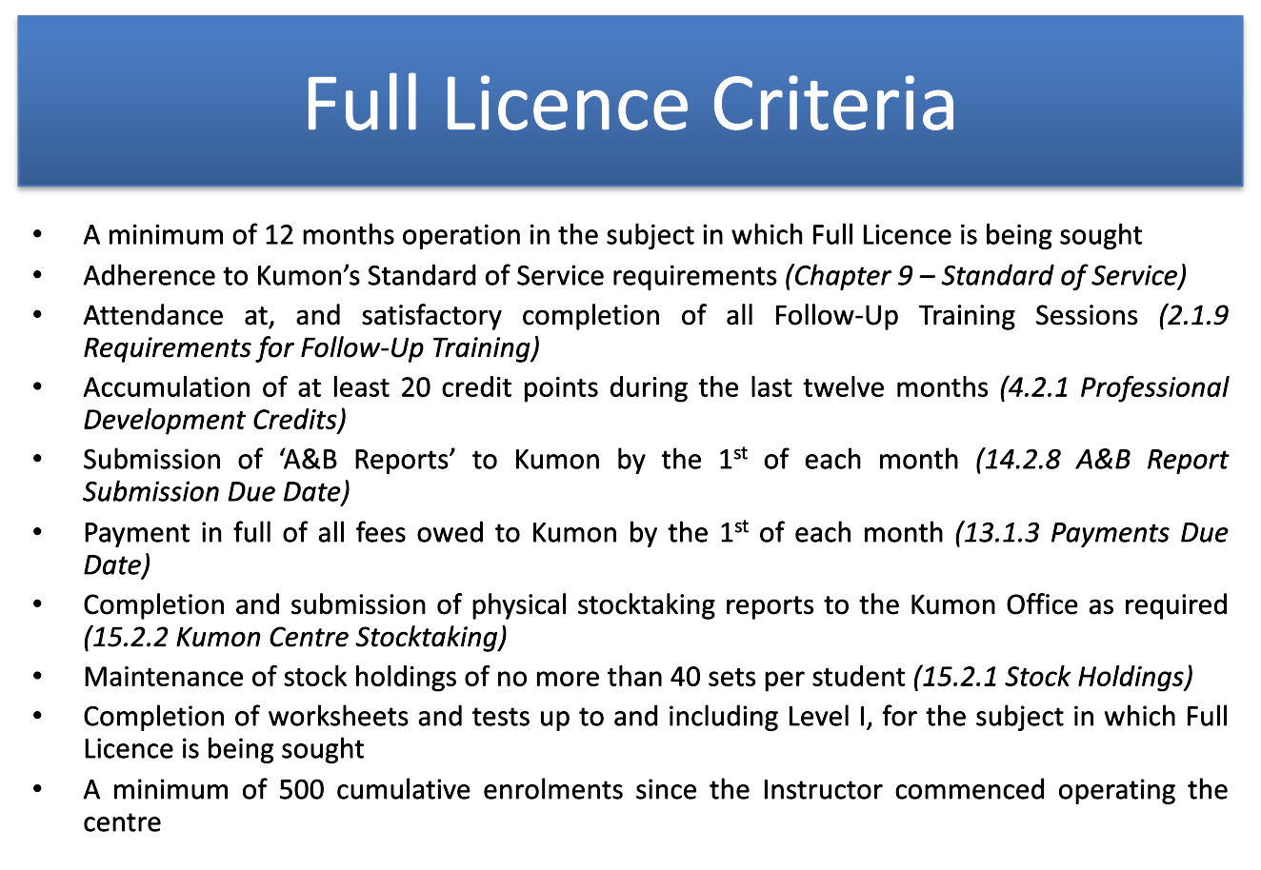

Professional development activities

- KAO conference- sets regional instruction direction
- Annual direction seminar- detailed presentation of the KANZ instructional direction to all instructors
- KANZ conference- provides best cases of implementation of direction
Mandatory to achieve at least 20 professional development credits per calendar year.

New instructors are encouraged to reach Level I in both Mathematics and English by the first 12 months.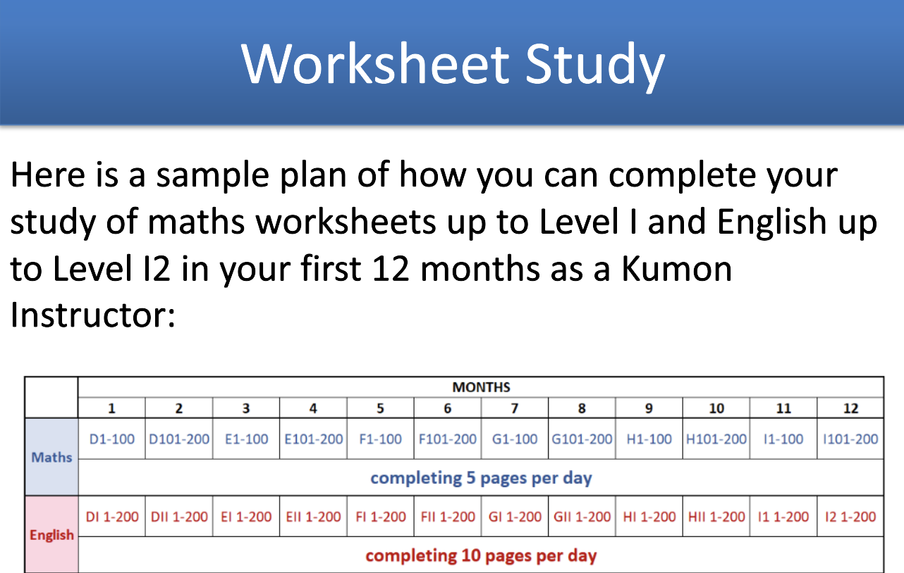

- Question: How do you plan to complete the maths worksheets up to Level I and English worksheets up to Level I2 in your first 12 months as a Kumon Instructor?
Answer: refer to excel sheet for personalised plan

- How will you achieve full licence status in both Maths and English in the first 12 months?
- How many students do you aim to enrol each month?
- What is your student number goal after one year?

Module 4: Financial Information

Start-up expenses
- Licence fee of $1000
- Updated the excel sheet

Revenue
- Enrolment fee (one-off)- $100 AUD
- Monthly tuition fee- $140 AUD

Royalty
- Enrolment fee royalty – 50%
- Monthly tuition fee royalty (payable in arrears, for May should be paid by 1st June) – Provisional licence 45% and Full licence 40%

Operating Expenses
- Rental expenses
- Advertising and Promotion expenses
- Communication expenses
- Insurances
- Direct debit fees
- Stationery and equipment

Projected profit = Projected Total Revenue – Projected Total Expenses

After Populating your cash flow projection, you should consider

- How much profit does the centre make each month?
Month | Subject numbers | Profit
Oct | 30 | 1302.58
Nov | 45 | 1670.76
Dec | 60 | 2720.76
Jan | 70 | 3193.48
Feb | 90 | 4822.91
Mar | 95 | 4098.21
Apr | 100 | 3662.45
May | 115 | 5167.00
June | 120 | 5062.45
July | 130 | 5280.63
Aug | 135 | 5403.36
Sept | 140 | 5753.36

- How profitable would it be if it had an extra 20 or 50 subjects?
Centre breaks even in the first month itself and starts earning profit. Of course, it would be more profitable if it had extra 20 or 50 subjects. However, I believe in organic growth and I would like my centre to grow meaningfully without a single miss on quality.

- What is the break-even point?
First month

- If the business is not making profit, what expenses can I avoid or minimise?
Alter the hours of operation and cut down on wages expenses. Re-direct these expenses towards marketing initiatives to generate revenue streams.

