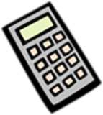
2016 Yr 11 Specialist Mathematics
Sequences and Series and Applications of Trigonometry
Technology Access & A4 Summary Sheet Test
Name: …………………………………………….. Time allowed: 45 minutes Total Marks: / 52

Section A. Multiple Choice Questions. Clearly circle your answer (2 marks each)

- The first three terms of the sequence defined by the rule t_{n} = 2 − 3n are:
A 2, 5, 8
B 2, −1, −4
C 1, 4, 7
D −6, −12, −18
E −1, −4, −7

- If t₁ = 5, t_{n} ₊ ₁ = t_{n} + 5, then t₅ is:

- 20

- 25

- 30

- 100

- 5

- The 70th term of the arithmetic sequence –8, −4, 0, … is:

- 74

- 260

- 264

- 268

- 228

- For the sequence −12, 6, −3, ..., S∞ is equal to:

A | −1
A | 2
B | 0
C | −24
D | −8
E | ∞

- $4000 is invested at 6.5% p.a. compounded annually. The value of the investment after 6 years is:

- $5836.57

- $5480.35

- $34 091.48

- $28 254.91
E $48 919.24

- The height, h m, of a television tower can be calculated by measuring the angles of elevation of the top of the tower from two points that are in line with the tower but that are 100 m apart.
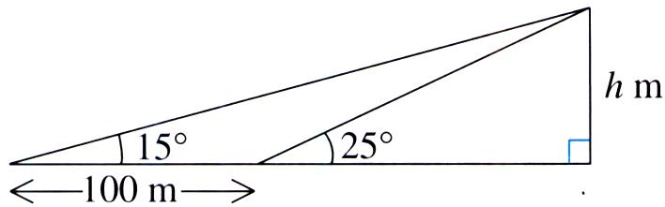

Which one of the following equations will give the correct value of h?

A | h = | 100 sin 15° tan 25°
 |  | sin 10°
B | h = | 100 sin 15° sin 25°
 |  | sin 10°
C | h = | 100 sin 10° tan 25°
 |  | sin 15°
D | h = | 100 sin 10° sin 25°
 |  | sin 15°
E | h = 100 tan 15°

- The length of AB, correct to one decimal place, is:

B
112º | 13 cm
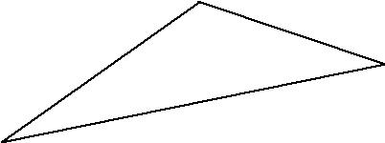
C

34º

A

- 7.84 cm

- 13.0 cm

- 21.6 cm

- 34 cm

- 40.6 cm

- A hiker travels a distance of 5 km from point P to point Q on a bearing of 030°. She then travels from point Q to point R on a bearing of 330° for 10 km. The distance west of R from P, in kilometres, is given by:

- 2.5

- 5

- 7.5

- 10

- 15

- If the area of the minor sector AOB in a circle of centre O and radius 35 m is 225 m², then the magnitude of ∠AOB, to the nearest degree, is:
- 18

- 21

- 11

- 42

- 368

- A vertical mast, AD, of height 20 m is supported by two cables attached to the ground at C and B as shown in the diagram. ∠CAB is a right angle. Cable CD is of length 40 m and cable BD is of length 30 m.
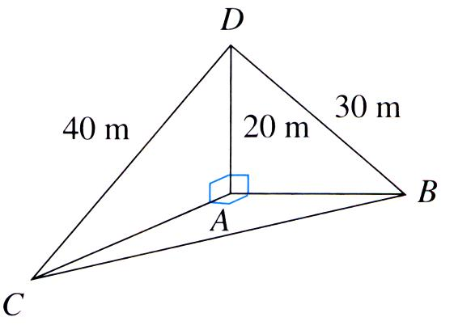

The angle ACB, to the nearest degree, is:

- 48°

- 42°

- 57°

- 60°

- 33°

Section B. Short Answer Questions (total 30 marks)

- Find the 15th term of the arithmetic sequence −10, −14, −18, ...

(2 marks)

- Find the 6th term of the sequence 16, −8, 4, ...

(2 marks)
- The first term of a geometric sequence is 16 and the sum to infinity is 32. Find r, the common ratio.

(2marks)
- A company sells ‘Cartoon Character’ cards in packets containing the following numbers of cards: 30, 45, 60, 75, …

- Find the number of cards in the 10th packet.

- If Megan buys one each of the first ten packets, how many cards will she have altogether?

- Megan wants to buy a single packet that will contain at least 2000 cards. Which is the minimum packet number she should buy?

- Megan’s sister Bridget decides to buy each of the first n packets so as to get at least 2000 cards in total. What is the minimum number of packets she needs to buy?

(2+2+2+3 = 9 marks)
- Find the area of triangle ABC, where AB = AC, correct to two decimal places.

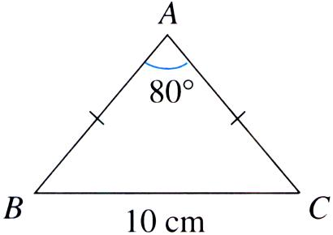

(2 marks)

- In this figure, PQRS is a rectangle inclined at an angle of 45° to the horizontal plane PQTU. The magnitude of ∠PQS = 60°. QT = 1m.
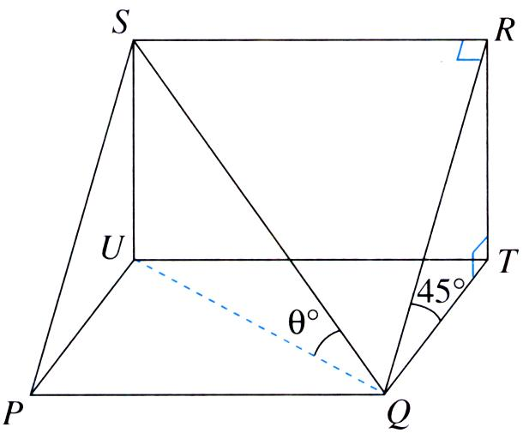

Let θ° be the angle of inclination of QS to the horizontal plane. Find the exact value of sin θ.

(3 marks)
- In the diagram, A, B and C represent three islands. B is 25 km from A on a bearing of 020° and C is 36 km from A on a bearing of 075°. Give your answers correct to 2 decimal places.

B
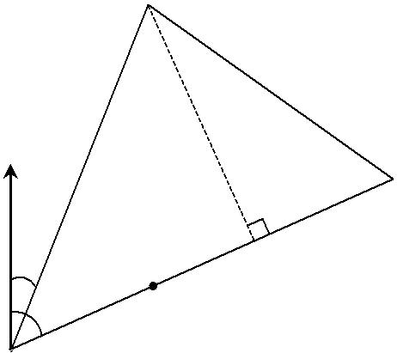

N

C

20° | X

75° ^{D}

A

- Calculate the true bearing of A from B.

- Calculate the distance of C from B, correct to two decimal places.

- A ship leaves A and sails directly to C. When the ship is at D it is due south of B.

  - Calculate the distance AD, correct to two decimal places.

  - Find the distance BX, where X is the point on AC closest to B, correct to two decimal places.

- On island A there are two towers, at P and Q respectively. The angle of elevation from P to Q′ is 25° and from Q to P′ is 20°. The tower at Q has a height of 20 m.

 | Q ′
P ′
 | 20 m
25° | 20°
P | Q
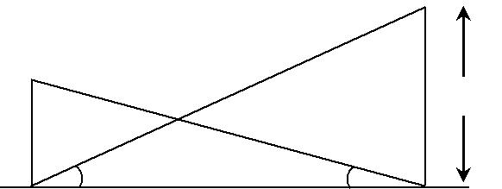
Find the height of the tower at P, correct to two decimal places.

(1+2+2+2+2=9 marks)

- Two circles of radii 3 cm and 4 cm have their centres 6 cm apart. Find the area of the region common to both circles, to two decimal places.

(3 marks)

