CASE STUDY

The carbon tax
The federal parliament in 2011 passed laws introducing a price on carbon, called a carbon tax. The tax was proposed by the Gillard government to address climate change. Under the carbon pricing mechanism, the businesses that emit the largest amounts of greenhouse gases (including electricity generators, gas suppliers, and resources and manufacturing companies) pay for each tonne of carbon they release into the atmosphere. The cost was initially set at $23 per tonne, to be increased gradually until 2015.
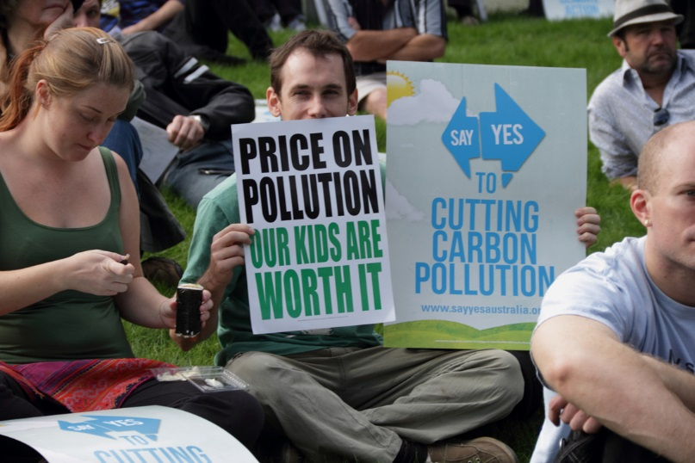
The Labor Party introduced several bills into the parliament, including the Clean Energy Bill, to support the carbon tax legislation. The bills passed the lower house and the upper house at the end of 2011, so the carbon pricing mechanism became law. However, when the Liberal Party was voted into power in 2013, Prime Minister Tony Abbott promised to remove the carbon tax and in July 2014 he successfully passed legislation in the Senate to do so. The Abbott government’s repeal of the carbon tax makes Australia the first country in the world to abolish a price on carbon.
Left:
Legislation establishing the carbon tax was introduced by federal parliament in response to the need to address climate change.

Questions:
- Who had the idea for the laws that established the carbon tax?
The Gillard government had the idea for the laws that established the carbon tax.
- What government policy did this law address?
This law addressed the government policy, ‘pricing carbon’.
- How did this idea become a law?
This idea became a law as the Labour Party introduced several bills into the parliament, one of which is the ‘Clean Energy Bill’. The bills passed the lower house and eventually the upper house at the end of 2011 which then made the carbon pricing mechanism a law.
- Research the development of the legislation to create the carbon tax. Write down the arguments supporting the tax and the arguments opposing it.
Pros | Cons
- Encourages alternatives. | - Production may shift to countries where there is no or lower carbon tax.
- Raises revenue. | - Possibilities of ‘tax evasion’.
- Leads to socially efficient outcomes. | - Difficult to the level of external costs.

- What arguments were used by the Abbott government to abolish the carbon tax in 2014?
He stated, “households will benefit on average by $550 a year from the repel, with gas prices to fall by 7% and electricity prices by 9%.”
- In your view, is the process of law making in Australia fair? Does law making by parliament give ordinary people enough opportunity to have their say when new laws are being made? Explain your answer.
Yes, mainly because there are two houses and especially the poorly populated places and have a say and explain their problems. Adding on, if we the public have a problem in our area we can immediately talk to the legal representative who will then convey the message to the parliament, finding a proper solution to the problem.

