Chicken Run Camera Shots

Type of Shot | Picture | Description
Long Shot | 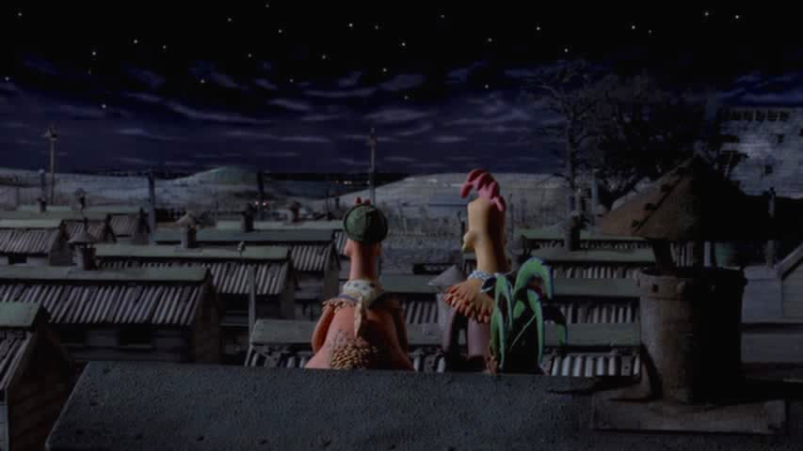 | This is when Ginger and Rocky are sitting on the roof looking at the mountains and when Ginger quotes, “you know, those mountains are looking closer than ever today.”
Close-up Shot | 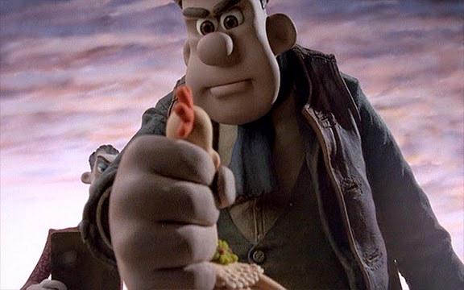 | This is the part where Mr Tweedy takes Ginger to test out the pie machine.
Medium Shot | 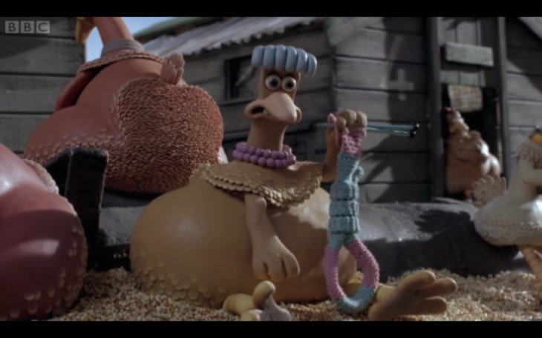 | This scene is where
Zoom Shot | 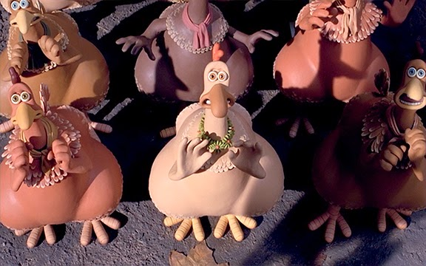 | This is when Mrs Tweedy comes to the farm to measure the size of the chickens.
Tracking Shot | 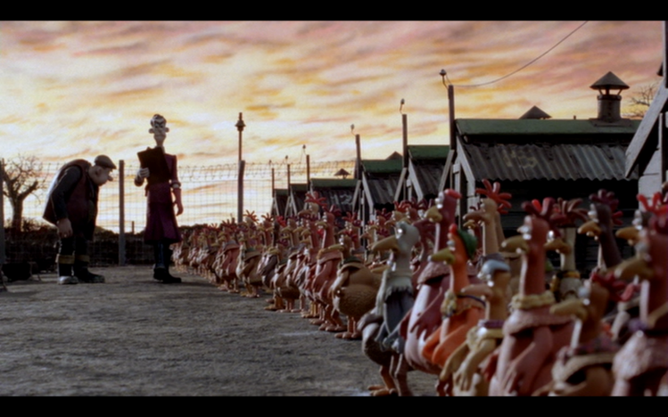 | This tracking shot shows Mrs Tweedy coming around to check if all the chickens laid there eggs or to kill them if they haven’t.
Panning Shot | 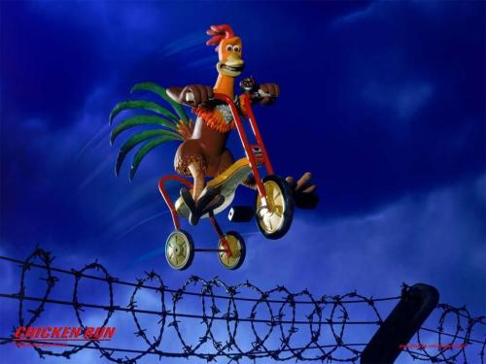 | This is when Rocky comes back to save the chickens and helps Ginger put the launch board up.
Close-up Shot | 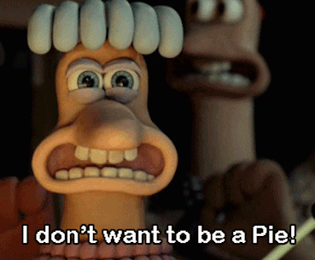 | This is the part where Ginger tells everyone that they are going to become pies and when Bounty says, “I don’t want to be a pie!”
Tilt-Down Shot | 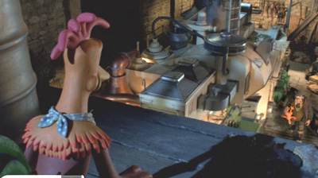 | This scene occurs when Rocky goes to save Ginger and looks down at the pie machine and say “what is the size of that thing?”

