- What is digestion and what is its purpose?
The human digestive system is a complex series of organs and glands that processes food. In order to use the food we eat, our body has to break the food down into smaller molecules that it can process; it also has to excrete waste. Most of the digestive organs (like the stomach and intestines) are tube-like and contain the food as it makes its way through the body. The digestive system is essentially a long, twisting tube that runs from the mouth to the anus, plus a few other organs (like the liver and pancreas) that produce or store digestive chemicals.

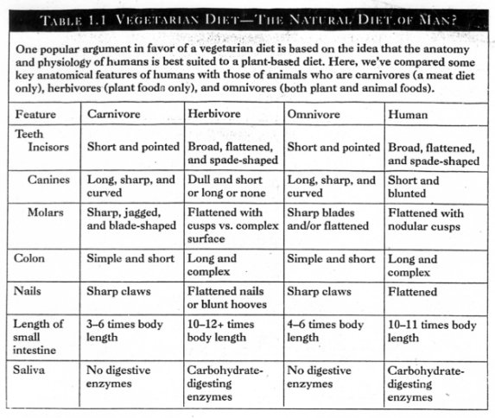
- What differences are there between the three organisms in terms of the way they obtain their nutrients?

- How can dentition be used to assist in determining diet?
Humans have teeth such as incisors, molars and canines; they are suited to our diet and help us eat a range of foods. Herbivores are animals that only eat plants; their teeth are specially adapted to cut through leaves and grass. Carnivores only eat meat so their teeth are specially adapted for hunting and killing. Some animals have no teeth at all!
- Why are the herbivore and human systems more similar to each other, yet different from the carnivore?
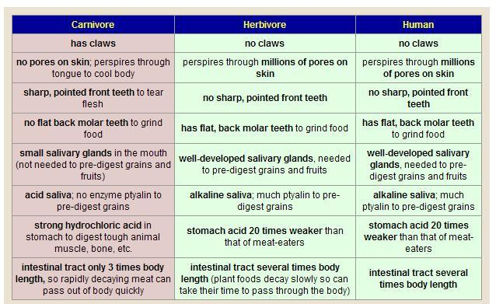
- Which organs are found in humans but not in herbivores? herbivores have special digestive system which allows them to digest grass.
- Describe the key differences in how nutrients are processed and distributed in the three organisms. Omnivores get energy and nutrients from eating a diet containing plants, animals, algae and fungi. Due to the large variety of food options, they will eat what they can hunt and scavenge in their environment to make the most of what is available. If it looks edible, they’ll give it a try!
Carnivores eat meat (and other animal tissue) to get the calories and energy to survive. Meat is a high energy food source. Carnivores find their food through predation or scavenging, and are often adapted with big claws, sharp teeth/beak and quick speed whether on land, in the sea or in the sky.
Herbivores only eat plants to get energy and nutrients. Most animals will eat the leaves and fruits of plants as these tend to be the more nutritious. Plant vegetation, however, is very hard to break down into energy so most herbivores have a specialised digestive system. A cow will chew grass and swallow, nothing unusual so far. The food then passes through not one but two stomachs to be digested, and then is regurgitated (brought back up) to be re-chewed. This part-digested grass is called cud It is then swallowed into third and fourth stomachs where the nutrients are absorbed into the blood. Herbivores graze for long periods throughout a day to gain as much energy as possible. So when you see a herd of cows looking like they’re just standing around chewing the cud they are- but their four stomachs are working hard to get the most out of every mouthful.

- Conclude by summarizing the key similarities and differences between the way the three organisms obtain, process and distribute their nutrients
- Define digestion, dentition, types of dentition of the three different organisms.
- How are nutrients processed and distributed in each of the following organisms?

