The Cardiovascular System Name: Pooja Sivakumar

Step One: Open the following link in Internet Explorer
http://www2.needham.k12.ma.us/eliot/technology/lessons/cir_sys/index.htm
Step Two: Click on ‘Great Heart Animations’ then click on ‘Interactive: view the heart with interactive labels’ and complete the following diagram
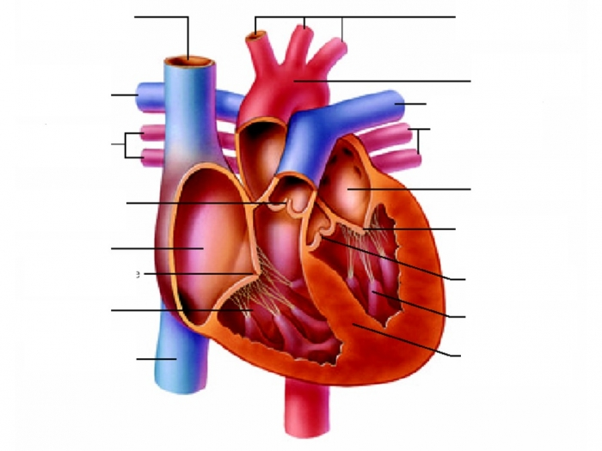
Inferior vena cava
Ascending Aorta
Semilunar Valve
Right Atrium
Tricuspid Valve

Right Ventricle
Superior Vena cava
Left Atrium
Aortic Valve
Descending Aorta
Left Ventricle
Arteries

Right pulmonary Artery
Left Pulmonary Artery
Left Pulmonary veins
Right pulmonary veins

Bicuspid Valve

Right Atrium | Pulmonary Artery x 2 | Septum | Bicuspid Valve
Aorta | Pulmonary Vein x 2 | Superior Vena Cava | Inferior Vena Cava
Tricuspid valve | Semilunar valve x 2 | Left Atrium | Right Ventricle
Left ventricle | Arteries

Step Three: Go back to the main menu and click on ‘Circulation Station’;
Step Four: Follow the prompts and answer the questions below;

- Define the following terms?
Right Atrium | The right atrium receives blood that needs to go to the lungs.
Left Atrium | Receives blood ready to go out to the body.
Valve | Valves open to let the ventricles pump blood out to the lungs and body.
Right & Left Ventricle | The right ventricle pumps oxygen-poor blood to the lungs. At the same time. The left ventricle pumps oxygen-rich blood out to the body.
Arteries | Arteries are blood vessels that carry oxygen- rich blood from your heart out to the rest of your body. These muscular tubes have thick strong walls to handle the high pressure of freshly pumped blood.
Capillaries | Capillaries are tiny blood vessels that distribute blood from your arteries to the billions of cells in your body, and then to your veins. The walls of the capillaries are very thin so thin that nutrients and oxygen can pass right through them.
Veins | Are blood vessels that carry your oxygen-poor blood back to the heart.

- Complete the loop;
- Read ‘A Doctor Making a Difference’;
  - What medical discovery did Helen Brooke Taussig M.D. make?
Notably, she is credited with developing the concept for a procedure that would extend the lives of children born with Tetralogy of Fallot (the most common cause of blue baby syndrome).
  - What impairments did she have?
Some of the babies died immediately, others only lived a few years.
- You are Finished!

