The Cardiovascular System Name:

Step One: Open the following link in Internet Explorer
http://www2.needham.k12.ma.us/eliot/technology/lessons/cir_sys/index.htm
Step Two: Click on ‘Great Heart Animations’ then click on ‘Interactive: view the heart with interactive labels’ and complete the following diagram
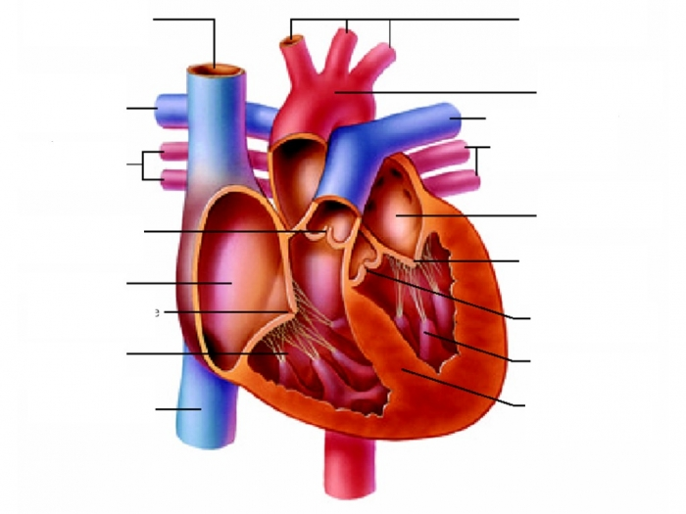

Right Atrium | Pulmonary Artery x 2 | Septum | Bicuspid Valve
Aorta | Pulmonary Vein x 2 | Superior Vena Cava | Inferior Vena Cava
Tricuspid valve | Semilunar valve x 2 | Left Atrium | Right Ventricle
Left ventricle | Arteries

Step Three: Go back to the main menu and click on ‘Circulation Station’;
Step Four: Follow the prompts and answer the questions below;

- Define the following terms?
Right Atrium
Left Atrium
Valve
Right Ventricle
Arteries
Capillaries
Veins

- Complete the loop;

- Read ‘A Doctor Making a Difference’;
  - What medical discovery did Helen Brooke Taussig M.D. make?

  - What impairments did she have?

- You are Finished!

