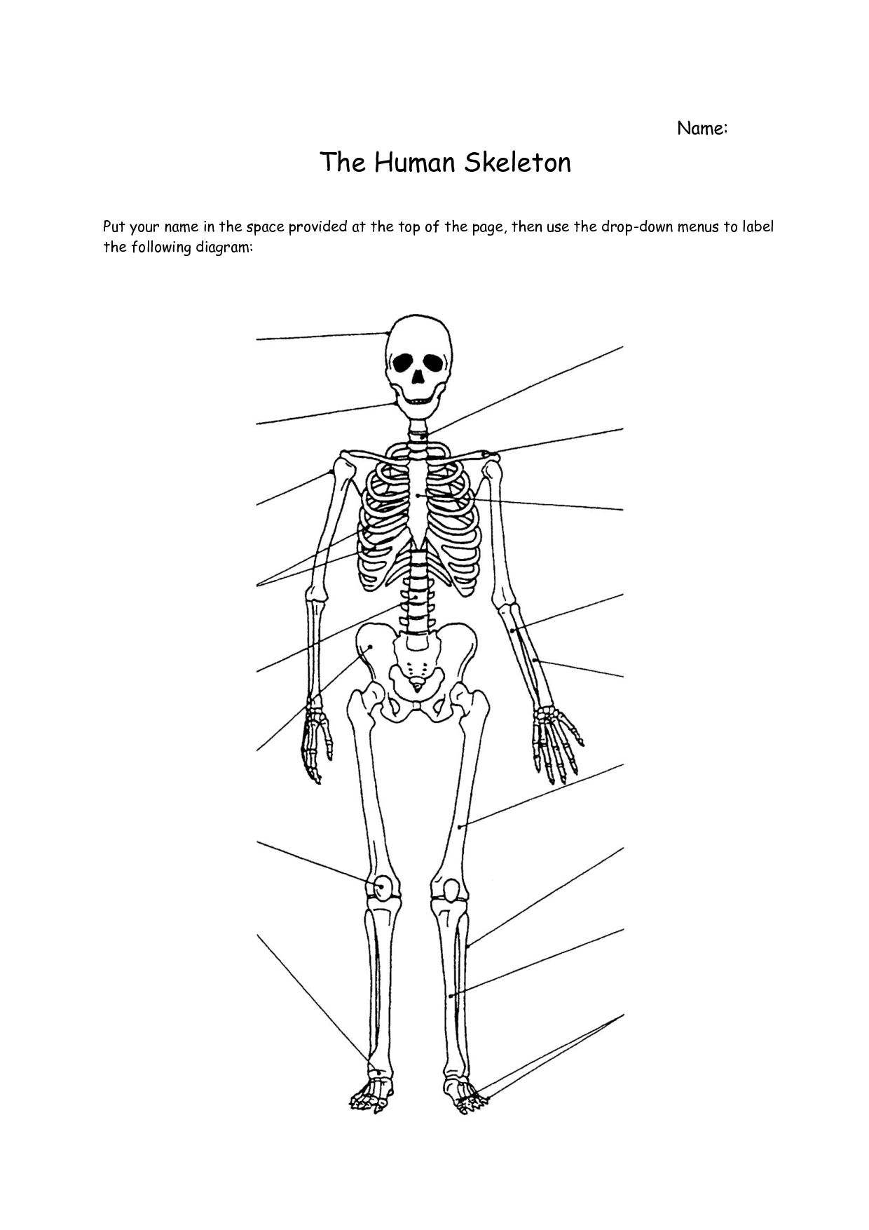
Please print out this worksheet and answer the following questions on Body Systems and Energy to revise for the CAT which will be held in your theory class next week.
The Skeletal System
Patella Ribs Sternum Cranium Pelvis Radius Femur
Metatarsals Clavicle Vertebrae Carpals Humerus Ulna Fibula
Tarsals Tibia 2x Phalanges Mandible Metacarpals Scapula

What are the 3 functions of the skeletal system?
1.
2.
3.

The Muscular System
Quadriceps Pectoralis Major Deltoid Latissimus Dorsi Gluteus Maximus
Hamstrings Gastrocnemius Trapezius Biceps Triceps Rectus Abdominus
Achilles Tendon Tibialis Anterior Soleus External Obliques Erector Spinae

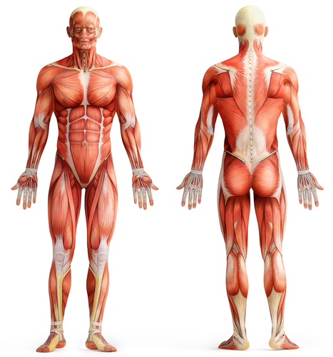
Outline the role of the muscular system:
____________________________________________________________________________________
____________________________________________________________________________________
____________________________________________________________________________________
____________________________________________________________________________________
____________________________________________________________________________________

Describe how the muscular and skeletal system interrelates.
__________________________________________________________________________________
__________________________________________________________________________________
__________________________________________________________________________________
__________________________________________________________________________________
__________________________________________________________________________________

The Circulatory System
Label the following diagram and colour the parts where the blood would be oxygenated (high in oxygen) and where the blood would be deoxygenated (low in oxygen)
Right Atrium | Left Pulmonary Artery | Cardiac Muscle | Bicuspid Valve
Aorta | Right Pulmonary Vein | Superior Vena Cava | Inferior Vena Cava
Tricuspid valve | Semilunar valve | Left Atrium | Right Ventricle
Left ventricle | Left Pulmonary Vein | Semilunar Valve | Right Pulmonary Artery
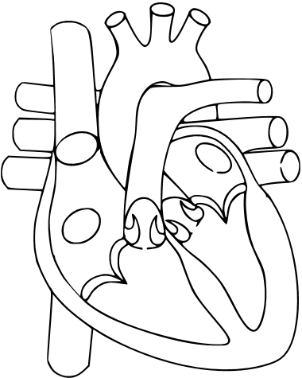
Explain the role of the circulatory system
__________________________________________________________________________________
__________________________________________________________________________________
__________________________________________________________________________________
__________________________________________________________________________________
__________________________________________________________________________________

The Respiratory System
Trachea | Pharynx | Alveoli | Larynx
Lung | Nose | Left Bronchi | Right Bronchi
Diaphragm | Smaller Bronchi | Lungs

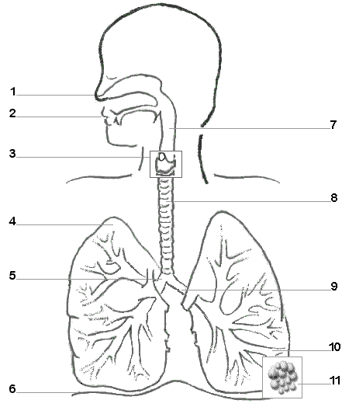
Explain the role of the respiratory system in our bodies
__________________________________________________________________________________
__________________________________________________________________________________
__________________________________________________________________________________
__________________________________________________________________________________
__________________________________________________________________________________
Discuss how the circulatory and respiratory systems interact in our bodies
__________________________________________________________________________________
__________________________________________________________________________________
__________________________________________________________________________________
__________________________________________________________________________________
__________________________________________________________________________________

Aerobic and Anaerobic Energy Systems
Fill in the blanks:

Name the 3 factors which determine which energy system is used:
__________________________________________________________________________________
Comment on how the three energy systems interrelate to produce energy. (think about how the 3 systems work together)
__________________________________________________________________________________
__________________________________________________________________________________
__________________________________________________________________________________
__________________________________________________________________________________

