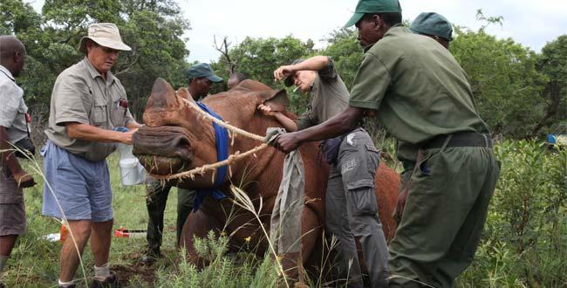
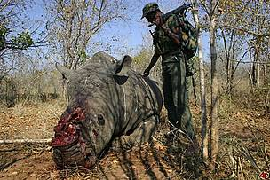
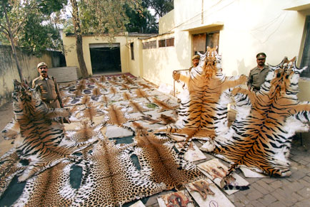
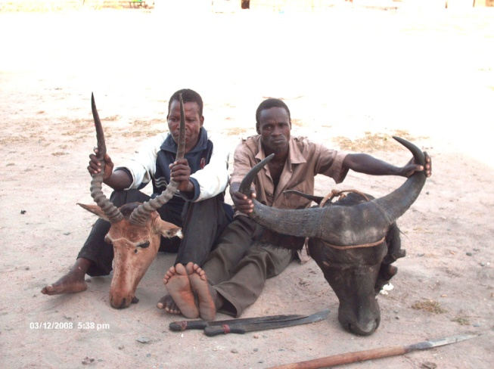
We have to try and catch the poachers because if we don’t the animals would become extinct and it would be rare to see a animal ever again. We have to try our best to catch the poachers and try to save the animals, in future we have to catch the poachers because they have killed a lot of animals and made threats to the animals. They also destroy the animals surroundings and tried to destroy their habitat, so this is the reason why the animals became endangered. So I hope that people would try to catch the poachers and save the animals at least in future.

