Objective One

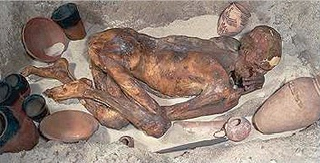

What made it possible for this body to be so well preserved for more than 5000 years?
Something which made it possible is mainly the interest and the care shown to the dead person. Also respect is one of the key to this job. The preservation of the body is also very sophisticated since scientists could even say how many bones were broken. It is believed that the bodies were treated with natron which acts as a drying agent absorbing all the water to prevent further decay. But however the important organs were extracted from the human and placed in Canopic jars were often decorated with one of the four animal headed gods Horus. But the habits changed after about 1000 BCE, the internal organs were then wrapped and put back into the body or bound with it or put in boxes instead of jars, but Canopic jars were still placed in the tomb however they were empty and served a symbolic purpose. The whole process lasted 70 days.

What does this show about the values and beliefs of the society that preserved this
body?
The preservation of the body gives us a clear picture of their unique values and beliefs. The most important point is that the findings showed us that they believe after life existed. But there is more to this than just that, the ancient Egyptian society believed that the dead person had to face many challenges before he could proceed to the afterlife. One of the cruellest part is when the person’s heart was weighed against a feather of the goddess of the truth Ma’at, if the heart is heavier than the feather than the person committed many sins and was fed to Ammit ‘the devourer’ but if the heart is balanced with the sacred feather, they could go to the afterlife. The objects in the tomb also proved that they gave a lot of value to their gods. Their tradition of placing Canopic jars decorated with one of the four animal headed gods ‘Horus’ was very common in the ancient society and so this made it possible for us to obtain the beneficial information on the ancient Egyptian values and beliefs.

What might be the reason this body has suffered broken bones? What helped to
reach this conclusion?
I think that the posture of the body when it was put in the tomb might have made the body suffer broken bones. I reached this conclusion because of the picture shown to us and it was very obvious that the body would have easily broken his bones. The priests that would have done the job might have wanted to fit the person in the miniature tomb and this leads us to think that the person might have not been in the upper end of the social classes since they couldn’t afford a proper tomb.

Compare this burial site to one from any Pharaoh’s burial chamber.
  - What similarities and differences can you find?

Some of the similarities found in the two various burial sites is that both were buried with some of their possessions and they were provided with some food. But there were many more differences found than similarities due to the amount of wealth and their social status in the society. The pharaohs were actually buried with servants and they were given ships, most importantly they were buried in a pyramid which was immensely decorated and their tomb was gold plated.

  - What conclusions can you offer about the person’s in the picture social class? What helped you to reach these conclusions?
I can easily say that the person in the picture was very low in the social class probably in the lower or the middle class. The way they were preserved is the key to this conclusion and also the amount of similarities and the differences give us a clear picture about the two people.

If this person died last year, what might be some ways that he could be ‘preserved’?
Normally the modern way of preserving a body is just to place them in a rectangular box and to bury the tomb in the mud. The person’s relatives commonly place flowers on top of the burial site as a remembrance. Unlike the Egyptians the current generation does not remove any internal organs.

What do you now know about the importance of the discoveries of Archaeologists and what they can tell us about a society?
I came to realise that it is important to learn from the past and pass it on to the current and the future generation. What we know today might have been discovered thousands of years ago. Just like Mendel who is a monk but he was the first founder of genetics but no one payed attention to the informative book he produced about genetics. After his death when someone else found that there was something named genetics his book was seen and it was proved to be correct and now he is called the father of genetics. Just like that example, life is all about learning and it is important that we respect everything and look back at the past just like the term ‘old is gold’. Today’s society is very different compared to the past. The findings of archaeologists are just like making a picture brighter and more clear. So past brings us to today and today will get us to the future.

Objective Two
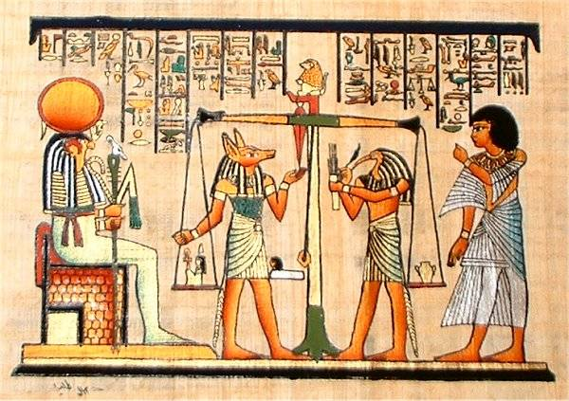

Explain why this ritual was so important.
This ritual is so important in consideration of their belief of the existence of afterlife because the picture shows us the most crucial part of the journey to the afterlife, the weighing of a person’s heart against a feather. This was often known as the last stage of the journey to the afterlife.

Compare this process of deciding whether a soul would have a ‘good’ or ‘bad’ afterlife to one modern day belief. How are they the same and how are they different?
This process of deciding whether a soul would have a good or bad afterlife to the modern belief in the Hindu culture is that they both believe that there is afterlife but however the Hindu society believes that Hell (the place for people who have committed sins) and Heaven (for people who are good) while the Egyptian society believed that there was only one which is Heaven but before they have to pass a test. Also the Egyptian belief of the weighing of the heart and a feather has a lot of difference to the Hindus who say that the gods have two different books where one is the things they have done for good and similarly another book for the things they have done for bad. So the bigger book is the decision maker of the person’s life after death if it is hell, or heaven.

How else did the Ancient Egyptians prepare souls for the afterlife? What does this show about the depth of their beliefs?
As a preparation for the afterlife is what we call the mummification process where the brain was removed and discarded, as its importance and function was apparently not understood. The heart was left as it is since it was considered the centre of intelligence and vital for survival in the next life. Other internal organs were often removed and the lungs, liver, stomach and intestines were singled out for special treatment. These organs were preserved, wrapped separately and stored close to the coffin. A set of four Canopic jars made from stone, pottery or wood was often used for this purpose.

How has your understanding of the values and beliefs of Ancient Societies been strengthened so far?
My understanding of the values and beliefs of the ancient societies have been backed up a lot after reading there mythical beliefs. Also their belief of legendary gods who have are often believed to have animal heads and human bodies. My belief was strengthened a lot due to the evidence provided and also the amount of research and reading backed up everything I had learnt.

