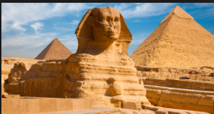
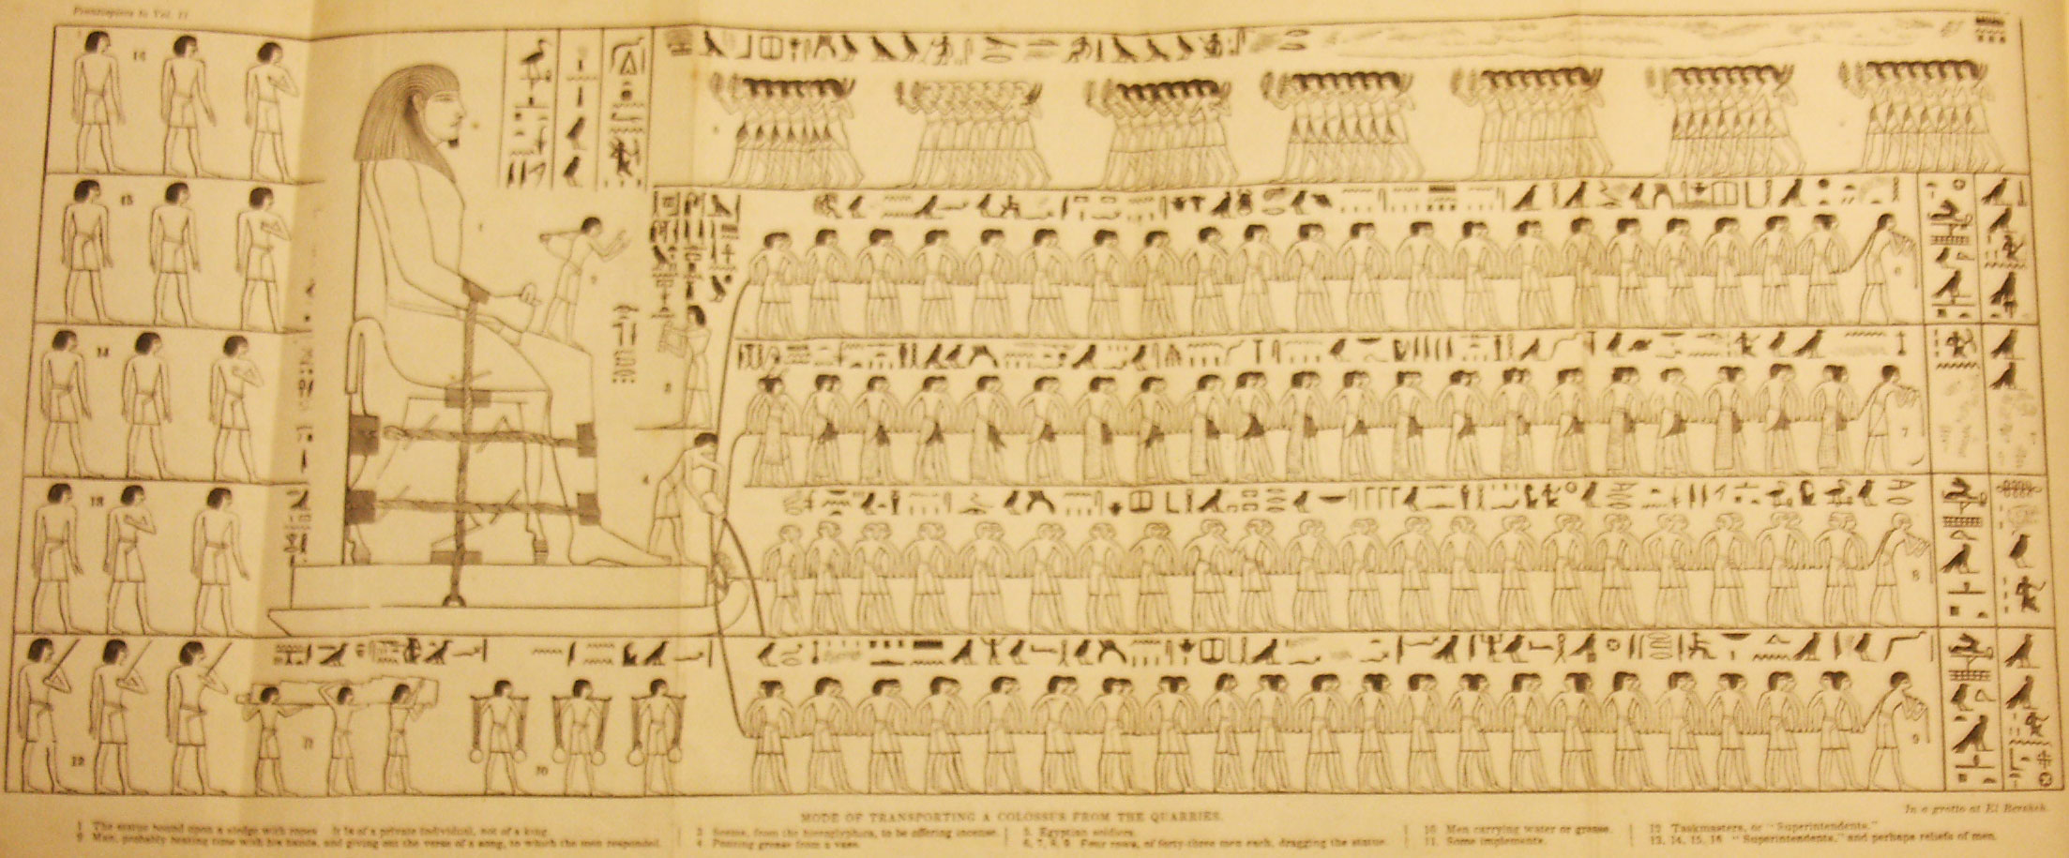
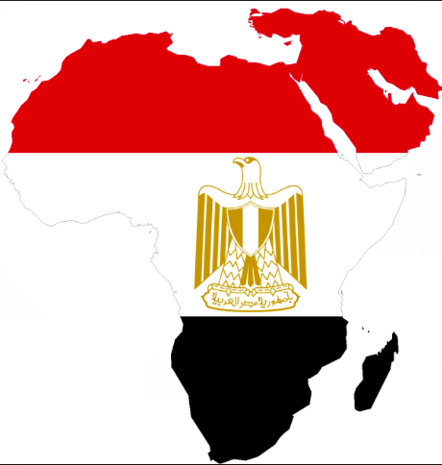
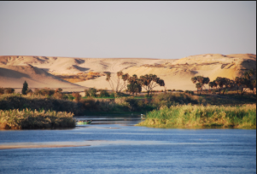
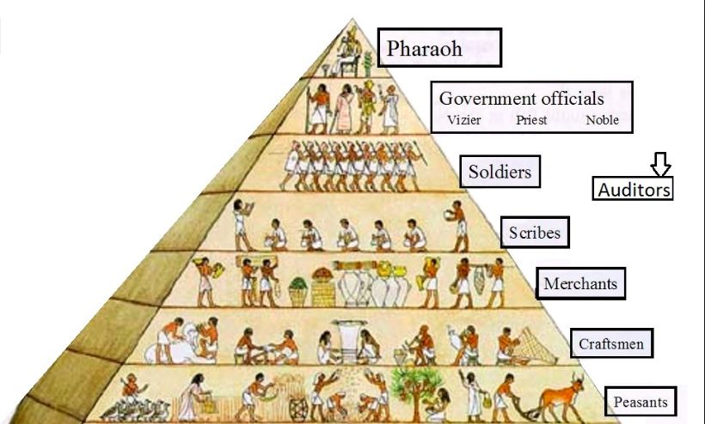
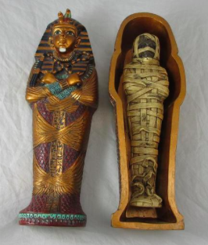
BY- VISHNU SIVAKUMAR
  - FACT SHEET

ANCIENT EGYPT
As humans we always want to be benefitted and comforted where ever we go. Like so the unique properties of Egypt attracted people to spend their life in Egypt. Some of the factors are the Nile River, fertile land, Sahara desert, Blue Nile, Sinai Peninsula, the lakes and the Naama bay. The world known Nile River is the most attractive out of the whole list, since water can be the biggest problem in some instances. Therefore some many people settled in Egypt thinking that there won’t be any problem for water. Not only the Nile River but Egypt also has fertile land which is capable of producing fresh food for the people of Egypt and exporting to other countries. The fresh lakes in Egypt also give access to fresh water for the people of Egypt. The Sahara desert sets a hot and yet a balanced temperature for the people living in the country. The Naama bay is very convincing because it makes the people think that it is easy for exports by ship. However one of Egypt’s biggest disadvantages is the ‘flood period’, this is when the Nile river overflows and floods destroy the houses plotted near the River, plus the Nile claims a lot of lives during these devastating times. But the Egyptians have found a way to overcome this problem, they observed that the water is a good fertiliser for the soil and so the citizens living near the river moved to another place and grew crops in the vacant and fertilised soil.

GEOGRAPHICAL FEATURES OF ANCIENT EGYPT AND THEIR INFLUENCE ON HUMAN SETTLEMENT
Nile River
As other ancient histories Egypt had own social groups. Egyptians were mainly classified in 6 various groups. The wealthiest and the foremost-recognized people were the pharaohs. Under them were the government officials. Some of the important officials were the viziers who are second-in-command to the pharaoh and the chief judge in many cases; Chief Treasurer who is responsible for the government’s wealth and collecting taxes however they paid in goods in place of money; The general of armies, the highest military commander in Egypt after the pharaoh and his job was also to give advice to the pharaohs in aspects of war and national security. In Egypt, religion was a large part of ancient Egyptian life and therefore priests were respected, priests were in charge of the temples and religious rituals and the important ceremonies. Below the priests were the scribes who had many responsibilities like: recording history and important events, describing everyday life, writing up contracts, calculating taxes, recording court cases, keeping track of food supply and keeping calculations for the pharaoh and government officials. The second last class was the artisans who could be carpenters, metalworkers, jewelers, painters, sculptors, potters, stone carvers or weavers. The Egyptian scribes were professional and very skilled but unfortunately they only had little social status in the society. The last in the social pyramid are the peasants who are farmers, construction workers and the unskilled laborers. When ancient Egypt is imagined without farmers, priests and scribes people would have no food to eat which will have a great impact on the citizens of Egypt, also if there are no priests there wouldn’t be any ceremonies or temples and most importantly if there weren’t any scribes majority of the great structures would not exist for example the beautiful artisans created with pure skill. In Egypt one of the unique advantages to women is that they are treated with the same respect as projected to men. Which is fair compared to other countries. Surprisingly there were jobs for women like: hairdresser, grinding girl, supervisor of cloth, supervisor of the wig workshop, treasurer, steward, composer, songstress, prostitute, weaver, dancer, musician, mourner, priestess, supervisor of the dancers of the king and supervisor of the royal harem.

SOCIAL GROUPS IN ANCIENT EGYPT
Social groups in ancient Egypt

ANCIENT EGYPTIAN BELIEFS, VALUES AND LIFESTYLE
The Egyptians give a lot of respect to their beliefs. One of their main beliefs was the afterlife. They thought that the afterlife was a fantastic place overall but before they thought that all of them had to pass a terrible test. At the end the person’s heart was weighed against a feather, this test was to see if they committed any sins through their life. Some of the values they give, are to gods and pharaohs. Pharaohs were believed to have supernatural powers. Not only this but Egyptians believed that pharaohs had descended from the sun god, Ra, and were believed to be living with the sky god, Horus. Moving on, some of the ancient legacies that regulated the Egyptians beliefs were the ancient pyramids, tombs and temples.
Egyptians made used of cosmetics regardless of their sex or their status. Oils and unguents were rubbed to the skin to protect it from the harmful heat waves. One of the most commonly used make-ups was the eye make, which is made by coal. The eye make-up was applied from the corner of the eye to the sides of their face. One of their main reasons to use make-up was their belief that sates cosmetics are capable to heal them. The ancient Egyptians spent their life in houses made of bricks, which consisted of mud and chopped straw. Some of the differences between the houses of the rich and the poor are that the rich had a minimum of 10 rooms while the poor just had 1, the rich had painted homes while the poor couldn’t afford to do the paint job, the poor had floor made of beaten earth when the rich had their floors tiled and the paupers slept on the bare floor, the roof or on a mat but due to the precarious scorpions the had a head rest to raise their head.

Egyptian tombs
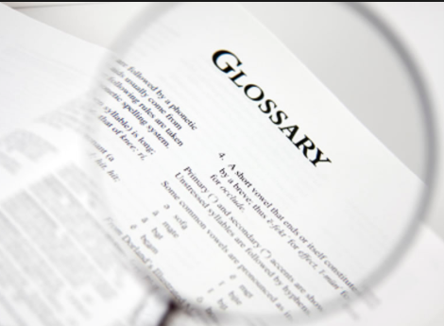

GLOSSORY AND BIBLIOGRAPHY
Word: | Definition:
Akhet | The season of the year when the Nile River flooded.
Afterlife | The place where the Ancient Egyptians believed they would go after they die.
Amulet | A charm worn that the ancient Egyptians thought had magical powers.
Amun | The main god of the new kingdom.
Canopic Jars | Special jars that held the organs of a mummy including the lungs, intestines, liver and the stomach.
Delta | The region of land where the Nile River split into several branches before empting into the Mediterranean Sea.
Book of The Dead | A text that had a number of magic spells that were supposed to help a person in the afterlife.
Papyrus | A material from a pithy stem from a water plant.
Pharaoh | Any person who uses power or authority to oppose others; Tyrant
Linen | Fabric woven from flax yarns.

Bibliography:
Glossary
www.reshafim.org.il
www.ducksters.com
http://6awchistory.weebly.com/
http://historylink101.com/
http://egypt-trade.wikidot.com/

The natural and raw properties of ancient Egypt have caused their country to be the richest and the most powerful civilizations of the ancient world. They were capable of importing and exporting with their neighboring countries. Some of the most common things they imported were gold, incense, timber, bronze, pottery, olive oil, ebony, ivory, lapis, lazuli, slaves and the skin of forest animals. But the exports they traded with other countries were beer, wine, cheese, oil, linen and implements for Nubian copper, gold, jewels, ebony, ivory, exotic animals and also slaves. Usually they traded with Lebanon, Africa, Afghanistan, Punt, Nubia and best allies. Normally in ancient Egypt the cheapest and the fastest way of trade was by ship. However Egypt’s association with other countries involved trade as well as conflict. Even though Egypt traded goods with Nubia it was a great campaign between Egypt and Nubia. But during the period of Reunification (2000 BC – 1700 BC) Egypt regained control of Nubia and built forts to secure the place. On the other hand, Egypt was also under war with the Libyans and other desert nations. However, the Hyksos weakened Egypt through the second intermediate period. But this time led Egypt to its greatest power. The armies of Pharaoh Ahmose later defeated the Hyksos and not only that but that was the time when he regained control over Nubia.

TRADE AND CONFLICTS
Nile River
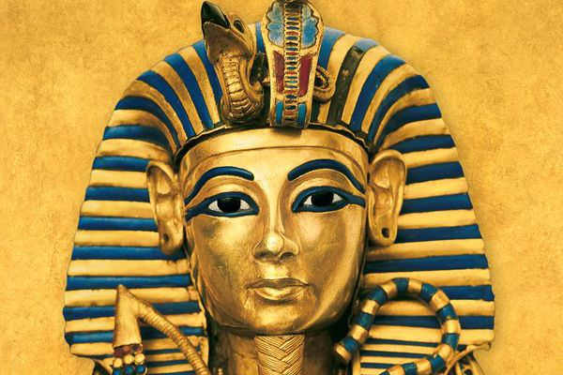
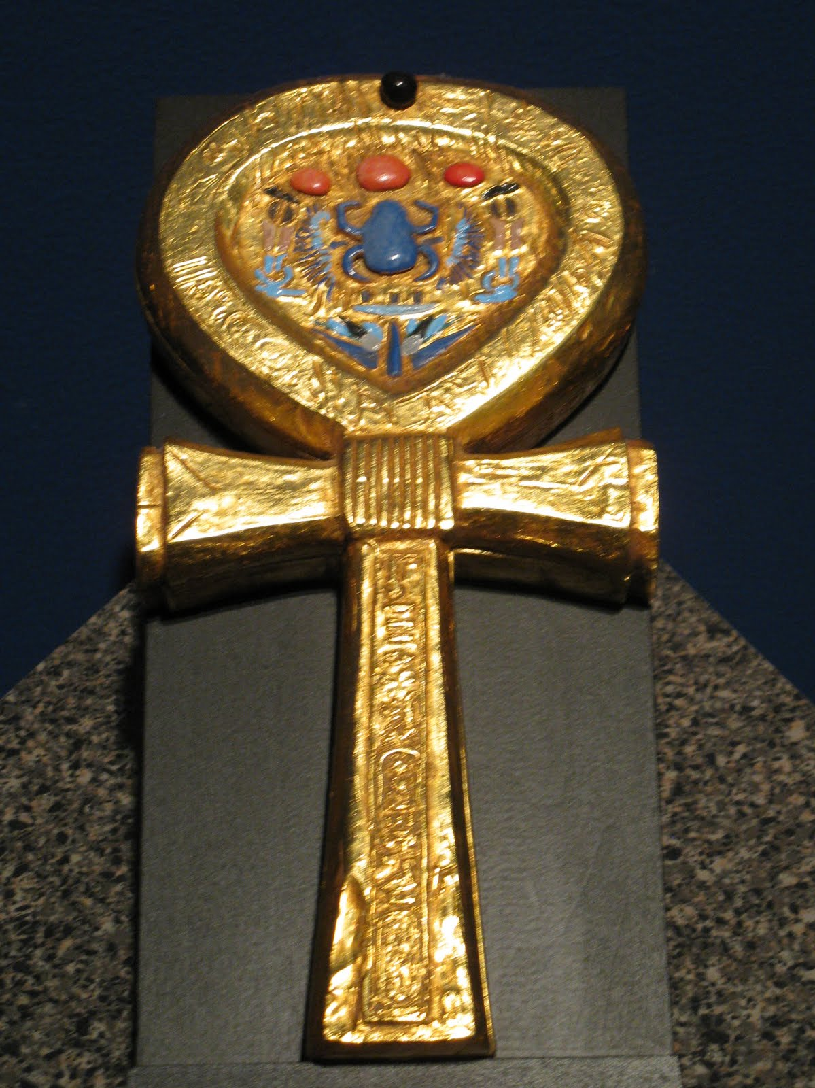
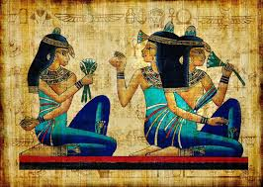
BY- VISHNU PRASAD SIVAKUMAR
ANCIENT EGYPT

