Lyndale SC Learning Sequence Design Tool


INTRODUCTION
This document is to be used to document the teaching, learning and assessment for an individual topic which is part of the Semester or Year-long Curriculum Map for a subject. In order to enable deep learning it is expected that each subject would have 2 learning sequences per semester (with the exception of Mathematics which might have 3-4). Each subject will use a Common Assessment Task and it is expected that the program detailed will be followed by all teachers. It is recognised that teachers will adapt the program to the needs of individual classes after considering the needs of the students in each of the four instructional groups. Learning sequences should be modified following the evaluation when the topic is completed.
Subject | Humanities – Civics & Citizenship | Topic Title (expressed to raise interest and curiosity) | What does it mean to be Australian?
Year level | 7 | Timeframe for Topic | 9 weeks

LEARNING INTENTIONS
Copy and Paste this from the relevant section of the Curriculum Map for the Semester/Year
Big Ideas | Shared values promote cohesion in Australian society no matter where one has come from on this earth.
Enduring Understandings | Only with an understanding and an observation of scared core
Essential Questions | What is our heritage?  What does an Australian citizen look like?  How is Australia a diverse society?  What factors contribute to a cohesive society?  What are values and how do we recognise them?  What do we value as Australians?

What aspect of the relevant STANDARD does this unit address? | Civics and Citizenship Knowledge and Understanding  - How Australia is a secular nation and a multi-faith society  - How values, including freedom, respect, inclusion, civility, responsibility, compassion, equality and a ‘fair go’, can promote cohesion within Australian society  - How groups, including Aboriginal and Torres Strait Islander Peoples, express their particular identities, how this influences their perceptions of others, and others’ perception of them  Civics and Citizenship Skills  Develop a range of questions to investigate Australia's political and legal systems  Identify, gather and sort information and ideas from a range of sources  Critically analyse information and ideas from a range of sources in relation to civics and citizenship topics and issues  Appreciate multiple perspectives and use strategies to mediate differences  Present evidence-based civics and citizenship arguments using subject-specific language  Reflect on their role as a citizen in Australia’s democracy
What General Capabilities will support the learning in this unit?  Which General Capabilities will be assessed and reported on? | Ethical Understandings
What Cross Curriculum Priorities can this unit address authentically? Years 7-10

LEARNING EVIDENCE
Teachers use data and evidence to determine the instructional groups - previous achievement data (Achievement data, students’ learning styles/multiple Intelligences, learning needs, prior knowledge of the students. Include information from Learning Support Staff, Sub-school Leaders, House Leader, KLA Leaders).

What Do I Know About My Learners?
- What are my four instructional groups? List the names of the students at the respective levels | Two or more levels below level (intervention required)  Almost at level,  At level  Above level

Which students have specific learning needs? Individual teachers use data and evidence to identify students in their class
- List the students with specific learning needs Egs. EAL students Short Term Auditory processing needs,
- What have I learnt from previous learning sequences and/or from data and evidence I have collected to help me identify specific students and interventions?

What is the Common Assessment Task? SUMMATIVE ASSESSMENT
All students will begin at the first exit then will progress onto the second and third having negotiated their readiness with their teacher. Teachers are advised to organise the learning environment to support changing group dynamics as students move on from through each exit. Students will start forming groups of ‘like minds’/ability and progressively work at a higher level of independence
AusVELS level | Teachers do: | Student do:
This will translate into a C level of achievement against the standard  APPLYING  Teachers fully scaffold the First Exit from the learning. All students begin here. | - Assist students to build connections and apply skills learnt  - Assist students to demonstrate achievement against the standard by scaffolding the CAT with literacy and thinking strategies/frameworks  - Provide opportunities for students to represent their understanding in multiple ways.  - Support students to establish independent practice routines to reinforce and extend their level of understanding, such as: thinking critically and problem solving in order to make decisions, persisting, planning, seeking / receiving / and giving feedback, reflecting, asking relevant questions to clarify intent and/or concepts, editing, using appropriate sources, etc  - Support students to use the language of the discipline, to select the mode of language appropriate to the task and to meet the literacy and thinking demands of the task  Promote and support persistence | Copy and paste the CAT from the Learning Map and then start to scaffold the learning (presuming the normal distribution)
Successful completion will translate into a B level of achievement against the standard  ANALYSING  Teachers fully scaffold the Second Exit by adding an Analysis dimension to the First Exit. Students move to this exit at their own pace and only after completing the first exit satisfactorily. | - Support students to provide evidence of learning in new contexts.  - Structure opportunities for students to demonstrate their deepening individual and collective understanding.  - Provide opportunities for students to critique one another’s ideas to increase the intellectual rigour of their response.  - Continuously monitor student progress and provide feedback that enables each student to understand what they need to do to strengthen their capacity to achieve the demands of the CAT at this level of complexity.  - Promote and support persistence
When this exit is completed satisfactorily, it will translate into a A level of achievement against the standard  EVALUATING/ CREATING  Teachers fully scaffold the Third Exit from the learning by adding an Evaluation dimension to the Second Exit. Students move to this exit at their own pace and only after completing the First and Second Exit satisfactorily | - Support students to provide evidence of learning in new contexts.  - Structure opportunities for students to demonstrate their deepening individual and collective understanding.  - Provide opportunities for students to critique one another’s ideas to increase the intellectual rigour of their response.  - Continuously monitor student progress and provide feedback that enables each student to understand what they need to do to strengthen their capacity to achieve the demands of the CAT at this level of complexity.  - Promote and support persistence

How is the CAT going to be moderated?
to be agreed by all teachers of this subject and year level
- How will the learning achievement in the CAT be moderated in order to ensure reliability, consistency and fairness across the cohort?
- What evidence will be collected at the Individual, Class, and Cohort levels?

LEARNING EXPERIENCES
Teaching, learning and assessment experiences for the Community of Learners are described here, detailing the elements of the learning landscape and making the teaching and learning visible The information can be adapted for each class and is used to inform decisions teachers make for differentiation and personalisation in their class
What do my students need to know so that they can engage in the learning? (Can be supported by Bloom’s taxonomy – Remembering)
Teachers do: | Students do:
- Introduce the topic for study, the enduring understandings and big ideas  - Introduce and negotiate the meaning of the essential questions  - Provide learners an overview of how the learning will be structured, i.e. establishing prior knowledge, introducing new ideas and developing understanding, the learning activities, assessment processes and students will be able to learn independently, groups etc.  - Use questioning to broaden students’ understanding of the dimensions of the new topic  - Use a variety of methods to determine prior knowledge (what does the learner bring to the learning?)  - Use questioning to determine conceptions and challenge misconceptions  - Introduce appropriate tools and strategies for learning (collaboration, self and peer feedback, reflection, teacher to student/student to teacher feedback)  - Reinforce appropriate behaviours for learning (Personal Learning/ Interpersonal Development) eg teamwork protocols  - What literacy practices will support students to access the learning of this unit? Eg- new vocabulary  - What thinking skills will support the learning, challenge learners to be creative problem solvers, promote reflection and metacognition, and promote inquiry?  - What resources are needed?  - Monitor student participation and engagement with the learning. Adjust/modify entry to learning if necessary (Assessment AS Learning) | Overview of learning example: this learning sequence begins by finding out what you already know about the topic and moves on to introducing new knowledge and understandings by making sure you will have every opportunity to participate and achieve your personal best), and inform students of the assessment processes you will use (for example: during the learning you will be given opportunities to try out new understandings, to work independently and with others, to ask questions and to clarify concepts)

What learning activities will my students do to develop their understanding of the skills, knowledge, and understandings? (Can be supported by Bloom’s taxonomy - Understanding)
Teachers do:  Explain the pedagogy and the rationale here | Students do:  Detail the lesson plan, embed relevant documents, explanations etc
- Introduce the new learning, knowledge skills understandings  - Differentiate your method of introducing new knowledge so that every learner can access the learning providing for each Instructional groups  - Continuously monitor student’s level of understanding (give timely and relevant feedback, structure opportunities for peer feedback and self reflection) (Assessment AS Learning)  - Assist students to select strategies and activities that will help them to make connections with prior learning and extend their knowledge of the new topic  - Give students choices to represent their learning in multiple ways  - Use Visible Thinking strategies to support positive learning dispositions  - Use explicit 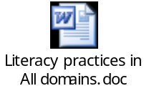literacy strategies (such as comprehension , to support the learning  - Teach explicit thinking skills that support the learning, challenge learners to be creative problem solvers, promote reflection and metacognition, and promote inquiry?  - What resources are needed? | Activity 1  Optional activity: Display the lyrics of Australian National Anthem on the white board. Encourage students to sing the anthem at the beginning of this unit.  Extension: How many students know the lyrics to the Australian National anthem? Can they remember the first and second verse?    Activity 2  https://www.youtube.com/watch?v=soMbV8gfwYw  (27 minutes)  This video introduces the students to Australia as a country with rich culture. This video focuses on Melbourne.  Students are to write down 10 facts which they find interesting in this video. They then share these facts with the class.  Activity 3  Create a family tree using the template provided. Make sure you include the names of your parents, grandparent and great grandparents. Find out where they were born and include this information as well.  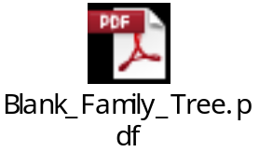  Extension Activity:  Use the Family Tree activity to write a story of your family’s migration to Australia.  Activity 4  Students create a fact file explaining how Australian immigration has changed over time.  Use Chapter 4.1 in Civics & Citizenship Alive 7 as a guide.  Activity 5  Think pair share: What is a value?  As a class come up with 5 values which are considered important by everyone in the class. Create a booklet which lists these values and explains, with examples, how these values should be demonstrated. This booklet could be given to new students coming into class.  Activity 6  As a class come up with 10 Australian values (for example: freedom, respect, inclusion, civility, responsibility, compassion, equality, and ‘fair-go’)  For each value you need to use Marzano model to demonstrate your understanding of each value.  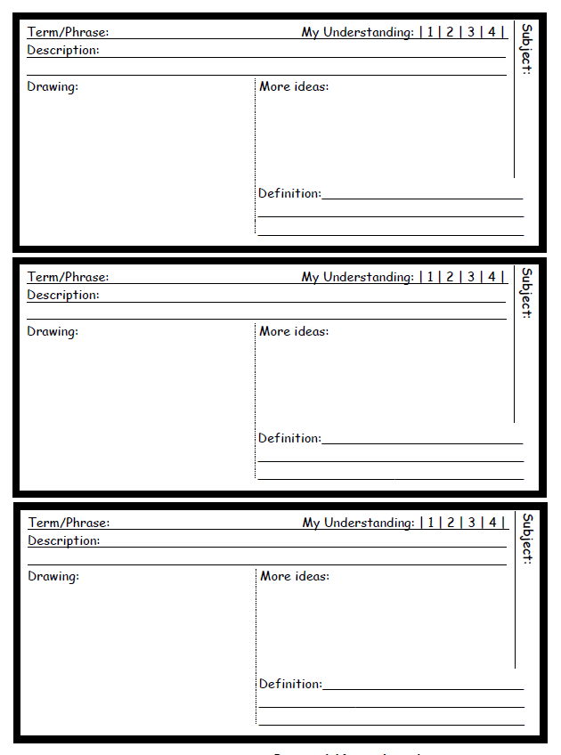  Activity 7  You need to select one value from the previous activity. With a partner, create a two minute presentation using PowerPoint/Prezi. You should explain what the value is, provide examples of this value, explain why this value is considered an important Australian value. This presentation should go for about two minutes.  Activity 8  Using the Australian values information you have gather in the previous activities, complete the chart below. The aim of this chart is to assist you in comparing Australian values with the national values of China.    Activity 9  Create a collage of what you think it means to be Australian. You may use clippings from newspapers and magazines along with google images. You need to include at least 20 images. For each image you need to explain why the image represents Australian national identity.  Activity: 10  Write a brief history of the Australian Aboriginal flag in one short paragraph, include information such as who designed it, what it represents and any other aspects you consider interesting.  Take some time to plan a design for your version of an Australian flag. In the design think about what it means to be an Australian and try to represent this in your flag. You should include an explanation of what each element in your flag represents.

LEARNING EVALUATION
At the conclusion of the topic complete the section below to inform the next topic and to improve the learning sequence
How well did the learning take place?
Was the learning transformative, focused on growth, dynamic and built on respectful relationships?
What changes do we need to make to the Learning Sequence to improve this topic next time we teach it?
What are my professional learning needs to further develop my teaching and support my students’ learning?
What does the evidence I have on my learners so far tell me about:
- the impact of my teaching
- my teaching and learning needs?

