Year 8C – Persuasive Language
Persuasive language: the kind of language we use to convince someone to change their mind or to convince someone to agree with us is called Persuasive Language. Advertisements use persuasive language deliberately (on purpose) in order to attract people to whatever they advertise. If people are convinced that the product or the service is useful for them, they are more likely to buy it.
Activity 1
Look at the advertisements below and explain how do you think they try to convince us to buy the product they advertise?

Advertisement 1



Advertisement 2


Advertisement 3


Advertisement 5
Advertisement 4


Activity 2
Look at the ad below and answer the following questions:
Which of the following ads is most appealing to you and why?
The most appealing to me is option C because it has a lot of description and it makes the reader want to eat.
What are the key differences between ads B and C? How do these differences make one advertisement more effective than the other?
- Has good descriptive words
- Has a lot of information about their food and quality.
These differences make a lot of difference sc
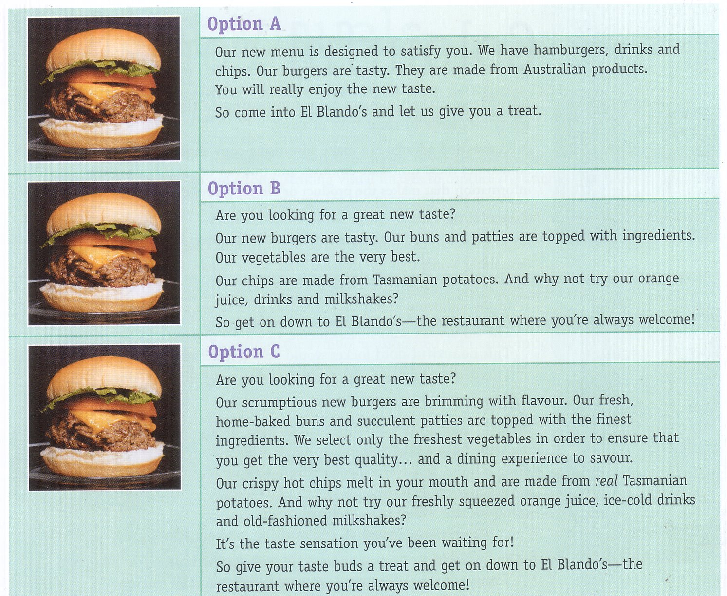

Language, font size, positioning of text, use of colour and use of visuals: all these elements are used skilfully by advertisers to attract our attention.
Activity 3
Go back to one of the packaging examples you used earlier on and use it to answer the following questions:
- How many different colours are being used on the front side of the package? What effect do the colours have on the consumer? Would a different colour be more appropriate? Why?
- Is the font size appropriate to be noticed from a distance? If not, why do you think the advertisers chose not to use a large font?
- Where is the written text on the front side of the packaging placed? Why do you think it is there and not somewhere else? Would you have placed it elsewhere?
- If this packaging was among many others, would you have noticed it easily? Would you have been attracted to it? Explain your answers.

