Name: _________________________________
Class: _________________________________
Teacher’s Name: _________________________________
YEAR 8 HUMANITIES HEADSTART 2015
HEADING BACK TO THE MEDIEVAL WORLD
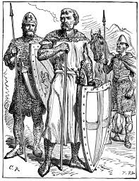
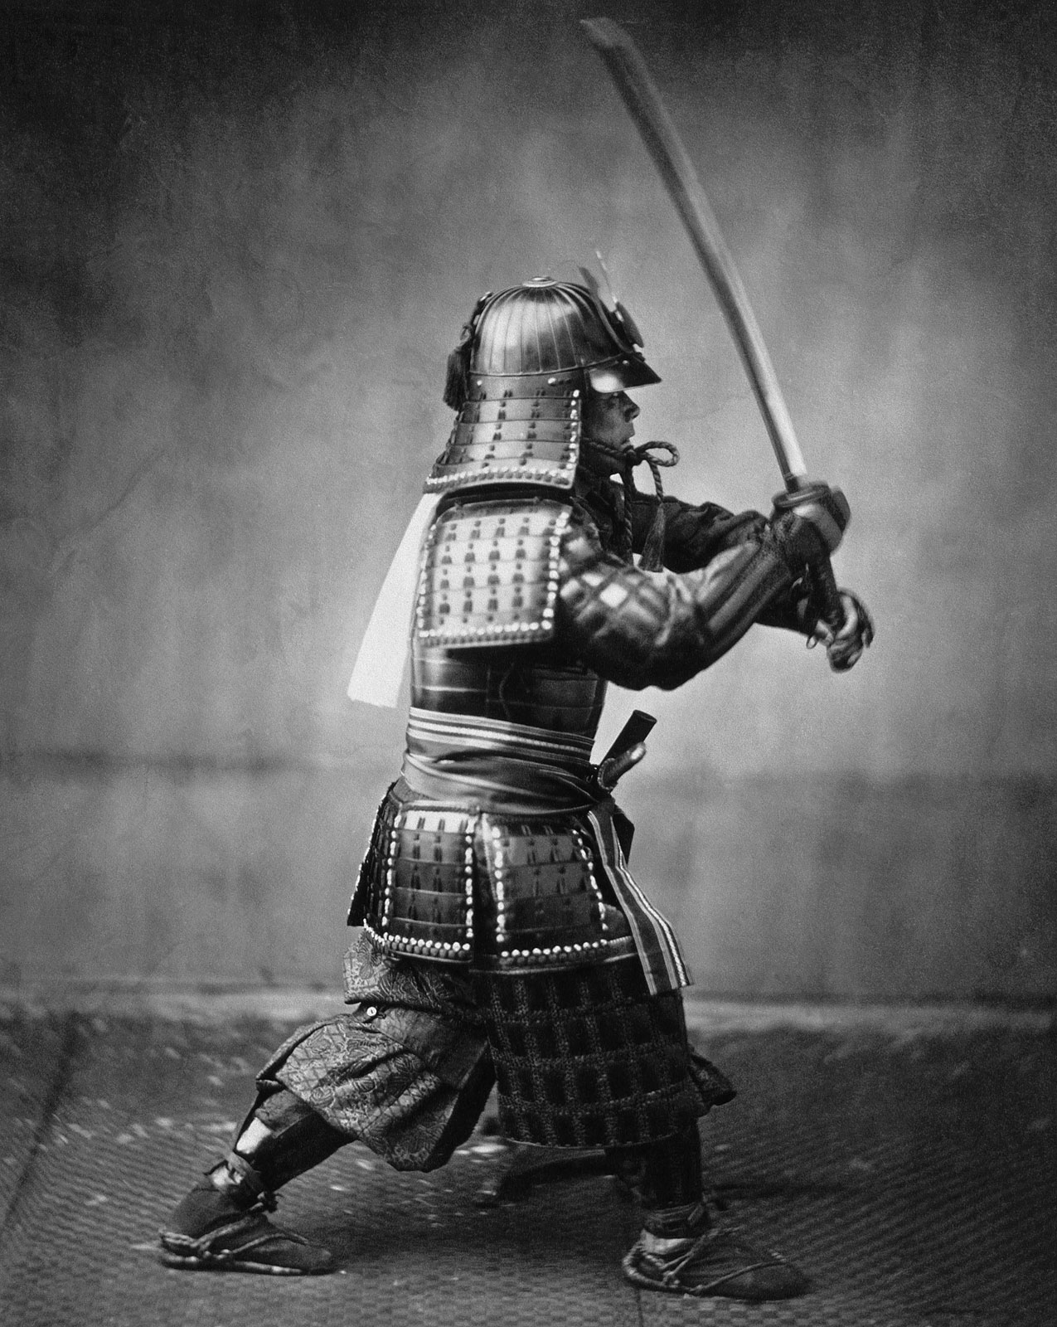

WHAT DO YOU ALREADY KNOW ABOUT THE MIDDLE AGES?
LEARNING TASK 1: Prior Knowledge: KWHL Table
K  What do I already know? | W  What do I want to know? | H  How can I learn this? | L  What have I learnt?

WHAT ARE THE MIDDLE AGES?
Enormous changes took place in the world from around 650 C.E to the early fifteenth century. Following the fall of the Western Roman Empire in 476 C.E, new forces shaped Europe and the old civilisations of western Asia and North America, while newer civilisations emerged in Africa, the Americas and other parts of Asia. The Middle Ages was the period between ancient and modern times. This time period saw the spread of Christianity in Europe and the rise of a new religion, Islam, and its expansion across much of the world. These changes would shape the world’s history right up to our own age.
LEARNING TASK 2:
Can you think of anything associated with the Middle Ages? List at least two examples.
Example 1___________________________________________________________________________________________________
Example 2: __________________________________________________________________________________________________

What impressions did you get of the Middle Ages from your listed examples? ______________________________________________________________________________________________________________________________________________________________________________________________________________________________________________________________________________________________________________________________________________________
LEARNING TASK 3:
HISTORICAL TERMS - VOCABULARY BUILDING
Using the Frayer Model, show your understanding and knowledge of the terms in each of the models provided.
Note that you can add information as it becomes apparent. But above all have a go and write or draw something in the spaces.

Definition (in own words) |  | Characteristics
PRIMARY SOURCE
Examples (from own life) |  | Non-Examples

Definition (in own words) |  | Characteristics
SECONDARY SOURCE
Examples (from own life) |  | Non-Examples

Definition (in own words) |  | Characteristics
PLAGUE
Examples (from own life) |  | Non-Examples

Definition (in own words) |  | Characteristics
FEUDALISM
Examples (from own life) |  | Non-Examples

Definition (in own words) |  | Characteristics
SHOGHUN
Examples (from own life) |  | Non-Examples

Definition (in own words) |  | Characteristics
SAMURAI
Examples (from own life) |  | Non-Examples
WHEN WERE THE MIDDLE AGES?
By using a timeline we are able to sequence events in chronological order. This means that it shows events in the order in which they happened in history. Timelines can be horizontal or vertical; they allow us to see change and continuity over time.
PRIMARY AND SECONDARY SOURCES
Historians use a wide variety of sources to answer questions about the past. In their research they use both primary and secondary sources.

Primary sources are actual records that have survived from the past, such as letters, photographs, articles of clothing and artefacts.

Secondary sources are accounts of the past created sometime after the event happened. Your history book is an example of a secondary source, someone wrote it long after the historical events described took place.
LEARNING TASK 4:
EXAMPLES OF PRIMARY SOURCES | EXAMPLES OF SECONDARY SOURCES
Reliable and unreliable sources:
If you can’t answer most of the following questions it means that the source you are using is unreliable. Before using a source ask yourself the following questions:
- What is this source?
- When was this source written/created?
- Where is this source from?
- Who created this source (author)?
- What is the purpose of this source?
- Does this information support or reinforce evidence from other sources?
Where do you think you would find reliable sources?
______________________________________________________________________________________________________________________________________________________________________________________________________________________________________________________________________________________________________________________________________________________

What kind of sources can you think of that might be unreliable?
________________________________________________________________________________________________________________________________________________________________________________________________________________________________________________________________________________________________________________________________________________________________________________________________________________________________________________________________________

Why do you think that primary sources are important links to the past?
________________________________________________________________________________________________________________________________________________________________________________________________________________________________________________________________________________________________________________________________________________________________________________________________________________________________________________________________________

ANALYSING PRIMARY AND SECONDARY SOURCES – THE BLACK DEATH
In 1347 something terrible happened across three continents – something that changed the course of history. This event is known as The Black Death or the plague. The Black Death was a disease that spread across the known world and wipes out whole towns and villages. In Europe alone, between 1347 and 1352, one-third of the population may have died as a result of this pestilence.
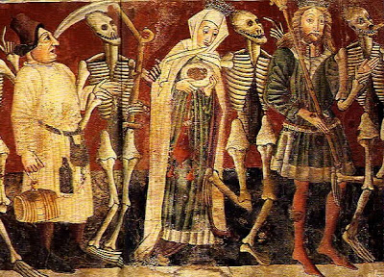
Source 1 - The Dance of Death by Vincent Kasta, 1474

‘The Scots. Hearing of the cruel plague of the English, declared that it had befallen them through the revenging hand of God… And thus the Scots, believing that the English were overwhelmed by the terrible vengeance of God, gathered… with the intention of invading the whole realm of England. The fierce mortality came upon them, and the sudden cruelty of a monstrous death winnowed (came upon the Scots.”
Source 2 - An excerpt from Henry Knighton’s Chronicon, an account written during the 14th century
LEARNING TASK 5:
Q1. Look at the above sources 1 and 2. Are they Primary or Secondary sources? Justify your answer.
______________________________________________________________________________________________________________________________________________________________________________________________________________________________________________________________________________________________________________________________________________________

Q2. How does source 1 show us about the Medieval attitude towards death?
________________________________________________________________________________________________________________________________________________________________________________________________________________________________________________________________________________________________________________________________________________________________________________________________________________________________________________________________________

Q3. What does source 2 tell us about the Medieval explanation for the outbreak of the Black Death?
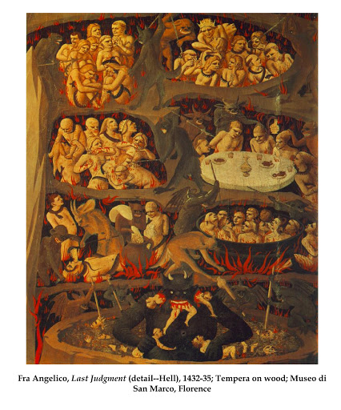
______________________________________________________________________________________________________________________________________________________________________________________________________________________________________________________________________________________________________________________________________________________

Source 3

Q4. What does source 3 tell us about the people in the Middle Ages view of the afterlife?
________________________________________________________________________________________________________________________________________________________________________________________________________________________________________________________________________________________________________________________________________________________________________________________________________________________________________________________________________

Q5. Are the above sources reliable? Why or why not?
________________________________________________________________________________________________________________________________________________________________________________________________________________________________________________________________________________________________________________________________________________________________________________________________________________________________________________________________________
Source 4 Source 5
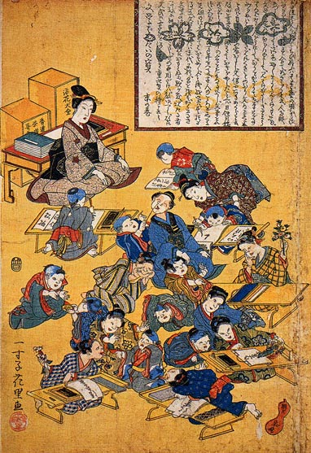
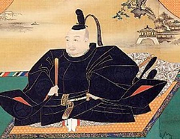

Q6. What do you see in the above sources?
Source 4: _____________________________________________________ _________________________________________________________________
_________________________________________________________________
_________________________________________________________________
Source 5: _____________________________________________________
_________________________________________________________________
_________________________________________________________________
_________________________________________________________________

After viewing the PowerPoint Presentation called “Was the BLACK Death a Disaster for Medieval Society?” complete the following Learning Task.

LEARNING TASK 6: WAS THE BLACK DEATH A DISASTER FOR MEDIEVAL SOCIETY?
Work out which SPEAR (Social, Political, Economic, Artistic & Religious) category the following information boxes should belong to. Also consider if they are good or bad effects:
About 33% of Wales and England’s population died. It took 250 years for the population to recover. | New medical discoveries and artistic ideas would later bring about a Renaissance (rebirth) of culture. |  | Less tax meant Kings had to think twice before going to war as it was too expensive. So, tax increased a lot.
New religious groups were set up, e.g. the Lollards who criticised the Catholic Church. | Creative works (paintings, murals etc.) became morbid, with the image of death everywhere. |  | Many Churches closed down. It was hard to find enough people to take over the jobs of priests.
The feudal system collapsed. Peasants could leave their village to find work’ land and freedom elsewhere. | Wages increased by 400% after the disease. Workers could demand more as fewer of them were alive. |  | Some villages, like Wharram Percy, never recovered from the disease, and were left abandoned.
Women had new job opportunities. | Poor people’s clothing improved. |  | Poor people’s diets improved.
Peasants’ attitude towards authority changed. They believed they could stand up to authority as God had spared them. | Some people thought the disease could return any day, so they lived a wild life. They drank, threw parties and lived carelessly. |  | Medical knowledge improved as doctors were allowed study corpses. People began to understand how the human body worked.
Lords saw the value of their land decrease. They lost a lot of money. | Harsh laws tried to stop the freedom and improvements of peasants’ lives. |  | Officials slowly realised that towns and cities had to be cleaner in future.
About 33% of Wales and England’s population died. It took 250 years for the population to recover. |  | New medical discoveries and artistic ideas would later bring about a Renaissance (rebirth) of culture. |  | Less tax meant Kings had to think twice before going to war as it was too expensive. So, tax increased a lot.
New religious groups were set up, e.g. the Lollards who criticised the Catholic Church. |  | Creative works (paintings, murals etc.) became morbid, with the image of death everywhere. |  | Many Churches closed down. It was hard to find enough people to take over the jobs of priests.
The feudal system collapsed. Peasants could leave their village to find work’ land and freedom elsewhere. |  | Wages increased by 400% after the disease. Workers could demand more as fewer of them were alive. |  | Some villages, like Wharram Percy, never recovered from the disease, and were left abandoned.
Women had new job opportunities. |  | Poor people’s clothing improved. |  | Poor people’s diets improved.
Peasants’ attitude towards authority changed. They believed they could stand up to authority as God had spared them. |  | Some people thought the disease could return any day, so they lived a wild life. They drank, threw parties and lived carelessly. |  | Medical knowledge improved as doctors were allowed study corpses. People began to understand how the human body worked.
Lords saw the value of their land decrease. They lost a lot of money. |  | Harsh laws tried to stop the freedom and improvements of peasants’ lives. |  | Officials slowly realised that towns and cities had to be cleaner in future.

http://www.tesaustralia.com/ResourceDetail.aspx?storyCode=6335061

LIFE IN THE MIDDLE AGES
Quality of life in the Middle Ages depended largely on what position a person had in the feudal system. For the nobility, who had the luxury of wealth and servants, life was certainly more comfortable than for peasants. Knights and barons enjoyed privileges befitting their rank; they could own several manors and lived off the taxes extracted from their peasants. The clergy led simple lives, forsaking possessions in the service of God. As the educated elite, they enjoyed the pursuit of scholarly learning in their monasteries. Although the clergy often engaged in the same kind of farm work as the peasants, many monasteries operated like manors, owning villages.
Here are 10 things about peasants in the Middle Ages:
- In the early Middle Ages, under the feudal system, the life of a serf was hard.
- Even in the later Middle Ages, the medieval peasant's life was hard and the work back-breaking. It followed the seasons – ploughing in autumn, sowing in spring, harvesting in August. Work began at dawn, preparing the animals, and it finished at dusk, cleaning them down and putting them back into the stalls.
- A peasant's hut was made of wattle and daub, with a thatch roof but no windows.
- Inside the hut, a third of the area was penned off for the animals, which lived in the hut with the family. A fire burned in a hearth in the centre of the hut, so the air was permanently eye-wateringly smoky. Furniture was maybe a couple of stools, a trunk for bedding, and a few cooking pots.
- Many peasants' huts included a simple loom. The daughter would spin wool using a distaff and spindle, and the wife would weave it into rough cloth.
- Peasant food was mainly vegetables, plus anything that could be gathered – nuts, berries, nettles. The usual drink was weak, home-brewed beer. Honey provided a sweetener. If he ate bread, the peasant did not eat white wheat bread, but black rye bread.
- The most difficult time was late spring, when food stores were running out, and new food was not yet growing. A poor harvest meant that some of the villagers would starve to death.
- A male peasant would wear a rough tunic, with a hood and gloves, and leather shoes with wooden soles. Women wore a coarse gown over a sleeveless slip.
- Towards the end of the Middle Ages, when some peasants were growing quite rich, 'sumptuary laws' forbade them to wear clothes above their class.
- Village life was not all misery. Holy days meant a day off work. Peasant fun was rough – wrestling, shin-kicking and cock-fighting. The ball was almost unnecessary to a medieval ball game, which was basically a fight with the next village. Occasionally a travelling musician or bear-baiter would pass through.

http://www.bbc.co.uk/bitesize/ks3/history/middle_ages/everyday_life_middle_ages/revision/7/

LEARNING TASK 7: EVERYDAY LIFE IN THE MIDDLE AGES

Choose the most appropriate answer and enter the letter in the table below.

- How did medieval writers divide society?
- Upper, middle and working class.
- Interests such as trade and land.
- Fighters, workers and prayers.

- Which room was the centre of a castle?
- Solar
- Great Hall
- Minstrel gallery

- What did the Normans invent to stop the hall filling with smoke?
- Chimney
- Hearth
- Smoke detector

- When a young nobleman joined the household of another lord, what was his position?
- Squire
- Page
- Knight

- Which of the following were people allowed to do in the street?
- Wear a mask.
- Eat fast food.
- Carry a weapon.

- What was the curfew?
- An order to stay indoors.
- A form of punishment.
- A bell to announce the start of the day.

- What did craftsmen become members of?
- Trade unions
- Guilds
- Political parties

- If a serf ran away from his village, what did he have to do to become a 'freeman' of the town?
- Join a guild.
- Pay a fine.
- Remain free for a year and a day.

- What did peasants drink?
- Tea
- Water
- Beer

- When did peasants get time off work?
- Bank holidays
- Summer holidays
- Holy day

1 |  | 6
2 |  | 7
3 |  | 8
4 |  | 9
5 |  | 10

RECORD ANSWERS IN THIS TABLE. →

THE FEUDAL SYSTEM
Medieval Europe
In 800 C.E Charlemagne, king of the Franks, gave land to churchmen and wealthy families in return for their support in running the empire. This method of ordering society is called feudalism. Although Charlemagne’s feudal system was based on practices that had existed for centuries, it is in this period that strong evidence first identifies a clear feudal system in Europe. It took hundreds of years for feudalism to spread. Some European countries never adopted the system, and some Asian societies, such as Japan developed their own particular feudal system.
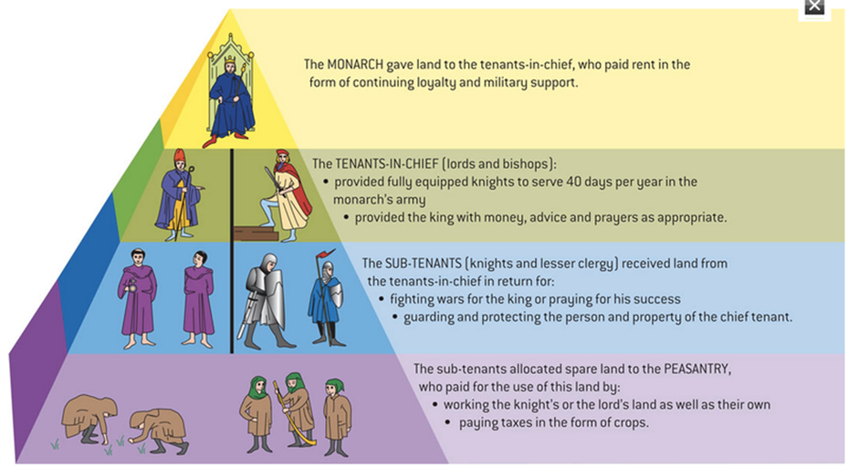
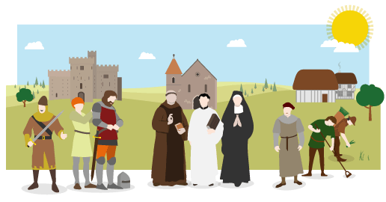
When Geoffrey Chaucer wrote his Canterbury Tales in the 1380s, he set them in the context of the time – he imagined a group of pilgrims going to the shrine of Thomas Becket at Canterbury.
In his introduction, he tells us about the people who were there, including:

carpenter | cook | Doctor | dyer
friar | knight | Lawyer | merchant
miller | monk | Nun | ploughman
priests | prioress | reeve | sailor
soldier | squire | tapestry weaver | weaver
Nowadays, we often analyse society in terms of wealth (rich, poor) or class (upper, middle, working). Medieval writers divided society into 'those who fight', 'those who pray' and 'those who work', and Chaucer included all three sorts of person in his book. From the list of his characters, which would you put in each category?
Chaucer grouped them in this order:
Knight, squire, soldier | (ie Those who fight)
Prioress, nun, priests, monk, friar | (ie Those who pray)
Merchant, lawyer, carpenter, weaver, dyer, tapestry weaver, cook, sailor, doctor, ploughman, miller, reeve | (ie Those who work)
http://www.bbc.co.uk/bitesize/ks3/history/middle_ages/everyday_life_middle_ages/revision/2/

Medieval Japan
The Feudal System was a medieval social system based on obligations between lords [who provided land to work on and protection] and vassals [who gave military service in time of war].
In medieval Japan this system consisted mainly of the Emperor, Shogun, Daimyo and Samurai at the top of this social standing and at the bottom the Ronin, Peasants, Artisans and Merchants.
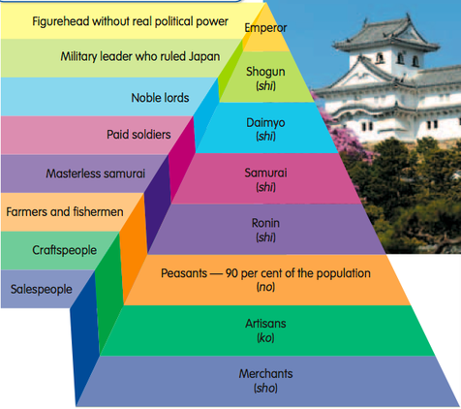
* The emperor and Imperial Court were in the highest social place in society. The emperor was adored by his people but did not hold much political power. People of the court lived excessive lives, separate to that of the rest of society, they were refined, cultured and educated people.
* The shogun was the powerful military leader, he controlled economic and military power. The shogun successfully ruled the country, he was in charge of managing laws and taxes. He would remain the shogun as long as he could unite a majority of daimyo.
* Daimyo were warrior lords who was in charge of areas of land and governed those who worked and lived there. The size of his land and the number of samurai he commanded effected a daimyo's power. These samurai were warriors who promised loyalty to their daimyo and sustained his authority.
* Samurai were Japanese warriors sworn to fight and serve for their daimyo, they followed a stern code of conduct called bushido.
* Ronin was another name for a masterless samurai. This happened when their master, their daimyo died or was killed.
* Peasants were farmers and fishermen, they worked the sea and land to harvest everyone's food. They were heavily taxed by the emperor's court. They were encouraged to improve production and produce extra crops, by the daimyo. Peasants made up 90% of Japan's medieval population.
* Artisans and Craftsmen made the specified items everyone needed but didn't have to time or longing to make themselves. Farmers would give their extra food for goods and services provided by the artisans and craftsmen.
* Merchants were almost the lowest class in Japan's medieval society feudal system, they came just before the eta, people who did the jobs no-one else would do. Merchants were seen as having no value; they didn't make, produce or protect anything. Although in time they became rich through trading goods with farmers and craftsmen, they also sold and lent the goods and money needed by numerous people because of the constant civil wars.
* Eta were the people who did the jobs no-one else would.
* Hinin were the absolute lowest social class, made up of beggars.
http://medievaljapanlauren.weebly.com/feudal-system.html

By the 12th century, control of Japan was taken over by the daimyo whose family name was Minamoto. For the next 700 years Japan was ruled by a number of military families. In 1192 the emperor gave the ruling family’s leader the title ‘shogun’, meaning ‘great general’. In theory the emperor in Kyoto ruled Japan, but the real political and military power lay with the Shogun at Edo. Rule by the shogun marked the beginning of feudalism in Japan.

LEARNING TASK 8:
Q1. Explain in your own words what feudalism is.
________________________________________________________________________________________________________________________________________________________________________________________________________________________________________________________________________________________________________________________________________________________________________________________________________________________________________________________________________
Q2. Do you think that feudalism still exists today in our society? Explain your answer.
______________________________________________________________________________________________________________________________________________________________________________________________________________________________________________________________________________________________________________________________________________________

LEARNING TASK 9:

MEDIEVAL JAPAN - FEUDAL SYSTEM QUIZ

Q.1 - What group of people made up 90% of medieval Japan's population?
- Samurai
- Ronin
- Peasants
- Artisans
Q.2 - Who were Ronin?
- People training to become samurai
- Samurai who had lost their master
- The name of a samurai's master
- The lowest social class
Q.3 - What was the bushido?
- The emperor's pet
- The most powerful samurai
- A strict code of conduct that all samurai followed
- The title given to an emperor's son
Q.4 - Which social class was seen as having no value?
- Ronin
- Merchants
- Eta
- Seppuku

Q.5 - What did the artisans and craftsmen do?
- Defend their daimyo
- Traded items with the merchants
- Work the land and sea
- Made the special items that everyone needed but no-one else wanted to do

Q.6 - Who ranked the highest in the social class?
- Shogun
- Merchants
- Emperor
- Ronin

Q.7 - Who was the lowest ranking social class?
- Ronin
- Eta
- Artisans
- Shogun

Q.8 - Who was the military leader?
- Shogun
- Emperor
- Merchants
- Daimyo

Q.9 - Who were the farmers and fishermen?
- Merchants
- Eta
- Peasants
- Samurai

Q.10 - Who were the Japanese warriors?
- Daimyo
- Shogun
- Samurai
- Emperor

1 |  | 6
2 |  | 7
3 |  | 8
4 |  | 9
5 |  | 10

RECORD ANSWERS IN THIS TABLE. →

LEARNING TASK 10: Homework
COMPARISON OF EUROPEAN AND JAPANESE FEUDAL SYSTEMS
Use the Compare and Contrast Graphic Organiser to show the similarities and differences between the European FEUDAL SYSTEM and the Japanese FEUDAL SYSTEM.
COMPARE AND CONTRAST GRAPHIC ORGANISER
_________________________________________________________________________________________________________________________________________________________________________________________________________________________________________________________________________________________________________________________________________________________________________________________________________________________________________________________________________________________________________________________________________________________________________________________________________________________________________________________________________________________________________________________________________________________________________________
_______________________________________________________________________________________________________________________________________________________________________________________________________________________________________________________________________________________________________________________________________________________________________________________________________________________________________________________________________________________________________________________________________________________________________________________________________________________________________________________________________________________________________________________________________________________

How are they different?
__________________________________________________________________________________________________________________________________________________________________________________________________________________________________________________________________________________________________________________________________________________________________________________________________________________
How are they alike?
Feudal System in Japan
Feudal System in Europe
LEARNING TASK 11: POSTER – THE RIGHTS OF PEASANTS
Imagine that you are a peasant living under feudalism. Design a poster listing complaints that you would like to make about your situation if you were a peasant. You will have one to two lessons to complete this depending on your teacher.

See the handout for this task for more instructions. You will attach the handout to the poster that you create and submit to your teacher.
BEING A KNIGHT OR A SAMURAI DURING THE MIDDLE AGES
Knights made up only a small percentage of the population in the Europe. In feudal society they played a particularly important role. Through the feudal hierarchy, many were given grants of land from their lords. In return they were expected to protect their lords when required, and also fight for the king.
Your teacher will show you a Prezi comparing the KNIGHT with the SAMURAI. Note that you can always view it in your own time and use as a reference when it is required.
https://prezi.com/i6m1xu9jutza/comparison-between-knights-and-samurai/
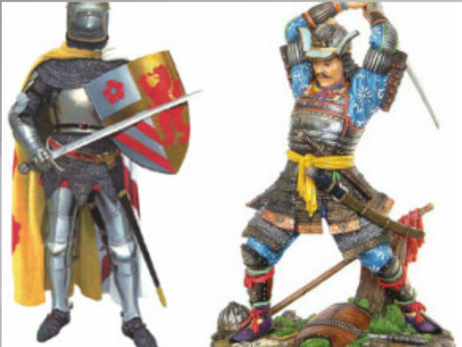
Your teacher may show you another Prezi on the similarities and differences of knights and samurai if time permits. Otherwise you can view in your own time.
https://prezi.com/xmydujtwq8jw/differences-and-similarities-between-knights-and-samurais/

CRIME AND PUNISHMENT
Throughout the Medieval period in Europe laws were extremely harsh and punishments were even harsher. Those in charge of law (kings and the nobility) believed that peasants and common people would only behave properly if they feared what would happen to them if they broke the law.
Even the most minor offences had serious punishments. Minor offences were heard by the village courts and more serious offences were heard by the manor courts and if found guilty were put in the stocks. The most serious charges were dealt with by the Church or the King’s court, and if found guilty people could be executed by being skinned alive or burned.
Traitors were often executed by being hanged, drawn and quartered. This involved first hanging a person, cutting them down while still alive, then pulling out their intestines while they watched and finally attaching each of their hands and legs to a horse and having the horses pull him apart.
LEARNING TASK 12:
Q1. How do we decide today if someone is guilty or innocent?
______________________________________________________________________________________________________________________________________________________________________________________________________________________________________________________________________________________________________________________________________________________
Q2. What kind of punishments do we have for breaking the law today?
______________________________________________________________________________________________________________________________________________________________________________________________________________________________________________________________________________________________________________________________________________________
Q3. Create a Venn diagram to show the similarities and differences of the punishments of the Middle Ages and the punishments of today.
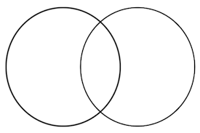
VENN DIAGRAM – COMPARISON
MEDIEVAL GAMES: ARE THEY STILL PLAYED TODAY?
Ring Around the Rosie
The words to the “Ring Around the Rosie” have their origin in English history. The historical period dates back to the Great Plague of London in 1665 (bubonic plague) or even before when the first outbreak of the Plague hit England in the 1300's. The symptoms of the plague included a rosy red rash in the shape of a ring on the skin (Ring around the rosie). Pockets and pouches were filled with sweet smelling herbs (or posies), which were carried due to the belief that the disease was transmitted by bad smells. The term "ashes, ashes" refers to the cremation of the dead bodies! The death rate was over 60% and the Great Fire of London only halted the plague in 1666, which killed the rats, which carried the disease, which was transmitting, via water sources. The English version of "Ring around the rosie" replaces Ashes with (A-tishoo, A-tishoo) as violent sneezing was another symptom of the disease. Players hold hands in the shape of a circle. While they walk in a circle, they sing or chant…. 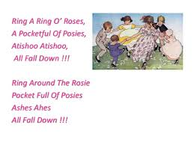
LEARNING TASK 13:
Q1. Explain why this children’s song/game relates to the Black Death?
______________________________________________________________________________________________________________________________________________________________________________________________________________________________________________________________________________________________________________________________________________________
____________________________________________________________________________________________________________________________________________________________________________________________________________________________________________________________________________________________________________________________________________________________________________________________________________________________________________________________________________________________________________________________________________________________________________________________________________________________________________________________________________________________________________

REFLECTION QUESTIONS
List 5 things that you learnt about Medieval Europe/Japan.
1.________________________________________________________________________________________________________________
2.________________________________________________________________________________________________________________
3.________________________________________________________________________________________________________________
4.________________________________________________________________________________________________________________
5.________________________________________________________________________________________________________________
Choose the 2 that you found most interesting from above and explain why.
1.____________________________________________________________________________________________________________________________________________________________________________________________________________________________________________________________________________________________________________________________________________________
2.____________________________________________________________________________________________________________________________________________________________________________________________________________________________________________________________________________________________________________________________________________________
Name two things that you found out about Medieval Europe or Japan that you found surprising.
1.________________________________________________________________________________________________________________
2.________________________________________________________________________________________________________________
Would you have liked to live in a Medieval village? Give reasons for your answer.
______________________________________________________________________________________________________________________________________________________________________________________________________________________________________________________________________________________________________________________________________________________
______________________________________________________________________________________________________________________________________________________________________________________________________________________________________________________________________________________________________________________________________________________
______________________________________________________________________________________________________________________________________________________________________________________________________________________________________________________________________________________________________________________________________________________

In the space below reflect on this HeadStart unit as a whole. What activities did you enjoy? What could be improved? Was there anything that you want to learn more about?
______________________________________________________________________________________________________________________________________________________________________________________________________________________________________________________________________________________________________________________________________________________
______________________________________________________________________________________________________________________________________________________________________________________________________________________________________________________________________________________________________________________________________________________
______________________________________________________________________________________________________________________________________________________________________________________________________________________________________________________________________________________________________________________________________________________

Now that you have completed the HEADSTART booklet go back to the start and finish filling out your KWHL Table with things that you have learnt throughout the unit.

Curriculum Writing Team 2015 – D. Bakopanos; C. Povey; S. Boubis

