
Project Motion
Current Team: Judy Li
Clinical Champions: Dr Natasha (Tarsh) Brusco, Dr Pamela Carreno-Medrano, Professor Dana Kulic
Affiliation/s: MIME, Monash Partners
Mission statement
Project Motion aims to reduce the risk of musculoskeletal condition development in workers who regularly engage in long periods of sedentary work by providing personalised interventions using socially assistive robots. Furthermore, we aim to raise awareness and promote education about musculoskeletal conditions, and improve general public health literacy.
Introduction of Unmet Clinical Need Impact of Solution
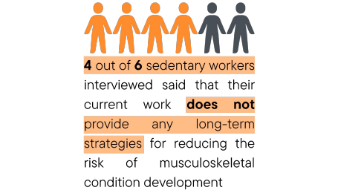
● 1.71 billion people worldwide have at least one musculoskeletal condition as of 2021 ● 1 in 3 Australians have at least 1 musculoskeletal condition
● Musculoskeletal conditions accounted for 87% of serious work claims in Australia from 2019 to 2020 according to Safe Work Australia
● Major risk factors of musculoskeletal conditions are poor posture and prolonged periods of sedentary work, both of which are particularly concerning for sedentary workers such as office workers, university students and staff, receptionists, and many other employees with the current COVID situation
Solution
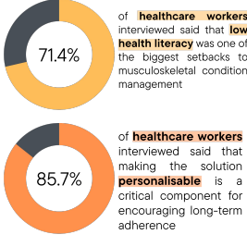
Through Project Motion, we aim to: ● Improve users’ quality of life ● Assist physiotherapy clinics
with at home patient therapy ● Reduce the burden of musculoskeletal conditions on healthcare workers in the future
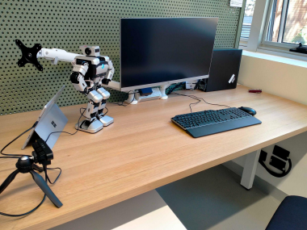
● Consists of a socially assistive robot, camera sensor, posture tracking system and hand gesture feedback system
● Non-invasive method of analysing users’ posture and providing real-time personalised audio and visual feedback on how to adjust their posture to reduce the risk of developing a condition
● Portable and accessible, and can be used in any workspace with an internet connection and laptop or computer
Timeline
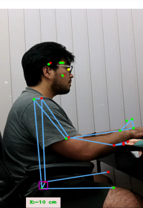
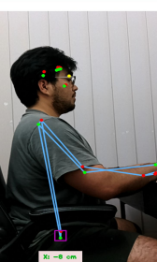
Posture
tracking on an upright posture (L)
compared to a slouching posture (R)
Following the conclusion of the HISS program, we aim to improve our solution and feedback system based on user feedback from the small scale study. Then, we aim to apply for external grants to conduct more research and a larger user study with a larger pool of participants and a more refined solution system.
_{Small scale user study} Improve solution based on user study feedback
External grant
applications Larger scale user studyProduct validation and development
Introduce to end users and stakeholders

