
Project Aesop
Current Team: Uni Han¹ and Tanushree Sharma¹
Clinical Champion: Dinah Humphries²
Affiliation/s: Monash University¹, Monash Health²
MISSION STATEMENT
Project Aesop’s mission is to create a mobile application to deliver social stories in a way that reduces maladaptive behaviours and enhances the psychosocial wellbeing of paediatric patients in the setting of hospitalisation and procedural interventions, and empowers health professionals, families, carers, educators, and other stakeholders to better support children with autism and special needs.
UNMET CLINICAL NEED IMPACT OF SOLUTION
Code Grey Activations
2016
1050
1682
2018
2019
It only takes a single negative experience for a child to develop anticipatory or pre-procedural distress. Acute agitation and behavioural escalations are a significant drain on clinician time and resources, and pose great costs to the health system where these escalations lead to the need for chemical sedation and physical restraints. Significantly, the paediatric population, in particular paediatric patients with developmental disabilities and special needs,

In a survey of 80 parents of children with ASD
50%
Autism spectrum disorder and intellectual disability are currently the largest primary disability categories for the NDIS. Children with autism and other developmental disabilities have high rates of comorbidity and are up to 10 times more likely to be admitted to hospital for medical illness. While they have an increased average number and length of episodes of hospitalisation, they often do

Behavioural
emergencies utilised
> 386 hrs of
emergency response
team time in 2018
Data Source: Royal Children’s Hospital Emergency Department
form an especially vulnerable group and are predisposed to developing posttraumatic stress disorders and to suffering iatrogenic trauma within the healthcare system. Due to the effects of the COVID-19 pandemic upon the health system, the ambient anxiety experienced by children has skyrocketed. Therefore, an increasingly broader demographic of paediatric patients may also benefit from the use of social stories.
Children with
complex needs are likely to be “frequent fliers.”
indicated that their child understood new information best through communication tools such as picture exchange communication systems or electronic devices.
not receive the same quality of care. Lack of support for behavioural and communication difficulties are significant factors. Our solution leverages the advantages of a digital medium to facilitate communication between neurotypical and neurodiverse minds, and to deliver information in a developmentally appropriate and disability friendly way.
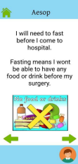
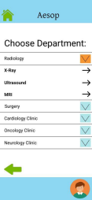
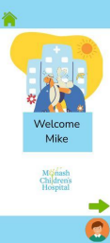
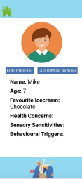
cross-platform
compatibility
intuitive UI
embodying
accessible design
principles
pictoral emotional/
SOLUTION
avatar
customisation
personalisable for
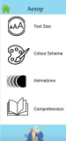end user needs
inbuilt communication passports
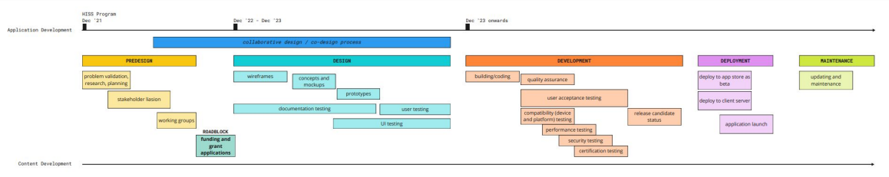
TIMELINE
behavioural rating
scales


