Systems map- if your systems map is on the shorter end, try adding additional information relevant to device/procedure as mentioned in example 3.

Eg 1 – very detailed and easy to understand the different locations involved.
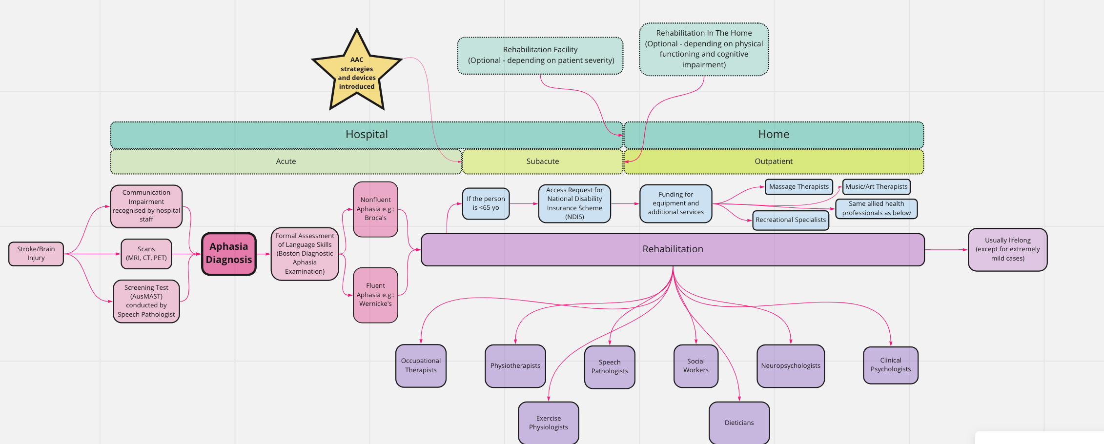

Eg 2- simpler and analysing the different escalation factors
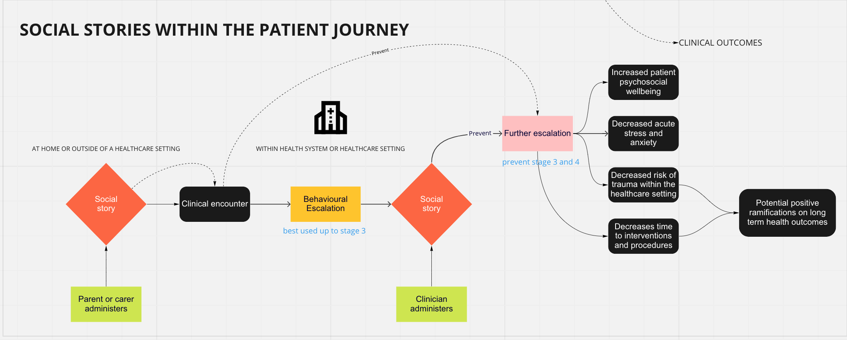

Eg 2

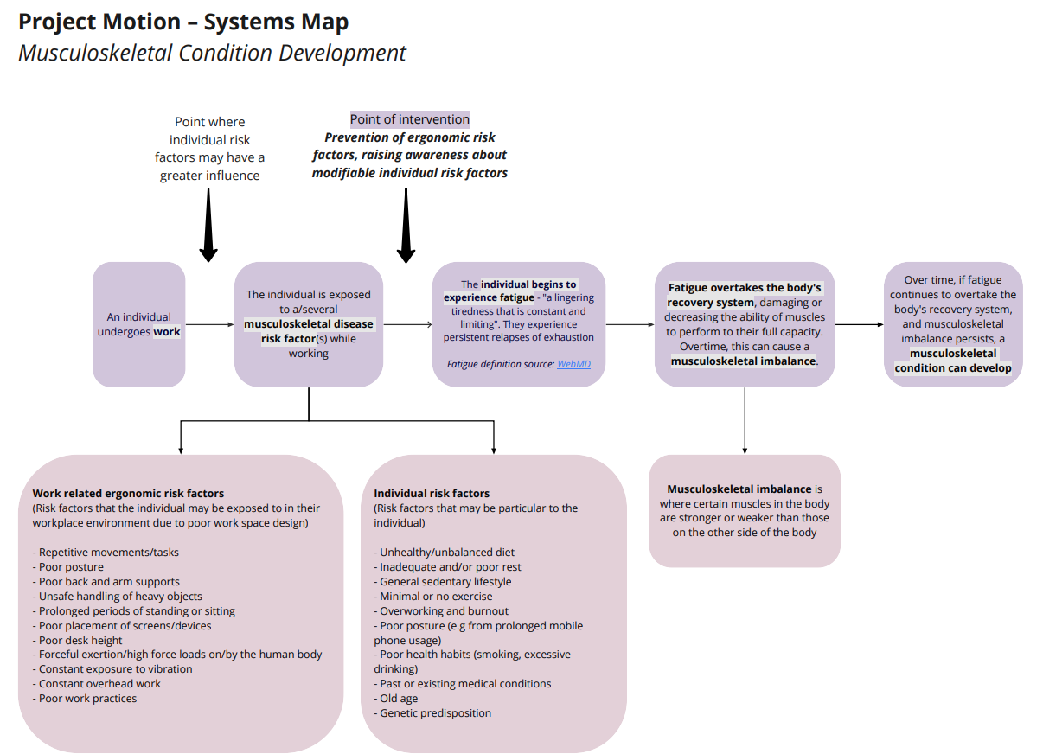

Eg 3- different procedures to understand but clear to see what is done when certain event occurs.
