Stakeholder map https://miro.com/app/board/uXjVOdbwTnk=/?invite_link_id=295753060380
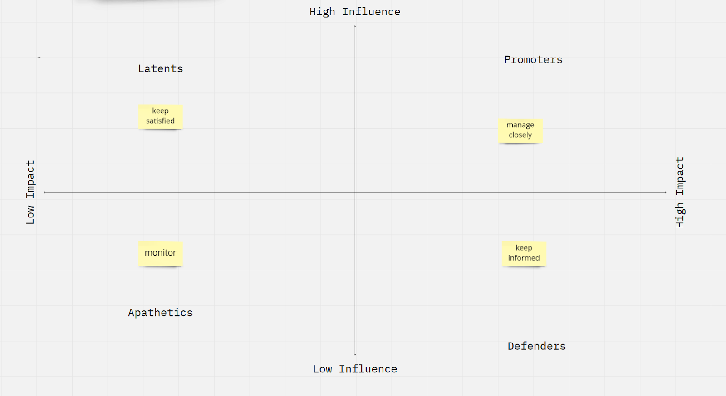
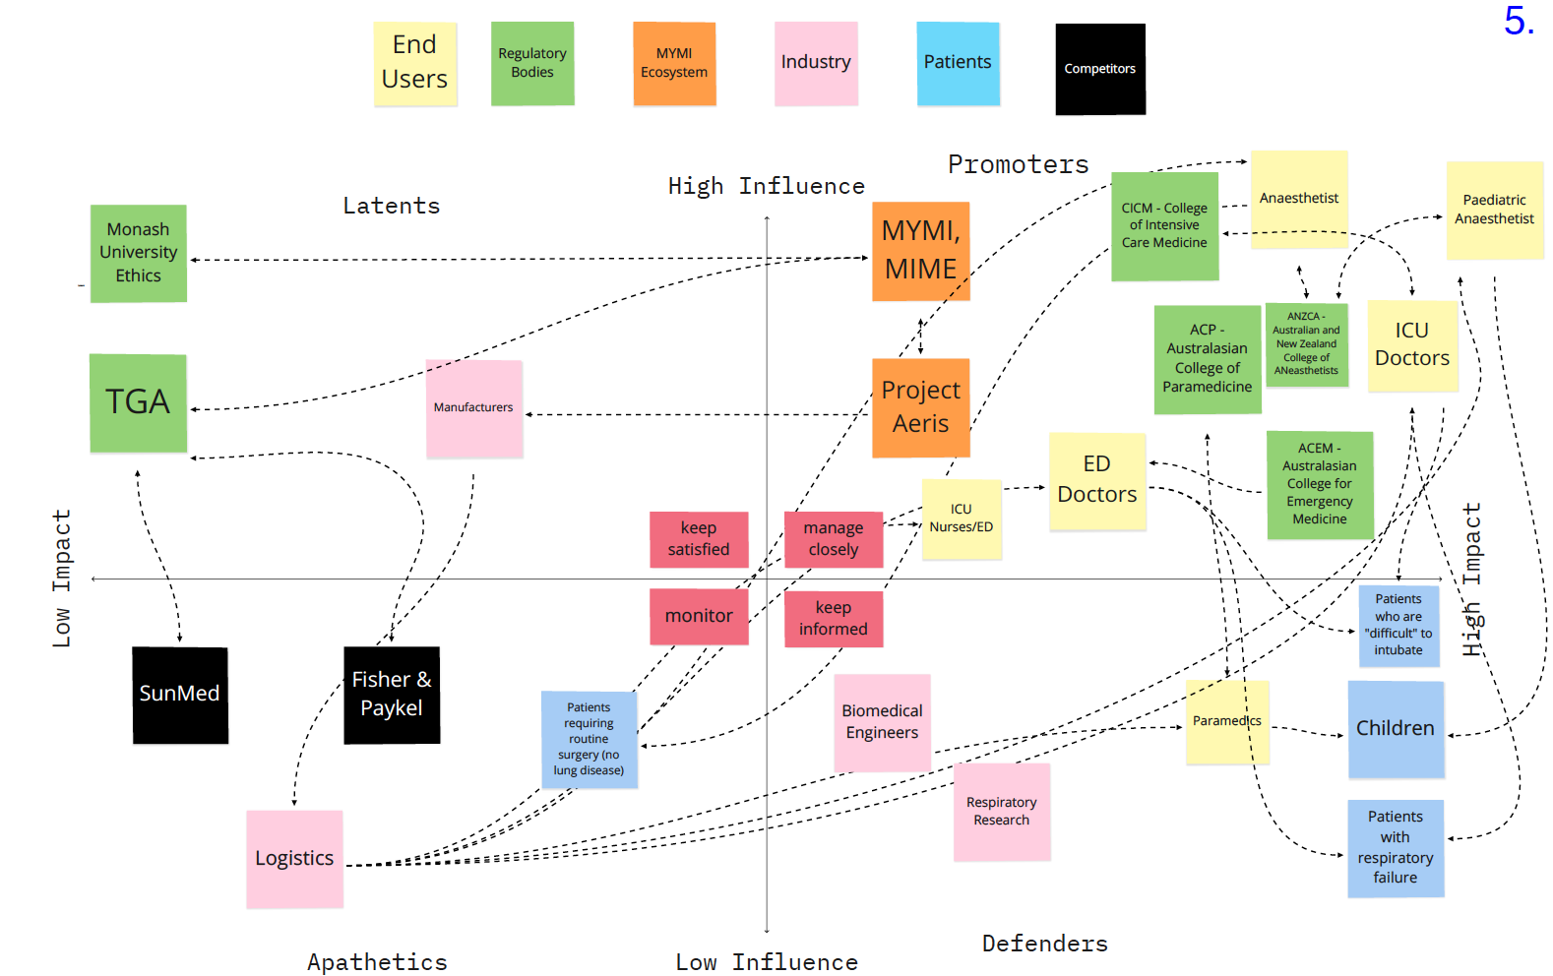
example 1
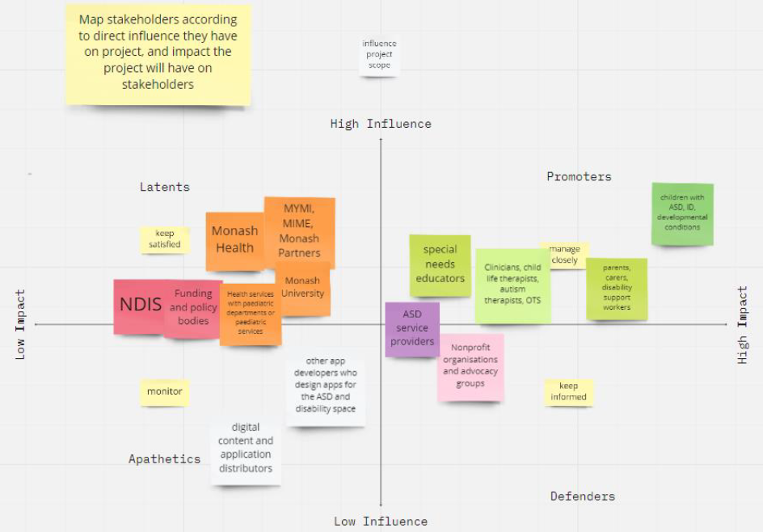
example 2

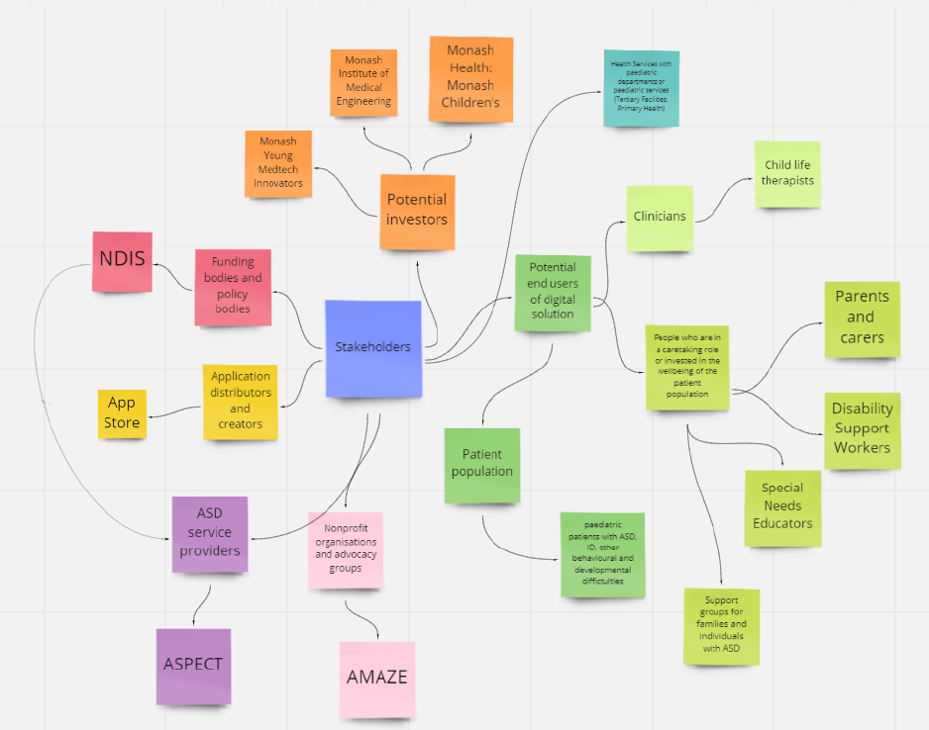
Stakeholder linking
eg2 continued.

