Type of solution to help stroke management
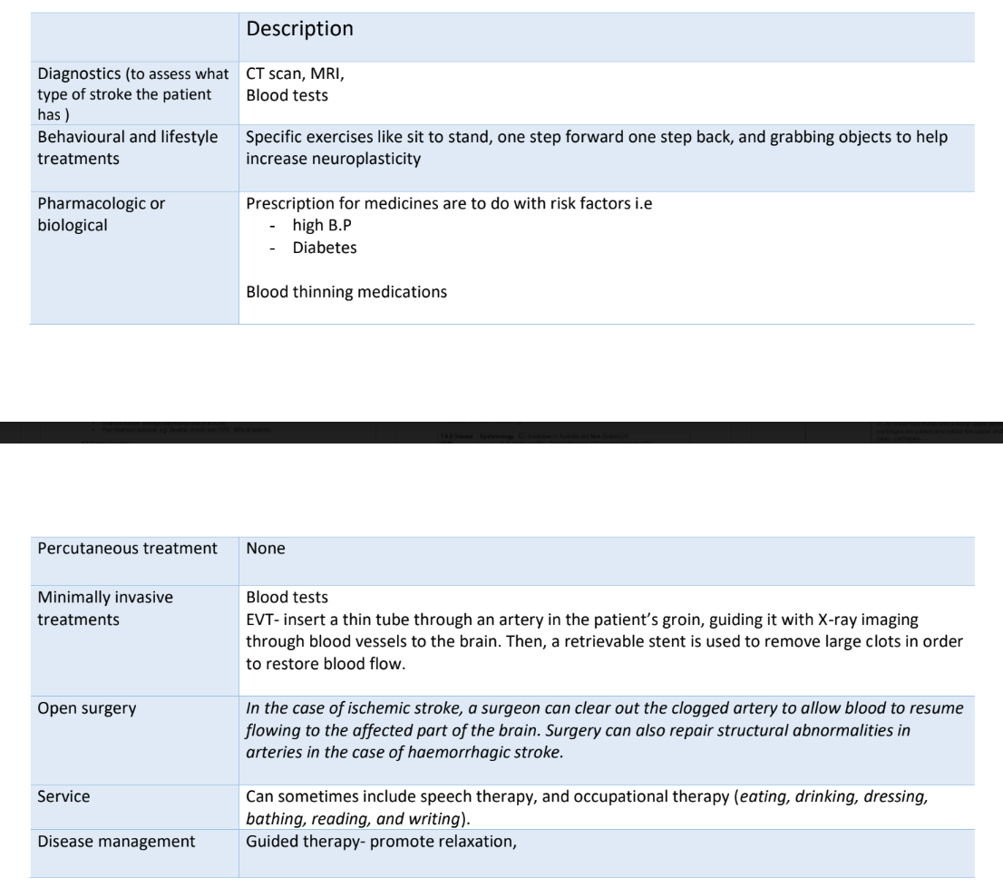

1.5.A Existing Solutions
Currently there is only one way of prescribing patients with exercises specific to their recovery which is done by their physiotherapist.
SOLUTION | HOW: WHY/WHAT | Solution alignment | Gap in solution
Specific exercises to  complete given on a piece of paper | Patients are given a set of instructions which tell them what exercise they have to (i.e sit to stand, wrist curlers and knee rotations etc.) and how many times  Their progress is checked via following appointments with their physiotherapist | There is no use of technology.  It is based of knowledge that the patient may already be familiar with. | With this type of post stroke rehabilitation  patients are left unmotivated and find it to be boring  recovery.  Due to this the overall  outlook of the patient on their recovery is negative and this often leads to a  prolonged recovery period with decreased rates of progress
Exercising apps for elderly - mighty health  - silver sneaker go | Apps which help people (general elderly population ) to keep a track of their  exercise and fitness levels | This follows the component of making it easier for patient track their daily activity goals  - has the potential of  including a  motivational aspect | There is the use of  technology which can be challenging for the elderly population to understand and operate

(plus even harder for adults with decreased mobility and neuroplasticity)
The exercises on the apps would be generalised and not specific enough for what the patients need to do.
There is also no input from the clinician to add/ remove patient exercise.
The clinician would not be able to track or see the
progress of the patient via this general app.

1.5 D Failed solution
A recent trial my clinician did included a sensor patch connected to a seat and was joined to a laptop with a specific software able to detect movement.
The failed aspect was due to the large amount of wiring and technical setting up required for the sensor to the laptop.
This would simply be impossible for someone who has just had a stroke and is trying to resume to a normal life.

