Collaboration to Commercialisation
Betty Zhang
CEO, Melbourne Bioinnovation Student Initiative
MBSI
MBSI
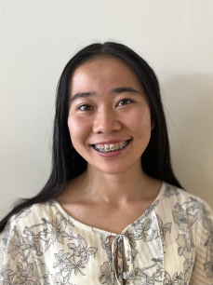

About me
Educational Background
- Bachelor of Science (Biotechnology specialising in Immunology)
Current Roles
- CEO, Melbourne Bioinnovation Student Initiative - Early Innovation Programs Lead, Medtech Actuator
Past Experiences
- Research Assistant, Walter & Eliza Hall Institute - Biotech Equities Analyst, Churchill Asset Management
- Disabilities Officer, University of Melbourne Student Union
MBSI
BioDesign Initiative MBSI


John Ertan BioDesign Team Leader


Daniel Gan BioDesign Officer

Anke Oatley BioDesign Officer

Tommy Li BioDesign Officer
Shanna Lam BioDesign Officer
Ryan-Lim Yip Vice-Chair
Internal
MBSI
Vinuri De Silva Biodesign Competition
● Pitch Night as part of the International Student Conference of IEEE Engineering in Medicine and Biology Society
● Prizes:
○ Vinuri De Silva BioDesign Competition Prize ($2,500)
○ Graeme Clarke Institute Prize ($2,500)
○ MedTech Actuator People’s Choice Award ($1,000)
● Sponsored by Graeme Clark Institute & MedTech ActuatorMBSI
MBSI
MBSI
MBSI
MBSI
MBSI
MBSI
MBSI
MBSI
MBSI
MBSI
MBSI
MBSI
MBSI
MBSI
Medtech Actuator - The Accelerator
MBSI

