
MONASH HEALTHCARE INNOVATION SUMMER SCHOLARSHIPS (HISS)
PROJECT NAME: Nemo
DELIVERABLES NUMBER: 8 (Week 9)
PROJECT MEMBER(S): David Levitz, Vishnu Sivakumar & Upani Mapala Gamage
Gantt chart:

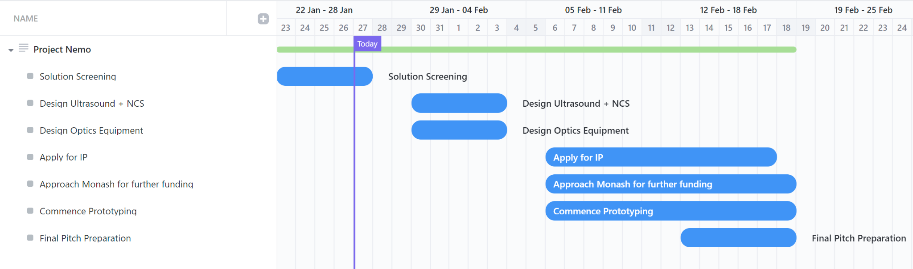

Patent search outcomes:
Need to brainstorm completely new ideas, therefore key features of our device are unknown as of yet.
Keywords: peripheral nerve, non-invasive, localisation, sensor, nerve localisation, nerve conduction studies.

Patent | Notes
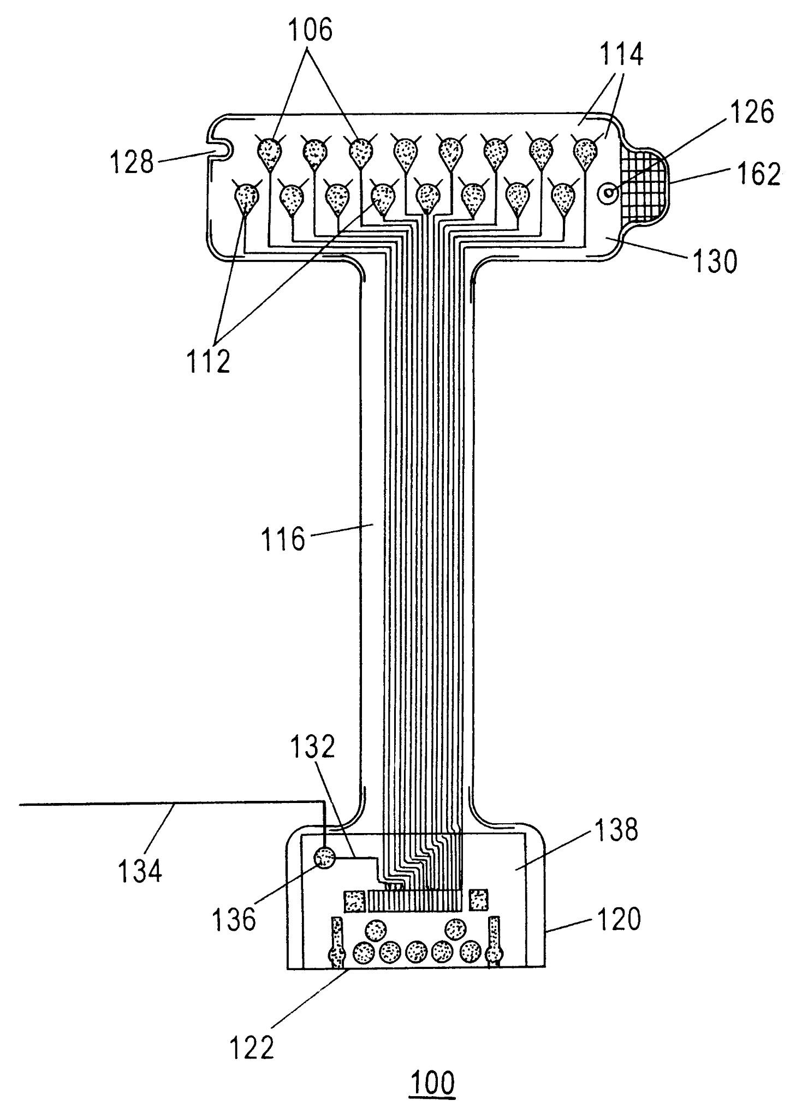  Electrode array and sensor attachment system for noninvasive nerve location and imaging device | - 2001, granted, expired 2020  - system for detecting and marking the positions of peripheral nerves is disclosed  - the electrode array is connected to a peripheral nerve detection instrument  - The disposable sensor attachment system is attached to an electrode sensor region.  - The sensor attachment system is then adhered to an area of skin, detection is carried out, and then the electrode array is peeled back from the skin, leaving a skin marking guide in place.  US6609018B2
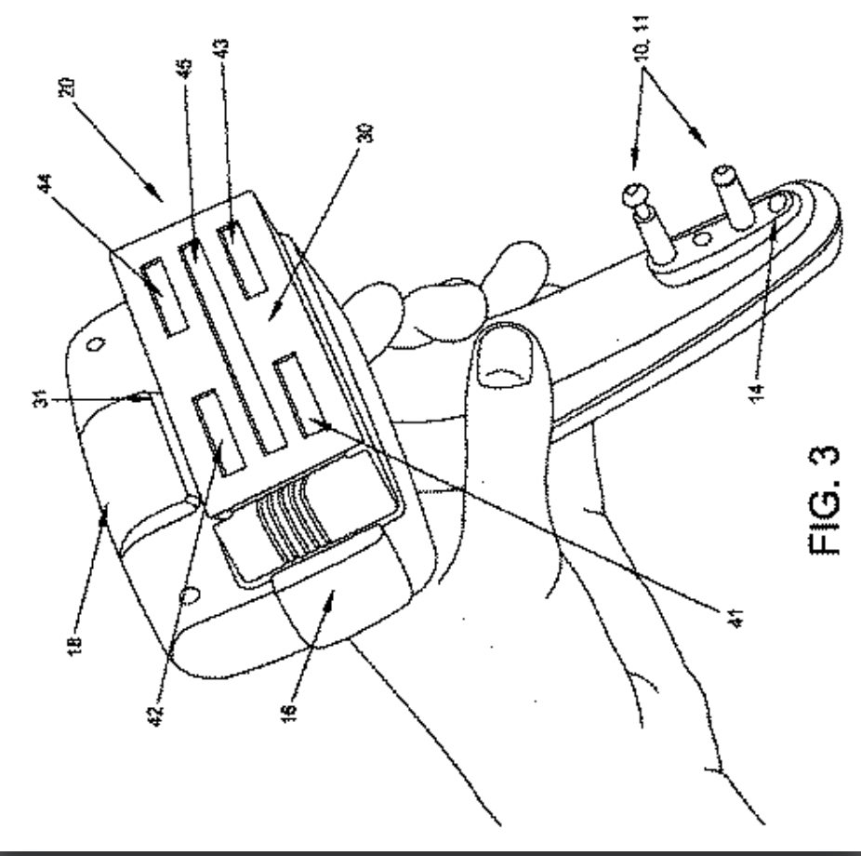  Single fully integrated handheld device | - Active, 2015, Japan  - handheld device for measuring the sural nerve conduction velocity and amplitude of any leg of patient  - We are looking for a device that can be used on any patient during the study of any nerve therefore this device is not exactly what we need. However, the technology used to localise nerves may be similar and would require a revisit
System and method for improving nerve finding for peripheral nerve stimulation  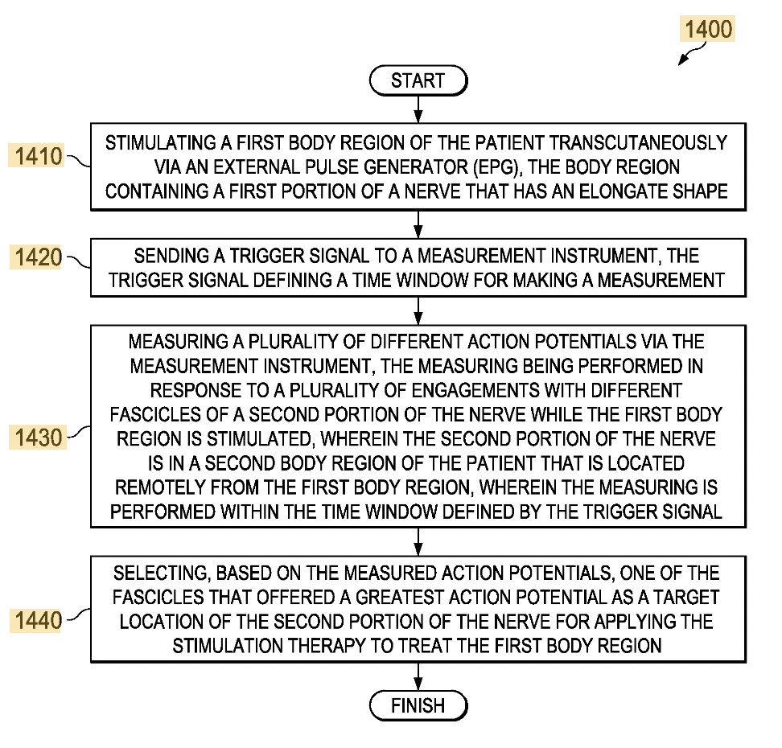 | - 2016, Ceased, 2021 anticipated expiration  - A method of identifying a location for applying a stimulation therapy to treat a patient includes stimulating a first body region of the patient transcutaneously via a stimulus generator  - The issue with this is that it increases time to conduct NCS which is something we want to avoid
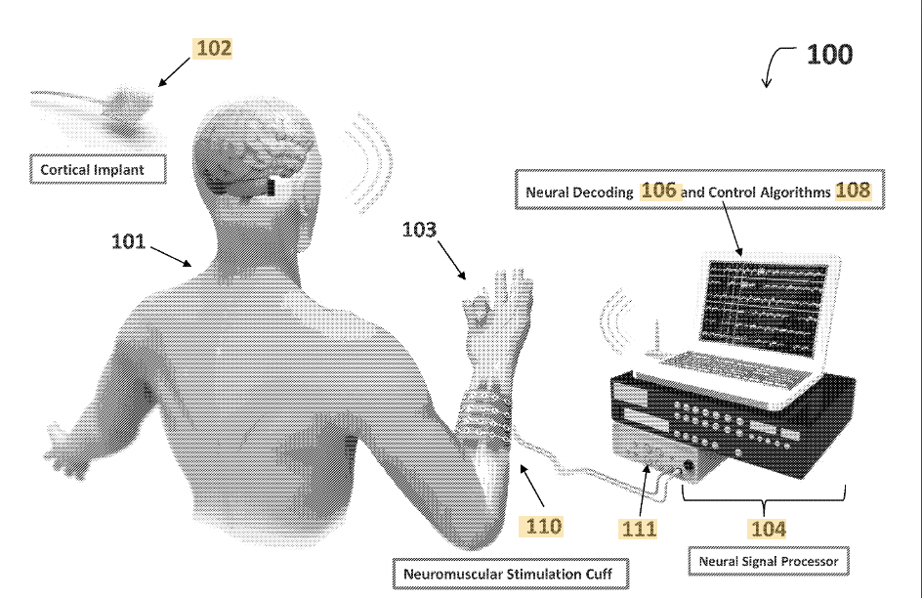  Neuromuscular stimulation cuff | - The neuromuscular stimulation cuff includes a flexible printed circuit board having at least one finger and a plurality of electrogel discs disposed on the at least one finger.  - The neuromuscular stimulation cuff may be produced by providing a layer of polyimide, etching a conductive copper circuit including a plurality of electrodes into the layer of polyimide to form an etched circuit layer, adhering a cover layer onto the etched circuit layer to form a flexible printed circuit board (PCB), and cutting at least one finger from the flexible PCB.  US20150290451A1

A more in-depth patent search will be conducted in the coming weeks, the above are for devices or workflows that localise nerves. None have a focus on difficult anatomy or have been tested on our target population.

For further research, look at devices that have referenced electrode arrays and sensor devices for more current patents and devices similar to what we might develop.

Prototyping progress:
Over this week we conducted more thorough and in-depth research into the mechanics of an ultrasound and the working principles of nerve conduction studies. After which, we were quick to realise that one of our solutions (stimulator and receptor cuff) is not feasible. Furthermore, the high levels of complexity involved in the engineering of equipment (ie. ultrasound & NCS machine) has narrowed our solution’s scope to only localising nerves and to keep the rest of the procedure identical to current practices.In addition to this, due to heavy time and budget constraints, we have collectively decided that a working prototype by the end of HISS cannot be finished. Therefore, we aim to submit detailed drawings/designs and potentially LAB testing results of individual components as part of the final pitch presentation.

