
MONASH HEALTHCARE INNOVATION SUMMER SCHOLARSHIPS (HISS)
PROJECT NAME: Project Blooming
DELIVERABLES NUMBER: 8 (Week 9)
PROJECT MEMBER(S): Jacinta Patel

Gantt chart:

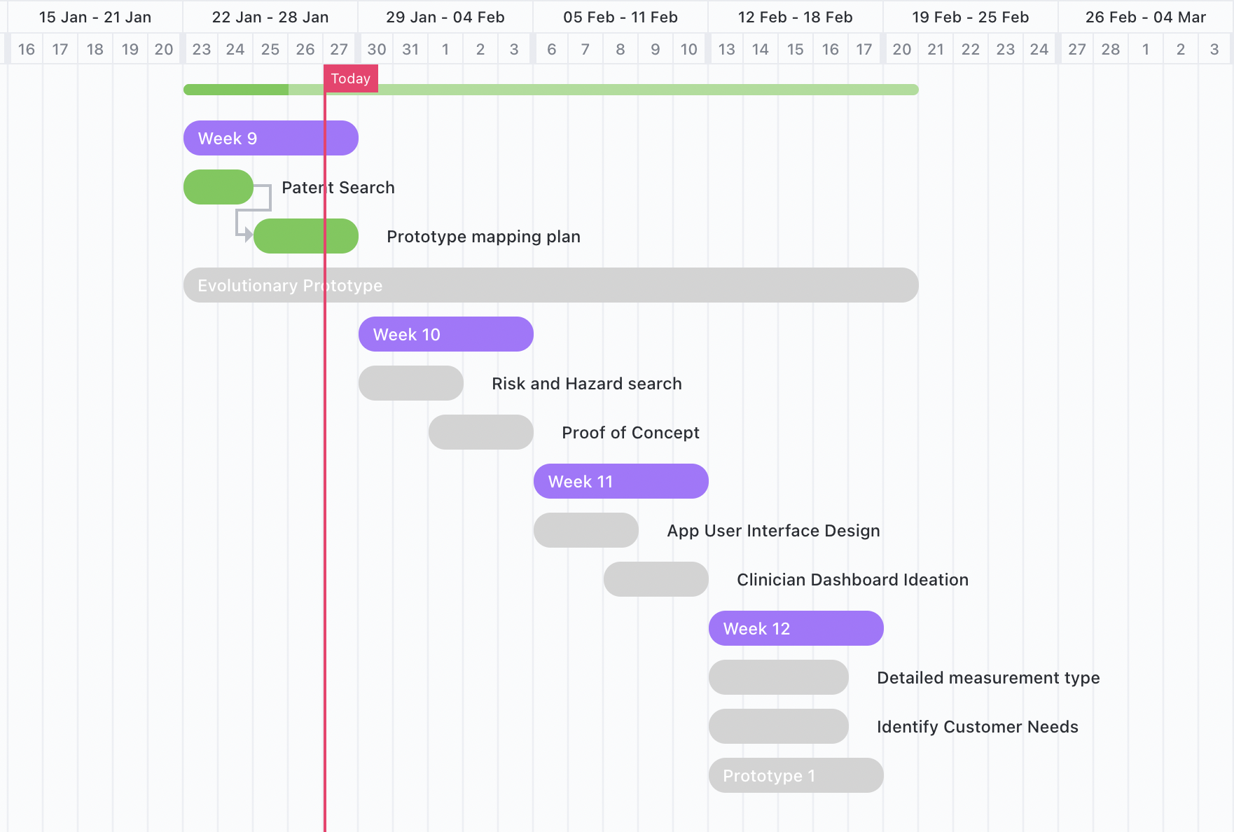

Objects and purple represent weeks, checks in green represents completed tasks and grey is to be completed.

Patent search outcomes:

The solution is a software product with novel technology. Specifically, a smart phone app that uses 3-D scanning and maybe Lidar + output novel scale. No exact existing patent has been found that would restrict this project’s freedom to operate.

Elements for search includes
- Breast measurements (volume, shape, size)
- Mobile app/Software
- 3D scanning/Lidar

Related patents have been listed below

- https://patentimages.storage.googleapis.com/b5/da/f3/3e682103629683/US20200000165A1.pdf
A method for determining a bra size patent in the US in 2019 by uploading chest parameters to a server analysing and matching with data on a database and then generating a bra size. 2-D or 3-D breast image is used. It could restrict my freedom to operate by restricting set an measurement method in the US (?).

- https://patents.google.com/patent/JP2020510271A/en?q=breast+measure+3D&oq=breast+measure+3D
A measurement method of human chest size selection and implementation of bra size in Japan. This patent can restrict a method of measurement related to the chest area in Japan (?). This was published in 2020 and has a pending status.

- https://patents.google.com/patent/US20190107391A1/en?q=breast+measure+3D&oq=breast+measure+3D
Tool systems and methods for standardisation of bra cup measurements in the United States Published in 2019 but was abandoned. The tools include software program that establishes the breast hemi circumference.

- https://patents.google.com/patent/CN103948196A/en?q=breast+measure+3D&oq=breast+measure+3D

Human body data measuring method from China published in 2014 and has a pending status. The human body modelling is carried out by 3-D human body surface scanning data and B spline curve surface shaping technology with human body data which is input into a reverse engineering software to determined measurements. Chest width, breast cross-section, breast angle, breast height, edge point, inner edge, the surface length and degree of depth.

- https://patents.google.com/patent/US20210182443A1/en?q=breast+measure+3D&oq=breast+measure+3D
Breast shape and upper torso enhancement tool which is specifically an app made in the United States published in 2021 with a pending status. Detect the location of breasts using markers and points with 3-D scanning. Ability of accounting accurate 3-D breast volume image.
- https://patents.google.com/patent/US7993288B2/en?q=breast+volume&oq=breast+volume
Anatomical recognition and dimensional analysis of breast volume to assist breast surgery published in 2011 in the United States with granted application in 2011 and anticipated expiration in 2029. Message techniques and modules for automated analysis of the 3-D representation of the upper front torso including addition of breast implants and breast nipple positioning for planning of breast surgery. Are uses a computer implemented method of determining a brisk volume in an automatic fashion from a 3-D representation of a conduit surface of the upper torso.
- https://patents.google.com/patent/US8834391B2/en?q=breast+shape&oq=breast+shape
Computer analysis of a breast shape to assist breast surgery published in 2014 which is active in the US with an adjusted expiration in 2031. Cleans his computer and implemented method of simulating breast appearance of a woman after breast surgery.
Prototyping progress:
Proof of concept and prototyping plans have been made but not formalised. As I don’t have the skills needed to make software and therefore, build a finalised prototype or minimal viable product I have and will be focusing on proof of concept and design. The proof of concept and design will help me find an evolutionary timeline of the prototype.

