
MONASH HEALTHCARE INNOVATION SUMMER SCHOLARSHIPS (HISS)
PROJECT NAME:
DELIVERABLES NUMBER: 8 (Week 9)
PROJECT MEMBER(S):

Gantt chart:

https://miro.com/app/board/uXjVPu8pe-8=/?share_link_id=693441510552

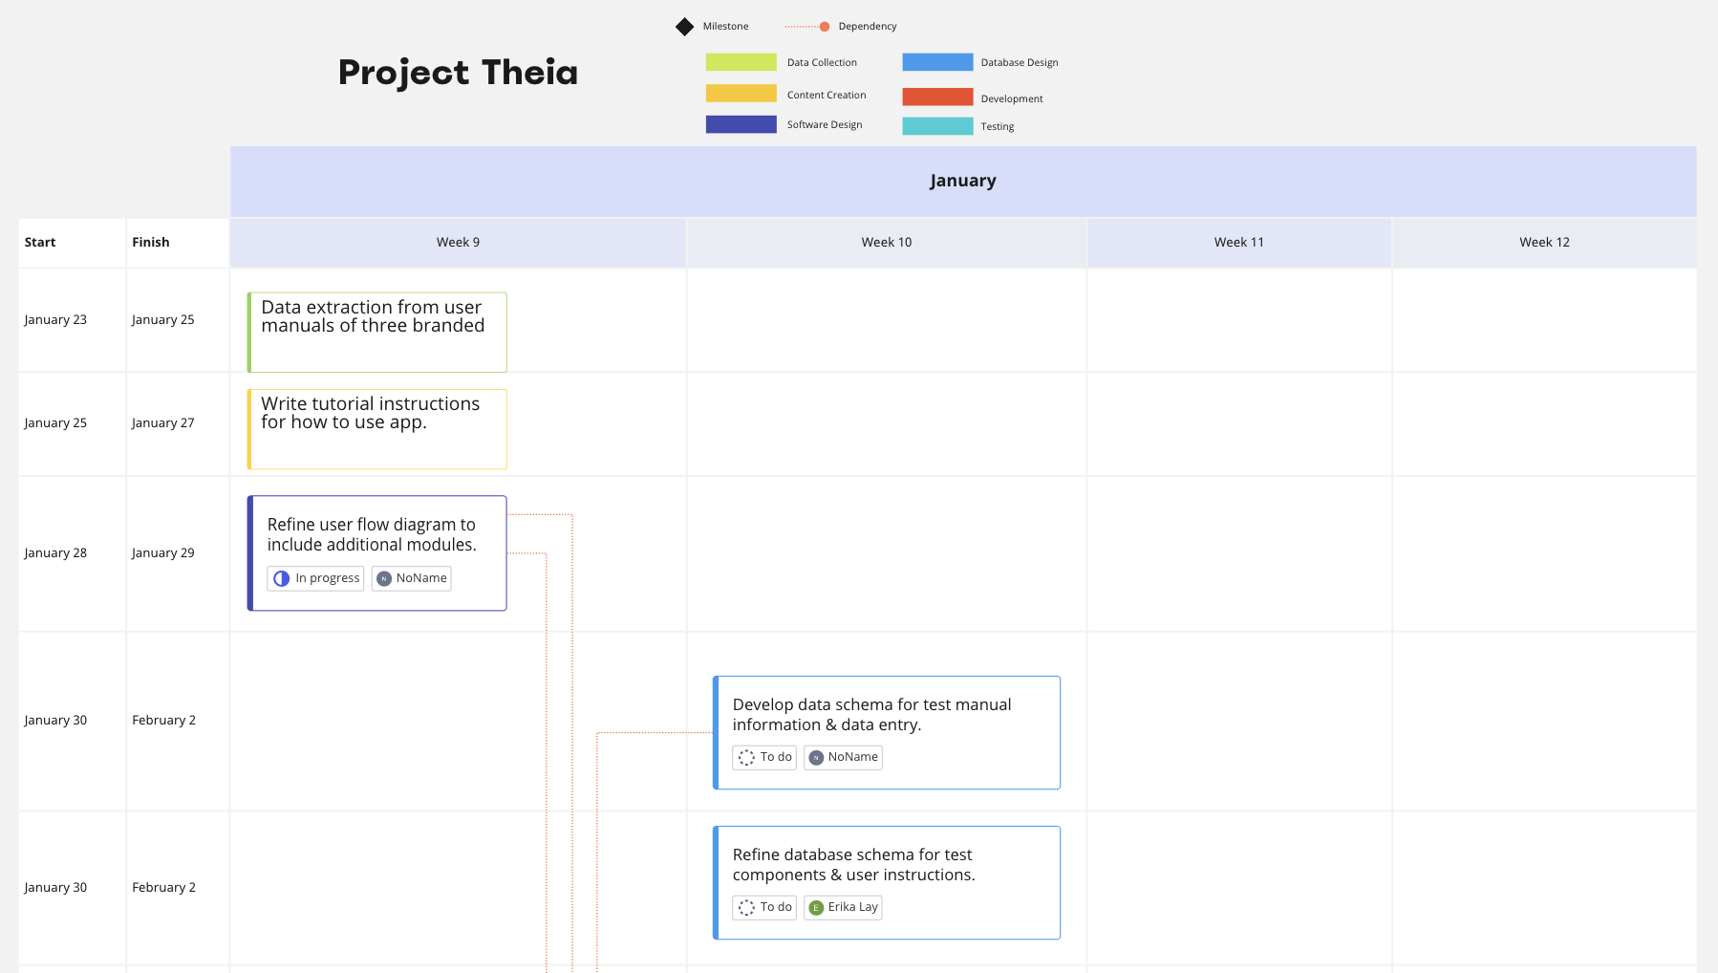
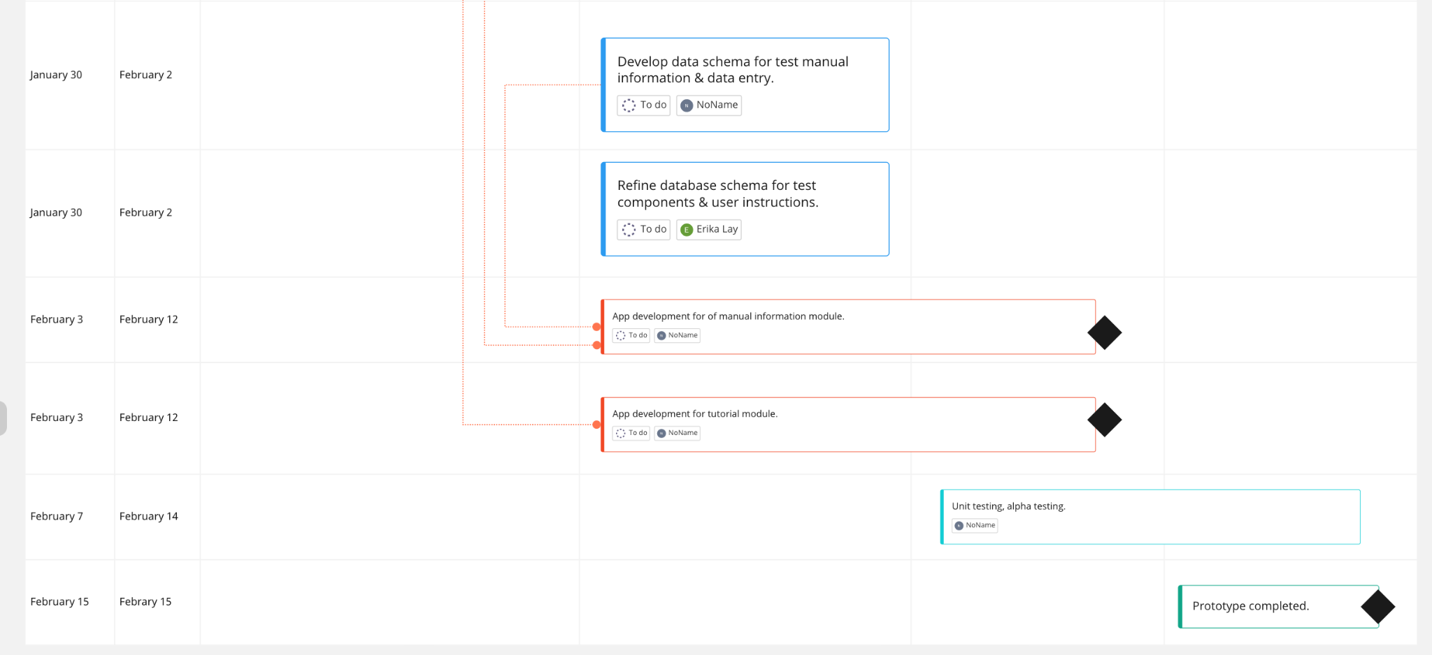

Notes:
- “No Name” refers to William Chen.
- The events on the Gantt chart reflect the current progress of prototype development for Project THEIA. From weeks 9 - 12, the key developmental milestones include the creation and development of two additional user functionalities to supplement the prototype:
  - A tutorial module.
  - A module for users to access all information present for a brand’s user manual.

Patent search outcomes:

- US10777097B2: Media streaming methods, apparatus and systems
  - Owned by AIRA, this patent restricts the use of a workflow in which a “visually-impaired” user utilizes a client device that has video-capturing capabilities, sends the video data and sensor data to a server, which sends this video data to an agent device. In this workflow patented by AIRA, the agent provides assistance to the user in real-time through audio instructions or other feedback.
  - Applies to U.S., but similar patents issued for Australia, EU and WO.
  - Analysis: This patent is relevant to THEIA’s proposed workflow whereby client images are sent to agent devices for annotation. The patent is unlikely to restrict current software workflow proposed by THEIA, as the workflow does not involve transmission of video content between agent and client devices. Furthermore, the workflow provides a distinct form of assistance following data transmission (e.g. asynchronous labelling occurs, rather than ‘guided’ or ‘navigational’ assistance).

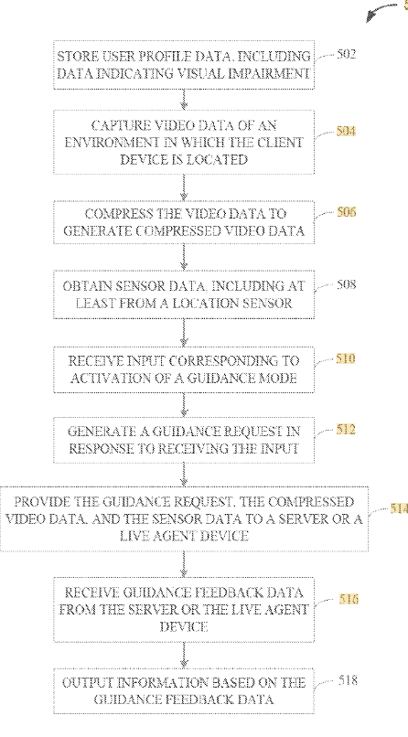
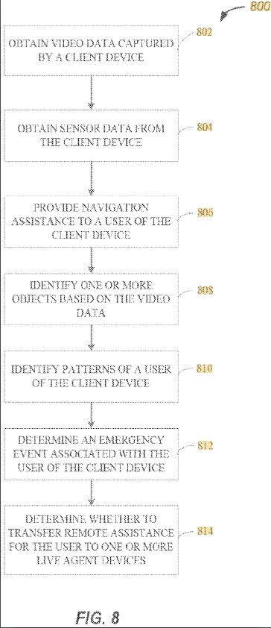
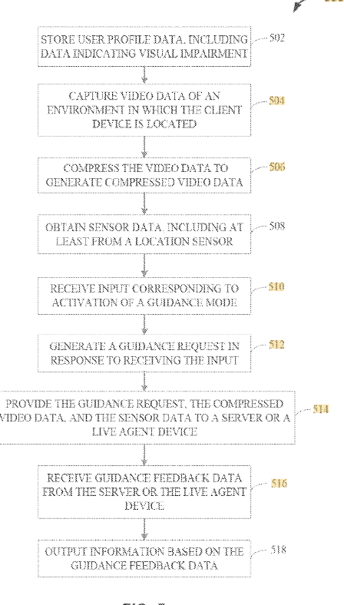

- WO2017172649A1: “Augmented imaging assistance for visual impairment”
  - Patent owned by Microsoft restricting the use of an assistive device that has an imaging system designed to capture an image of a scene, transmis this data towards a distributed assistance service that processes the data to recognise properties of the scene, and then provides feedback to the client device which has a user interface configured to provide this form of feedback to the client.
  - International patent protection.
  - Analysis:
    - Workflow used by THEIA does not involve the transmission of data to a distributed assistive service, and instead involves transmission of data to a locally-hosted artificial .
    - Imaging system used by THEIA does not capture a ‘scene’ but an image of a selected, recognized object.

Prototyping Progress:

As of Week 9, the THEIA app includes the following fully-developed components: 1) an account creation system for blind and low-vision users; 2) a module through which users can learn how to conduct the test; 3) a module through which users can receive step-by-step audio instructions regarding how to the test; and 4) an automatic image-capturing system which utilises an AI model to recognize a diagnostic self-test. The development of an AI/ML model for detection of self-test testing windows for results interpretation has been halted until further clarification from the TGA has been received.

