
MONASH HEALTHCARE INNOVATION SUMMER SCHOLARSHIPS (HISS)
PROJECT NAME: Project Sentinel
DELIVERABLES NUMBER: 8 (Week 9)
PROJECT MEMBER(S): Calvin Zheng, Diana Kovaleva

Gantt chart:
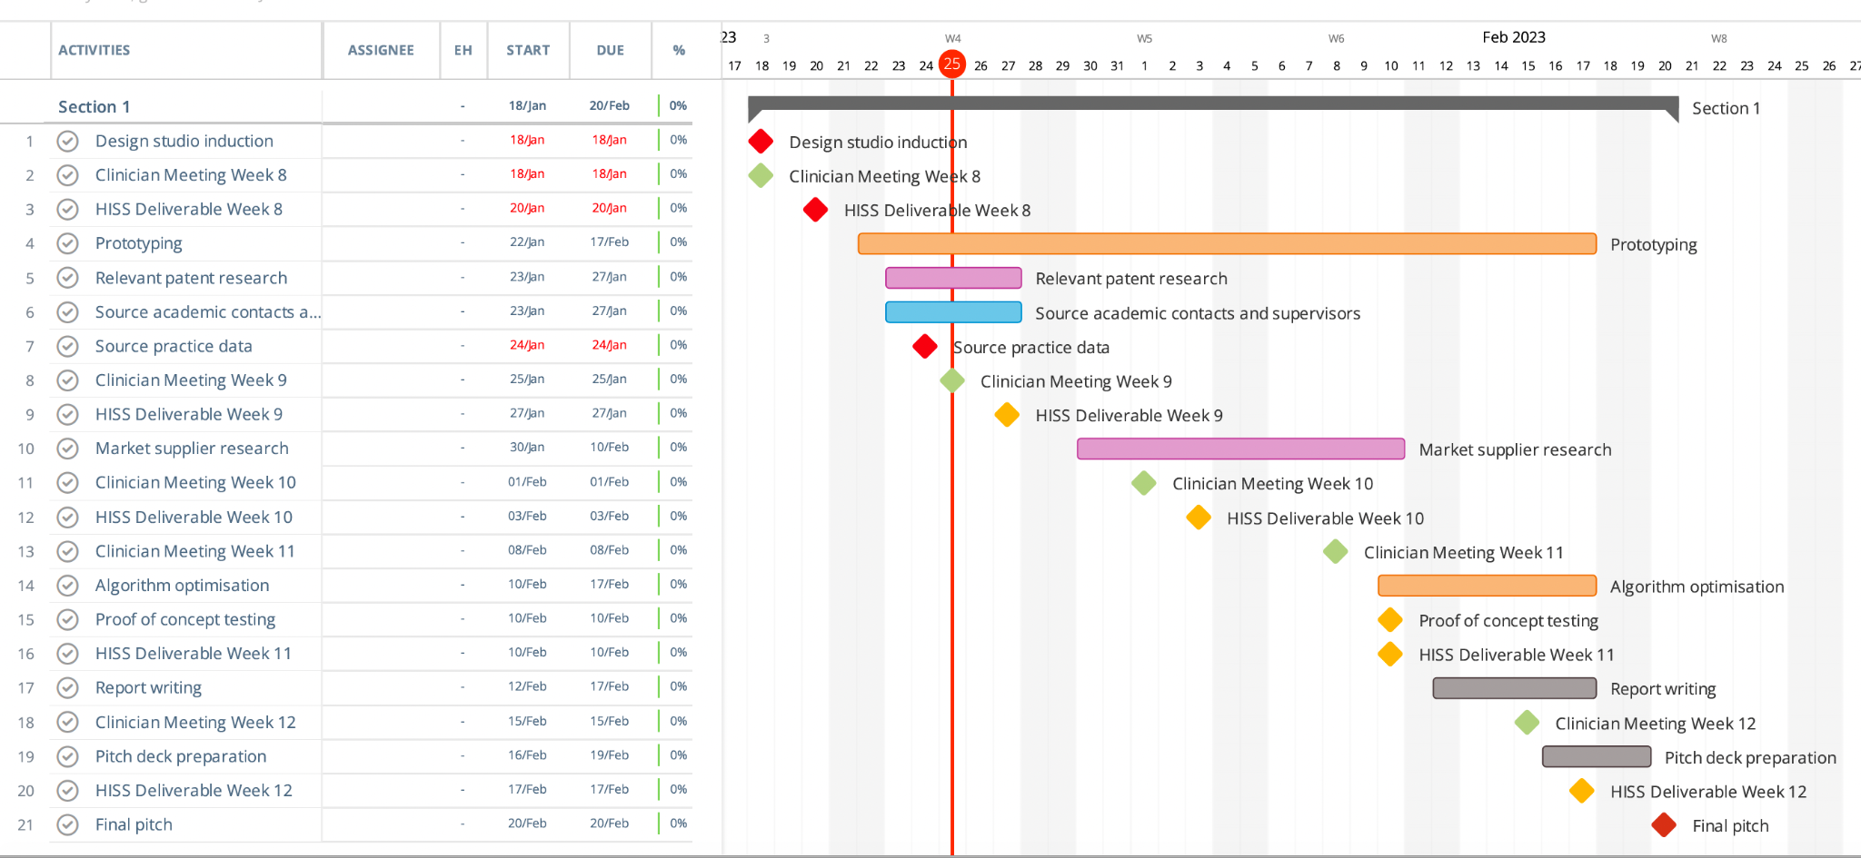

Patent search outcomes:
Patent Name | Diagram | Patent Number | Brief description/ restriction
System and method for current source analysis of seizures | 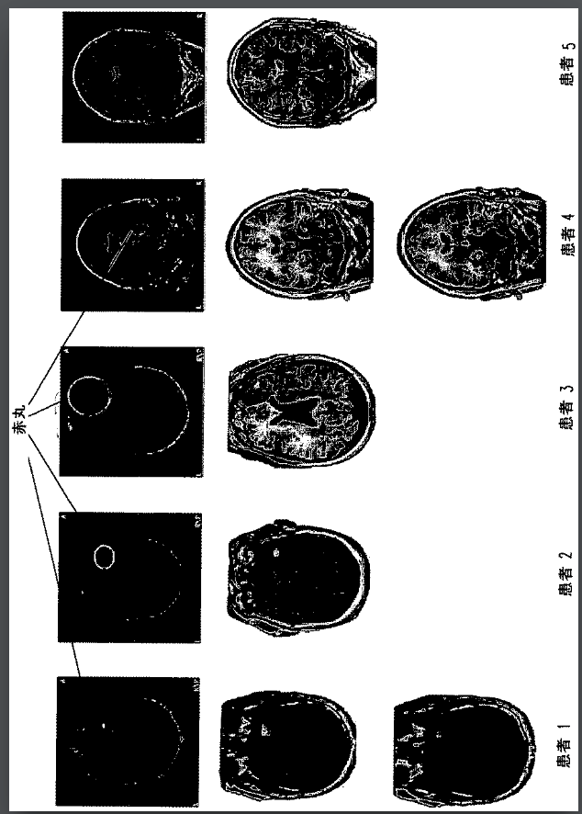 | JP2009534103A | The processor is configured to execute a subspace current source location estimation algorithm (localisation)  Using the series of measurements and the model to solve an inverse problem (inverse problem solution)
System and method for assessing electrical activity using an iterative sparse technique | 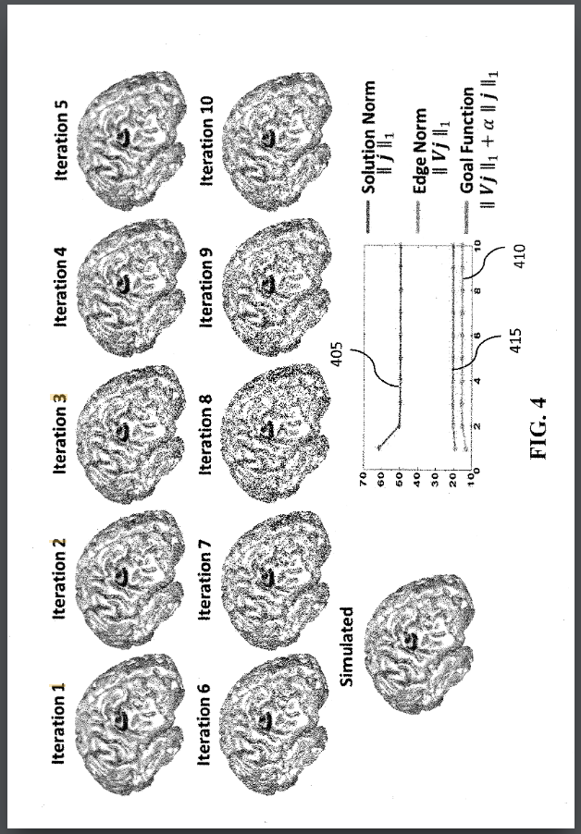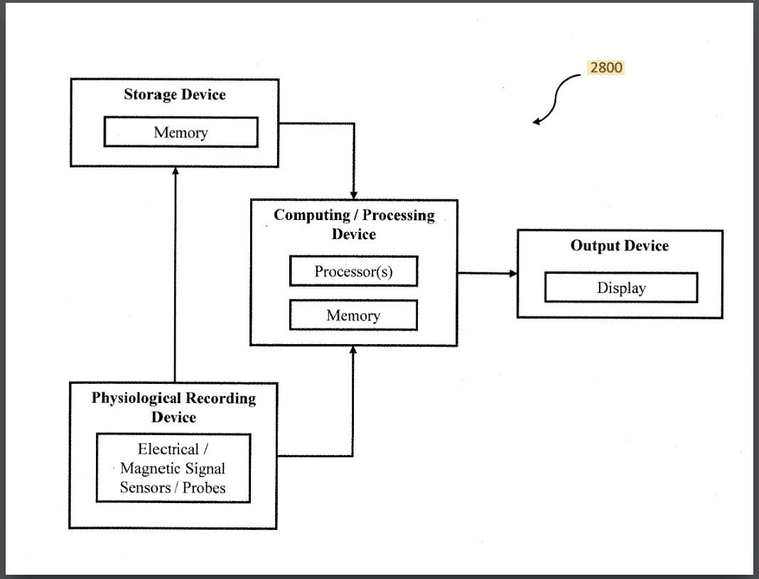 | US20180055394A1 | The processor is configured to generate a series of images or a movie depicting spread, in time, of electrical activity, and time-course of electrical activity through the biological system (temporal application)
Qeeg statistical low resolution tomographic analysis | N/A | WO2009079384A1 | Visual characteristic includes a color for the brain region of origin, the color corresponding to a hue that is proportional to a probability of abnormality in the brain region of origin (coloured representation)  Visual characteristic of the brain region of origin visually represents an extent to which the standard score deviates from the control data (determination of patient “baseline” values)

Prototyping progress:

The first stage of prototyping for project sentinel is proof of concept. The goal of the proof of concept stage is to write a piece of code that is able to take in a csv file of a patient’s EEG data over a period of time, and then visualise the brain activity recorded through the EEG data on a 3D map of the brain.

This week we have found some online APIs for Python and Matlab that could aid in testing our solution. To aid with the proof of concept, we have acquired a set of anonymous patient EEG data this week.

A major issue experienced this week is the mapping of signals onto the brain; every patient’s brain size and fold locations are different, so most of the APIs require an MRI scan of the brain to produce a 3D image from which the EEG data signals can be visualised onto, but using an MRI goes against the acceptance criteria of our solution. Thus, we will need to use a more generalised approach, likely just lowering the resolution of the final output to just the approximate area in the brain rather than exact location.

