
MONASH HEALTHCARE INNOVATION SUMMER SCHOLARSHIPS (HISS)
PROJECT NAME: Project Impetus
DELIVERABLES NUMBER: 8 (Week 9)
PROJECT MEMBER(S): Dan Lin
Gantt chart:

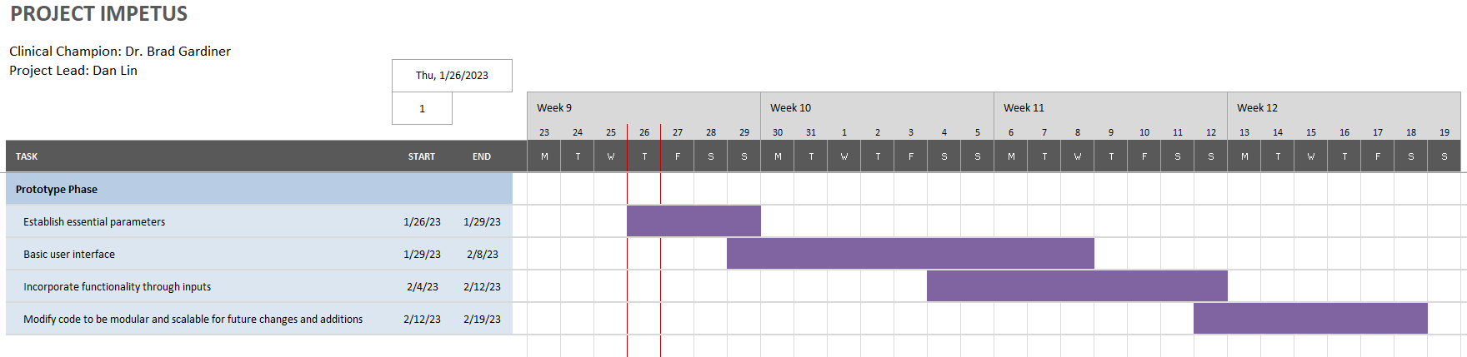

Patent search outcomes:

My project is software-based and the types of algorithms that are to be implemented have not yet been established. Thus, a patent search is not applicable in this situation.

Prototyping progress:

The current version of the prototype contains a very rough prediction of how the software’s user interface will be laid out. There are simple inputs for some basic variables, and a results section that will display the calculated/recommended drug dosage, advice for the future, evidence and calculations behind the computed result, and an info panel for project members. There is a placeholder graph that will be replaced in later prototypes with other graphical representations of the information.

