
MONASH HEALTHCARE INNOVATION SUMMER SCHOLARSHIPS (HISS)
PROJECT NAME: Project Dolphin
DELIVERABLES NUMBER: 8 (Week 9)
PROJECT MEMBER(S): Maya Wilmshurst

Gantt chart:
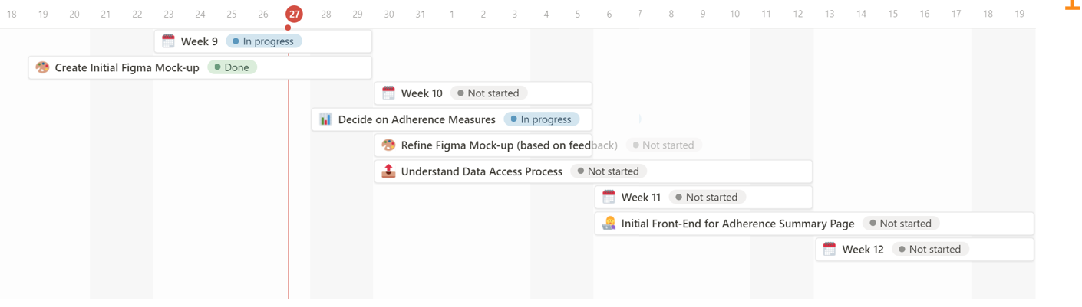

https://rowan-pressure-3e1.notion.site/Gantt-Chart-6ee70750d0a7438d9a418018f1966c32

Patent search outcomes:

Patents are not relevant to this project. The solution being developed is a software product without any novel/unique technology (it is applying known functions that are broadly used). No existing patents were found that restrict the project’s freedom to operate. Somewhat related patents have been summarised in the link below for interest.

https://rowan-pressure-3e1.notion.site/Patent-Searching-5b61ea5f3c2f469fb718ea5eb2a6bcf2

Prototyping progress:

This week, I validated the clinical workflow of the solution. I have also developed a Figma mock-up of the basic UI of the main pages of the website. This includes:
- Adherence Summary Page: includes overall adherence statistics as well as per medication statistics.
- Dispensing Records: includes records of when and where each medication was dispensed. This is simply a display of the data already stored on various pharmacy platforms (currently inaccessible to clinicians). This is similar to the system used for monitoring the dispensing of addictive drugs through safescript.

It has been determined that the Minimum Viable Product (MVP) mainly concerns these two pages. Further features regarding aiding clinicians in determining the cause of non-adherence and finding solutions to the barrier will be developed later down the line to add on to the existing service.

