
MONASH HEALTHCARE INNOVATION SUMMER SCHOLARSHIPS (HISS)
PROJECT NAME: Activus
DELIVERABLES NUMBER: 8 (Week 9)
PROJECT MEMBER(S): David Cheng

Gantt chart:
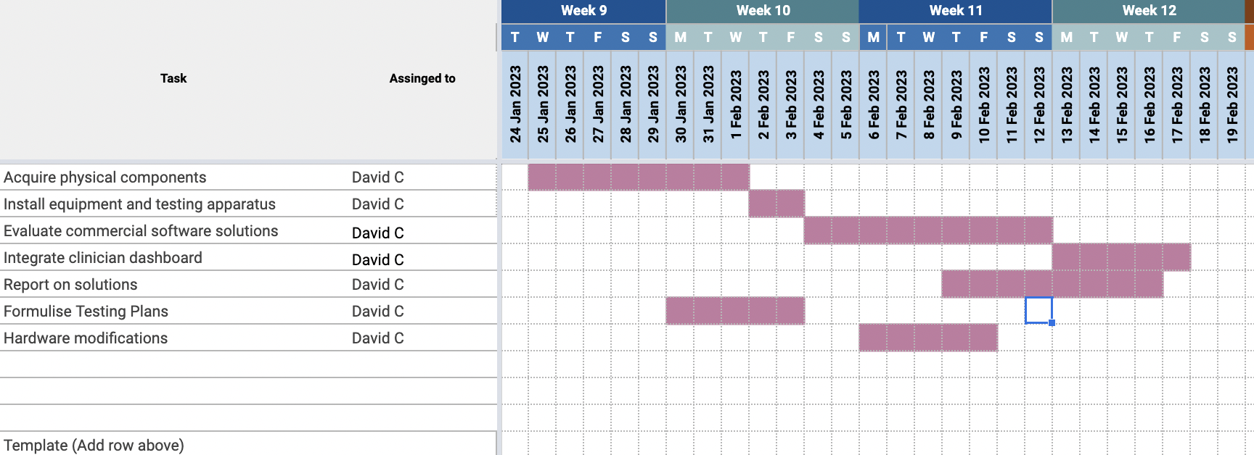

The Gantt chart is made in google sheets so that it is easily modifiable, and it will be in the centre of the workspace of the new Project Activus shared google drive.

Patent search outcomes:

The solution mainly involves software solutions, and as such will automatically be covered by copyright. Additionally, the solution will heavily utilise existing solutions on the market, and there will be no new technological features that are unseen in the market. Instead, resources are being pooled together in an inventive way to meet an unmet need.

Prototyping progress:
Prototyping efforts include the acquisition of a cadence sensor, and an attachment so that a bike can be used as the pedalling machine. Testing plans have also been made, although not yet formalised, and will include a vigorous testing criteria, and troubleshooting steps to try and incorporate existing solutions.

