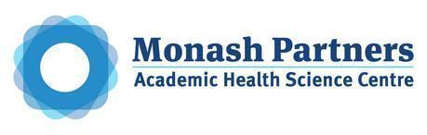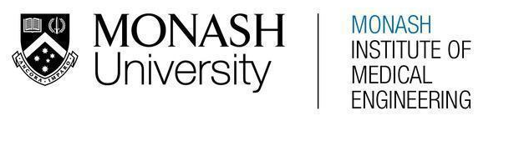
MONASH HEALTHCARE INNOVATION SUMMER SCHOLARSHIPS (HISS)
PROJECT NAME: EBOARD
DELIVERABLES NUMBER: 8 (Week 9)
PROJECT MEMBER(S): SAHIL BHATIA, MARIA ZARCO-VERA, LLOYD LOK

Gantt chart:

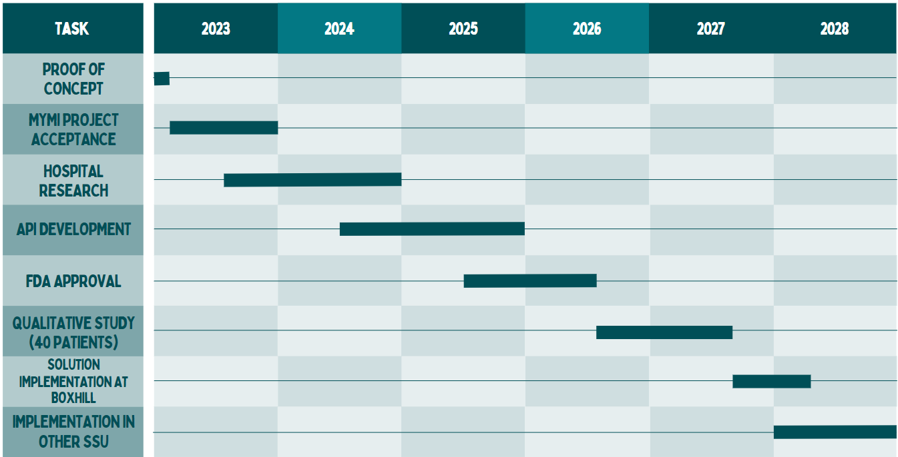

Patent search outcomes:

Non applicable.

Prototyping progress:

The meeting with Paul helped manage expectations as there are only 3 weeks left of HISS. It was discussed that this project has the potential for implementation in SSU but an extended research project would be necessary. Therefore, these weeks will be important in solidifying the proof of concept so that the pitch is successful and the work can be continued as a MYMI project. In week 10, we will begin investigating how, Python, Figma Wireframes and APIs can be incorporated in displaying EMR information in a different form for patients which will aid when pitching the solution. Once it becomes a MYMI project, the following 12 months will focus on research from hospital settings, to understand what specific information is required by patients in SSU, and this will be used to further develop a code that links the EMR to a program. Beyond this first year, as the solution is developed and ready for testing, approval from FDA will be required. If approval for the solution is successful, a qualitative study with 40 patients will take place and then the solution may be implemented into hospitals, stating with Boxhill Hospital.

