Project Relay – Onboarding Information
TEAM & CONTACTS
Project lead: Maria Zarco-Vera mariazarco02@gmail.com
Clinical Champion: Mark Voskoboynik M.Voskoboynik@alfred.org.au
Cancer Trials Research Manager: Christine Brooks chr.brooks@alfred.org.au
Project Officer for Outpatient Mail: Evan Kittelty E.Kittelty@alfred.org.au
Ambulatory Cancer Services Manager: Ellen Heywood E.Heywood@alfred.org.au
Team Leader, Early Phase Medical Oncology Research: Nikki Byrne ni.byrne@alfred.org.au
Trial Coordinator, Early Phase Medical Oncology Research: Rachel Borg ra.borg@alfred.org.au
Clinical Trial Assistant- Admin: Neethu Namia N.Namia@alfred.org.au
BACKGROUND
Oncology clinical trials are defined as complex due to the nature of the designs, conduction, analyses and reporting. A key element of these trials is the appointment system. At the Department of Medical Oncology at The Alfred, complex oncology clinical trials have two types of appointments with their respective systems. There are doctor appointments and “trial related” appointments. Doctor appointments are booked by coordinators through Cerner and then these automatically appear on the Patient Portal. On the other hand, trial related appointments (for a couple of months) are handwritten on a yellow card, as shown below. It is very hard to reschedule appointments through Cerner and is described as “archaic”, hence coordinators opted for the hard copy card.
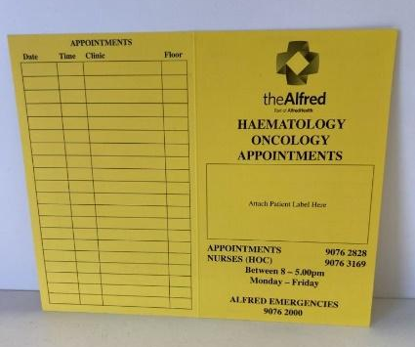
Figure 1. Yellow card
The benefits of this system is that if one appointment is missed and subsequently the others get cancelled, then the patient can get a new yellow card rather than manually rescheduling all appointments through Cerner. However, this system raises issues if the patient is forgetful and forgets which card to follow, or if they lose the card. Additionally, the card does not have an automatic notification system like the patient portal does, thus it relies on the coordinators keeping track of the patients coming and of the reminders.

THE NEED
Trial coordinators will spend at least 10 hours a fortnight rescheduling the missed appointments and almost half a million dollars will be lost a year in Victoria due to inefficiencies in clinical trials in Victoria. This 25% of healthcare budget in Australia, can be better spent. Therefore, project Relay aims to improve communication between patients, carers and trial coordinators in complex oncology clinical trials.
SOLUTIONS
It is worth noting that other centres like The Royal Melbourne Hospital, The Peter McCallum Cancer Centre and The Royal Women’s Hospital use an app called HealthHub which allows for appointments to be rescheduled in an easier manner. However, this app falls under Epic which is a competitor of Cerner so it would not be possible to implement it at The Alfred.
Examples like that of the Parkville hospitals highlighted that the best solution would be one that could be easily integrated with the existing system, that is: Cerner. Additionally, this was reinforced after speaking with Evan Kittelty who is the Project Officer for Outpatient Mail. Evan also introduced the idea behind the solution that project Relay is proposing – Cerner’s PowerChart Oncology.
Cerner PowerChart Oncology is a comprehensive oncology specific EHR. As it is already part of Cerner, trial related appointments would automatically show on the patient portal, hence fitting in the clinical workflow. Additionally, The Alfred already holds the digital/structural skeleton of Cerner so the clinical adoption strategy would be more in regards to adopting the new features of the Oncology EHR. The hard copy yellow card would be dismissed thus decreasing the number of appointments missed. Additionally, the coordinators would share the workload with the Patient Portal in regards to rescheduling appointments.
Powerchart Oncology features a series of new tools in Cerner:
- Ability to plan multiple cycles of treatment for a patient at one time
- Treatment order sets available on chemotherapy day
- Integration of Chemotherapy Order Templates
I believe that these would be capable of replacing the yellow card as well as facilitate the work of clinical trial coordinators. However, it must be noted that I have not been able to speak with a clinician who has worked with this program yet and information online is limited. As well, the efficiency of this new system at The Alfred will be heavily linked with the related training undertaken by the trial coordinators.
Evan mentioned that Ellen Heywood, the Ambulatory Cancer Services Manager, is pushing for this service to be implemented at The Alfred. Therefore, I advise that moving forward communication should be established between Ellen and the Medical Oncology team, so as to discuss the timeline of implementation as well as assess if this new service will meet the trial related needs.

