Project EBoard is attempting to build a digital bridge that directly connects patients to a summary of their EMR data. The below drawing demonstrates what this potential solution may look like.

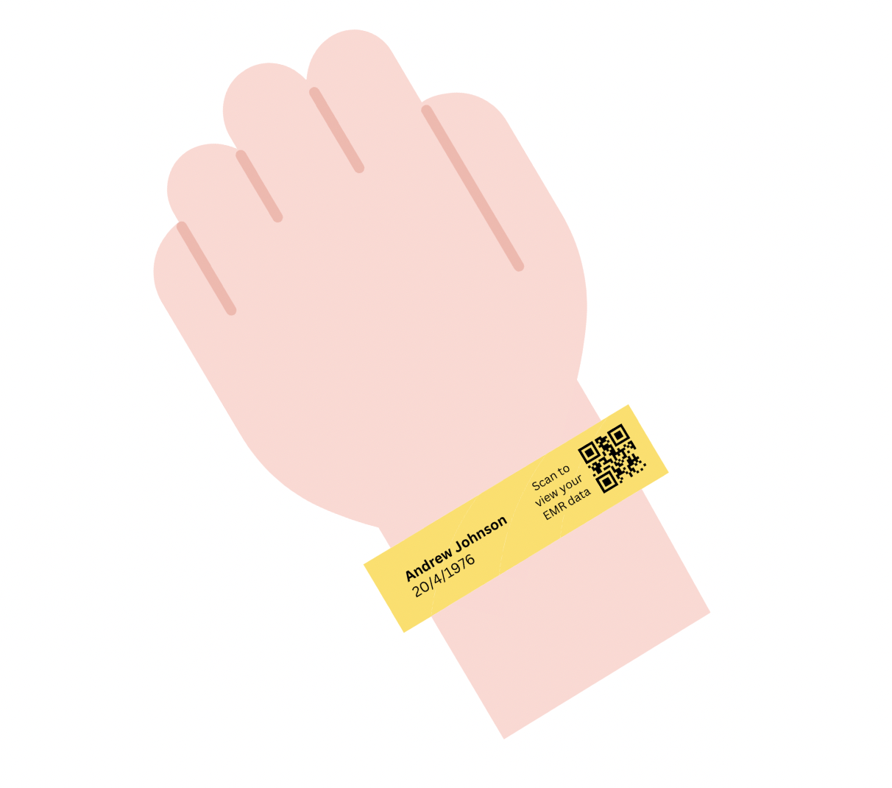
The problem posed is two-sided, affecting both patients and healthcare workers.

Patients are concerned about the details of their stay, including who is on their treating team, what their schedule is like for the day and what medications they are allowed to take. Physicians and nurses, due to the overwhelming nature of the emergency department, are unable to respond to all questions posed by patients. Ultimately, affecting both the patient and physician experience.

For new team members joining project EBoard, there are a few assumptions that need to be validated moving forward:

- What information patients would like to know that the EMR data shows (determining the “common questions” that patients have);
- What information do physicians and nurses want to give patients, but can’t due to time constraints.

There are several problems however that have been raised that also need to be addressed during the second half of the HISS program.

- From a project point of view, the project is possibly a solution in search of a problem, as opposed to a problem that requires a solution. This is because, whilst patients do want a quality patient experience, this is mostly related to communication with the treating team as a means of ensuring their care is of utmost priority as opposed to simply wanting to know what’s on their EMR.
- Furthermore, if patients were to access their EMR data, there is a possibility they may have even more questions to ask clinicians and nurses - such as explaining the information to them or reading it out loud to them. This may lead to further time being consumed, which defeats the purpose of a QR code system which is supposed to save time.
- It may be unlikely that this is a scalable solution as many healthcare networks may be hesitant to allow patients to access to their EMR data - medicolegal issues were mentioned by one clinician at Monash Health during the Week 7 pitches and, in order to protect their own interests, hospitals may be unwilling to integrate such a system which could work in contrary to its initial intentions.

Key Contacts:

Dr Paul Buntine (Clinical Champion) - paul.buntine@monash.edu
Dr Paul Buntine is an emergency physician at Boxhill Hospital. He is the clinical champion for project EBoard and should be the first point of contact for any questions and requests to shadow him in the emergency department.

Sahil Bhatia (Student) - sbha0045@student.monash.edu

Link to Report: https://drive.google.com/file/d/1eGYKo0faBpDXzrl5i9kLaVuJ6Xq-k38P/view?usp=sharing
Link to Pitch PPT: https://docs.google.com/presentation/d/1b93HVRRkw8az5WpUV5OYKe4i1LnAsZE9/edit?usp=sharing&ouid=109821682467348116310&rtpof=true&sd=true

