
MONASH HEALTHCARE INNOVATION SUMMER SCHOLARSHIPS (HISS)
PROJECT NAME: Project Activus
DELIVERABLES NUMBER: 7
PROJECT LEAD: David Cheng

Prompt:
Can you piece together existing solutions to look like what you are proposing? How much is it? Links to everything? Show this to your clinician - is a novel solution required or do the existing software/hardware make it for a good price (pedal thing, magnet attachment that counts pedals, strava/heart rate monitor on wearables - watch)

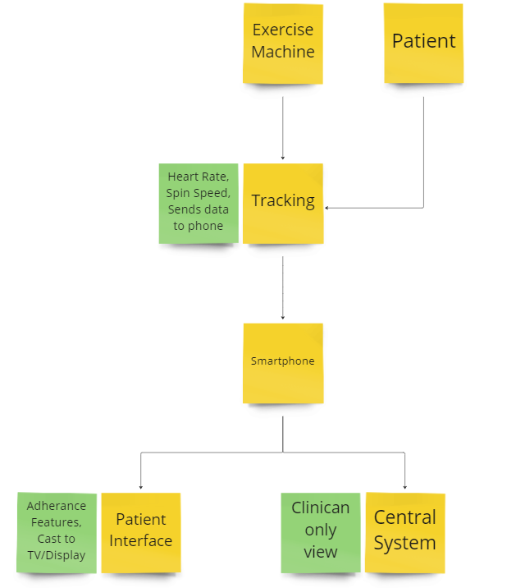
Figure 1 (Above): Diagram of all the different components that needs to fit and link together for the proposed solution.

Acceptance criteria:
SS: Tracks workout (spin speed) - Smartphone App, Fitness trackers, Group monitoring
HR: Tracks workout (heart rate) - Smartphone App, Fitness trackers, Group monitoring
PH: Sends workout data to phone automatically - Fitness trackers
CS: Sends workout data to a central system automatically - Smartphone App
AD: Includes adherence features such as a game function/community system/class - Smartphone App
CA: Can cast/display patient interface onto a TV or larger display - Smartphone App

Smartphone Apps on the market (SS, HR, CS, AD, CA)
Title | Image | Adherence | Link
Indoor Cycling Workouts: Spin | 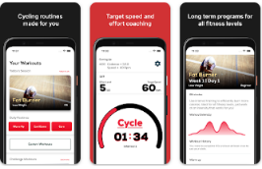 | SS, HR, | https://play.google.com/store/apps/details?id=fitness.vigour.biketrainer
Peleton - Fitness and workouts  $16.99/month | 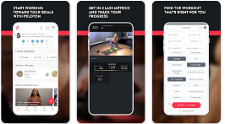 | SS, HR, CA, AD | https://play.google.com/store/apps/details?id=com.onepeloton.callisto
Track my indoor workout | 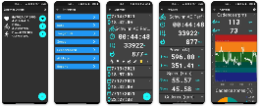 | SS, HR, | https://play.google.com/store/apps/details?id=dev.csaba.track_my_indoor_exercise
Strava | 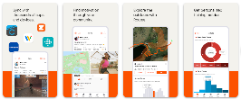 | SS, HR, | https://play.google.com/store/apps/details?id=com.strava
BodyBike | 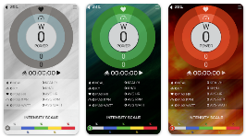 | SS, HR | https://play.google.com/store/apps/details?id=com.bodybike.bbsmartplus
Arcade fitness, Indoor cycling - free | 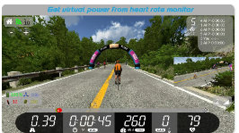 | SS, HR, CS, AD | https://play.google.com/store/apps/details?id=com.bipr.arcade.running
Rouvy  $103/Year | 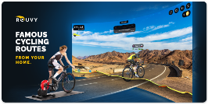 | SS,HR, AD | https://play.google.com/store/apps/details?id=eu.virtualtraining.rouvy.android
KinoMap  $103/Year | 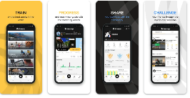 | SS, HR, CS, AD, CA | https://play.google.com/store/search?q=Kinomap&c=apps
Zwift  $15USD/month |  | SS, HR, CS, AD, CA | https://us.zwift.com/

Fitness Trackers (SS, HR, PH)
Title | Image | Comments | Link
Wahoo RPM cycling Cadence sensor  $57.95 | 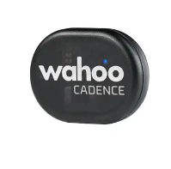 | SS, PH | https://au.wahoofitness.com/devices/bike-sensors/wahoo-rpm-cadence-sensor
Kogan Active + II Smart watch  $65 | 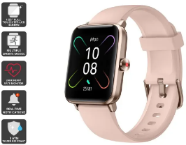 | HR, PH | https://www.kogan.com/au/buy/kogan-active-ii-smart-watch-rose-gold-kogan/
Kogan Alex Built in Smart Band  $15 | 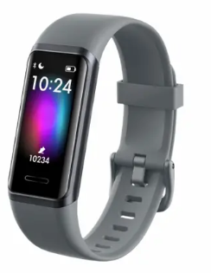 | HR, PH (manual?) | https://www.kogan.com/au/buy/kogan-alexa-built-in-smart-watch-band-arctic-grey-kogan/
Polar Verity Optical Heart Rate Sensor  $129 | 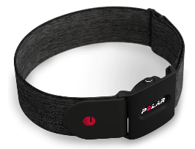 | HR, PH | https://www.jbhifi.com.au/products/polar-verity-optical-heart-rate-sensor
COOSPO Heart Rate Monitor, Bluetooth, ANT+  $32 | 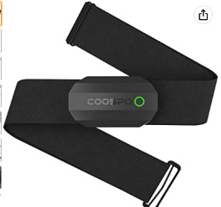 | HR,PH | https://www.amazon.com/CooSpo-Fitness-Tracker-Waterproof-Bluetooth/dp/B07R8741CN/ref=as_li_ss_tl?crid=2H9WSQNCQBY1S&dchild=1&keywords=bluetooth+heart+rate+monitor&qid=1586963657&sprefix=bluetooth+heart+rate+m,aps,174&sr=8-15&linkCode=sl1&tag=kateheavy-20&linkId=dc6ea0ee82d4554c3f46ed058f6661eb&language=en_US

Group Management Software (SS, HR)
Title | Image | Comments | Link
Strava  Free with premium | 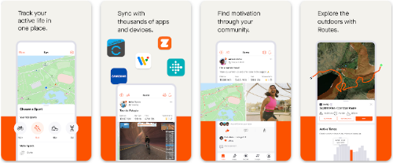 | SS, HR. | https://play.google.com/store/apps/details?id=com.strava&hl=en_AU&gl=US
Performance IQ by ClubReady  Price unknown (needs consultation) | 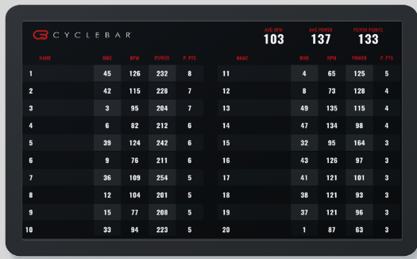 | SS,HR | https://www.clubready.club/performance-display-power-training
Motosumo  Free | 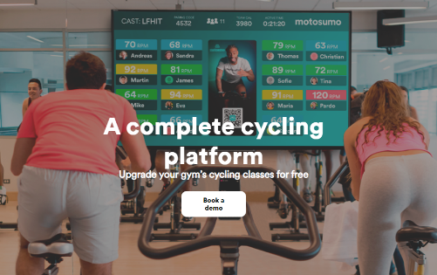 | SS, CS | https://www.motosumo.com/gym-solution
RGT Cycling (Wahoo X) $12.42 USD/month  (Also a smartphone App) | 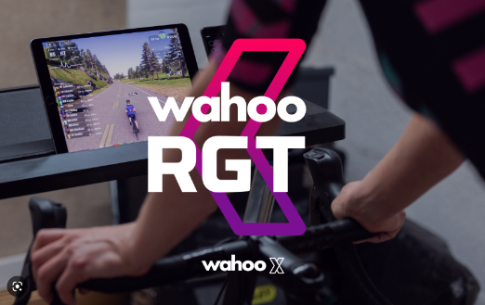 | SS, CS | https://www.rgtcycling.com/

Software Discussion:
There are many great apps that already exist on the market. Some solutions such as KinoMap and Zwift allow users to join a private group, and ride in an interactive way. The main barrier with these kinds of solutions are that they may not be suited for the elderly population and that other adherence features such as a feature where riders will be able to ride with one another may not be possible. Additionally, group monitoring integration for clinicians seems to be through Strava – meaning data from patients may be visible to the rest of the renal unit. Alternatively, RGT cycling through Wahoo X appears to be a more cohesive system but may be geared towards a more vigorous exercise program. All of these solutions cost a substantial amount of money, however, which while may be fine for a pilot study, does not represent a viable long term solution for the project.

Note on adherence validation:
Long term exercise adherence is an ongoing area of research with evidence regarding the effectiveness of strategies to promote adherence to exercise routines largely inconclusive. Unfortunately, patients on haemodialysis are more likely to drop out of an exercise program compared to the general population due to fatigue, lack of energy, or morbid health conditions [1]. Additionally, patients on haemodialysis that would be the largest beneficiaries of an exercise program are older patients who may have accumulated more time being sedentary. Modifiable factors associated with exercise adherence among older adults are listed below:

Knowledge about exercise.
The understanding of health, fitness, and exercise practices does not seem to have a direct effect on middle-aged and younger adults' adherence to physical activity [2]. However, knowledge about exercise has been linked to predicting the involvement and commitment to a structured exercise program among elderly people [2]. Knowledge can also be significant when beginning to exercise [2]. Additionally, proper exercise behaviour such as the correct technique, intensity, and necessary equipment for particular activities could be imperative for elderly people to stay on their exercise program and reduce the risk of injury while enjoying the activity [2].

Social Support
Retrospective self-report studies have consistently shown that perceived social support is a key factor in the elderly's adherence to exercise [2]. Additionally, it has been found that non-kin social support is essential for elderly people to begin exercising, according to the findings of a survey of 6780 senior citizens aged 70 and over [2]. Survey research shows that physicians' opinions have a substantial effect on the elderly, particularly when compared to younger people [2].

Activity Enjoyment
It is important to consider the type and nature of exercise when attempting to increase adherence - as choice over activity, enjoyment, and the level of exertion has all been shown to improve adherence [2]. Furthermore, enjoyment of the exercise programme has been identified as a key determinant of short- and long-term adherence among younger and middle-aged adults [2]. Consequently, to maximise adherence in the elderly population, a variety of activities that are relatively low-exertion and highly enjoyable should be available. Gamification is an example of a method that demonstrates overall positive psychological outcomes as well as behavioural ones regarding exercise [3].

References:
- Hannan M, Bronas UG. Barriers to exercise for patients with renal disease: An integrative review. Journal of Nephrology. 2017;30(6):729–41.
- Matallaoui A, Koivisto J, Hamari J, Zarnekow R. How effective is ðexergamificationó? A systematic review on the effectiveness of gamification features in Exergames. Proceedings of the 50th Hawaii International Conference on System Sciences (2017). 2017;
- Rhodes RE, Martin AD, Taunton JE, Rhodes EC, Donnelly M, Elliot J. Factors associated with exercise adherence among older adults. Sports Medicine. 1999;28(6):397–411.

