
MONASH HEALTHCARE INNOVATION SUMMER SCHOLARSHIPS (HISS)
PROJECT NAME: Project Blooming
DELIVERABLES NUMBER: 6
PROJECT LEAD: Jacinta Patel
Summary
There is numerous tape measure app that were all like 1 and 2. Listed here are 15 free IOS apps that consist of tape measure, 3D, Lidar, and podiatry apps. I have also included the competitor, Breast-V to the list. I deemed 3D apps such as (14) Scaniverse and useful (13) SiteScape as not only did they give 3D models that was very realistic but also had useable features to do linear measurements on the app. I also liked (3) Verifyt very much as it has an easy and good-looking interface with clear instructions. (4) NAKED considers changes over time by recommending scanning regularly, considers gender (transwomen) and creates graphs to track and visualise your metrics.

- Apple's "Measure" app
About: Free utility app
Features: You point camera at something and then pin it and drag the line to the second point.
Output: Linear measurements - measures in inches or cm. No shape or size and no surface area, volume. Can do multiple linear measurements at the same time but in one dimension this not good for breasts.
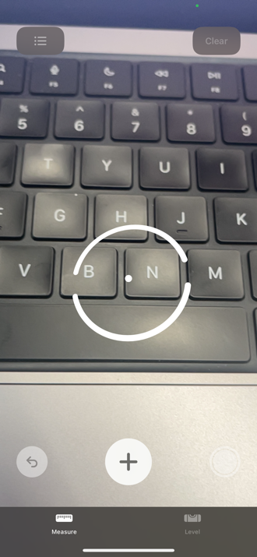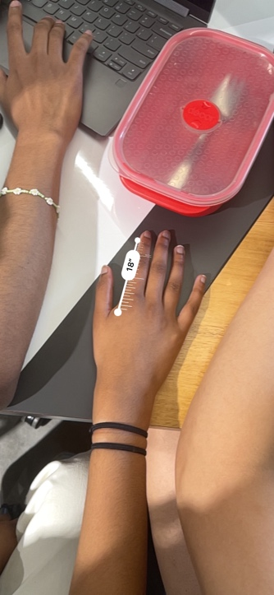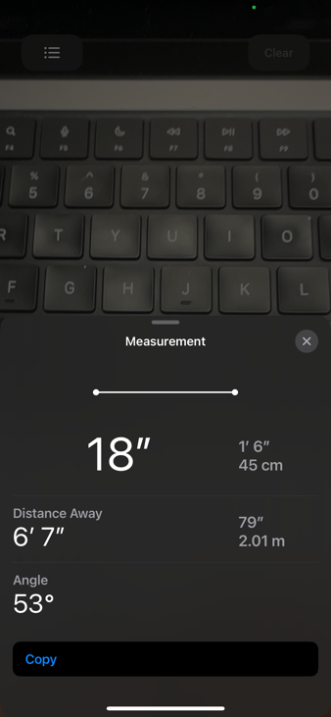

- “Tape measure “
About: Free utility app
Feature: Has point + shoot ruler, angles, and height settings though all difficult to use as your hands need to be still.
Output: Measures in inches and measures angles and hard to be accurate unless you have a camera stand. Only linear measurements.
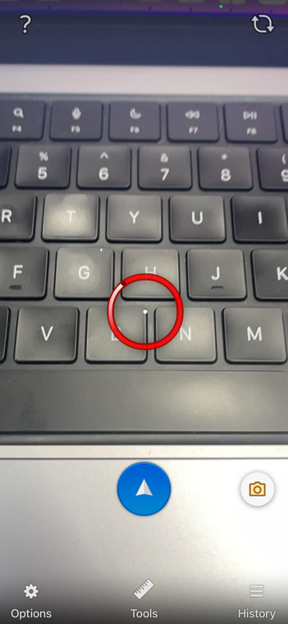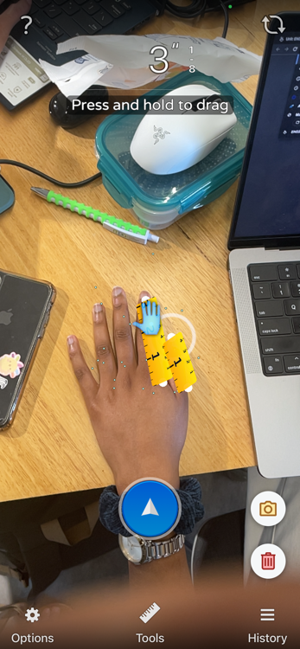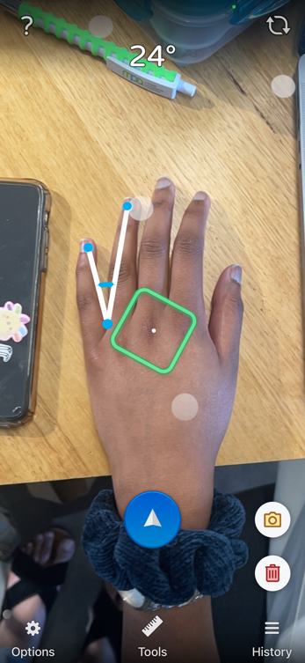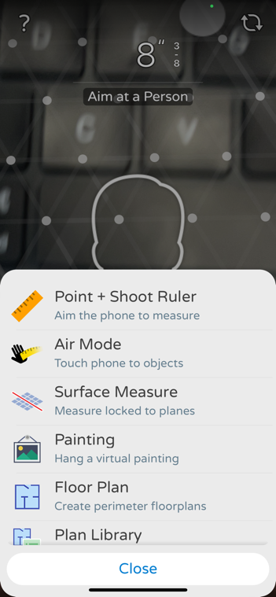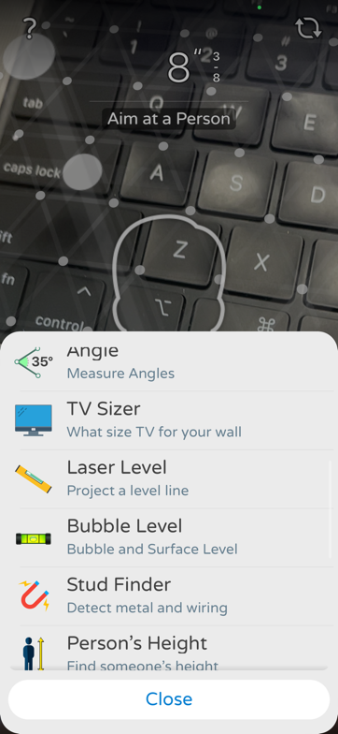

- Verifyt
About: Free ‘shopping’ app
Feature: Has good security as it uses terms and conditions, security code through text and sign in. Does full body and feet’s scans. Has good and clear spoken instructions with an illustrated tutorial. Talks about factors (environmental and clothing guidelines) that could affect measurements. This app is meant to find oyur size and fit your favourite brands.
Output: Measurements in inches or cm. Has bust and under bust metrics which are relevant measures to this project

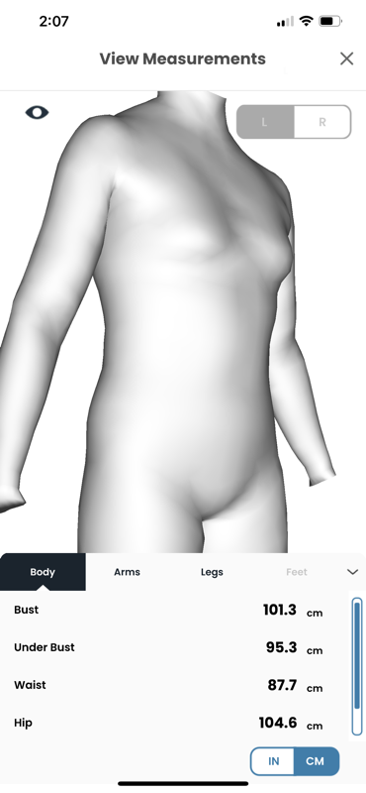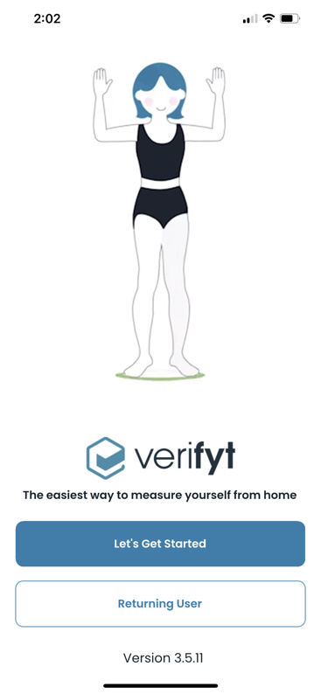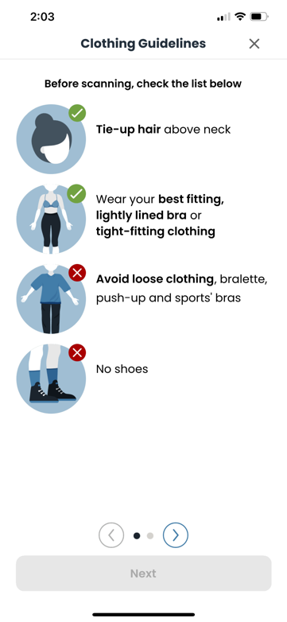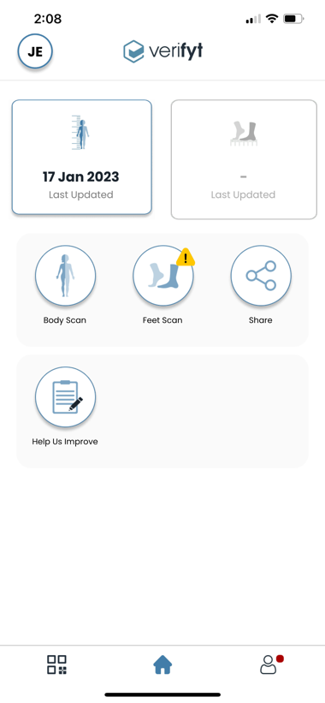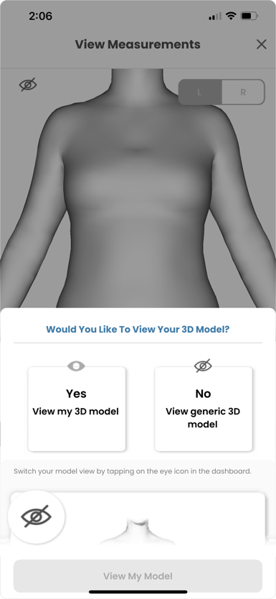

- NAKED - 3D home body scanner
About: App itself is free to download but an external tool is needed with Bluetooth connection called “NAKED BOX” which costs $1,395 US.
Feature: Talks about clothing environmental effects of scans such as loose clothes and hair. When filling information out they do ask about your height, gender (including trans women) and race. 18+, cares about privacy and security so you keep the data and not them unless you agree so.
Output: They recommend scanning weekly to minimise noise and show progressions. Takes into account body fat percentage, lean mass, fat mass and ratios with side by side comparisons of your body. It also has graphs to track and visualise your metrics.

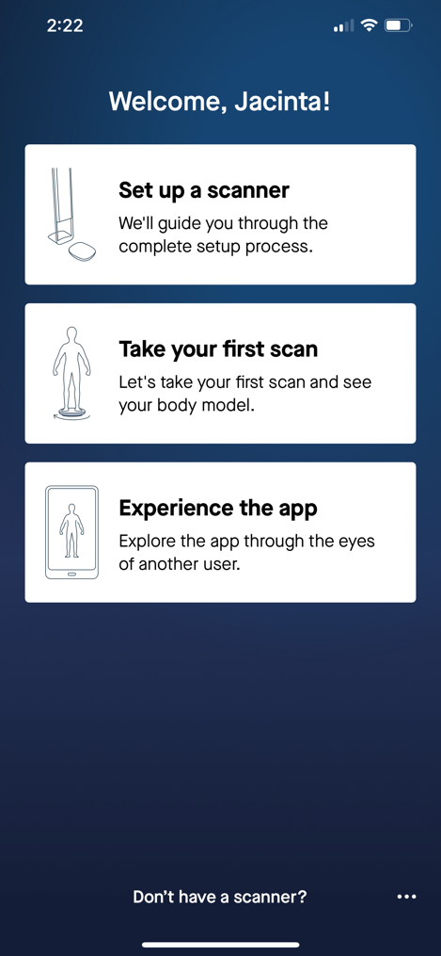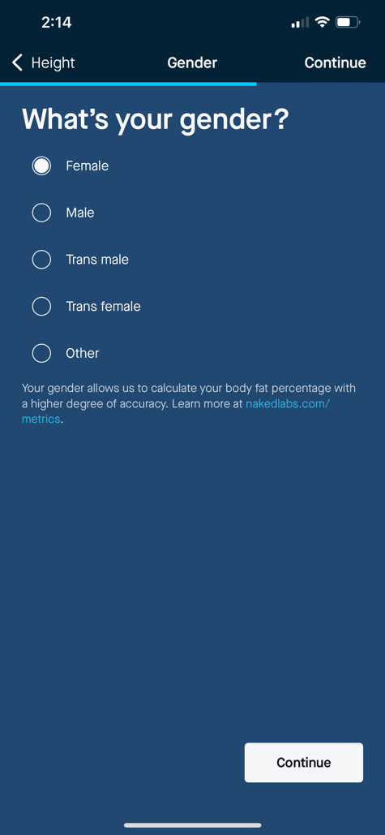

- NetteloPro
About: Special sign in so not everyone can use it. Free lifestyle app.
Feature: Takes a single post Infront of the camera creates 3D avatar with measurements. Able to share 3D avatar.
Output: Able to find your clothing size. Track how body changes overtime or compare 2 different bodies by side-by-side comparison, morphing animation, and dimension comparisons.

- BodyID – Your virtual tailor
About: Free health and fitness app.
Feature: Takes pictures of front and side profiles. Asks about height and weight. Manually calibrate where each point of body is which takes a long time. Simple with instructions voiced tutorials. Talked about environmental and clothing factors. Only sign in required.
Output: Measures the width across of your chest in cm only. Linear measurements only.

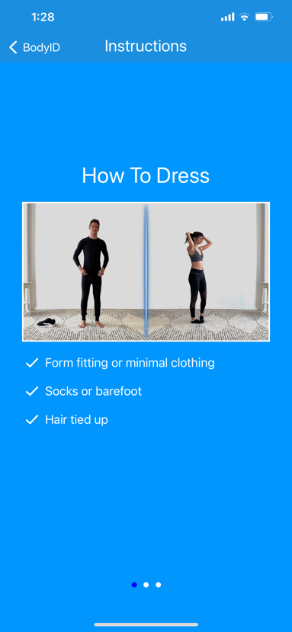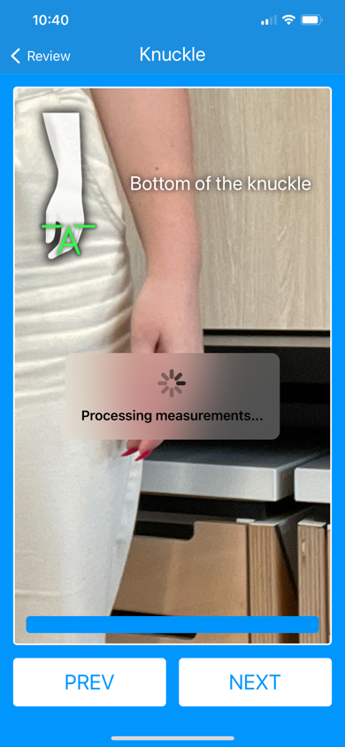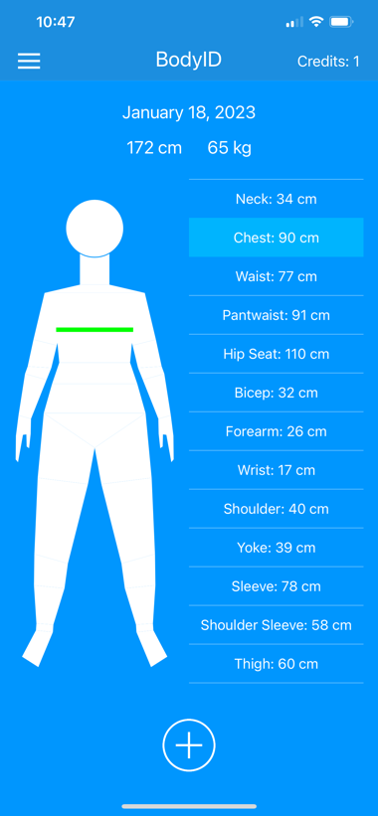
- MeThreeSixty
About: free health and fitness.
Feature: Sign in and email activation. Asks about height and weight. Voiced instructions with guidelines – red and green for wrong or correct. Takes front and side facing shots. Talks about clothing and environmental factors.
Output: Generates a 3D figure that is not so accurate. Outputs chest in cm
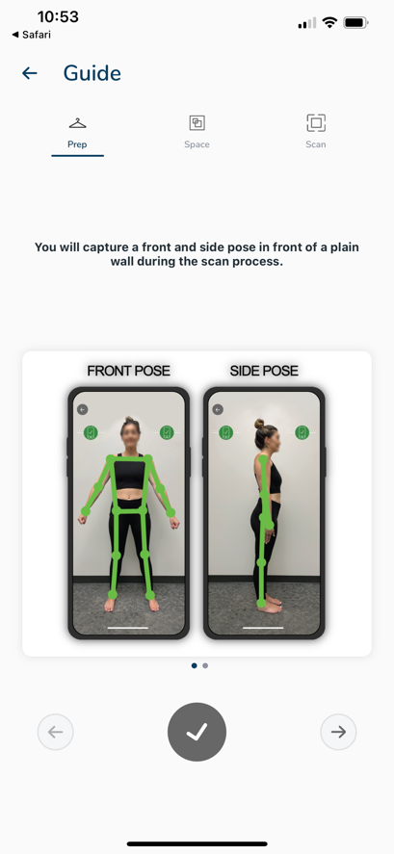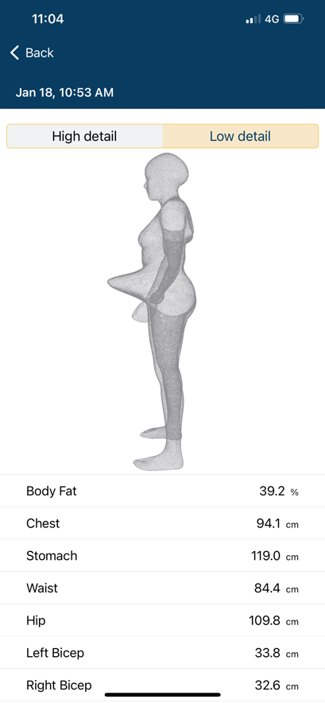

- Bodymapp
About: Free health and fitness app.
Feature: Visualise your body in 3D. Sign in required. Assisted voiced tutorial and a real video tutorial. Scans front, back and sides shots. Processing scan takes a good long time.
Output: -Measures across chest in inches and has ability to compare scans and metrics over time. Scan metrics for chest width in cm. In-app purchase for more measurement metrics. Able to compare old and new scans.
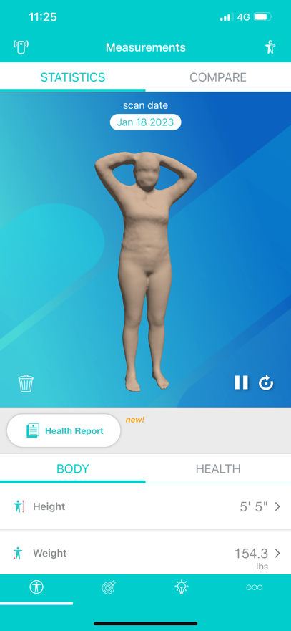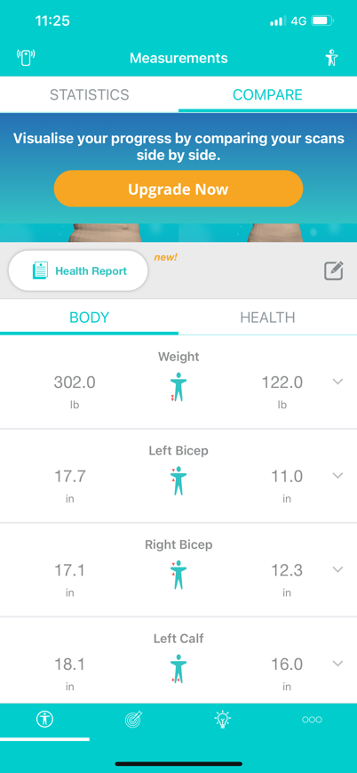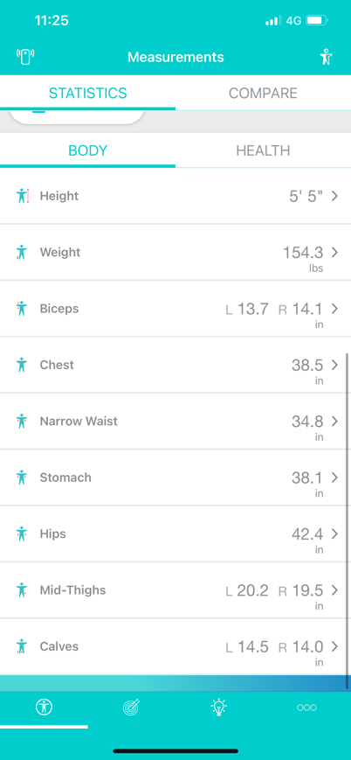

- Gespodo Footscan 3D
About: Free health and fitness app for podiatry
Feature: Special sign in
Output: Translate therapeutic choices and the device plan for design and 3-D manufacturing of custom-made insoles.

- Breast-V (competitor)
About: Free medical app used for research.
Feature: Measures anatomical pinpoints and output one measurement
Output: Breast Volume (cc/gr)
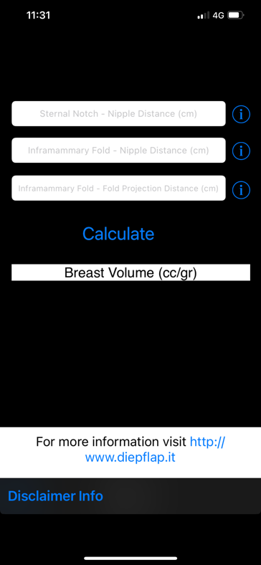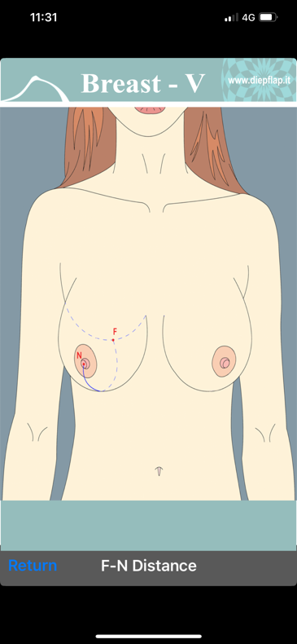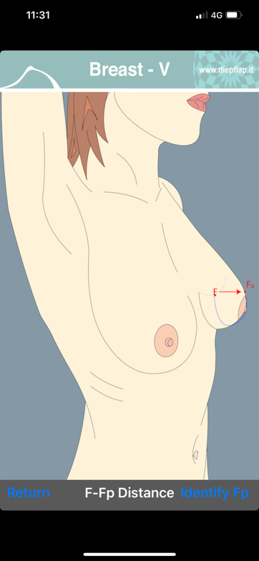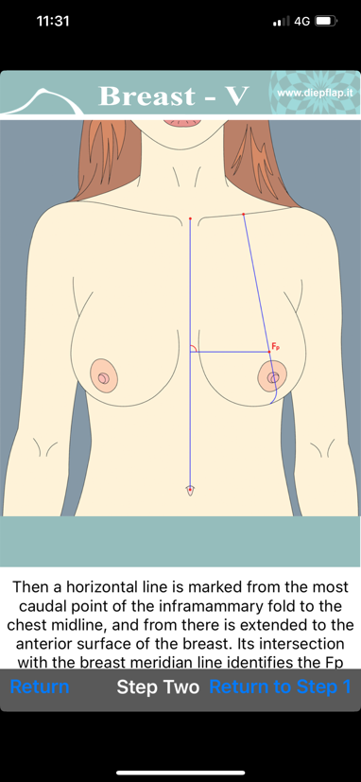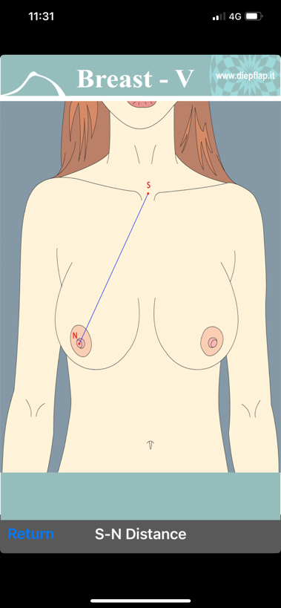

- KevinRoot Medical
About: Free and is categorised as medical app. Podiatry app that uses clinicians and patient information
Feature: Need an external Bluetooth website
Output: 3D scan – collects point clouds, et of data points in space of patient’s feet which is converted to mesh modules through surface reconstruction
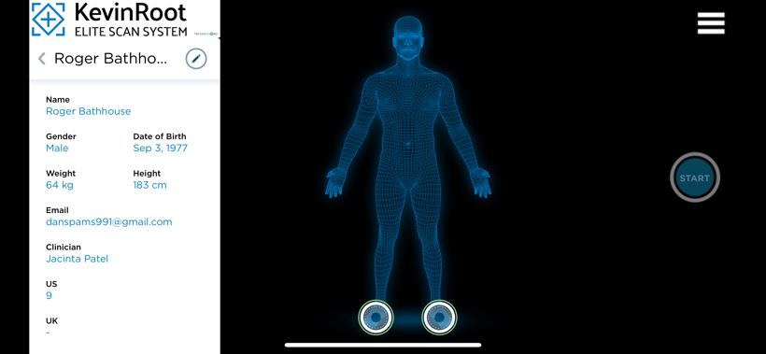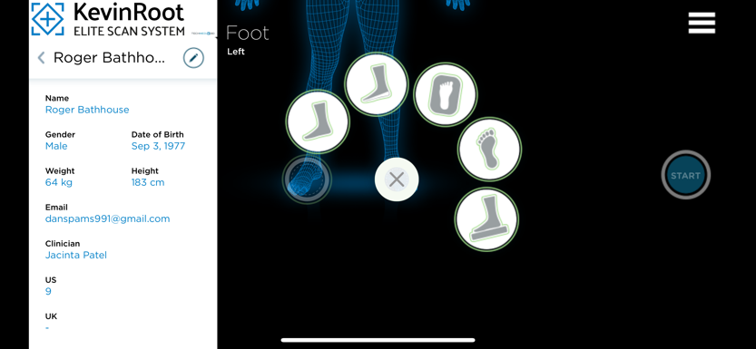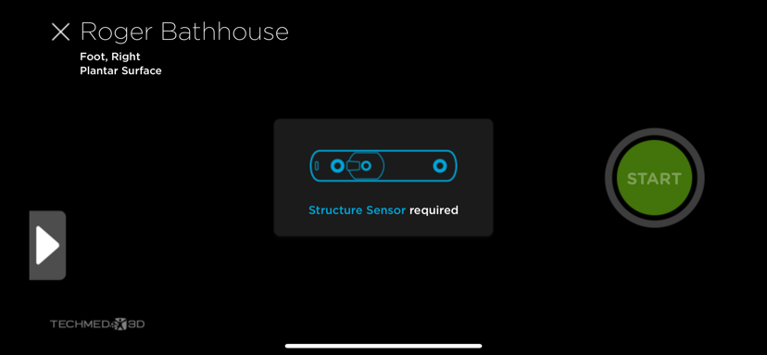

- Arkad Scan
About: free medical app for - 3D Podiatry app that uses clinicians and patient information
Feature: Needs a structure sensor – external Bluetooth device. Used in iPhone X or later. Created by TechMed 3D –Becker orthopaedic 3D, smart cast, 3Dit Medical, Medlix, foot health 3D, Thuasne3D Scan. 3DsizeME can scan bust when combined with Structure Sensor
Output: Digitize different imprints taking and has a ergonomic and intuitive interface to make 3D scans on IPADS. Scans in less than 20 seconds

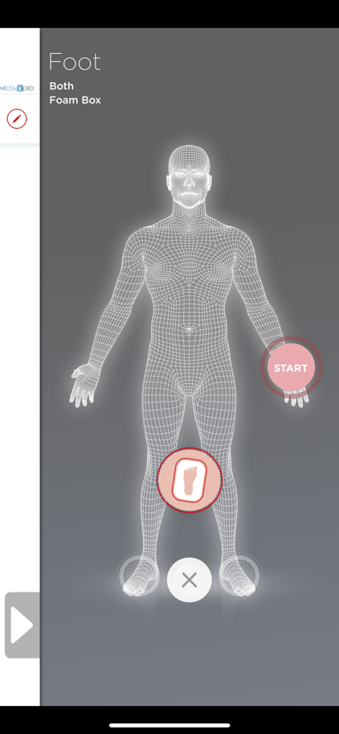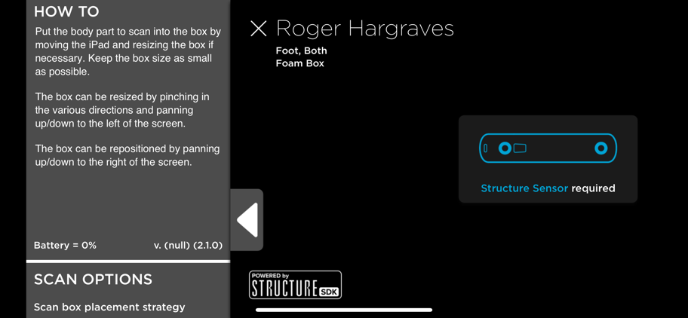

- SiteScape – LiDAR 3D scanner
About: A free utility app for 3D modelling of furniture, for architecture, engineering, and construction
Feature: Target object and dots with develop as you scan and walk around it. Saves Scan and has ability to share through files. Scans are a bit blurry
Output: A 3D scan that can be saved. Not any other features.
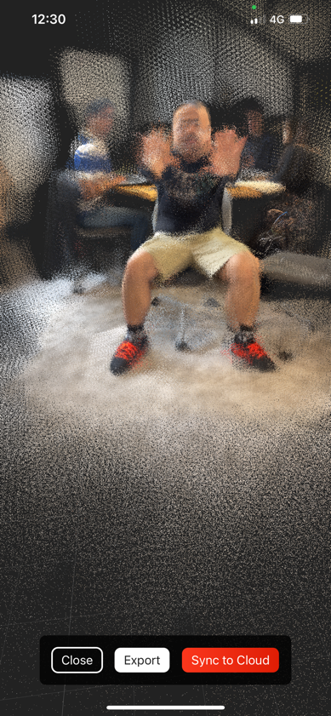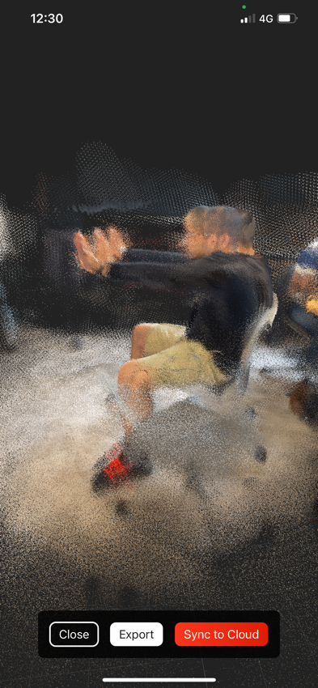

- Scaniverse - 3D Scanner
About: Free photo and video app and can be used on all iPhone and iPad even without LiDAR
Feature: Can be saved to files and shared. Can be viewed in AR or 3D on any device
Output: Uses photogrammetry to reconstruct objects and using Lidar, delivers a higher level of accuracy. Also takes linear measurements using scan
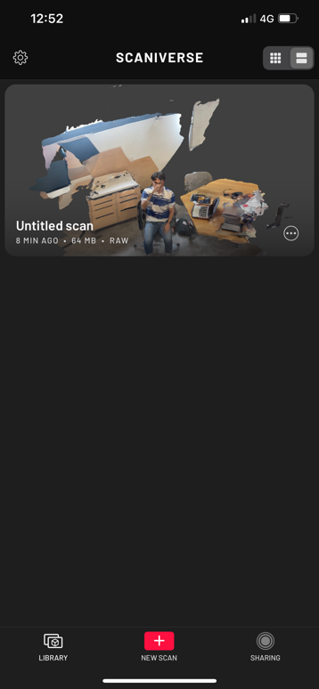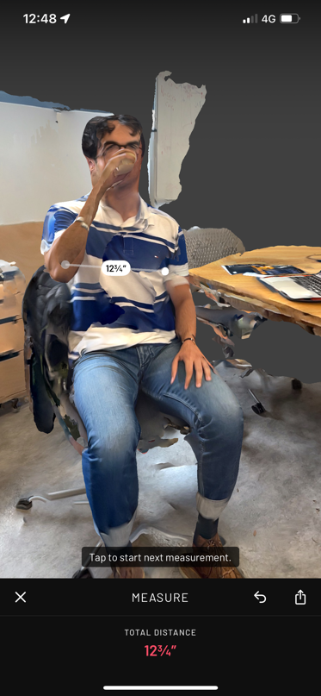

- EM3D: Ethan makes 3D scanner
- Free app
- Scans 3D but does not have any other features.
- Looks pretty accurate looking and not so messed up. Creates a full colour 360-degree selfie and captures it in 3Dthat can be exported. Supports Bluetooth shutter buttons for 3D scanning on tripod.
