
MONASH HEALTHCARE INNOVATION SUMMER SCHOLARSHIPS (HISS)
PROJECT NAME: Project Blooming
DELIVERABLES NUMBER: 6.2
PROJECT LEAD: Jacinta Patel
Augmented reality (AR) - an interactive experience that combines the real world and computer-generated content which can span multiple sensory modalities, including visual, auditory, haptic (sense of touch), somatosensory and olfactory. It is designed to add digital elements over real-world views with limited interaction

Key features:
It combines the digital and physical worlds, interactions made in real time, and accurate 3D identification of virtual and real objects.
https://dynamics.microsoft.com/en-us/mixed-reality/guides/what-is-augmented-reality-ar/

One of the practical uses of Augmented Reality (AR) is the AR Measuring application, which helps to measure the distance or length between any two points.
One thing to be noted here is that AR measuring gives a decent estimate measurement, and it should not be used for professional purposes but still it is fun to use. (Maybe we can try to overcome this)
For measuring any object, you just must aim the camera toward it and move from one point to another
https://www.cashify.in/top-5-augmented-reality-apps-for-android-and-ios

For shape we can make multiple doted lines around the object while size we can do multiple pictures by moving the phone around.

Files: gITF, GLB and USDZ
- glTF is a 3D file format maintained by the Khronos Group. It is an all-purpose transmission format, but it has been adopted by Google as the format of choice for Augmented Reality (AR) on Android's Scene Viewer.
- GLB is a binary container format of glTF. It bundles all the textures and mesh data into a single file.
- USDZ is a 3D file format created by Pixar. It has been adopted by Apple as their format for AR applications on iOS AR Quick Look.

3D data includes meshes, objects, vertex, polygon, animations, material information. There are options for texture resolutions. Each file type has their own technical limitations.

https://help.sketchfab.com/hc/en-us/articles/360046421631-glTF-GLB-and-USDZ

There are 2 types of augmented reality. Market-based AR using image recognition to identify objects already programmed into the device/app and marker-less AR that’s more complex as there’s no point in which your device will focus on and recognise items are they appear in view. The latter is compatible with the project as a recognition algorithm is used where the app will look for colour, patterns, and similar features to determine the object and then overlay an image.

Components: artificial intelligence (most times), AR software processing lenses and sensors
https://dynamics.microsoft.com/en-us/mixed-reality/guides/what-is-augmented-reality-ar/

Software developed are needed and are the backbone to programme and test the AR app. Then design and graphic engineer and project managers.
https://www.viewar.com/blog/professionals-involved-in-the-creation-of-augmented-reality/

Saudi Arabia, UAE and United States are the hotspots for Augmented Reality app consumers and tech start-ups.
https://www.tekrevol. com/blogs/how-to-build-an-augmented-reality-apps/

Cost
- A basic Augmented Reality app costs approx. $65,000.
- An intermediate-level AR app development cost range $70,000 – $130,000.
- Advanced AR applications with AI and ML functionalities cost more than $150,000.
- Factors: features, Development hours, Human resource, Hiring locations/people, Complexity of UI and UX design. Tools and technologies, frameworks, software development toolkits, Cloud services, Third party integrations and Database services
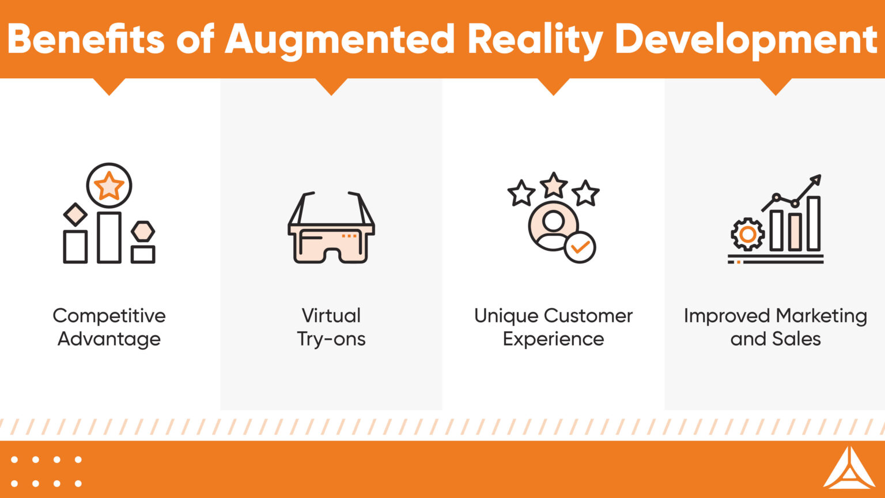
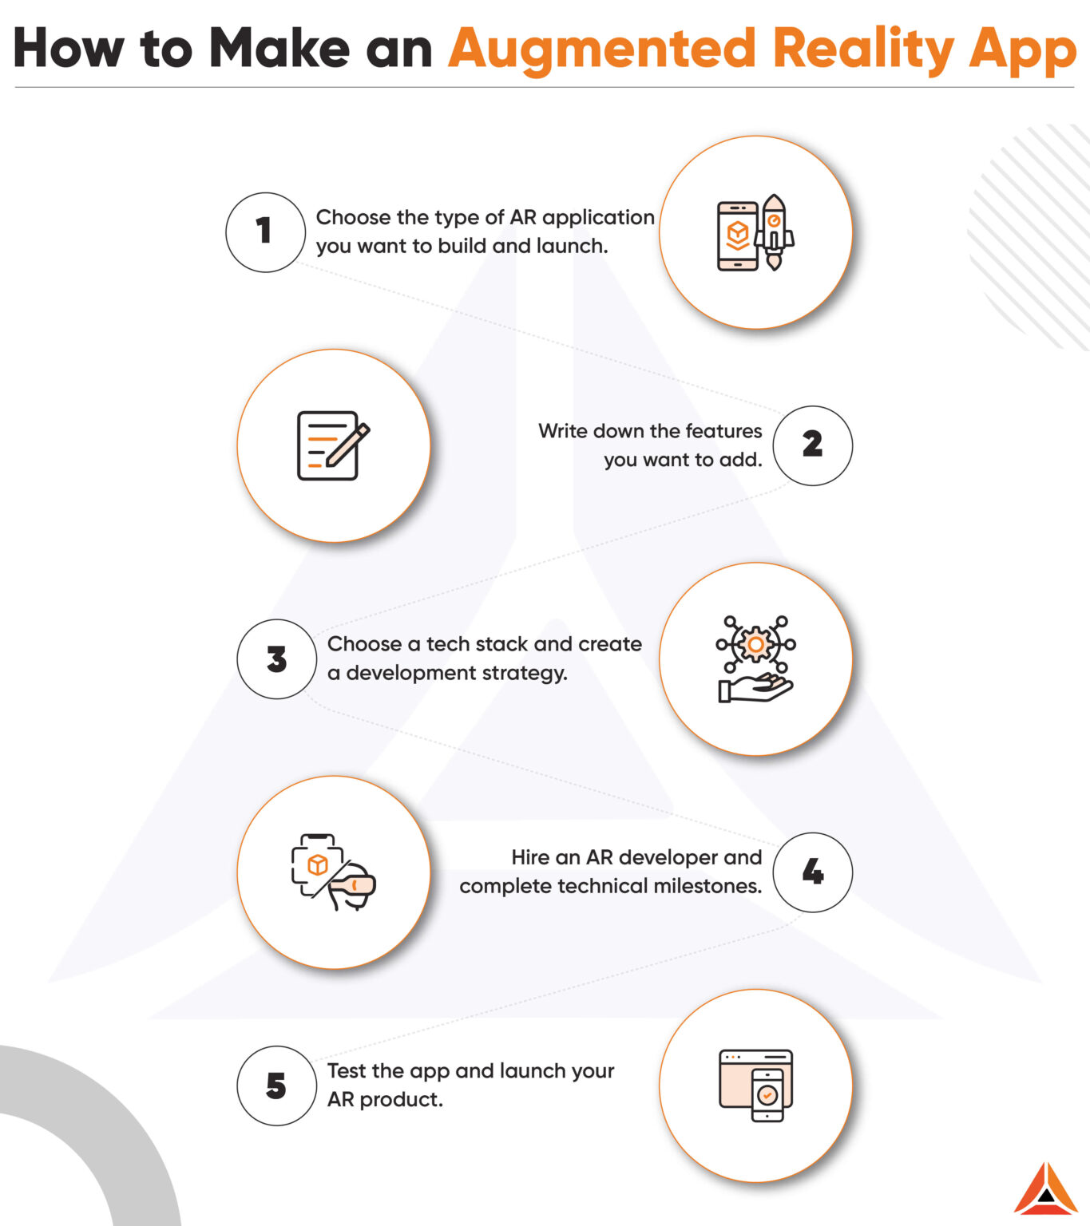
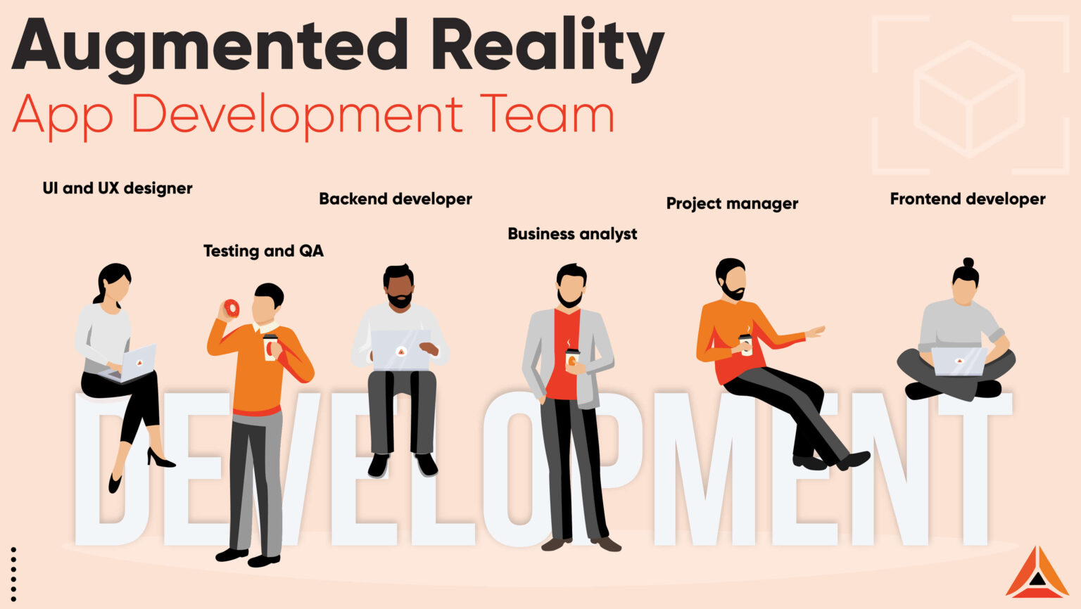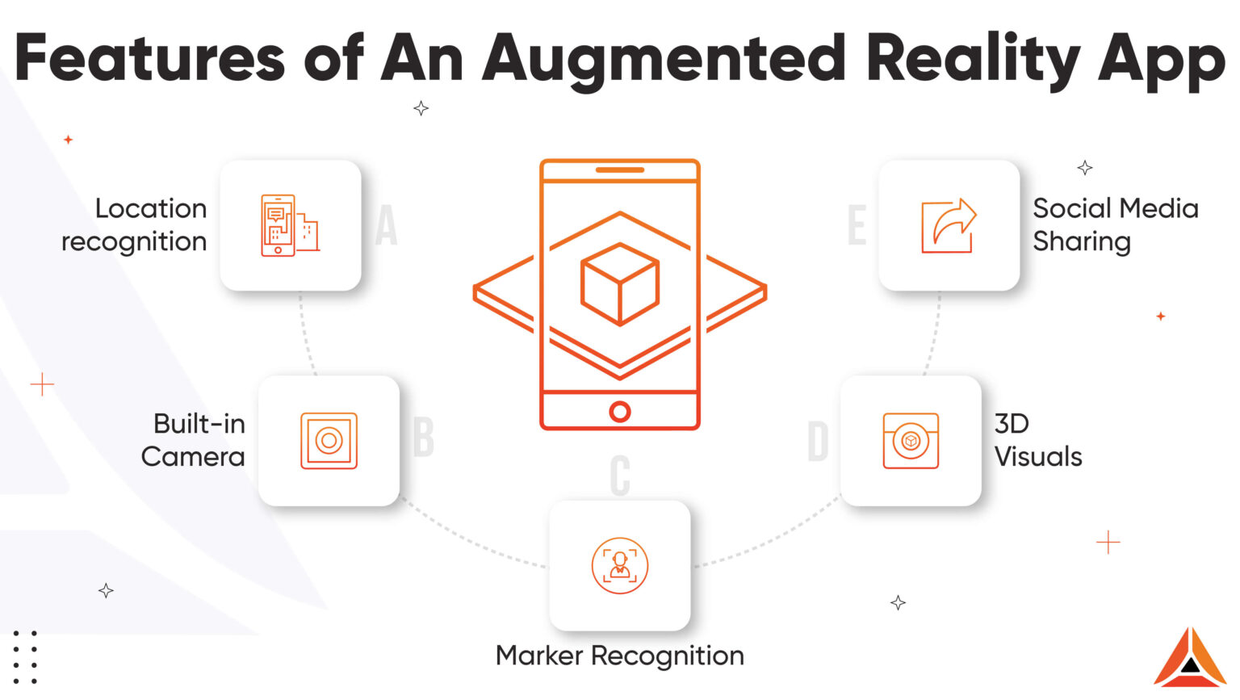
https://www.tekrevol.com/blogs/how-to-build-an-augmented-reality-apps/

