
MONASH HEALTHCARE INNOVATION SUMMER SCHOLARSHIPS (HISS)
PROJECT NAME: Sentinel
DELIVERABLES NUMBER: 5
PROJECT LEAD: Calvin Zheng, Diana Kovaleva
Proposed business model

Our current aim will be to use a fee per patient pricing model for our proposed solution.

Capitated fee model - set fee per patient, regardless of treatment
More beneficial for companies with broad product lines
Increased certainty in costs for customers → less money lost on difficult cases for the hospitals
May be difficult to incentivise customers to pay when fewer equipment is involved → should not be a problem in our case, since stroke is usually a multi-stage treatment program
Needs high IP protection/ barriers to entry to not be challenged by other businesses and other business models

Business model - cost
- How much would it cost to prototype?
Personal salary. Estimated $50/hr.

- How much would it cost to make a unit of the product?
Software, therefore cost per unit not applicable.

- How much would it cost to maintain a unit of the product?
Full time pay for a small team of developers.

- What are the other anticipated costs associated with the product? Consider regulatory, patenting, clinical trials, labour costs, etc
One time cost for medical device registration.
Patent fees
https://www.ipaustralia.gov.au/patents/timeframes-and-fees#fx-tabs-0-panel-2

Business model - revenue/reimbursement

- Who pays for it?

Will be paid by the hospital, with support from the government body.

The Commonwealth provides three types of funding for public hospitals (in addition to capital works funding):
- Activity Based Funding (ABF), which is based on the number and mix of patients a hospital treats, with the Independent Hospital Pricing Authority setting the price and the weight for each service type
- Block funding for certain public hospital services, particularly smaller rural and regional hospitals
- Public health funding aimed at improving overall health and preventing poor health, such as youth health services and essential vaccines.
Medicare Benefits Schedule (MBS), the Commonwealth Government also pays 75% of Medicare Schedule fees for procedures rendered to private patients treated in public hospitals.

- How will you make money?
A fee will be charged per stroke patient administered the EEG treatment with the visualisation technology. This model will allow it to gain an initial customer base, until the device is more wide-spread.

- What is the sales/market penetration strategy?

Product modifications → differentiates from competitors by providing a uniques visualisation experience

Partnerships - (hospitals, Monash Health, other similar companies, etc.) - allows to enter the market as a smaller start-up; creates an existing client base

- What is your proposed price? What are the current prices of competitors?
Range of $50 - $150 per patient. Limited by EEG price: $344.25, according to Medicare.

- What is the reimbursement strategy?

Medicare does not provide reimbursement on medical trials

Can provide reimbursement for some medical devices, but prior clinical trials need to be extensive (so more money) and needs to be part of MBS for regulated medical devices

Can be done through private health insurance

- What is the health economic profile compared to the SOP (standard operating procedure)?
Cost implementation
Cost effectiveness
Cost utility

Annual registration for class IIa device - $975 per annum to be included in the ARTG
Application fee - $1098 one time payment

QALY gained/cost
https://pubmed.ncbi.nlm.nih.gov/23924531/
In hospital mortality for stroke patients is between 6-14%

- Can you use an existing Medicare code? Do you need a new code?

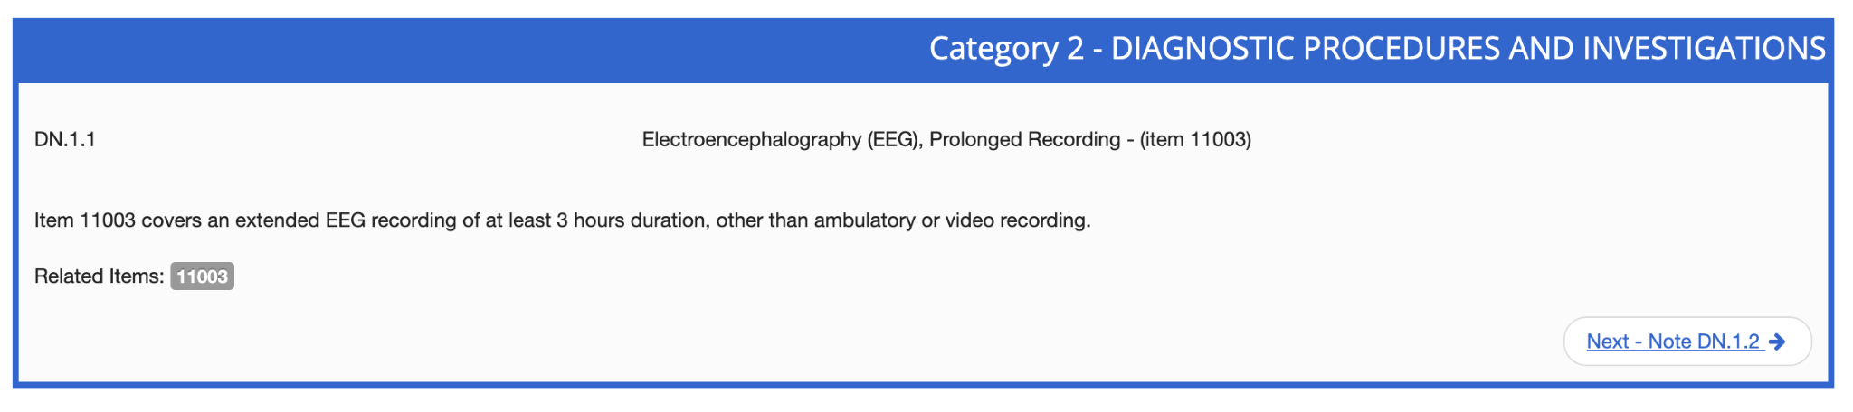
Existing medicare code can still be used, since the software is just a visualisation procedure

- Can the code be claimed for your intended clinical context? Has there been precedence of this being done before?
Yes. the existing code can be used.

Business model - risk management

- What is the exit strategy?
  - Who are the potential acquirers?
    - Merger and acquisition exit strategy (M&A deals)
    - Selling your stake to a partner or investor

- Does it fit within the hospital’s KPIs?
  - KPIs:
    - Safety and effectiveness
      - In hospital mortality rates
        - This solution seeks to reduce the mortality rate of patients who were admitted to hospital due to an ischaemic stroke and are under clinical monitoring after their initial treatment.
      - Hospital associated infection
        - The solution is a non-invasive method of monitoring patients, thus reducing the chances of infection.
      - Postoperative VTE (Venous thromboembolism)
        - The solution is a monitoring system that checks for blood clots within the brain, thus reducing the damage caused by postoperative VTE in the brain.
      - Harm
        - The solution aims to provide a ground truth on the state of the brain of an ischaemic stroke patient which should inform clinicians and surgeons on how to better treat the patient and to avoid causing harm.
    - Equity and access
      - Specialist care wait length
        - The solution seeks to take over one of the menial tasks done frequently by neurologists, which is to check stroke patients for recurring strokes, thus freeing up their time and creating shorter specialist waiting times.
    - Efficacy/value for money
      - Cost
        - The cost over the entire length of stay for a patient using this solution is cheaper than current technologies such as the CT scan or MRI scan as the only hardware cost is an EEG, which is much cheaper to buy and maintain compared to the previously mentioned devices.
    - Patient centred/experience
      - In-patient personal needs
        - A key issue of current monitoring methods where neurologists conduct physical tests is that it prevents the patient from resting which is an important need for the health and experience of recovering patients; this solution solves these issues by using a wearable EEG cap.

  - What is the investor ROI?
Cerebrospinal fluid management devices are said to predominate, but all sectors are expected to grow → CARG of 6.1 to 8.1% from 2019 to 2026 according to various sources. Based on the figures, the ROI is assumed to be similar to the rate of annual market growth.

- What are the most significant risks and what is the de-risking strategy?
  - Industry risk: What can go wrong with the market?
    - This market is currently untapped, so getting into the market faster reduces the risk caused by competition.
    - Protect IP early
    - Create a brand name to secure a customer base
    - Have competitive pricing
  - Execution risk: How well the company has performed in the past in meeting its budgets and the strength of its management team
    - Hire professional administrators.
  - Technology risk: Inefficient or outdated tools used in the business.
    - Acquire patient data and reviews to identify areas of improvement.
  - Supply chain risk
    - Make our software compatible with many different brands of EEGs.
    - Keep up to date with modern hospital equipment.
  - Customer risk: Too small of a customer base that may find alternatives instead
    - Maintain continuous communication with existing customers.
    - Use marketing and networking to expand the customer base.

Market analysis

- What is the TAM (Total Addressable Market)?
Total demand for market/ service, calculated in annual revenue

Global neurology device market for 2022: $12.4 USD billion

$1.06 USD billion annually for the EEG market

Neurological Monitors Market Is Likely to Rise to USD 21.22 Billion and is expected to undergo a CAGR of 7.60% by 2029
Ischaemic strokes:
7.6 million new cases annually.
77 million cases living with ischaemic stroke experience annually.

- What is the SAM (Serviceable Available Market)?
Target market serviced by company

50% of patients that were admitted for a stroke require extended hospital stay (more than 2 days). ¼ of stroke admission cases are false alarms. ⅓ of confirmed cases are mild, and do not require extended stay.

Approximately 5 million ischaemic stroke cases annually require extended stay. This is the SAM, which requires monitoring.

- What is the SOM (Serviceable Obtainable Market)?
Percentage of SAM that can be realistically achieved

Approximately 20 000 people annually for the Australian market.

- Who are your competitors within the market?

Seer Australia - diagnostic monitoring using EEG at home
- Monitor seizures → focus on epilepsy
- Physical product → portable EEG devices
- Also aim to remove patients from hospitals/ shorten hospital stay → reduces burden on medical staff and benefits patients
- Real time monitoring and quality assurance → requires resources, not concerned with visualisation software
- Takes 5 weeks for monitoring report to be sent to assigned doctor

NextGenNeuro - remote cEEG and EEG monitoring
- Extension of neurodiagnostic team
- Continuous and intermittent remote monitoring
- Retrospective EEG review
- Reading physician services

Neurotech - continuous EEG monitoring for hospitals
- On-call staff
- 24/7 IT support

None of the competitors directly produce visualisation software, but their services are more variable, so there is possibility of extension into the visualisation technology. Need for IP protection and barriers to entry reinforced.

- What are the segmentations within the market? Which one(s) are you targeting?
Neurological devices segmented into product, end user and region.

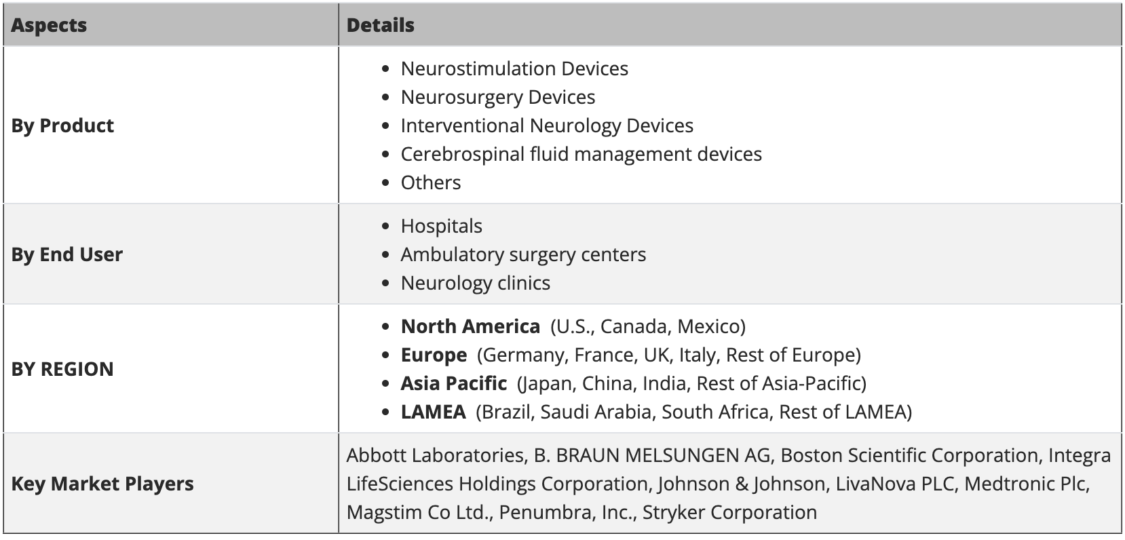

Targeted market segments: others, neurology clinics and hospitals, Asia Pacific (Australia)

- Can the market be expanded?

Maret can be expanded inter-state and internationally, but regulations need to be accounted for.

- What are the major market forces?
https://www.prnewswire.com/news-releases/neurological-monitors-market-is-likely-to-rise-to-usd-21-22-billion-and-is-expected-to-undergo-a-cagr-of-7-60-by-2029-size-share-industry-trends-and-value-forecast-301622059.html

Market driver for neurologicals monitors:
- Increase in the prevalence of neurological disorders
- Rise in chronic diseases
- Rise in clinical trials

