
MONASH HEALTHCARE INNOVATION SUMMER SCHOLARSHIPS (HISS)
PROJECT NAME: Nemo
DELIVERABLES NUMBER: 5
PROJECT LEAD: David Levitz & Vishnu Sivakumar
Proposed business model
[insert proposed business model & explanation for your choice]

We are planning on prototyping the nerve cuff and combined ultrasound machine

Reusable (or capital equipment) with disposable electrodes and a service fee

If the device lasts less than a year before requiring a service or updating it would fall into the reusable business model

Recurring revenue stream would come from the disposable electrodes and service fee

As a result we may be able to sell near or at cost with the expectation that greater recurring revenue will come from the sale of service and disposables.

Business model - cost
[consider the following questions]
- How much would it cost to prototype?
  - Cuff
    - Electrode probe: 1 probe costs ~ 126$
      - (https://www.medi-shop.gr/en/physiotherapy-disposables/electrostimulation-probe-pg330?srsltid=AeTuncq2JjQk-S4aggMfPZpAgm0Qk112yTPvqkixA-7PVI5v9RkTgH1CumY)
    - For prototyping:
    - Electrode recorder: box of 50 = 21 dollars
      - https://www.yesmed.com.au/3m-red-dottm-ecg-foam-monitoring-electrode-sticky-gel-4-x-3-5cm-box-of-50.html?utm_source=google_shopping&gclid=CjwKCAiAwc-dBhA7EiwAxPRylLCDddXk9X7YbYBeKByqCoqg6PTKD3zl7llKAmzmm0QungA_LBc-uBoChDgQAvD_BwE
    - Arduino Mega 2560 = $25
    - Integrated circuit - cents
    - Monitor - cheap ~ $80 - 100 or use existing computer
    - Variable resistor - cents
    - Current regulator - ~$15-20 (https://www.amazon.com/Current-Regulator/s?k=Current+Regulator)
    - Circuit board - $1 (https://www.google.com/search?q=circuit+board+costs&rlz=1C1CHBF_en-GBAU884AU884&source=lnms&tbm=shop&sa=X&ved=2ahUKEwi1uOjVo7H8AhVWt2MGHdZoBq0Q_AUoAXoECAEQAw&biw=1536&bih=714&dpr=1.25)
    - 9V battery ~$18 (https://www.google.com/search?q=9V+battery+cost&rlz=1C1CHBF_en-GBAU884AU884&oq=9V+battery+cost&aqs=chrome..69i57j0i512l2j0i22i30l7.3301j0j7&sourceid=chrome&ie=UTF-8)
    - Alligator clips - $5 (https://www.google.com/search?q=alligator+clips+cost&rlz=1C1CHBF_en-GBAU884AU884&oq=alligator+clips+cost&aqs=chrome..69i57j0i15i22i30j0i22i30l5j0i15i22i30l2j0i390.3333j0j7&sourceid=chrome&ie=UTF-8)
    - conducting pads made with stiff copper wire covered with Foil, Metal probe, or sponge soaked in saline - cents, 126 as above,cents
    - Tape - $10
    - DC Power supply variable regulator ~ $50 - 100 (https://www.amazon.com.au/Adjustable-Electronics-Electrolyzation-Electroplate-Researching/dp/B07L3K5952/ref=asc_df_B07L3K5952/?tag=googleshopdsk-22&linkCode=df0&hvadid=463598473184&hvpos=&hvnetw=g&hvrand=14794471244524106144&hvpone=&hvptwo=&hvqmt=&hvdev=c&hvdvcmdl=&hvlocint=&hvlocphy=9071331&hvtargid=pla-639343705105&psc=1)
  - Ultrasound
    - $2200
      - (https://www.google.com/search?q=prototype+ultrasound+cost&rlz=1C1CHBF_en-GBAU884AU884&source=lnms&tbm=shop&sa=X&ved=2ahUKEwiFlqWE16z8AhV14DgGHdXSDFoQ_AUoAXoECAEQAw&biw=1536&bih=714&dpr=1.25#spd=3144782617809066027)
    - Highly dependent on model
    - Price range 1450 to 50,000 averaging 16815
      - (https://www.medicalsearch.com.au/buy/ultrasound-machine)

- How much would it cost to make a unit of the product?
  - 15 probes - Mid price. Probes tend to be more expensive
  - 15 receivers - Cheap - electrodes are quite cheap
  - One Integrated circuit - cheap
  - Monitor/Display - Moderate
  - (ultrasound) - Expensive
- How much would it cost to maintain a unit of the product?
  - Maintenance for the ultrasound will cost around 10 - 15% of the purchase price per year (https://www.themeridian.com/en-au/company/blog/how-much-does-an-ultrasound-machine-cost#:~:text=The%20cost%20of%20maintenance%20is,15%25%20of%20the%20purchase%20price).
- WHat are the other anticipated costs associated with the product? Consider regulatory, patenting, clinical trials, labour costs, etc
  - Regulatory
  - Patenting: Provisional patent ~$110, standard - $370, patent attorney ~ 8,000 - 10000
  - https://www.ipaustralia.gov.au/patents/timeframes-and-fees#fx-tabs-0-panel-0
  - https://www.bitlaw.com/guidance/patent/what-does-a-patent-application-cost.html
  - Clinical trials
  - Labour costs - Initially likely won’t be too expensive. Would require more for sales and marketing and services in the future
- Reusable product has higher level of risk
  - used by customers for extended period of time
  - Increased cost of maintenance
Business model - revenue/reimbursement
[consider the following questions]
- Low cost disposable attached to reusable device
  - Electrode and machine reusable
  - Electrodes disposable
- Service fee

- Who pays for it?
  - Public - Neurology Department
    - Depends on hospital:
      - Alfred: Procurement and Supply Chain Department
  - Private
    - Private clinic funds
- How will you make money? (? Revenue stream)
  - Selling the device
  - Ongoing revenue stream: Service fee, disposable electrodes
  - Aim for margin of 70 - 80%
- What is the sales/market penetration strategy?
  - Utilise our clinician who is predominant in this space to advocate for the equipment
  - Focus the equipment in one centre for clinical trials (referral for more difficult patients)
  - Expand to more clinics as they notice efficacy of the device
  - May involve a sales team
  - Organise meetings with clinicians

  - What is your proposed price? What are the current prices of competitors?
  - Moderately priced reusable products
  - As reusable recurring revenue may be limited (with the exception of a service fee)
    - May not be able to support specialised sales force
    - Sold through medical catalogs or major distribution companies
- What is the reimbursement strategy?
  - Players involved:
    - Medicare
    - Private health insurance
  - Our solution is consistent with value based programs rewarding cost as well as still being acceptable with a fee for service incentives allowing clinicians to see a greater volume of patients
  - Utilise existing reimbursement pathways for new technology: Likely model on the current medicare reimbursement for nerve conduction studies
  - Improved clinical performance and save money in the overall treatment of the disease.
  - Reduces
  - Physicians are paid:
    - Increased time efficiency
    - Clinical centres: Increased accuracy leads to
  - Medibank gap cover scheme including medicare benefit”

Our reimbursement strategy would be modelled on the current medicare codes for nerve conduction studies. The codes involved include ….., with larger reimbursement for more nerves tested.

The health economic profile compared to the standard operating procedure
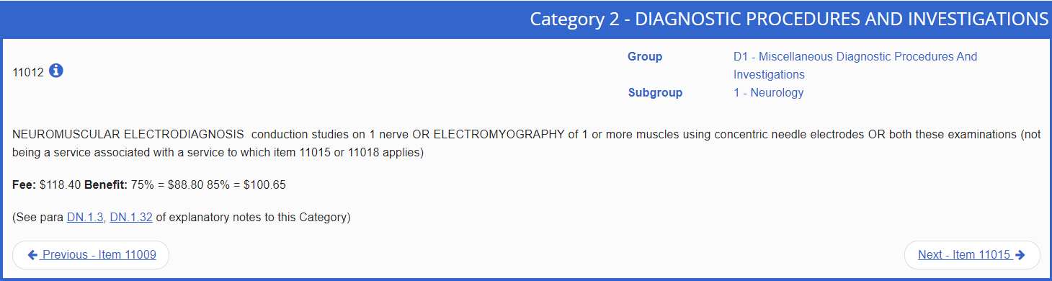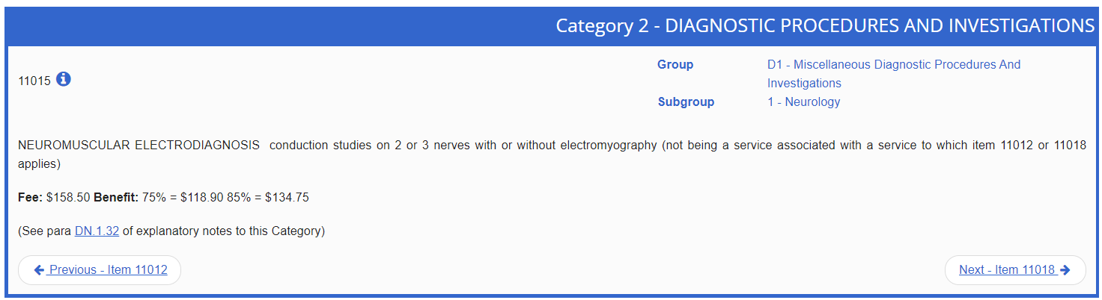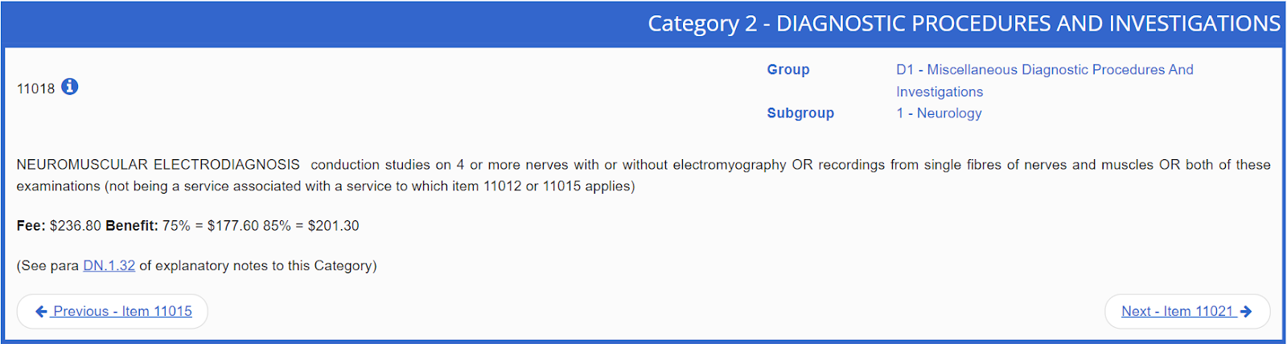

BUPA

- What is the health economic profile compared to the SOP (standard operating procedure)?
  - DALYs of existing vs current treatment
  - QALYs
  - Cost effective analysis
    - How much it costs vs what is the benefit
  - Cost/Benefit ratio
    - Important to justify reusable products (such as stethoscope or scale)
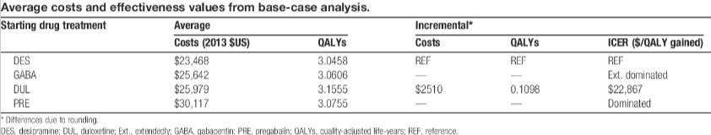’
QALYs associated with starting early pain treatment for diabetic neuropathy
https://journals.lww.com/pain/pages/articleviewer.aspx?year=2016&issue=01000&article=00021&type=Fulltext

0.69 QALY
incremental cost-effectiveness ratio (ICER) of $23,250/0.69 ≈ $35,000.
https://onlinelibrary.wiley.com/doi/10.1111/ene.13836
https://link.springer.com/article/10.1007/s40273-020-00912-8
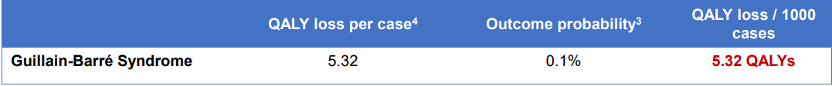
https://www.efsa.europa.eu/sites/default/files/event/150611a/af150611a-p11.1.pdf

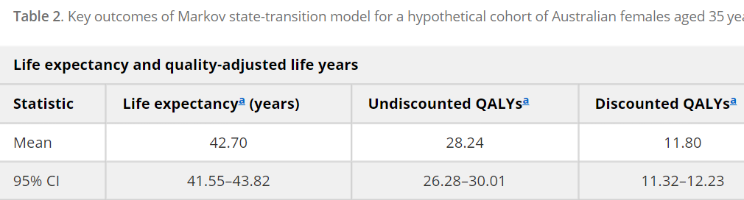
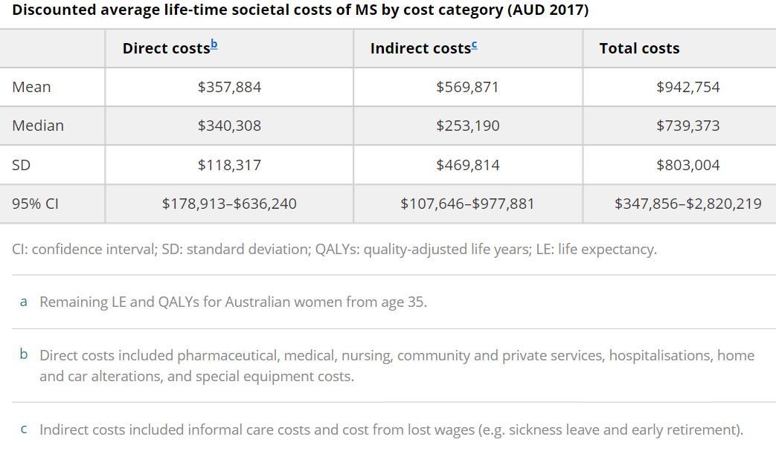
https://journals.sagepub.com/doi/10.1177/1352458519831213?url_ver=Z39.88-2003&rfr_id=ori:rid:crossref.org&rfr_dat=cr_pub%20%200pubmed

- Does it fit within the hospital’s KPIs?
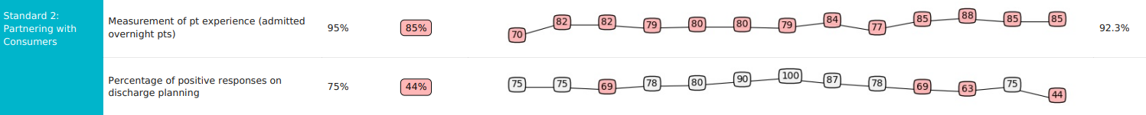
- Not aware: must be careful
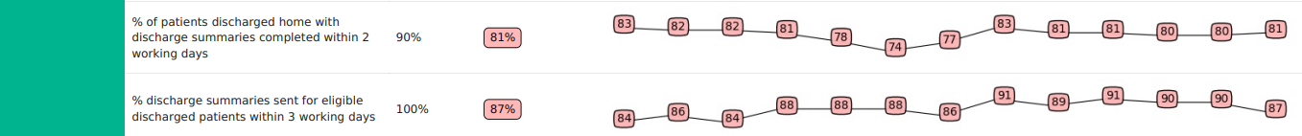
- Reduces burden on the hospital
- Can you use an existing Medicare code? Do you need a new code?
- Can the code be claimed for your intended clinical context? Has there been precedence of this being done before?
- What are the other, comparable codes?
  - Conduction study on 1 nerve: $118
  - 2 or 3 nerves: $158.5
  - 4 or more nerves: $236.8
—---------------------------------------------------------------------------------------------------------------------------------------------------
Business model - risk management

- What is the exit strategy?
- Selling your stake to a partner or investor
- Merger and acquisition
Pitch products to medical equipment manufacturers and ask for royalty in return
- Acquihire
Apply for positions at med tech companies by showcasing knowledge and expertise on the basis of this project
Failed Startup:
- Initial Public Offering
- Liquidation
- Bankruptcy

- Who are the potential acquirers?
  - Medtronic
  - Johnson and Johnson
  - Siemens Healthineers
  - Phillips
  - Stryker

- What is the investor ROI?
Potentially 80%+ (based on Koah’s presentation)

- What are the most significant risks and what is the de-risking strategy?
- No Proof of Concept:
As there are no prototypes of the device yet, the increase in accuracy is only a possibility. As a way of de-risking the following may be produced to convince investors that the idea is feasible:
- Circuit schematics
- 3D CAD models
- Device schematics

- Device Malfunctioning:
In the case of the device malfunctioning or significant power surges the following may occur:
  - Cardiac arrest
  - Electric Shock burns
  - Electrical Fire
Cardiac arrests and burns can be avoided by incorporating surge protectors or circuit breakers within the system. For cases such as electrical fires, an electrical fire extinguisher will be sufficient.

Market analysis
- What is the TAM (Total Addressable Market)?
Nerve Conduction Study Market

- What is the SAM (Serviceable Available Market)?
Nerve Conduction Velocity Testing Market
Valued at USD 736.0 million in 2017 at a CAGR of 8.8%.
Nerve Conduction Velocity NCV Testing Services Market Research Report 2020-2028 (dataintelo.com)

- What is the SOM (Serviceable Obtainable Market)?
Neurology Sectors in Hospitals associated with Monash Partners

- Latrobe Regional Hospital (our clinician’s hospital)
- Alfred Health

- Eastern Health
- Monash Health
- Peninsula Health
- Cabrini Health
- Epworth HealthCare

- Who are your competitors within the market?
All of the potential acquirers

Startups:
  - Thync - Manufacture non-invasive wearable devices for neurostimulation.

- What are the segmentations within the market? Which one(s) are you targeting?
  - Alfred hospital patients
    - Suffering from neurological disorders
      - Require a nerve conduction velocity testing

- What are the major market forces?
The market may be inflated due to a rise in patients suffering from:
- Carpal tunnel syndrome
- Guillain-Barre syndrome
- Charcot-Marie-Tooth disease
- Herniated disk disease
- Chronic inflammatory polyneuropathy and neuropathy
- Sciatic nerve problems
- Multiple Sclerosis
- Parkinson’s Disease

https://www.hopkinsmedicine.org/health/treatment-tests-and-therapies/nerve-conduction-studies

