
MONASH HEALTHCARE INNOVATION SUMMER SCHOLARSHIPS (HISS)
PROJECT NAME: Project Impetus
DELIVERABLES NUMBER: 5
PROJECT LEAD: Dan Lin
Proposed business model
- Subscription model
- Hospitals will pay an annual fee to use the software
- Each dosage calculation operation will incur a small fee
- The annual fee will be the total number of dosage calculations performed within an institute

Business model - cost
- How much would it cost to prototype?
  - There may possibly be no costs associated with early prototype creation as they can be web mockups that only contain essential functionality
  - It is difficult to estimate the cost of later-stage prototypes since the project requirements may change significantly depending on research outcomes
- How much would it cost to make a unit of the product?
  - The cost depends on the skill of the developer being hired to make the flagship software model
    - It is difficult to provide an estimate of the complexity of the software and the size of the development team required to make the software
  - Hosting services, domain name
- How much would it cost to maintain a unit of the product?
  - New transplant data may be continuously included to modify the algorithm behind the software, and a dedicated team may be required to maintain the product
  - Again, the cost would depend on the complexity and size of the transplant data
- What are other anticipated costs associated with the product?
  - Clinical trials
  - Maintenance
  - Regulatory
  - Patents
Business model - revenue/reimbursement
- Who pays for it?
  - Hospitals/companies that pay a subscription to implement the software
- How will you make money?
  - Money from sponsors and subscriptions
- What is the sales/market penetration strategy?
  - Approach clinical directors, IT staff, and front-line clinicians who will be using the software
  - Demonstrate the software, showing how it will improve patient care, increase efficiency, and reduce risks
  - Possibly present case studies and data analysis if possible
- What is the reimbursement strategy?
  - N/A, no reimbursement strategy required for software development
- What is the health economic profile compared to the SOP (standard operating procedure)?
  - There is no definite method to quantify the benefits of the health economic profile over the SOP, since the project aims to reduce the risk of over- and under-immunosuppression
  - The only way to measure this is to compare the rates of over- and under-immunosuppression before and after the software is implemented. However, the overall quality of life and economic costs cannot be accurately predicted.
- Does it fit within the hospital’s KPIs?
  - Revenue reduces the cost of patient stays
  - Revenue could increase the quality of specialist care
  - Revenue could enhance in-patient personal needs

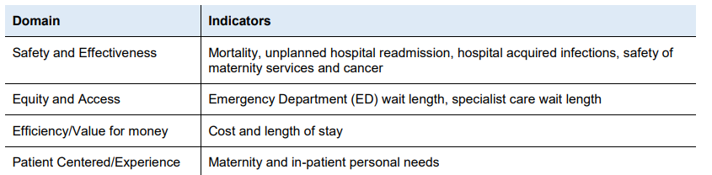

- Can you use an existing Medicare code? Do you need a new code?
  - This product will most likely not require a Medicare code, since it is not a medical service being provided to a patient

Business model - risk management
- What is the exit strategy?
  - Continued software support/updates: open access software, available for infectious disease modellers who may want to continue and contribute to the software as clinical trials progress
  - Most likely modellers who are associated with Alfred Health, since the data is from the Alfred
- What are the most significant risks and what is the de-risking strategy?
  - The correlation between drug dosage and immunological assays may be affected by novel or undiscovered factors, possibly significantly affecting predicted drug dosages
Observe irregular patient symptoms after administration and have a dedicated team to determine whether the abnormalities are random or related with certain factor
- Does it fit within the hospital’s KPIs?
  - Yes - the measures will hopefully lower:
    - Mortality rates
    - Unplanned hospital readmission rates
    - Emergency Department wait length
    - Specialist care wait length

Market analysis
- What is the TAM (Total Addressable Market)?
  - Estimated number of organ transplants worldwide in 2020: 144,000 (Home - GODT (transplant-observatory.org)
  - Immunosuppressive drug dosages are modified with a different frequency for each patient depending on their needs and response to treatment, and other factors. We will assume that the average patient requires their dose to be modified twice each week following their transplant, for a period of a year
    - 52*2 = 104 dosage modifications for 1 year
  - 104 modifications per person = 104 x 144,000 = 15 million dosage modifications per year
  - If we introduce a subscription business model where a fee is paid per dosage modification (eg. $10), then that leaves us with a TAM of 15 million x 10 = $150 million

- What is the SAM (Serviceable Available Market)?
  - There are 1750 Australians on the waiting list for an organ transplant (Statistics in Australia | DonateLife)
  - Using same assumption of 104 dosage modifications for 1 year
  - 104 modifications per Australian = 104 x 1750 = 182800 dosage modifications per year
  - Using the same business model leaves us with a SAM of 182800 x 10 = $1.8 million

- What is the SOM (Serviceable Obtainable Market)?
  - Assuming the realistic reach of the software will initially be in Victoria, we can divide the SAM by the number of states and territories in Australia - 8
    - 1.8mil / 8 = $225,000
    - This is a conservative estimate, since Victoria likely manages a larger proportion of transplant procedures compared to other states and territories

