
MONASH HEALTHCARE INNOVATION SUMMER SCHOLARSHIPS (HISS)
PROJECT NAME: Embrace
DELIVERABLES NUMBER: 5
PROJECT LEAD: Sue Liu
Proposed business model: Subscription
A Q&A forum website that is initially free, however there is an annual subscription model to access higher-level features such as increased storage.

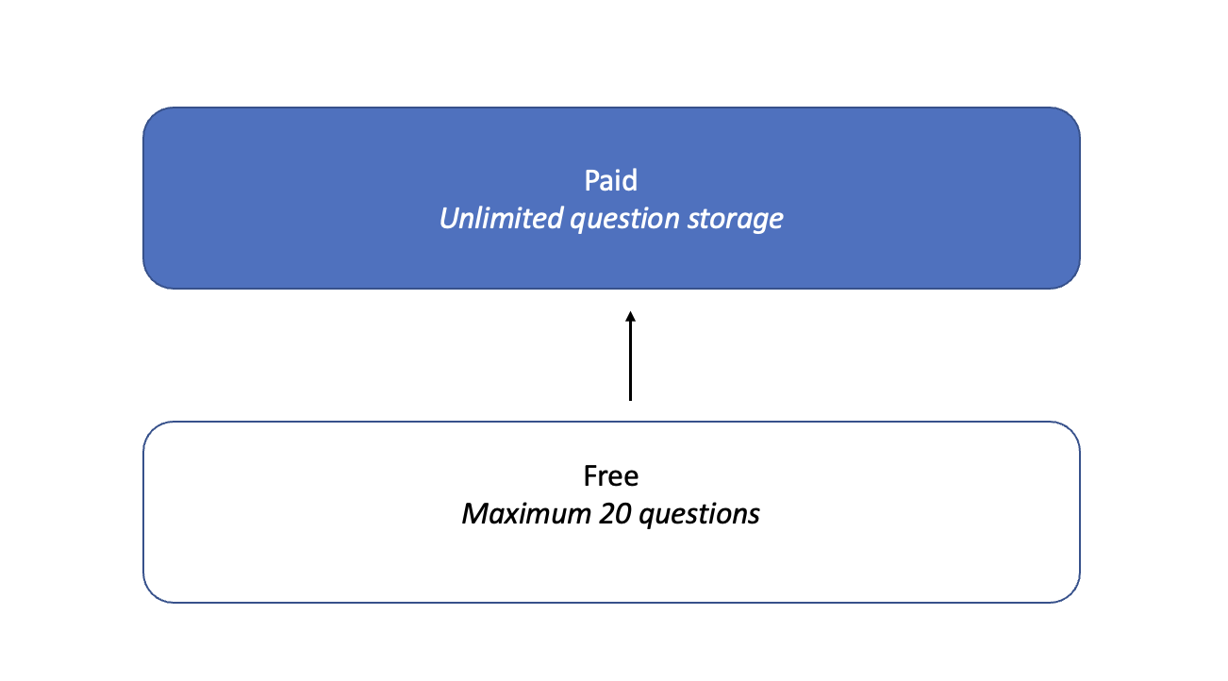

Business model - cost
- How much would it cost to prototype? $5280
Item | Time | Cost ($)
Website development labour | 4 weeks/160 hrs | 4800 (assumed wage $30/hr)
Initial database development labour | 3 hours | 180 (assumed wage $60/hr)
Consumer adoption | 6 hours (6 people) | 300 (assumed $50 per hour per person)

The estimated cost for website development is variable depending on the labour that is hired eg. software developer (local or international) or student

- How much would it cost to make the product? $1380
Item | Time | Cost ($)
Website development + deployment labour | 1 weeks/40 hrs | 1200 (assumed wage $30/hr)
Initial database development labour | 3 hours | 180 (assumed wage $60/hr)
Data storage | - | - (as utilising pre-existing services)

- How much would it cost to maintain the product? $3312 annually in initial years
Item | Time | Cost ($)
Website hosting/storage (Squarespace Personal) | - | 192
Ongoing database development labour (borne by healthcare professionals eg. oncologist or cancer nurse coordinator) | 52 hours (1 hr weekly, this will decrease over time) | 3120 (assumed wage $60/hr)

- What are the other anticipated costs associated with the product? Consider regulatory, patenting, clinical trials, labour costs, etc
  - Labour costs – for clinical team to answer questions and update existing posts (have been included in ongoing database development labour cost)
  - Consulting costs – amongst various HCP including oncologists, cancer nurse coordinators, other specialists and consumers

Business model - revenue/reimbursement
- Who pays for it? Hospital purchasing committees on behalf of outpatient clinic services
- How will you make money? Subscription fees for a higher tier “premium” product which provides a larger volume of storage to host more content. As the database of questions continues to grow, organisations are incentivised to continue subscribing to the service to maintain the impact of the product in helping patients.
- What is the sales/market penetration strategy?
  - Offer 6-month free trial of premium tier to oncology centres – this includes unlimited question space which incentivises the database to quickly become populated
    - At the 6-month mark, centres will decide if they want to begin paying for the service
    - They may have surpassed the 20 question limit for their own forum – and may be reluctant to lose this service/information
- What is your proposed price? What are the current prices of competitors?
Proposed pricing is $20/month, $240 annually, to make a small profit after breaking even (Squarespace requires minimum $192 annual fee)

There are no direct competitors offering a Q&A website product.
I have included the prices of services offering website hosting with blog/Q&A capabilities, these may also be utilised instead of Squarespace.
- Wix – free + premium tiers (cheapest $180 annually)
- WordPress – free + premium tiers (cheapest $60 annually)

Services with premium tiers have extra capabilities compared to their free eg. removing ads, custom domains, storage space and bandwidth. The services vary in their capabilities and user friendliness.

- What is the reimbursement strategy?
  - Currently, there are no appropriate MBS codes
- What is the health economic profile compared to the SOP (standard operating procedure)? N/A
- Does it fit within the hospital’s KPIs?
  - Unplanned hospital re-admission – as patients are having their questions answered, this reduces the risk of non-compliance and adverse events occurring and therefore reduces unplanned hospital re-admission
  - Preventable hospitalisations for chronic disease - as patients are having their questions answered, this reduces the risk of non-compliance and adverse events occurring and therefore reduces unplanned hospital re-admission
  - Survival rates in cancer patients – as patients are able to more effectively receive chemotherapy achievement, this improves survival rates
  - Toll on emergency department eg. wait length, admissions – as patients are having their questions answered, this reduces the risk of non-compliance and adverse events occurring and therefore reduces the burden on the emergency department
- Can you use an existing Medicare code? Do you need a new code?
  - Currently, there are no appropriate MBS codes
- What are the other, comparable codes?
  - Item 871 or 872 (medical practitioners participating in a multidisciplinary treatment planning meeting for patients with cancer)

Business model - risk management
- What is the exit strategy?
  - M&A with existing Cancer Council forum
  - Selling to stakeholders – including other outpatient clinics/services
- Does it fit within the hospital’s KPIs?
  - Fits within performance measures as stated earlier
- What are the most significant risks and what is the de-risking strategy?
Risk | De-risking
Lack of patient engagement | Consolidate initial database of questions to make it an initial reference point and inspire more questions  Promotion of the service through the staff during appointments and posters etc.
Lack of clinician engagement | Roster specific hours for database work  Identify other possible contributors
Lack of funding from hospital buyers | Identify other cheaper website development/hosting services to make product more affordable  Promote to other relevant departments that may utilise the product eg. dementia  Consider changing format of product to implement relevant MBS codes eg. telehealth

Market analysis
- What is the TAM (Total Addressable Market)? $480,000 annually
  - All international oncology health services (estimated) = 2000 centers
    - Aus – 295
    - USA - 913
    - UK - 62
    - Canada - 34
    - Europe - 109
    - Asia - 587
      - India – 27
      - China – 150
      - Japan – 393
      - Korea – 17
- What is the SAM (Serviceable Available Market)? $70,800 annually
  - Australian oncology health services (295 centres in total)
- What is the SOM (Serviceable Obtainable Market)? $240 annually
  - Given there are no competitors
  - Alfred Health outpatient oncology services - $240 annually (1x subscription)
- Who are your competitors within the market?
  - Cancer Council Online Community (free)
  - Online doctors eg. 13-Doctor, Instant Consult (min $45/consult)
- What are the segmentations within the market? Which one(s) are you targeting?
  - Oncology market -> research, clinical care
  - Clinical care segmented into direct treatment provision, patient experience (education, advocacy, support groups)
- Can the market be expanded?
  - Can expand into management for chronic disease eg. dementia, Alzheimer’s
- What are the major market forces?
  - Extent of Medicare/public health funding
  - Cancer incidence – prevalence (according to specific risk factors present in the demographics), diagnosis

