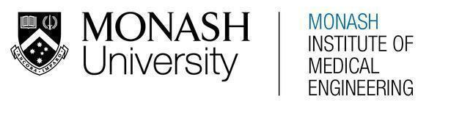
MONASH HEALTHCARE INNOVATION SUMMER SCHOLARSHIPS (HISS)
PROJECT NAME: Project DOLPHIN
DELIVERABLES NUMBER: 5
PROJECT LEAD: Maya Wilmshurst
Proposed business model: Disposable product

Rather than being bought by the patient - as an over the counter (OTC) or prescription product – the medication monitoring device would be provided to the patient. The cost would be covered by the hospital rather than by the patient and Medicare. This model is similar to that used for medication monitoring devices for clinical trials in hospitals, in which the trial or sponsor provides the tool for medication monitoring at no cost to the patient.

Alternatively, a fee-per-use model could be used wherein the hospital would pay for each instance of the system used, ie. each patient who accesses the physical hardware as well as the connected software. A subscription model could also be used for the software to accompany the disposable (or reusable) hardware.

Business model - cost
- How much would it cost to prototype?
  - The system could likely be prototyped using existing Medication Event Monitoring System (MEMS) technology such as that available through the AARDEX group who fabricate and sell it for use in clinical trials. The prototyping would involve connecting this hardware to an alternative online platform to make it relevant for oncology treatment (rather than clinical trials). This would be significantly cheaper than prototyping both aspects of the system initially.
  - Prototyping the connected software: the cost would depend on how high-fidelity the prototyped software needs to be to prove the concept. This website (https://visartech.medium.com/how-much-does-it-cost-to-create-a-prototype-of-an-app-like-uber-e2a6780fecc2) estimates prototyping costs at $4,000 - $15,840 for an app like Uber. The costs would be less for this web application due to lower complexity.
    - If the web app could be prototyped in-team, this would reduce the cost significantly. However, this may increase prototyping time and decrease the quality (not a significant loss for prototyping phase).
- How much would it cost to make a unit of the product?
  - Hardware product: this would depend on if this aspect of the system is being bought (ie. from Aardex) or made ourselves.
  - Connected Software:
    - Approximately $20K-$30K (https://estimatemyapp.com/). This depends on complexity of the web application.
- How much would it cost to maintain a unit of the product?
  - Hardware product: No maintenance costs due to the disposable nature of the product. (Particularly if this is bought from AARDEX Group or other).
  - Connected Software: The linked website/application will need to be maintained and may need to be improved in line with clinician requests.
    - IT support: Up to $99-$199 per user/month for outsourced IT support OR salary for full-time IT support employee for $50K-$80K/year
    - Hosting: for Amazon Web Hosting (AWS), cost is up to $100/month depending on complexity and capabilities of web application.
    - Domain name: $10-20/year
- What are the other anticipated costs associated with the product?
  - Clinical trials would likely not be required as the AARDEX MEMS software is already being used within the hospital network for some clinical trials. This would be developing the software and expanding the scope to make it cater to oncology treatment as well.

Business model - revenue/reimbursement
- Who pays for it?
  - Initial funding through MIME
  - Ongoing revenue from the Alfred initially and then hospitals more generally
- How will you make money?
  - The Alfred would pay for a number of units of the product per year/month in line with the number of oral chemotherapy patients they have. This would be able to be effectively estimated each year based on previous years’ numbers with expectation of growth due to the increasing number of cancers able to be treated using oral chemotherapy.
  - In the future, this system for monitoring and improving oral chemotherapy patients’ medication management could be implemented in other hospitals more broadly with a similar system.
- What is the sales/market penetration strategy?
  - The medication management system - including Medication Event Monitoring System and connected online tool (to allow collection and summary of data as well as provision of medication management tool suggestions) – would be sold to the Alfred oncology department. It would initially be made specific to the types of cancers treated there using oral chemotherapy.
  - The system/product would then be spread throughout the local health network – this would likely require some expansion of the product to account for variations in the types of oral chemotherapy available in each hospital.
- What is the reimbursement strategy?
- What is the health economic profile compared to the SOP (standard operating procedure)?
  - The initial cost for hospitals is higher than the SOP given that there is currently no medication monitoring system in place. Ultimately however, the solution would lower the cost for the hospitals:
    - The improvement of cancer prognosis would result in reduced reliance on healthcare resources. This would reduce cost per patient as each patient would be in the hospital system for less time, thus costing less in service costs (payment for clinician time etc) and resource cost (cost for in-patient stays, tests etc)
    - This would also lower the cost for the government as improved cancer prognosis would result in lower cost of providing pharmaceuticals.
- Does it fit within the hospital’s KPIs?
  - The only Alfred Hospital specific KPIs that could be identified were the following: https://www.alfredhealth.org.au/images/resources/performance/Board_Quality_and_Safety_Indicators_November_2022.pdf
  - None of these are directly relevant to cancer treatment or outpatient care
  - The implementation of this service would have an effect on the ability of the Alfred to offer Comprehensive Care (Standard 5) to their patients as it would improve the cancer prognosis of patients and thus reduce their likelihood to need to be seen in the ED or through a Specialist Clinic referral. This would help with overall quality of comprehensive care as well as with (more specifically):
    - % of ED patients with length of stay in ED <= 4 hours
    - % of Specialist Clinic (Urgent, Routine) Referrals seen within 30 days
  - Considering the Monash Health KPIs, the solution relates to:
    - Unplanned hospital re-admissions: the system would improve cancer prognosis, resulting in reduced hospital re-admissions due to cancer symptoms. Increased adherence to cancer medication could however result in an increased level of complications due to cancer symptoms.
    - Cancer (Five year relative survival rates are used with cervical cancer patients, breast cancer patients, and colorectal cancer patients all measured): improvement to cancer prognosis would increase survival rates.
- Can you use an existing Medicare code? Do you need a new code?
There are none relevant (particularly given the system will most likely be purchased by the hospital rather than the patient) however the following may be related if it ends up being purchased by the patient.
- Medication Management Reviews (sessions in which out-patient interacts with health practitioner and pharmacist to develop medication management plan if there is a risk)
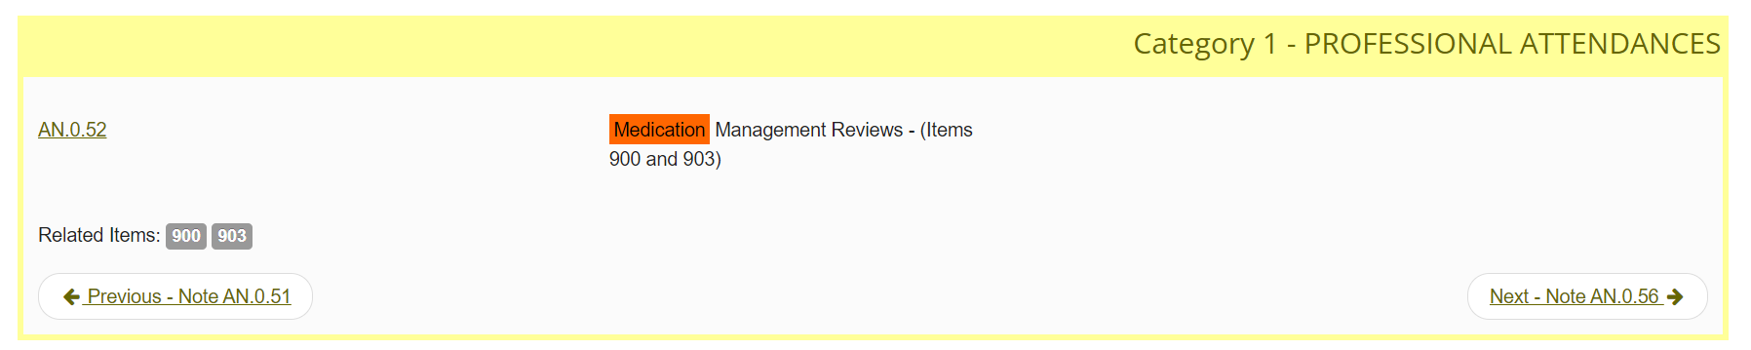
- Follow up service for an Indigenous person who has received a health assessment (can involve: education regarding medication compliance and associated monitoring, or checks on clinical progress and service access)
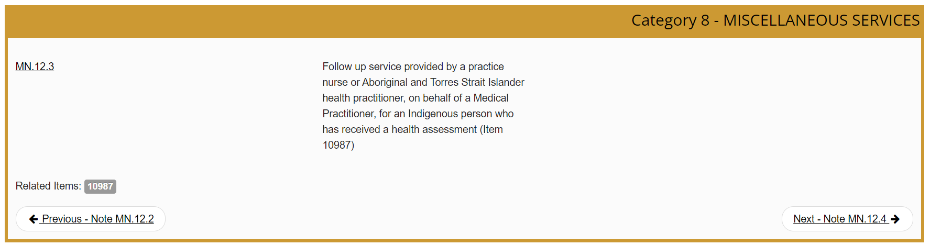

- Similar to the above; providing monitoring and support for individuals with chronic disease (including checks on clinical progress, monitoring of medication compliance, self management advice and collection of information to support clinician reviews of Care Plans)
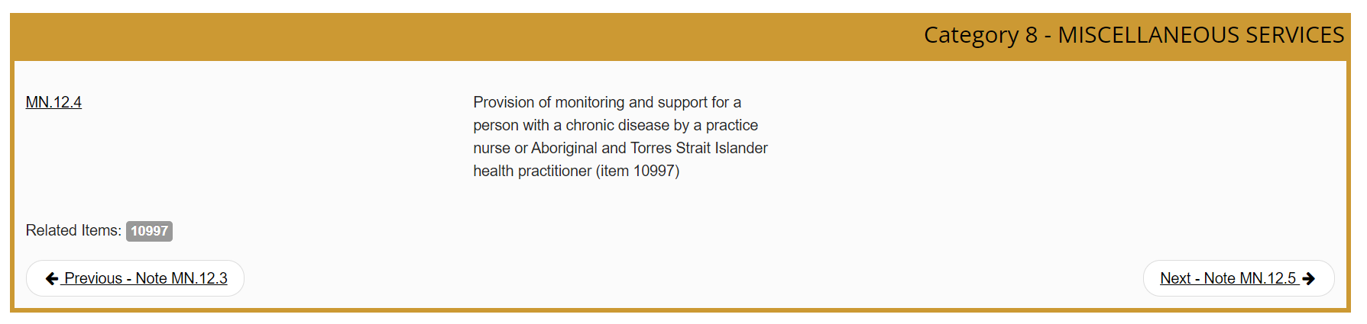

There are other similar codes under Professional Attendances. There aren’t any (that could be found) relating to hardware/software allowing for medication management/monitoring.

Business model - risk management
- What is the exit strategy?
- Sell the web application to the Alfred and ensure that they can continue purchasing hardware from an external source (such as Aardex) that could be linked to the web app.
- Partner/merge with an external company such as Aardex to expand the scope of their market to deal with treatment of disease (medication management) as well as clinical trials (as they do currently).
- What are the most significant risks and what is the de-risking strategy?
Risk | De-risking strategy
Low-uptake:  - There is a risk of there being low-uptake of the technology at the Alfred (initially) if the benefits of medication management are not seen by clinicians – many clinicians are currently unsure if this is an issue that needs to be addressed among oncology patients. | - Do an initial trial with a small number of clinicians at the Alfred to highlight (currently unknown) adherence rates and how the system allows for improvement. This would facilitate broader adoption of the technology in the Alfred and more broadly.
Privacy:  - Software is storing patient data (not highly sensitive but relevant to the medications they are taking and when).  - Given data is being shared through the system (between clinicians and patients), there is higher likelihood of security breaches. | - Similar data (relevant to which medications they are taking) is already stored within the hospital network. The de-risking strategy would be to consult in-hospital tech support/consultants to use a similar privacy system.  - The software system should use strong security measures using authentication systems to ensure that only patients and their clinicians are able to access the data.
Funding:  - Significant funding would be required to prototype and commercialise the system. | - Initial costs can be reduced by relying on a lower fidelity prototype, and potentially using university resources/human resources.  - Funding should also be acquired externally through investors etc.  - Consider partnership with the Alfred to develop the technology and secure ongoing service to their hospital (revenue pathway).
Competition/partners:  - There are existing companies (particularly Aardex) which develop MEMS technology. | - Team to gain better understanding of possible partnership strategies to use existing MEMS technology (partnership) or not infringe on patents etc if new technology is to be created.

Market analysis
Assuming cost for MEMS/patient to be ~$US219.4 (https://assets.researchsquare.com/files/rs-970723/v1/733cc8f8-4332-4025-9b48-593c4480b3bf.pdf?c=1637646390) which is ~$AUD325. (Need to confirm these prices by using AARDEX group’s estimates).
Only considering new cancer patients. This is a significant under-estimate of total cancer patients as it does not consider patients with ongoing treatment for >1 year.

- What is the TAM (Total Addressable Market)?
  - All hospitals in the world with oncology patients using oral chemotherapy.
  - Total cancer cases per year: 18.1 million (new cases in 2020) (https://www.wcrf.org/cancer-trends/worldwide-cancer-data/#:~:text=Find%20information%20about%20world%20cancer,and%208.8%20million%20in%20women.)
  - Percentage of cancer patients on chemotherapy: ~28% (UK, 2013-2014) -> ~5.068 million patients started on chemotherapy each year (https://www.cancerresearchuk.org/health-professional/cancer-statistics/treatment)
  - Percentage of chemotherapy taken orally: ~25% (US) (https://www.uspharmacist.com/article/challenges-to-oral-chemotherapy-adherence#:~:text=According%20to%20the%20U.S.%20National,reduce%20patients'%20burden%20of%20care).
  - Number of cancer patients taking oral chemotherapy worldwide: ~1.267 million/year
  - TAM: ~$AUD 412 billion/year
- What is the SAM (Serviceable Available Market)?
  - Australian hospitals with patients using oral chemotherapy.
  - Total cancer cases per year: 151,000 Australians diagnosed with cancer per day (2021 estimate (https://www.aihw.gov.au/reports/cancer/cancer-in-australia-2021/data)
  - Assuming similar oral chemotherapy percentage estimates to TAM: 28% on chemotherapy, 25% of those on oral chemotherapy
  - Number of Australian cancer patients taking oral chemotherapy: 10,570 patients/day
  - SAM: $AUD 3.4 million/year
- What is the SOM (Serviceable Obtainable Market)?
  - The Alfred and their patients using oral chemotherapy. Initially target those only using oral chemotherapy (rather than oral and IV).
- Who are your competitors within the market?
  - No major competitors. If anything, the product would benefit ‘competitors’ in the market as it would provide guidance for clinicians or patients looking to find medication management tools, thus increasing the use of applications and hardware solutions that improve adherence.
  - If the current Medication Event Monitoring Systems are not used (ie. we create our own technology with similar capabilities), the current manufacturers are competitors (ie. AARDEX Group).
- What are the segmentations within the market? Which one(s) are you targeting?
  - Only the oral chemotherapy segment of the market is currently being targeted.
- Can the market be expanded?
  - The system initially targets oral chemotherapy; however this service could be expanded to other disease states treated using ongoing oral treatment. Many of these alternatives likely have lower adherence rates than chemotherapy, making the system amenable to be used in these contexts. Particularly if the system has demonstrated efficacy in the oncology space, the market could be easily expanded to other disease states (this would however require modifications to the software to allow it to be used to manage other medications).

