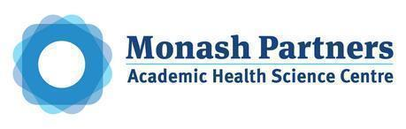
MONASH HEALTHCARE INNOVATION SUMMER SCHOLARSHIPS (HISS)
PROJECT NAME: Project Activus
DELIVERABLES NUMBER: 5
PROJECT LEAD: David Cheng
Proposed business model
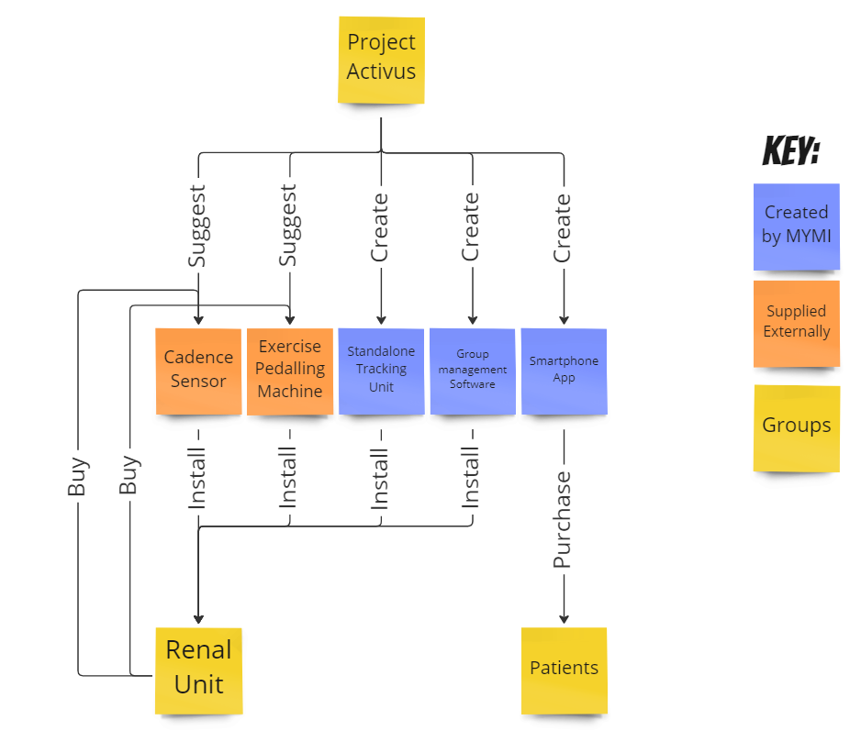

Above: A summary of the different products that are required for the proposed solution. Blue represents potential products that can be created by MYMI, orange represents products that can be supplied externally, and yellow represents the different consumers.

Consumers and the proposed business model:
Renal units:
Capital equipment - pure or combined.
The capital equipment required for this solution will largely consist of existing commercial products such as exercise machines and cadence sensors. The reason for this is because these existing solutions have the potential to be of higher quality, cheaper, and more readily available then anything this project can hope to create. Where Project Activus can come in is suggesting the most appropriate pedalling machines or cadence sensors - those that are known to work well with our software solution package. Products that can be produced by Project Activus can include a custom standalone tracker device. This standalone tracking device is meant to replace the smartphone app if a smartphone cannot be used (i.e because of complexity or otherwise). This can be purchased by the renal unit or the patient (if they are using it in a non-clinical setting). A guide can also be purchased for renal units to start their own exercise programs - it may include recommendations of devices, etc.

Service - Attached to product.
The services involve the instalment, maintenance, and education of renal units on how to operate smart pedalling devices. This can include installing the cadence sensor, and all the other necessary smart devices required for accurate tracking. Additionally, consulting services may be added to aid renal units start their own exercise program by recommending the required exercise machines, cadence sensors, etc, that are best suited for the solution.

Dialysis patients:
Subscription model
The smartphone app can be made into a subscription model, and paid for by the dialysis patients. Alternatively, the smartphone app can be a one time purchase for the dialysis patients.

Business model - cost

Cost to prototype:
The cost to prototype is based on a minimum viable product model aimed to satisfy a clinical trial. The reason for this is because an entire program needs to be tested before it can be brought to market/utilised, and it does not make economic sense to sink tens of thousands of dollars into an app/solution that will need to be altered immediately after a trial. Additionally, a management software solution, gamification systems, and an app needs to be developed - the exact requirements of which will be developed after a trial is completed. Below is each component and the cost to prototype:

Equipment

Item | Procurement Strategy | Cost | Maintenance | Other Costs
Exercise Pedalling machines | Buy | <$100 | Nil | Nil
Cadence Sensor | Buy | <$50 | Nil | Nil
Standalone Tracker | Create | <$100 | Nil | Labour costs may be covered by volunteer efforts of the team.
Chromecast type device | Buy | $50 | Nil | Nil

Software

Software Item | Procurement Strategy | Cost | Maintenance | Other costs
Smartphone App | Create | Nil: MVP app will be made using the labour of volunteer efforts of the team. | Nil | Some consulting costs may be incurred if external help is required and/or hosting costs are required.
Standalone Tracking Software | Create | Nil: MVP app will be made using the labour of volunteer efforts of the team. | Nil | Some consulting costs may be incurred if external help is required and/or hosting costs are required.
Group management software | Create | Nil: MVP will be made usingthe labour of volunteer efforts of the team | <$10 dollars per year for small web hosting service | Some consulting costs may be incurred if external help is required and/or hosting costs are required

Business model - revenue/reimbursement
Who pays for it?
The renal unit will be responsible for funding the shared exercise equipment and associated software to manage and monitor the exercise of patients. Alternatively, patients can be charged on a subscription model, with the money going back into paying back for the exercise equipment. This means that the renal units will earn their money back, essentially meaning they will obtain the exercise equipment for free.
How will you make money?
The program will sustain itself through 3 different streams of revenue:
- Consulting and installation services: Expertise can be provided in terms of selecting the correct commercial products to purchase and the special installation of these products to suit the requirements of the exercise program. A guide book can also be sold if a renal unit chooses to pursue an exercise program on their own.
- The app may involve some form of payment for access. This includes a one time payment for each user, or a subscription model for using the app. The subscription costs may be used for any maintenance costs that are incurred - both for the exercise machines and associated software.
- A standalone tracking device can be made and sold to renal units or patients that do not wish to use the smartphone app. It is not expected that this will be a popular option due to the ease of use of a smartphone app; but is an option for outlier cases and/or special cases where a smartphone app cannot be used. This includes patients that may not be able to or comfortable enough to use a smartphone app.
What is the sales/market penetration strategy?
The market penetration strategy is to first get a clinical trial to evaluate and improve our product. This is because once a clinical trial is conducted, theories can be validated before further development of the smartphone app, dashboard monitoring system, etc are conducted. Additionally, a clinical trial may provide exposure once published about the various systems used, and further drive interest and sales.

Funding has been listed as one of the biggest hurdles facing the implementation of exercise programs. Therefore, one market penetration strategy is for MYMI to fund the procurement of the exercise machines and all other associated capital expenditures. Patients will then be given a 6 month free trial to use the machines and services available - after the fact will be charged monthly. The feasibility of this strategy is detailed in the next few sections, but from the perspective of a renal unit, they will obtain smart exercise machines without any costs. In the market penetration phase, the installation of these machines can be carried out by volunteer efforts of the team.

Proposed price
Equipment Installation price
The equipment installation price will be set at roughly $20 AUD per machine. This price was determined based on the assumption that:
- Technicians are paid $40/hour
- It takes approximately 20 minutes to set up each machine
- The transportation of exercise equipment is not included.
- At least 10 machines will be set up.
The cost to transport exercise equipment will vary depending on the number of machines needed. It costs roughly $150 AUD to rent a truck for one day, or $120 AUD to rent a van for one day. These costs may be covered by the renal unit. The reason for a minimum of 10 machines to be set up is to ensure that sufficient revenue is generated to cover the cost of any additional equipment required, transportation, or other miscellaneous costs (i.e food).

Program consultation price
The consultation price will be set at roughly $40 dollars per hour. This is based off of a $35/hour rate paid to our expert, leaving $5 dollars for profit. The exercise guide will cost $50 AUD, and will be distributed electronically, meaning there will be no cost of sale.

App subscription price
The proposed price of an app service subscription will be set at $10 AUD per month or $120 AUD per year. This is competitive with other indoor cycling apps on the market, which can cost upwards of $20 AUD per month, or $240 AUD per year. This money will be used for further app development and to reimburse the upfront equipment costs.

Reimbursement strategy
Internal Renal unit funding. Alternatively, raising funds through hospital or medical centre grants, patient memorial funds, patient donations, and community events to pay for exercise equipment. The smartphone app will be paid for by the patient to use, and can be used to fund the exercise equipment and associated costs.

What is the health economic profile compared to the SOP (standard operating procedure)?
The current standard operating procedure does not involve an exercise program. Therefore, any implementation of an exercise program with the associated equipment will mean the renal unit will be losing money with the solution. However, on a wider scale where the entire healthcare system is considered, the potential benefits of the exercise program in reducing falls and conditions associated with a sedentary lifestyle may outweigh the procurement and maintenance costs of the solution. It is estimated that in the year 2000, 1.5% of total healthcare expenditure in the United States was attributed to sarcopenia. Frailty was also independently associated with increased direct costs, indirect costs, and total costs associated with clinical admissions, with frail patients often incurring 50% higher costs compared to non-frail patients. Frailty may also complicate kidney transplants or other invasive procedures, as frailty increases recovery times and risk of mortality.

Does it fit within the hospital’s KPIs?
This solution will not currently fit within the hospital’s KPIs. This could be due to the non-existent nature of an exercise program to improve outcomes of patients. A broad key performance indicator could be reduced hospitalisations in general; the reduction of sarcopenia and frailty will decrease hospital admissions, and reduce hospital costs.

Can you use an existing Medicare code? Do you need a new code?
There is no known Medicare code that will fund the procurement of medical devices.

Business model - risk management
What is the exit strategy?
The exit strategy is to reclaim all exercise equipment and resell it. It should be noted that this repossession of exercise equipment will largely be carried out by volunteer efforts by those on the team at little cost. Customers will be refunded purchases if they are on a subscription.
Who are the potential acquirers?
Existing fitness apps and system providers may take an interest. Particularly, equipment manufacturers may be in a position to develop an integrated cadence sensor/ smart exercising equipment and app to be more competitive.
Does it fit within the hospital’s KPIs?
The solution does not currently fit into any formal hospital/renal unit KPIs.
What is the investor ROI?
The profitability of this solution is high, with a low upfront cost required followed by a steady stream of revenue.
What are the most significant risks and what is the de-risking strategy?
The most significant risk is low to no uptake of the exercise program. Since our business model aims to pay for the exercise equipment for renal units, the money is made back through the subscription service targeted towards patients. At an estimated cost of roughly $200 dollars per machine, it would require 20 months of subscriptions to completely cover the cost of setting up the machine. This would imply 20 months for one patient to cover the cost, or 10 months for two patients to cover the cost. For 4 patients, the complete cost of the exercise equipment can be covered in as little as 5 months. The de-risking strategy is to utilise a trial to evaluate uptake and refine the exercise program to ensure good adherence and high uptake.

Market analysis
TAM (Total Addressable Market)

Product | Customer | Total Population | Average Cost | TAM
Subscription | Dialysis Patients | ~ 20 million worldwide. | $150/Year AUD | 4 billion AUD/year
Exercise Equipment | Dialysis Units | 45,000 units, average of 10 seats per unit = 450,000 | $200 + $20 | 99 million AUD

What is the SAM (Serviceable Available Market)?

Product | Customer | SAM population | SAM
Subscription | Australian Dialysis Patients | 36000 | 5.4 million AUD/year
Exercise Equipment | Dialysis Units | 1200 | 2.64 million AUD

What is the SOM (Serviceable Obtainable Market)?

Product | Customer | SOM population | SOM
Subscription | Victorian Dialysis Patients | 8844. Assuming 10% will use the service: | $132,660 AUD/year
Exercise Equipment | Dialysis Units | 20 dialysis units, 10 machines per unit: | $44,000 AUD

Who are your competitors within the market?
Competitors would be existing smart exercising manufacturers and app makers. They have the potential to create a really streamlined albeit more expensive option. They shouldn't be too much of a threat though because an exercise program is just as important as the machines, of which they may find it harder to enter.

Can the market be expanded?
Haemodialysis patients aren't the only group of individuals that need exercise. Particularly elderly individuals in general who may spend a considerable amount of time being seated may benefit from this device. Additionally, other rehabilitation applications may be an area where this solution can expand into.

What are the major market forces?
Funding to get the solution off the ground will be crucial to the start of the program. From there, trial success will determine how well the solution performs for a wider range of dialysis patients.

