
MONASH HEALTHCARE INNOVATION SUMMER SCHOLARSHIPS (HISS)
PROJECT NAME: Sentinel
DELIVERABLES NUMBER: 4 (Week 5)
PROJECT LEAD: Calvin Zheng, Diana Kovaleva

Summary of current gold-standard:

The current gold standard of care for monitoring ischaemic stroke patients for repeated blood clots is to use the National Institute of Health Stroke Scale. It is a physical test done by neurologists to determine the state and health of a patient post stroke. The test involves 11 main checks for:
- Level of consciousness
- Horizontal extraocular movements
- Visual fields
- Facial palsy
- Arm motor drift
- Leg motor drift
- Limb Ataxia
- Sensation
- Language/aphasia
- Dysarthria
- Extinction/inattention
These tests have been optimised to be as objective as possible, but subjective errors may still occur.
The only equipment needed for these tests are some images of words to test for aphasia, which is completely free and easy to obtain. It is expected for patients to be on a bed while this test is being conducted. This test can be done at any time and does not require any preparation, but it takes up to 30 minutes to conduct, thus neurologists only check each stroke patient up to twice a day.

Pugh matrix:
Acceptance criteria:
- Offers a rapid response signal of ischaemic stroke occuring within a patient
- Offers continuous surveillance of the patient’s neuronal activity over a period between 30 minutes and 24 hours
- Functions automatically.
- Provides a ground truth about the state of the patient, and the severity and stability of the stroke.
- Cheap enough for the average hospital to be able to use it on every stroke patient simultaneously.
- Non-invasive and does not cause discomfort within the patient
Solutions:
- EEG with inverse solution
- Laser doppler flowmetry
- Duplex ultrasonography (Doppler + B-mode)
- Magnetoencephalography
- 24 hour MRI monitoring
 | Current gold standard | Weight | EEG | Laser doppler | Duplex ultrasound | Magnetoencephalography | 24 hour MRI
Rapid Response | Baseline | 3 | + | + | + | + | +
Continuous | Baseline | 2 | + | + | + | + | +
Automatic | Baseline | 3 | + | S | S | S | S
Ground truth | Baseline | 2 | + | S | + | + | +
Cheap | Baseline | 1 | - | - | - | - | -
Comfortable and safe | Baseline | 2 | + | + | + | + | -
Total | Baseline | 13 | 11 | 6 | 8 | 8 | 4

Final verdict:

From the Pugh matrix, the best rated solution will be to use an EEG with an inverse solution. This method attaches an electrode cap onto the patient to measure the electrical signals generated by their neuronal activity. An algorithm is implemented to recognise patterns within the brain activity and to raise an alert instantly if the recorded signal changes and differs from the base signal of a stable brain. A destabilisation of brain activity should signify the occurrence of another stroke. An inverse solution, which is a type of algorithm, is used to then convert the recorded electrical signals into a 3 dimensional model where the source of electrical potential within the brain is localised. This information will be useful for a neurologist to determine the state of the stroke and the potential location of the blood clot; this will aid in determining the type of treatment to use in curing the ischaemic stroke.
This method should be fully automatic and continuous as the electrode cap is not too restrictive and the EEG can be placed by the bedside of a patient with no supervision. EEGs are relatively affordable, averaging around $1,500 for one machine.
Current gold standard inverse solutions that may be implemented in this system include sLORETA (Standardized Low Resolution brain Electromagnetic Tomography Algorithm) and eLORETA (Exact Low Resolution brain Electromagnetic Tomography Algorithm), and density spectral array.
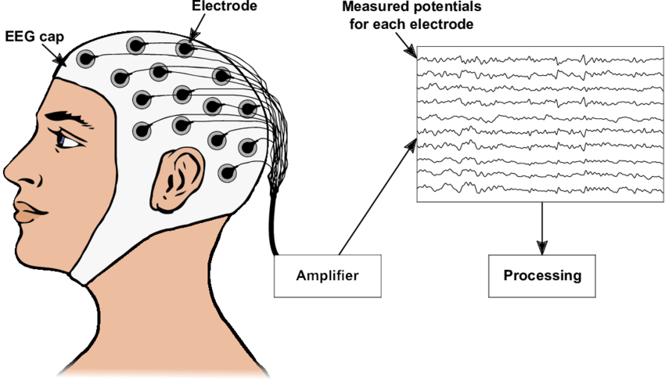
Electrode cap
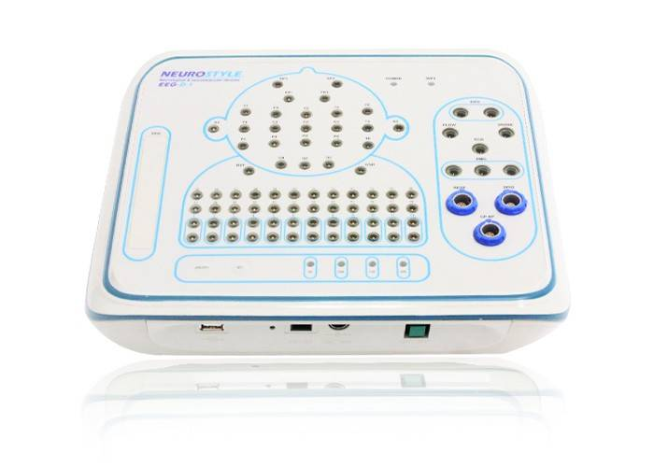
EEG machine
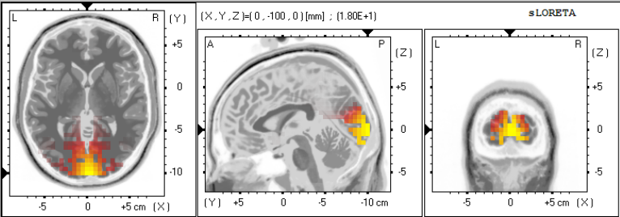
LORETA visualisation

