
MONASH HEALTHCARE INNOVATION SUMMER SCHOLARSHIPS (HISS)
PROJECT NAME: NEPHROS
DELIVERABLES NUMBER: 4 (Week 5)
PROJECT LEAD: Nandini, Upani

Summary of current gold-standard:

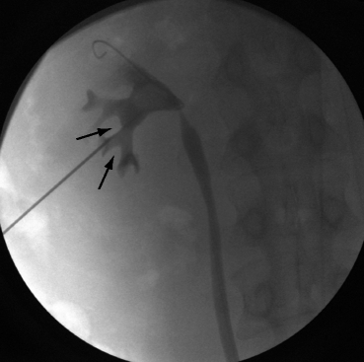
The existing gold standard uses fluoroscopy to visualise the kidney’s anatomy during PCNL surgery. This technique allows for real-time visualization intraoperatively and is relatively inexpensive to conduct.
One of its major downsides are that images produced during the surgery are not of high resolution and two dimensional, making navigation of the needle from the skin to the stone tedious and inaccurate.
Fluoroscopy also exposes both patient and operating team to radiation. Although this does not significantly affect the surgeons due to lead PPE used (but PPE is uncomfortable).
The accuracy of the puncture that is guided by fluoroscopy is also dependent on the respective surgeons’ expertise and optimal routes are guesswork based on stone positioning from the diagnostic 2D scans (for e.g. CT scans).

Pugh matrix: Acceptance Criteria

- The solution will reduce the need for multiple punctures, hence reducing levels of sepsis and bleeding.
- The solution will be easily incorporated into the existing healthcare system i.e surgeon and operating team training, private vs public hospital uptake…
- The solution will allow surgeons to navigate real-time visuals of the kidney
- The solution will utilise a high resolution scan and/or reconstructed model of the kidneys for better accuracy
- The solution will register stone location and plan the most optimal route of puncture
- The solution will reduce radiation exposure for the patient and operating team during surgery due to reduced fluoroscopic exposure.
- The solution reduces operator dependency, increasing surgical confidence

 | Current gold standard | Weight | Solution #1 | Solution #2 | Solution #3
Acceptance criteria #1 | Baseline | 3 | + | + | +
Acceptance criteria #2 | Baseline | 1 | - | + | -
Acceptance criteria #3 | Baseline | 2 | + | S | +
Acceptance criteria #4 | Baseline | 2 | + | - | +
Acceptance criteria #5 | Baseline | 2 | + | + | +
Acceptance criteria #6 | Baseline | 1 | + | S | S
Acceptance criteria #7 | Baseline | 2 | + | + | S
Total | Baseline | 13 | 11 | 6 | 8

Solution #1: 3D reconstruction of the kidney using segmented CT scans + stereotactic guidance
Solution #2: Fluoroscopy + stereotactic guidance where route is mapped using normal CT
Solution #3: 3D reconstruction of the kidney using segmented CT scans + surgical expertise and guesswork puncturing (current puncturing method, fluoroscopy)

Final verdict:

Solution #1 most favourably rated - 3D reconstruction of the kidney using segmented CT scans + stereotactic guidance

Proposed workflow:
- Patient is scheduled for PCNL surgery
- CT scans are taken (during diagnosis or in preparation for the surgery)
- Segmentation of CT scans is used to construct a 3D model.
- Using the 3D reconstruction (in a program like 3D slicer) target registration of the kidney stone occurs and a trajectory is planned - target registration and stereotactically planned surgery can also occur using 2D CT slices however a 3D is extremely useful during intraoperative visualisation.
- To obtain an accurate access point on the patient’s skin, a stereotactic system is used to place fiducials/nodes on the patient’s skin. Then puncture is made according to the proposed trajectory from skin to stone - live tracking on the 3D model of the needle tip useful to guide puncture
- Surgeon uses a 3D model, node placement (stereotactically), endoscope through trocar during the procedure to view and remove kidney stone - once needle is in - surgery proceeds as usual.

