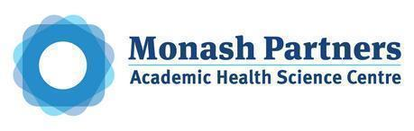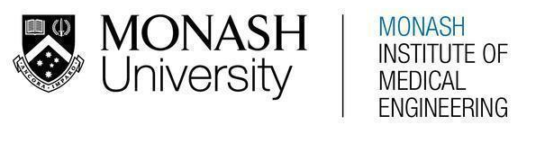
MONASH HEALTHCARE INNOVATION SUMMER SCHOLARSHIPS (HISS)
PROJECT NAME: Nemo
DELIVERABLES NUMBER: 4 (Week 5)
PROJECT LEAD: David Levitz & Vishnu Sivakumar

Summary of current gold-standard:

The current gold standard solution for increasing the accuracy of nerve conduction tests when there is ambiguity due to difficult anatomy - namely increased subcutaneous fat and oedema - involves a variety of different techniques. The probe may be used to stimulate an axial plane of tissue circumferentially until a reading is picked up by the sensory electrode. Additionally, the strength of the stimulus may be gradually increased to improve the chances of stimulating a nerve (increasing the pain). Various maneuvers of the limb employed by clinicians may make stimulation more accurate. Clinicians may refer to or request assistance from more senior colleagues for advice or guidance.

Other factors that affect accuracy may be mitigated. For example, cold peripheries may lead to inaccurate diagnosis. The clinician may place the patient's distal limbs (usually the hands) in warm water to increase the accuracy of interpretation.

If attempting to stimulate proximal nerves, vessels running with the nerve may be located through palpation to estimate the location of the nerve. This is less helpful in distal nerves.

Finally, if a clinician has tried all these methods and is still unsure of whether they have stimulated the nerve, they may decide to leave it and interpret the conduction study in the context of other stimulated nerves and clinical history and exam. Further invasive procedures such as biopsies may be rarely performed to confirm conditions such as neuropathy.

Pugh matrix:

 | Current gold standard | Weight | Solution #1 -  NCS Accompanied with Ultrasound | Solution #2 - Ultrasound with centralised marker | Solution #3 - Stimulator Cuff with Feedback Receptor | Solution #4 - Digital Measurement Device | Solution #5 - Nerve Finder Pen
Training | Standard NCS Training | 1 | - | - | - | - | -
Accuracy/reliability | Highest Action Potential | 3 | + | + | + | s | +
Patient Comfort | Uncomfortable procedure | 2 | + | + | + | s | +
Time | 40 mins | 3 | + | s | s | + | +
Cost (long term) | $700 (without insurance) - $4000 (if other tests are required) | 2 | + | + | s | - | +
Is it effective in target population |  | 3 | + | + | + | + | s
FINAL SCORE |  |  | 12 | 9 | 7 | 3 | 9

Final verdict:

Based on the data in the table, it has been determined that the combination of nerve conduction studies (NCS) and ultrasound imaging is the most effective solution for project Nemo. This decision was made after consulting with multiple clinicians and considering the available options. While MRI and ultrasound are both capable of visualizing nerve fibers and can sometimes detect nerve pathologies, an MRI is not practical in this situation due to its large physical volume, high maintenance requirements, and time-consumptive process. On the other hand, ultrasound is portable, requires minimal training, and is more cost-effective compared to MRI. Therefore, by combining NCS and ultrasound into a single unit, nerves can be localised in a time efficient manner and be stimulated with utmost accuracy.

