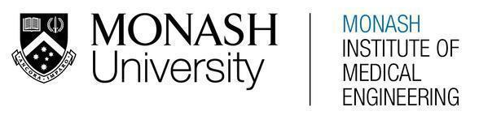
MONASH HEALTHCARE INNOVATION SUMMER SCHOLARSHIPS (HISS)
PROJECT NAME: Project Embrace
DELIVERABLES NUMBER: 4 (Week 5)
PROJECT LEAD: Sue Liu

Summary of current gold-standard:

The current gold-standard practice for patients to receive answers to their questions directly from a clinician is for them to phone the caring team with a provided number. This number is usually manned by a Symptom and Urgent Review Clinic (SURC) nurse. This practice allows for patients to ask very specific questions regarding their circumstances, with the SURC nurse having access to their appropriate medical information. Furthermore, the nurse is able to consult with the oncologists/other healthcare professionals in the team as needed, in order to provide a holistic perspective to the patient's question/scenario. Phone translators can be utilised to aid access to CALD populations. Due to the other competing demands of the role, SURC nurses may not always be able to pick up calls immediately.

Pugh matrix:

- Results in increased patient confidence in undergoing chemotherapy
- Easily accessed by patients undergoing chemotherapy and their carers
  - Accessible via devices already available to the public (ie. smartphones, computers)
  - Information is understandable to those with low health literacy and culturally and linguistically diverse populations
- Patients can access information that is relevant to their circumstances
- Information can be delivered and updated by healthcare professionals following approved guidelines where applicable
- Easily integrated into existing healthcare system workflows
  - Affordable
  - Does not require excess time from healthcare professionals

 | Patient phones team | Weight | Q&A website run by Alfred team | Chemotherapy education sessions | Monthly “Town Hall” video call amongst patients | Patient question checklist | Provide patient with relevant list of signposting resources
Increases patient confidence | Baseline | 1 | S | - | - | - | -
Accessible via common devices + software | Baseline | 3 | - | + | - | + | -
Accessible to elderly | Baseline | 2 | - | + | S | + | -
Accessible to CALD | Baseline | 2 | - | - | S | - | -
Information can be specific to patients’ needs | Baseline | 2 | - | - | - | S | -
Delivered by HCP | Baseline | 3 | + | S | S | S | S
Affordable to implement | Baseline | 2 | + | - | + | + | +
Does not require excessive time from HCP | Baseline | 3 | + | - | + | S | +
Total | Baseline |  | -1 | -5 | -1 | 4 | -5

Final verdict:
The most favourably weighted solution is to implement patient question checklists into standard practice during a patient's chemotherapy appointment. There are pre-existing versions of these checklists which have been developed by reputable sources eg. Cancer Council, eVIQ and are a printed/online list of questions for patients to directly ask their clinician/healthcare professionals during their interactions. This allows for the patient to "remember" questions that they may not normally have thought of, to ask and be informed of the answer before they run into circumstances where the information is needed. These are already utilised in some chemotherapy education sessions, however these sessions do not currently run in all healthcare networks for chemotherapy patients. Furthermore, there appears to be limited awareness/implementation of these checklists into existing practice.

