
MONASH HEALTHCARE INNOVATION SUMMER SCHOLARSHIPS (HISS)
PROJECT NAME: Project Blooming
DELIVERABLES NUMBER: 3
PROJECT LEAD: Jacinta Patel

Stakeholder map
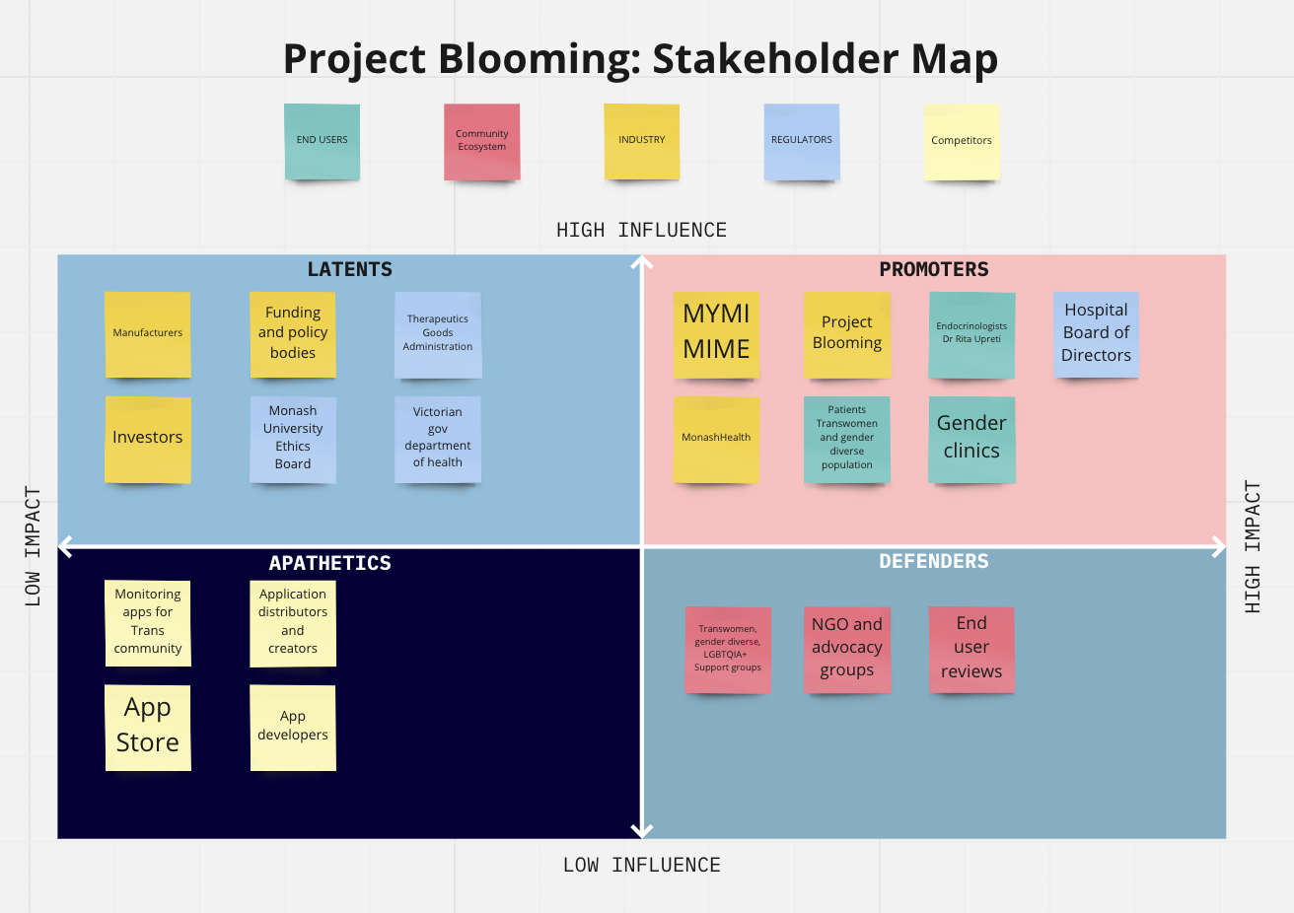

Systems map
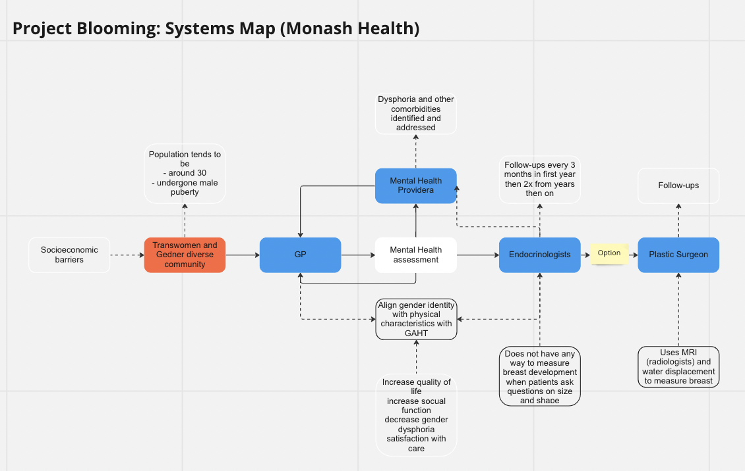

Solutions ideation
 | Selection/Acceptance Criteria
Solution Description | Easy to use | Affordable | Time efficient | Aid in tracking progress of breast development | Done independently by patients | Accessible
- Video course (educational) teaching women to gauge their own breast development | Yes | Yes | Yes | No – does not mention way to measure | Yes | Yes
- Ultrasound device to measure the ‘volume’ of the patients’ breasts as a measure of growth | Depends on user who translates | No | No | Yes | No | No
- Blood test to measure prolactin as a measure of development | Depends on user who translates | N/A | No | No? – Prolactin itself does not directly stimulate breast development but rather increases Estrogen and Progesterone receptor expression and endogenous synthesis of both hormones | No | Yes – at GP
- ‘Elastic bra’ (market on material) that fits all breasts sizes (bra grows as breasts grows) and tracks growth digitally | Yes | N/A | Yes | Yes | Yes | N/A
- Bra size stencil of bra cups of different sizes to measure | Yes | N/A | Yes | Yes | Yes | N/A
- Tape Measure (normal or smart) | Yes | Yes | Not Really | Yes | Yes | Yes
- AR app that visualises breast size | Yes | N/A | Yes | Yes | Yes | No
- Affirming picture book describing each stage | Yes | Yes | Yes | No – doesn’t measure problem | Yes | No- who sells it?
- Social campaign to de-emphasise large breasts as a feminine trait | Yes | Yes | Yes | No | Yes | Yes
- Sensors on bra to measure the dimensions of the breasts | Yes | N/A | Yes |  | Yes | N/A
- Education/tips to self-measure without tools - Qualitative measure to improve satisfaction and reduce satisfaction that comes with numbers | Yes | Yes | Yes | Yes- but how accurate | Yes | Yes
- Lidar technology mobile apps to estimate volume alongside GAHT, informational/educational modules  - Visualisation  - Potential journal format | Yes – depends on how it is made | N/A | Yes | Yes | Yes | N/A
- 3D modelling/surface imaging and software like Spectra | No - Depends on user to translate | No | Yes - depends | Yes | No | No
- MRI | No - Depends on user to translate | No | No | Yes | No | No
- X-ray/ mammography | No - Depends on user to translate | No | No | Yes | No | No
- Grossman–Rounder measuring device | No - Depends on user to translate | Yes | Yes | Yes | Yes | No
- CT | No - Depends on user to translate | No | No | Yes | No | No
- Cast (negative) | Yes | N/A | No | Yes | Yes? | No
- Using visualisation of Tanner staging of breast development in females  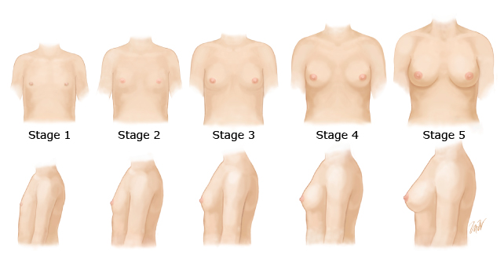  Stage 1: Prepubertal.  Stage 2: Breast bud stage with elevation of breast and papilla; enlargement of areola.  Stage 3: Further enlargement of breast and areola; no separation of their contour.  Stage 4: Areola and papilla form a secondary mound above level of breast.  Stage 5: Mature stage with projection of papilla only, related to recession of areola. | Yes | Yes | Yes | Yes | Yes? | Yes
- Water Displacement | Yes | Yes | Yes | Yes | Yes | Yes
- Plastic Cups | Yes | Yes | Yes | Yes | Yes | Yes

