
MONASH HEALTHCARE INNOVATION SUMMER SCHOLARSHIPS (HISS)
PROJECT NAME: THEIA
DELIVERABLES NUMBER: 3
PROJECT LEAD: Patrick Kwan & YaoYao

Stakeholder map
https://miro.com/app/board/uXjVP7sGSAo=/?share_link_id=843494140825

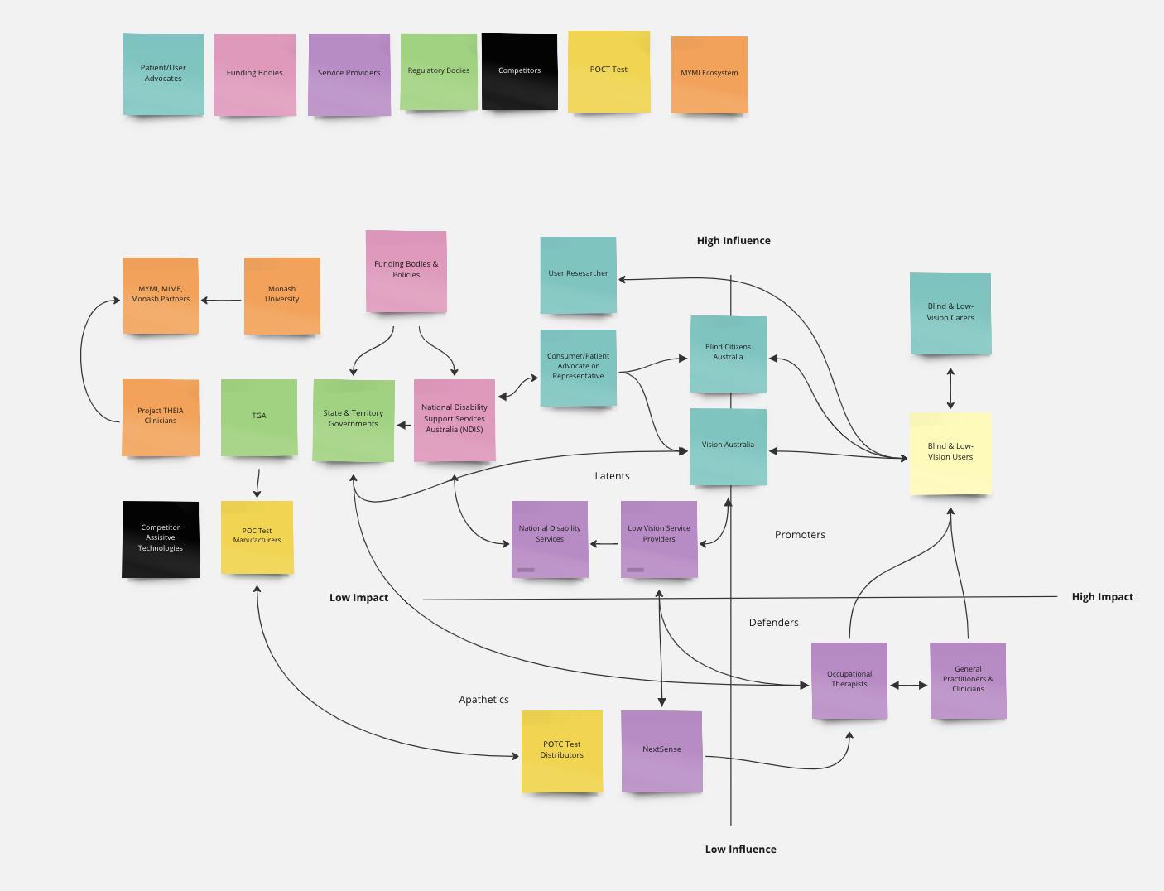

Systems map
https://miro.com/app/board/uXjVP6krBzI=/?share_link_id=907579905119
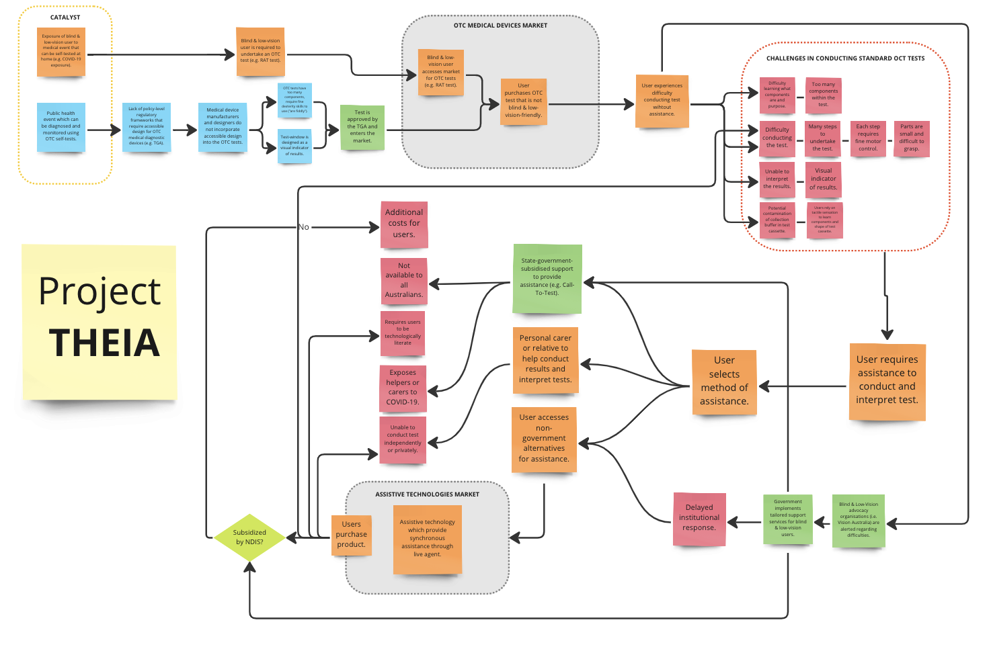
Solutions ideation

 | Selection/Acceptance Criteria
Solution Description | Criteria #1 | Criteria #2 | Criteria #3 | Criteria #4 | Criteria #5 | Criteria #6 | Criteria #7
- Develop a mobile software application that reads out specific test instructions to users, and uses AI software to verbalise the results shown on the test-window.
- Develop a hardware that uses a camera to recognise test-window results, and provides tactile feedback.
- Digitise existing POCTs through partnerships with existing manufacturers
- Modify existing POCTs to provide tactile feedback as a part of the result interpretation process
- Develop a reusable digital POCT that is BLV friendly
- Instantiate a government funded scheme for locally trained agents to assist BLV users for medical devices
- Distribute Braille instructions with every POCT sale through partnerships with pharmacies
- Policy-level changes: modify existing TGA regulations to require manufacturers to make their consumer products BLV friendly
- Distribute standardised POCTs to BLV users
- Modify existing POCTs to provide audio, read-out results.
- Develop an application that enables users to take anonymous photos of their results and send them to a community of trusted users to annotate them.
- Create a mobile application for centralised healthcare services, information and concerns (including instructions to conduct and interpretation of point-of-care, over-the-counter self-tests) which are tailored in accessible format towardsblind and low vision users.

