
MONASH HEALTHCARE INNOVATION SUMMER SCHOLARSHIPS (HISS)
PROJECT NAME: Sentinel
DELIVERABLES NUMBER: 3
PROJECT LEAD: Calvin Zheng, Diana Kovaleva
Stakeholder map
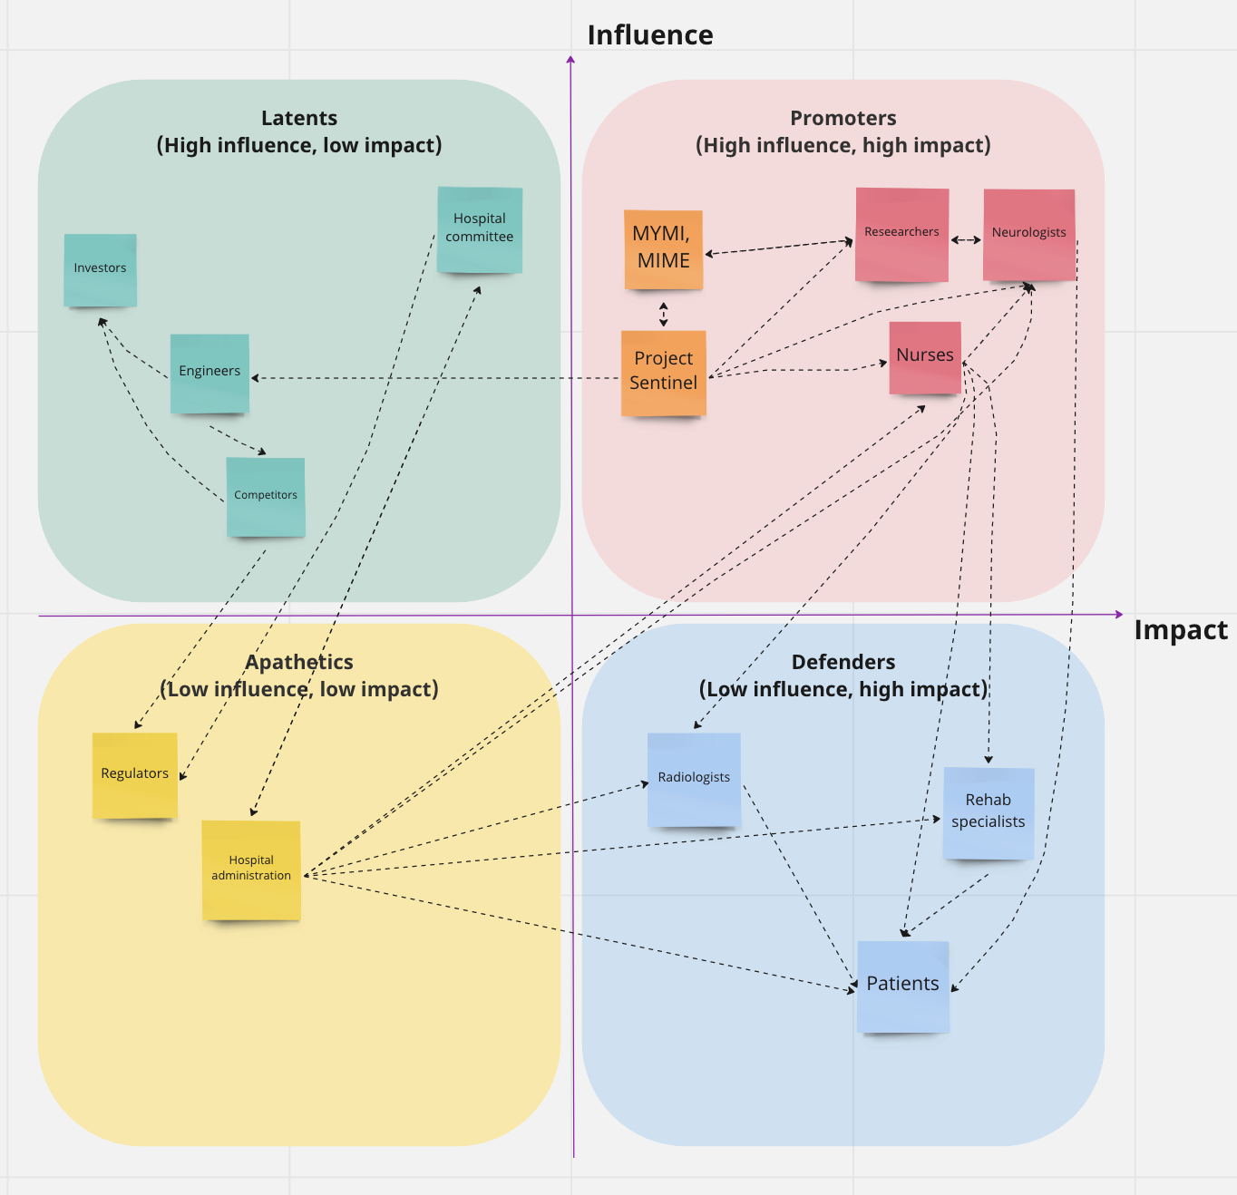

Systems map
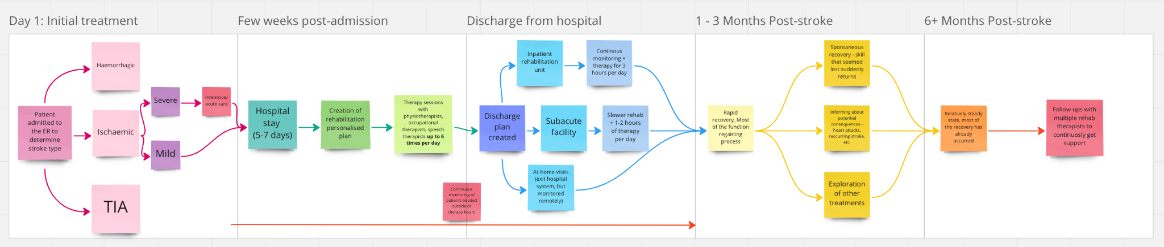
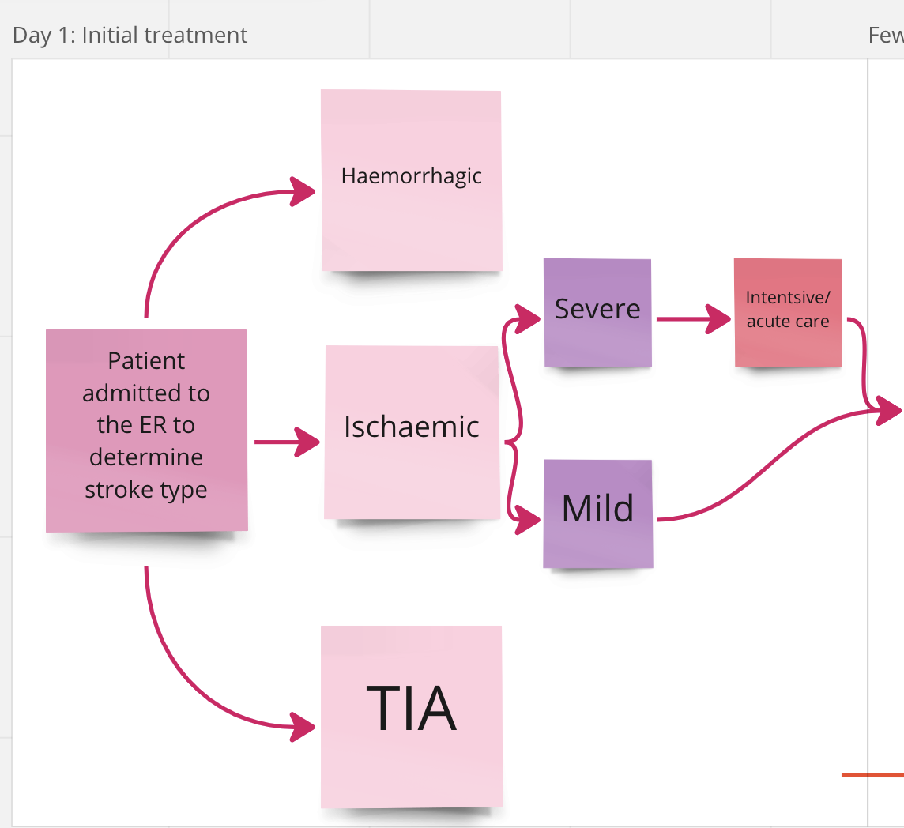
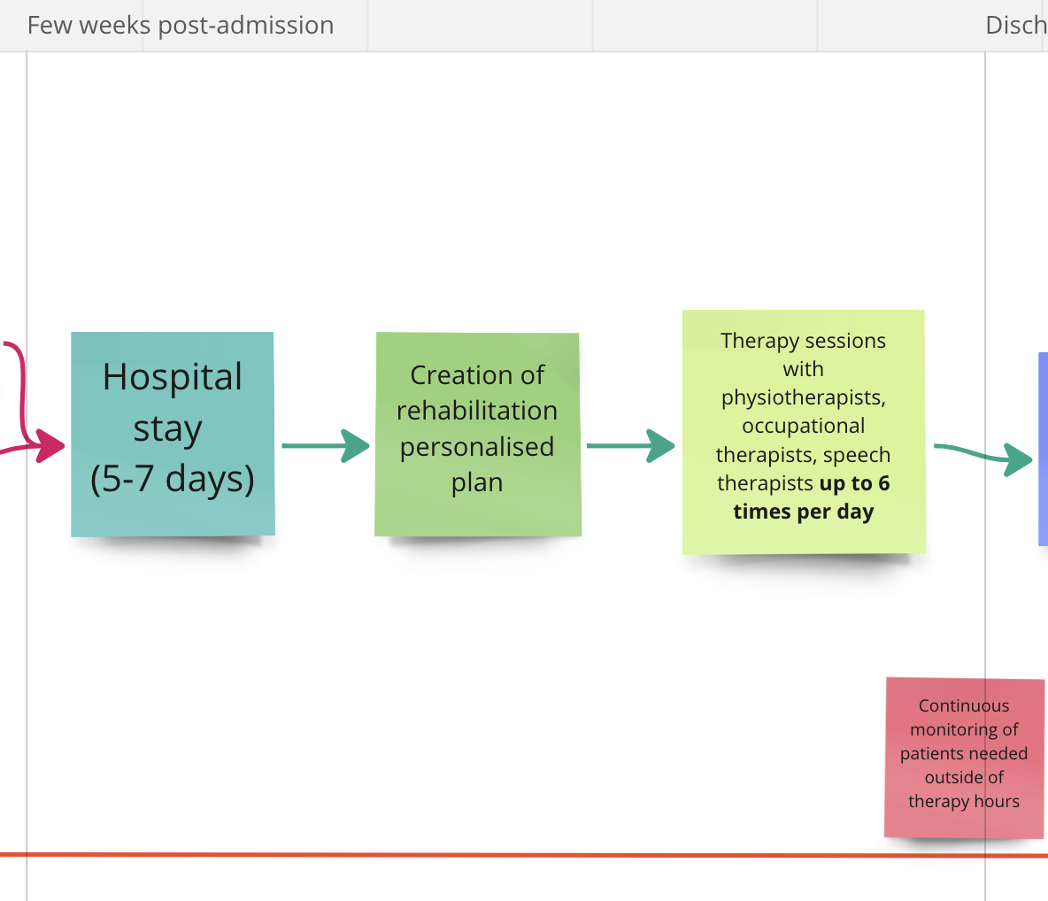

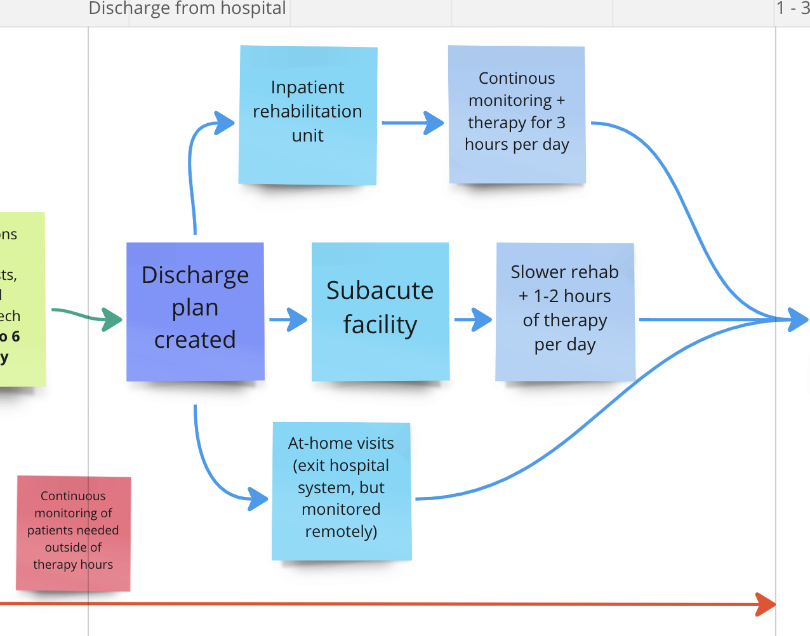
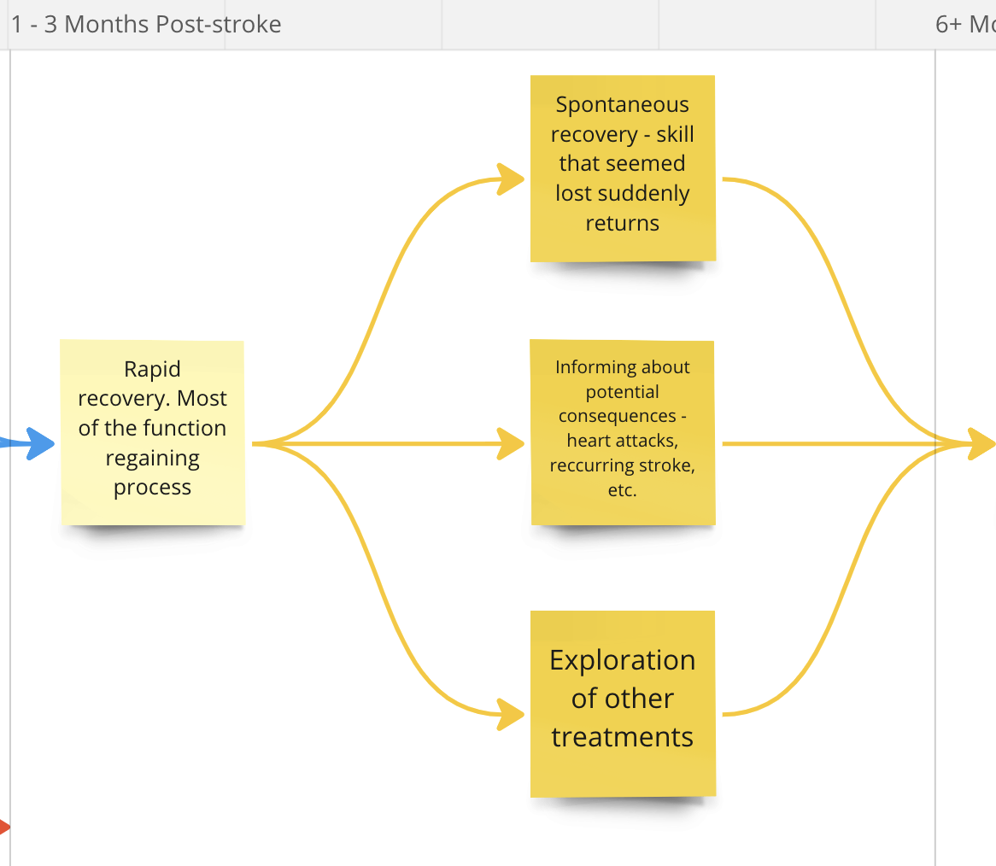
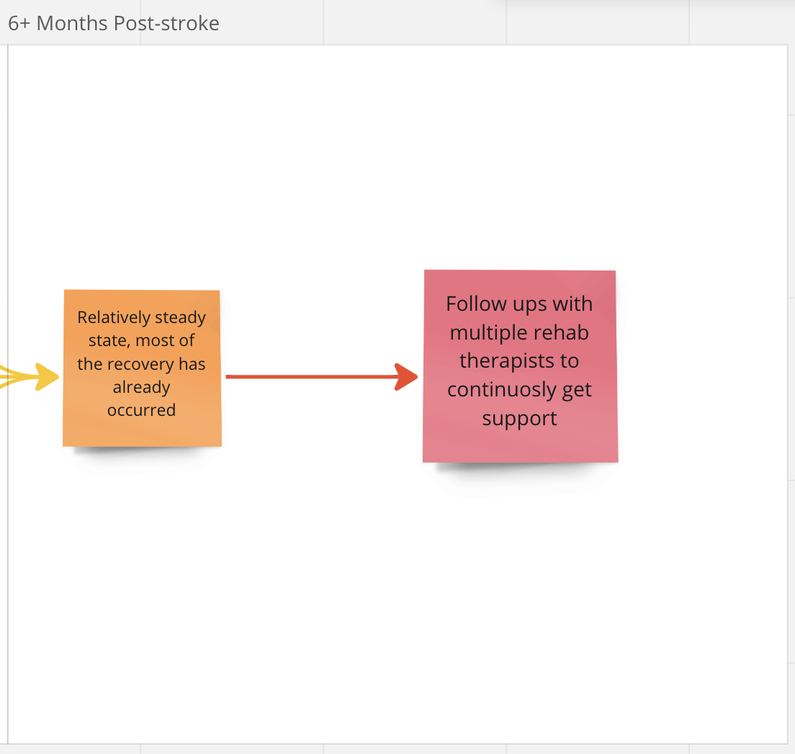

Solutions ideation
- Offers a rapid response signal of ischaemic stroke occuring within a patient
- Offers continuous surveillance of the patient’s neuronal activity over a period between 30 minutes and 24 hours
- Functions automatically.
- Provides a ground truth about the state of the patient, and the severity and stability of the stroke.
- Cheap enough for the average hospital to be able to use it on every stroke patient simultaneously.
- Non-invasive and does not cause discomfort within the patient

 | Selection/Acceptance Criteria
Solution Description | Criteria #1 | Criteria #2 | Criteria #3 | Criteria #4 | Criteria #5 | Criteria #6
Using an EEG with inverse algorithm
Hire more neurologists to do NIHSS
Train more nurses to do NIHSS
Teach patients how to monitor stroke symptoms in themselves
Use an ECG to detect atrial fibrillation which is a common cause of strokes
Develop an easier and faster physical test that anyone could do to detect strokes.
IR scanning modified to penetrate the thickness of the adult human skull
Do continuous blood tests on the patient to check for potential clots
Have a device that is attached to the patient’s bloodstream to continuously check for clots
Use camera with AI that can detect stroke symptoms
Make a phone app using an AI camera that the patient could use to monitor themselves with.
Make a phone app calculator that the patient could input their own symptoms into to figure out the severity of their stroke
Use magnetoencephalography to monitor the patient.
Use laser doppler technique to monitor blood flow and check for clots
Place sensors on muscles and neck to detect speech and movement capabilities which are usually affected by a stroke.
Invent nanomachines to insert into the patient to monitor their bloodstream and brain state.
Use an ECoG with inverse algorithm
Use single/multi unit spiking to read brain signals
Put the patient in an MRI over 24 hours
Put the patient in an CT over 24 hours

